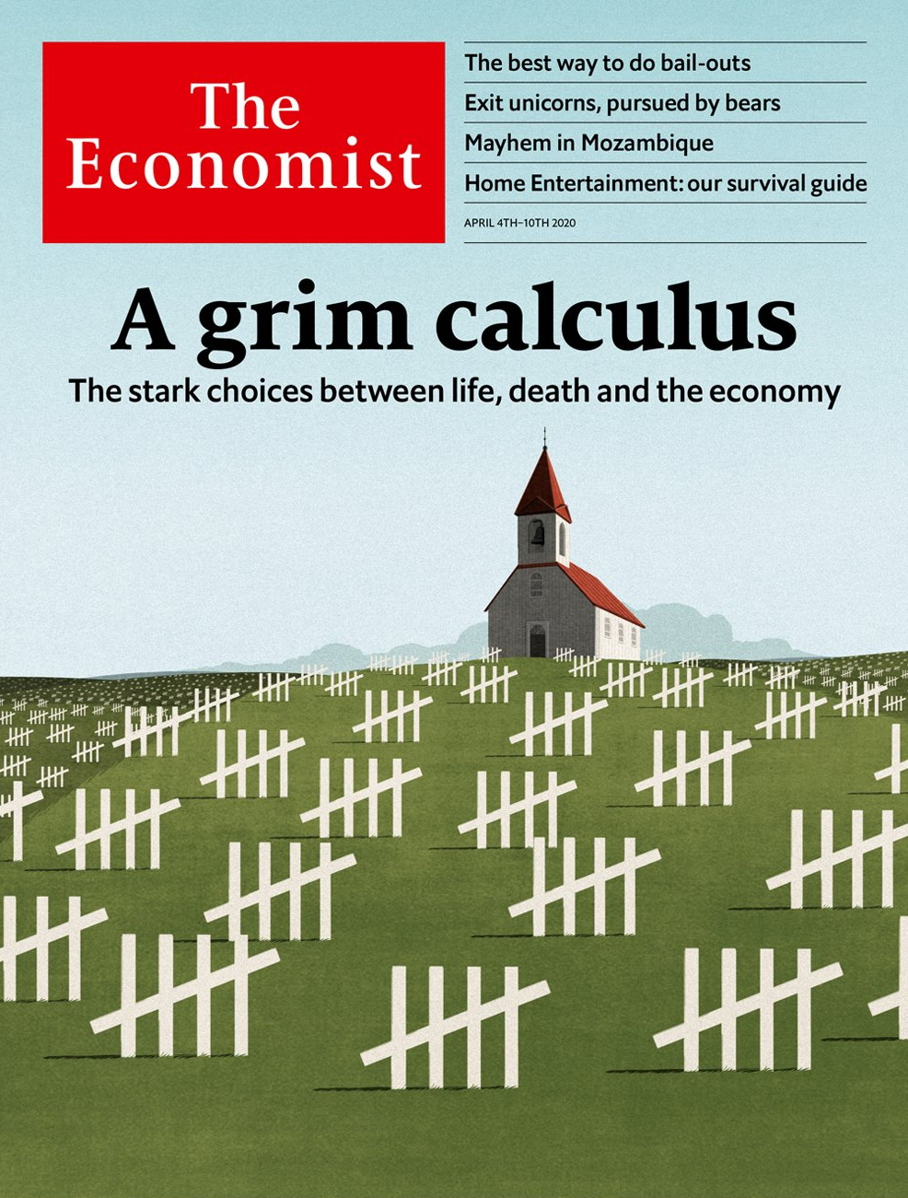

# Table of Contents

The world this week

Politics this week

Business this week

KAL’s cartoon

Leaders

Pandemic trade-offs: A grim calculus

Corporate bail-outs: Bottomless Pit, Inc

The technology industry: Don’t waste a good crisis

Mozambique: Gas, guns and guerrillas

Oil and geopolitics: The Rosneft riddle

Letters

On covid-19, Bolivia, sports, rivers, lichen: Letters to the editor

Briefing

Pandemic trade-offs: Hard choices

Medical ethical dilemmas: Triage under trial

Anatomy of an investing bubble: Exit unicorns, pursued by bears

United States

Covid-19 and the states: It can happen here

Social distancing: Movement Republicans

The labour market: Trough to peak

Wisconsin’s chaotic elections: Petri-dish democracy

The presidential campaign: Reade’s digest

Military strategy: Send the marines

Lexington: A shadow over the Sunshine State

The Americas

Venezuela: Maduro rap

Cuban doctors: Mercy and money

Bello: Wisdom and witlessness

Asia

Migration and the virus: Under pressure

The occult in Myanmar: A wizard wheeze

Thailand’s economy: Sigh-am

South Korea and America: Stay-at-home allies

Love in Indonesia: Wed first, ask questions later

Banyan: The drifters

China

The gig economy: Visible and vocal

Chaguan: A Chinese mirror

Middle East and Africa

Cabo Delgado: Mayhem in Mozambique

Chocolate in Africa: Sweet dreams are Congolese

States of emergency: Stay home or be whipped

A lost year in Saudi Arabia: Stalled

Faith and covid-19: Insular, but not isolating

Europe

France and covid-19: The new war

European agriculture: Farmhands needed

Sweden and covid-19: Europe’s outlier

Germany’s would-be leader: Söder’s moment

Kosovo: A Balkan bust-up

Charlemagne: The Orban way

Britain

Innovation: Move fast and try not to break things

Life under lockdown: Home comforts

Testing: Negative result

Policing a lockdown: Booby on the beat

The army: War, or something like it

Rough sleeping: Shelter from the storm

The steel industry: Braced for trouble

Call centres: Please hold

Bagehot: The return of the opposition

International

Covid-19 and mental health: Only connect

Self-improvement: Net benefits

Business

Corporate rescues: Great white night

Boeing: Up in the air

Show business and the pandemic: Aaaaand cut!

Huawei: Indestructible

Bartleby: Just the job

Schumpeter: You’re furloughed!

Finance and economics

Emerging economies: Stringent but stingy

Projecting uncertainty: Economists’ forecasts for GDP growth in 2020 vary widely

Squeezed incomes in America: Bills, bills, bills

Buttonwood: Advantage Norway

Allianz: Lonely work

Free exchange: Chinese rate trap

Science and technology

The coronavirus pandemic: Testing’s testimony

Treating patients: A racing chance

Overloaded telecoms: Breaking the net

Books and arts

Geopolitics: The victor’s curse

New fiction: Secrets and lies

Pandemics of yore: How to understand a plague

Creatures of the deep: Rich and strange

Johnson: Corona-speak

“I, Claudius”: A family affair

All-in together: Gambling with the future

Economic and financial indicators

Economic data, commodities and markets

Graphic detail

Coronavirus statistics: Fatal flaws

Obituary

Joseph Lowery: Justice like waters



### Friday, April 3, 2020

|  |  |
| --- | --- |
| The world this week | 3 |
| Leaders | 5 |
| Letters | 1 |
| Briefing | 3 |
| United States | 7 |
| The Americas | 3 |
| Asia | 6 |
| China | 2 |
| Middle East and Africa | 5 |
| Europe | 6 |
| Britain | 9 |
| International | 3 |
| Business | 6 |
| Finance and economics | 6 |
| Science and technology | 3 |
| Books and arts | 7 |
| Economic and financial indicators | 1 |
| Graphic detail | 1 |
| Obituary | 1 |

|  |  |  |
| --- | --- | --- |
|  | Sections | Leaders |

The world this week

Politics this week

.

Business this week

.

KAL’s cartoon

.

|  |  |  |
| --- | --- | --- |
|  | Sections | Leaders |

|  |  |  |  |
| --- | --- | --- | --- |
|  | Articles | Sections | Next |

# Politics this week

Apr 4th 2020 |

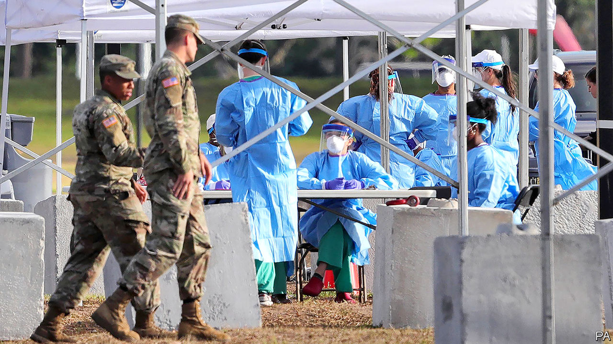

Scientists advising the American government about the covid-19 outbreak predicted that between 100,000 and 240,000 Americans could die, even with partial lockdowns and social-distancing measures in place. Donald Trump warned his compatriots “to be prepared for the hard days that lie ahead”. The United States now has more reported infections than any other country. New York city has recorded more deaths from the coronavirus than all but half a dozen countries. Lagging behind other states, Florida at last ordered people to stay at home. See article.

## Fortress China

With most of its newly confirmed cases of covid-19 now being found among travellers from abroad, China closed its borders to most foreigners. On a visit to Zhejiang province, President Xi Jinping said curbing imported cases, which mostly involve returning Chinese citizens, had become the “most important” task in the country’s fight against the virus and could remain so “for a long period”. State media coverage of the trip showed Mr Xi without a mask; he had always worn one on previous outings during the crisis.

Fights broke out on the border between Hubei and Jiangxi provinces after Hubei allowed people to move freely across it for the first time in two months. In many parts of China Hubei residents are treated as potential carriers of the virus.

India’s prime minister, Narendra Modi, apologised for the suffering he caused by locking down the country with so little preparation. Millions of migrant workers struggled to get home to their villages. Many crowded into transport hubs, making social distancing impossible. Videos emerged of police beating people who broke the quarantine laws. See article.

Japan reaffirmed its 2015 goal to reduce greenhouse-gas emissions by 26% by 2030 based on levels from 2013, disappointing environmentalists who want it to cut deeper and faster. Japan is the only G7 country still building coal-fired power stations.

Meanwhile, this November’s UN climate-change summit, COP26, was postponed until next year. The talks, which are expected to speed up action on reducing emissions, will still take place in Glasgow.

## A narco state

America charged Venezuela’s dictator, Nicolás Maduro, and 14 other members of his regime with drug-trafficking, money-laundering and “narco-terrorism”. The State Department offered a reward of $15m for information leading to Mr Maduro’s arrest. The indictments allege that he co-founded the “cartel of the suns”, which sought to flood America with cocaine. The State Department later said America would lift sanctions on Venezuela if it agreed to its framework for restoring democracy. See [article](https://www.economist.com/node/21783189).

The ELN, a guerrilla group in Colombia, declared a one-month ceasefire starting on April 1st. It called the decision a “humanitarian gesture” in response to the covid-19 pandemic. The ELN killed more than 20 cadets at a police academy in Bogotá in January 2019.

## Nothing will stop them

Fighting in Yemen continued despite calls for a truce to fight covid-19 instead. Saudi Arabia, which supports the Yemeni government, said it intercepted missiles launched by Houthi rebels towards Saudi territory. The Saudi-led coalition then bombed targets in Sana’a, the Yemeni capital. Yemen has not yet recorded any cases of covid-19.

Israel’s prime minister, Binyamin Netanyahu, self-isolated after an aide tested positive for covid-19. Mr Netanyahu himself tested negative (though the health minister came down with the disease). He is in talks with Benny Gantz, the leader of the opposition, over forming a unity government. See [article](https://www.economist.com/node/21783237).

Ethiopia postponed parliamentary elections scheduled for the end of August because of covid-19. The poll will be the first test of the popularity of Abiy Ahmed, a reformist prime minister, who assumed the role in 2018 after the resignation of his predecessor.

Opposition parties in Guinea rejected the result of a constitutional referendum that could allow President Alpha Condé to run for a third term of five years, saying it was marred by violence. Electoral officials said 91% of votes cast were in favour of the new constitution.

## Grasping an opportunity

Hungary, which has been dismantling checks and balances on the executive for a decade, passed a covid-19 emergency law that gives Viktor Orban the power to rule by decree as prime minister. The opposition says the country has become a dictatorship. But the EU did not criticise Hungary by name, and the European People’s Party, the EU-level group that includes Mr Orban’s Fidesz party, made no move to expel it. See article.

European leaders were at loggerheads over the issuance of so-called coronabonds, government bonds jointly guaranteed by all countries of the euro zone. Rich northern countries have refused to countenance these, but a group of nine mainly southern countries are warning of economic calamity and threats to the single currency if they are not created.

## Coronavirus briefs

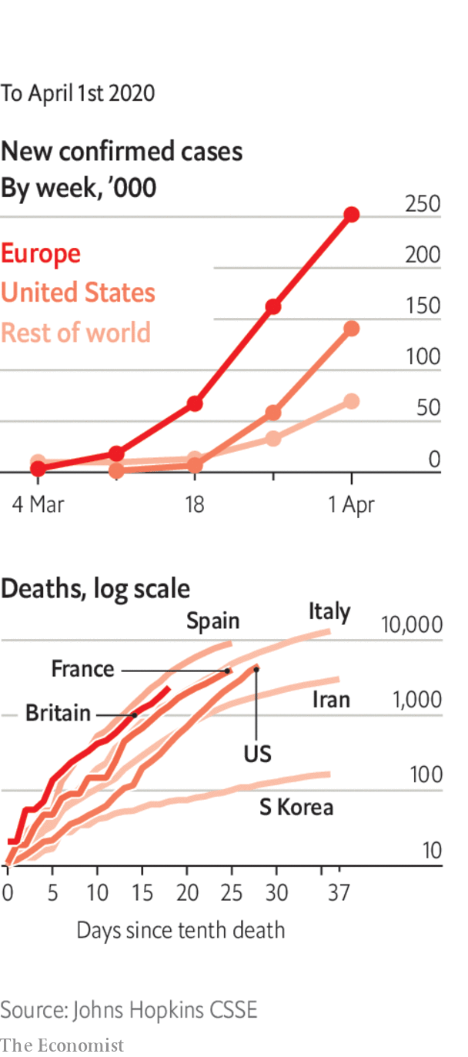

Boris Johnson contracted covid-19, the first political leader of a country to do so. The British prime minister is self-isolating at Number 10.

Austria made it compulsory to wear face masks in supermarkets. The Czech Republic and Slovakia have put similar measures in place.

The captain of an American aircraft-carrier docked in Guam asked the navy for help following an outbreak of covid-19 on board. Around 100 sailors on the USS Theodore Roosevelt have tested positive for the new coronavirus.

The world’s biggest condom-maker, which is based in Malaysia, warned of a global shortage because it has had to shut factories. Forecasters have already predicted a baby boom because of couples staying at home.

The Wimbledon tennis tournament was cancelled.

This article was downloaded by calibre from <https://www.economist.com/the-world-this-week/2020/04/04/politics-this-week>

|  |  |  |  |
| --- | --- | --- | --- |
|  | Articles | Sections | Next |

|  |  |  |  |
| --- | --- | --- | --- |
| Previous | Articles | Sections | Next |

# Business this week

Apr 4th 2020 |

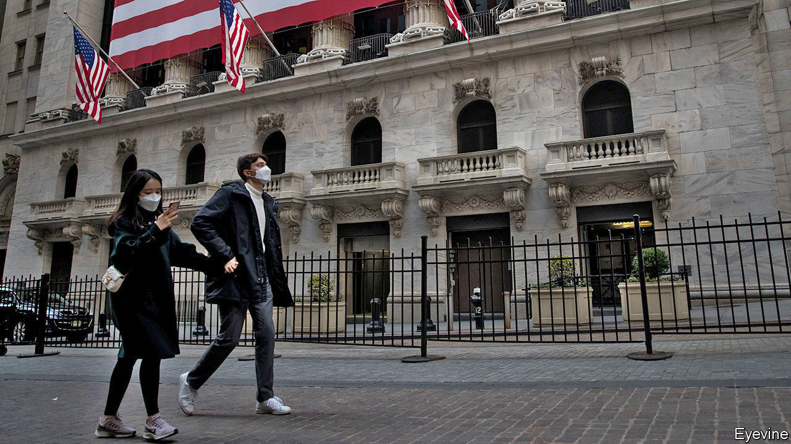

After a few days of relative calm, stockmarkets were once again beset by volatile trading. Many global markets recorded their worst quarter since the start of the financial crisis in 2008. The S&P 500 fell by 20% over the three months; the Dow Jones Industrial Average was down by 23%. London’s FTSE 100 dropped by 25%, its worst quarter since 1987. Commodity prices also slumped. The price of Brent crude oil plunged by 55% in March, but rose this week amid hopes that Saudi Arabia and Russia might end their price war.

## We’re all in this together

The European Central Bank told banks in the euro zone to suspend dividend payments so that they can increase their lending capacity. After the Bank of England mooted similar rules, big British banks did the same. Non-financial companies are under no such obligation. Shell took out a $12bn credit facility, which should ensure it continues its shareholder dividends.

With investors flocking to the haven of the dollar, the Federal Reserve created a new facility to help many foreign central banks access the greenback and stabilise the market.

The British government expanded its rescue package for workers and companies to include paying employers’ national-insurance and statutory pension contributions up to a wage cap of £2,500 ($3,100) a month.

India’s central bank announced a raft of measures to help exporters and state governments. This came after it cut its benchmark interest rate by three-quarters of a percentage point, to 4.4%.

More than 80 emerging-market economies have turned to the IMF for help in recent weeks, according to the fund, and more are likely to follow suit. Its current estimate for the finance needs of emerging markets is $2.5trn. See [article](https://www.economist.com/finance-and-economics/2020/04/04/emerging-market-lockdowns-match-rich-world-ones-the-handouts-do-not).

China’s official manufacturing index rose sharply in March, bouncing back from a record low in February. The national statistics agency said that more than half of the businesses it surveyed had resumed production, though the situation was still far from normal. Similar indices for Japan, South Korea and other Asian countries pointed to sharp contractions in their factory output.

Australia tightened its rules on foreign takeovers amid concern that businesses struggling because of covid-19 restrictions, particularly in the airline industry, could be snapped up cheaply.

New York’s attorney-general reportedly asked Zoom to beef up its security and privacy procedures. Now that most office workers are based at home demand for the videoconference app has soared. The FBI warned separately that it had received many reports of Zoombombing, where online meetings are hijacked by trolls to display pornographic or hate images.

Using civil-defence powers enacted during the Korean war, Donald Trump ordered General Motors to start making hospital ventilators, and criticised the carmaker for being slow in its response and wanting “top dollar”. GM had already begun working on plans to produce the life-saving machines.

Under pressure from American sanctions, Rosneft, a Russian oil firm, sold its assets in Venezuela to the Russian government. See article.

More American retailers who have had to close their stores during the coronavirus outbreak forced their shop workers to take a leave of absence. Gap said it was “pausing” staff pay but would continue to offer benefits. Macy’s, which was struggling before the crisis, told its 125,000 employees that it would continue to pay health insurance until at least the end of May.

OneWeb, a startup seeking to provide cheap internet connectivity through a network of satellites, filed for bankruptcy protection pending a sale of the business. It blamed covid-19, having reportedly failed to secure a loan from SoftBank, one of its investors. Meanwhile, it emerged that SoftBank has pulled out of a deal to buy back $3bn-worth of shares from investors in WeWork, a startup that saw its planned IPO implode last year.

Xerox abandoned its $30bn hostile takeover bid for HP because of market uncertainty.

## How to spend it

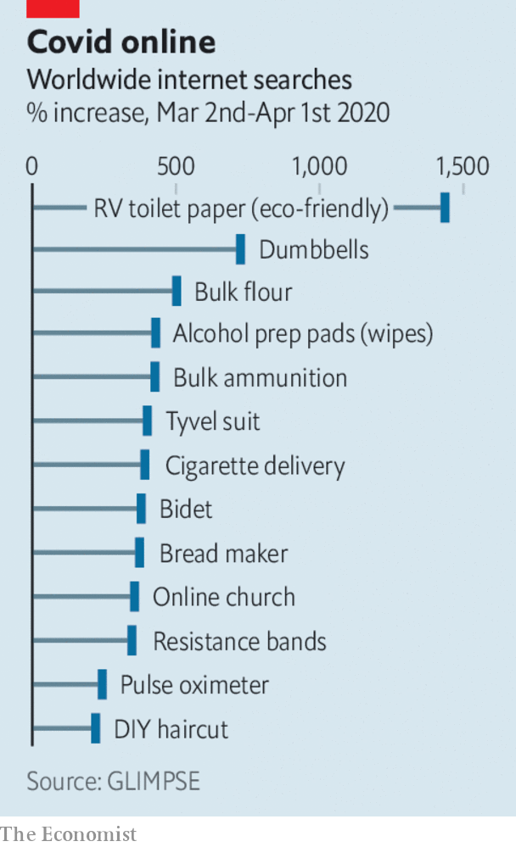

March was the best month on record for British supermarkets, with sales rising by a fifth compared with the same month in 2019, according to retail research. Sales of frozen food were up by 84% (Iceland’s revenue rose the most among the big chains). With pubs closed, alcohol sales jumped by an intoxicating 67%. An analysis of global search trends over March showed a sharp rise of interest in eco toilet paper, bidets, weights equipment and bulk ammunition.

This article was downloaded by calibre from <https://www.economist.com/the-world-this-week/2020/04/04/business-this-week>

|  |  |  |  |
| --- | --- | --- | --- |
| Previous | Articles | Sections | Next |

|  |  |  |  |
| --- | --- | --- | --- |
| Previous | Articles | Sections | Next |

# KAL’s cartoon

Apr 4th 2020 |

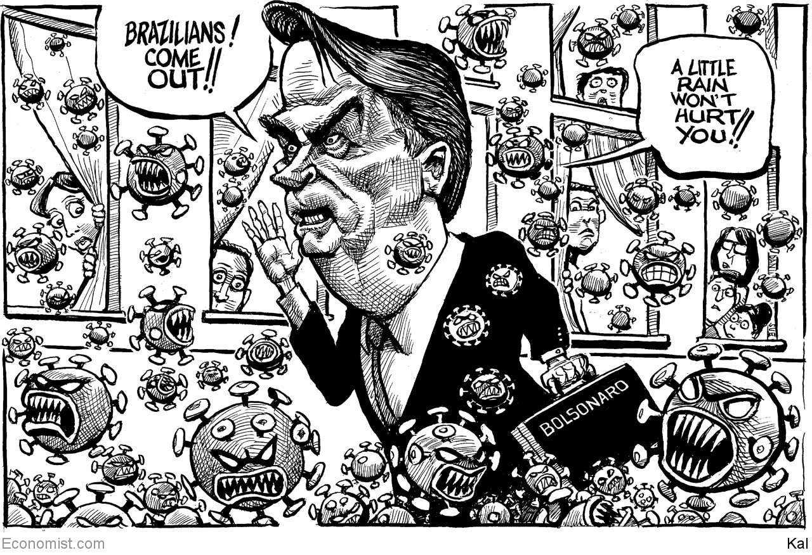

This article was downloaded by calibre from <https://www.economist.com/the-world-this-week/2020/04/04/kals-cartoon>

|  |  |  |  |
| --- | --- | --- | --- |
| Previous | Articles | Sections | Next |

|  |  |  |
| --- | --- | --- |
| The world this week | Sections | Letters |

Leaders

Pandemic trade-offs: A grim calculus

.

Corporate bail-outs: Bottomless Pit, Inc

.

The technology industry: Don’t waste a good crisis

.

Mozambique: Gas, guns and guerrillas

.

Oil and geopolitics: The Rosneft riddle

.

|  |  |  |
| --- | --- | --- |
| The world this week | Sections | Letters |

|  |  |  |  |
| --- | --- | --- | --- |
|  | Articles | Sections | Next |

#### A grim calculus

# Covid-19 presents stark choices between life, death and the economy

The trade-offs required by the pandemic will get even harder

Apr 2nd 2020 |

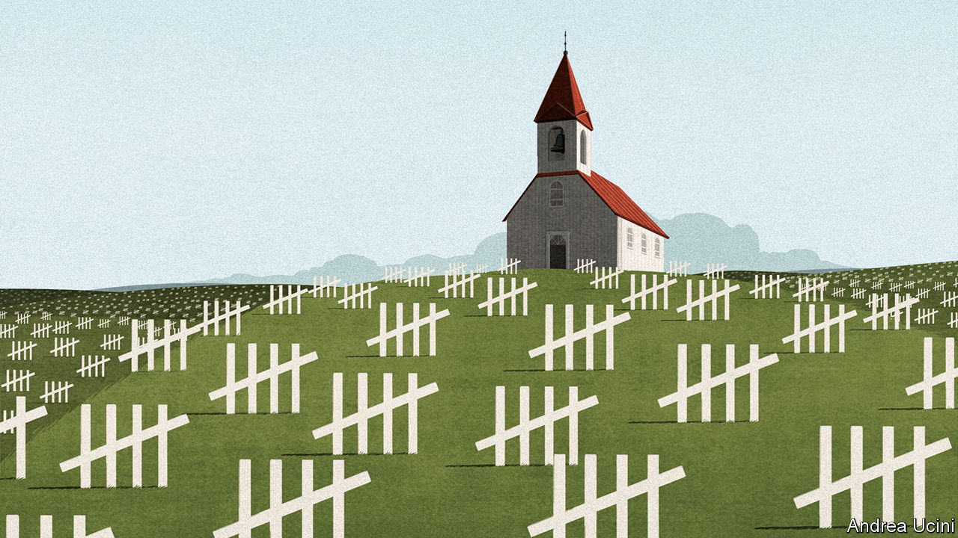

Editor’s note: The Economist is making some of its most important coverage of the covid-19 pandemic freely available to readers of The Economist Today, our daily newsletter. To receive it, register [here](https://www.economist.com/newslettersignup). For more coverage, see our coronavirus [hub](https://www.economist.com/coronavirus)

IMAGINE HAVING two critically ill patients but just one ventilator. That is the choice which could confront hospital staff in New York, Paris and London in the coming weeks, just as it has in Lombardy and Madrid. Triage demands agonising decisions (see [Briefing](https://www.economist.com/briefing/2020/04/02/the-tough-ethical-decisions-doctors-face-with-covid-19)). Medics have to say who will be treated and who must go without: who might live and who will probably die.

The pandemic that is raging across the world heaps one such miserable choice upon another. Should medical resources go to covid-19 patients or those suffering from other diseases? Some unemployment and bankruptcy is a price worth paying, but how much? If extreme social distancing fails to stop the disease, how long should it persist?

The governor of New York, Andrew Cuomo, has declared that “We’re not going to put a dollar figure on human life.” It was meant as a rallying-cry from a courageous man whose state is overwhelmed. Yet by brushing trade-offs aside, Mr Cuomo was in fact advocating a choice—one that does not begin to reckon with the litany of consequences among his wider community. It sounds hard-hearted but a dollar figure on life, or at least some way of thinking systematically, is precisely what leaders will need if they are to see their way through the harrowing months to come. As in that hospital ward, trade-offs are unavoidable.

Their complexity is growing as more countries are stricken by covid-19. In the week to April 1st the tally of reported cases doubled: it is now nearing 1m. America has logged well over 200,000 cases and has seen 55% more deaths than China. On March 30th President Donald Trump warned of “three weeks like we’ve never seen before”. The strain on America’s health system may not peak for some weeks (see article). The presidential task-force has predicted that the pandemic will cost at least 100,000-240,000 American lives.

Just now the effort to fight the virus seems all-consuming. India declared a 21-day lockdown starting on March 24th. Having insisted that it was all but immune to a covid-19 outbreak, Russia has ordered a severe lockdown, with the threat of seven years’ prison for gross violations of the quarantine. Some 250m Americans have been told to stay at home. Each country is striking a different trade-off—and not all of them make sense.

In India the Modi government decided that its priority was speed. Perhaps as a result it has fatally bungled the shutdown. It did not think about migrant workers who have streamed out of the cities, spreading the disease among themselves and carrying it back to their villages (see article). In addition, the lockdown will be harder to pull off than in rich countries, because the state’s capacity is more limited. India is aiming to slow its epidemic, delaying cases to when new treatments are available and its health-care system is better prepared. But hundreds of millions of Indians have few or no savings to fall back on and the state cannot afford to support them month after month. India has a young population, which may help. But it also has crowded slums where distancing and handwashing are hard. If the lockdown cannot be sustained, the disease will start to spread again.

Russia’s trade-off is different. Clear, trusted communications have helped ensure that people comply with health measures in countries like Singapore and Taiwan. But Vladimir Putin has been preoccupied with extending his rule and using covid-19 in his propaganda campaign against the West. Now that the virus has struck, he is more concerned with minimising political damage and suppressing information than leading his country out of a crisis. That trade-off suits Mr Putin, but not his people.

America is different, too. Like India, it has shut down its economy, but it is spending heavily to help save businesses from bankruptcy and to support the income of workers who are being laid off in devastating numbers (see article).

For two weeks Mr Trump speculated that the cure might be worse than the “problem itself”. Putting a dollar figure on life shows he was wrong. Shutting the economy will cause huge economic damage. Models suggest that letting covid-19 burn through the population would do less, but lead to perhaps 1m extra deaths. You can make a full accounting, using the age-adjusted official value of each life saved. This suggests that attempting to mitigate the disease is worth $60,000 to each American household. Some see Mr Trump’s formulation itself as mistaken. But that is a comforting delusion. There really is a trade-off, and for America today the cost of a shutdown is far outweighed by the lives saved. However, America is fortunate to be rich. If India’s lockdown fails to stop the spread of the disease its choice will, tragically, point the other way.

Wherever you look, covid-19 throws up a miasma of such trade-offs. When Florida and New York take different approaches, that favours innovation and programmes matched to local preferences. But it also risks the mistakes of one state spilling over into others (see Lexington). When China shuts its borders to foreigners almost completely, it stops imported infections but it also hobbles foreign businesses. A huge effort to make and distribute covid-19 vaccines will save lives, but it may affect programmes that protect children against measles and polio.

How should you think about these trade-offs? The first principle is to be systematic. The $60,000 benefit to American households, as in all cost-of-life calculations, is not real cash but an accounting measure that helps compare very different things such as lives, jobs and contending moral and social values in a complex society. The bigger the crisis, the more important such measurements are. When one child is stuck down a well the desire to help without limits will prevail—and so it should. But in a war or a pandemic leaders cannot escape the fact that every course of action will impose vast social and economic costs. To be responsible, you have to stack each against the other.

## Hard-headed is not hard-hearted

A second principle is to help those on the losing side of sensible trade-offs. Workers sacked in forced shutdowns deserve extra help; children who no longer get meals at schools need to be given food. Likewise, society must help the young after the pandemic has abated. Although the disease threatens them less severely, most of the burden will fall on them, both today and in the future, as countries pay off their extra borrowing.

A third principle is that countries must adapt. The balance of costs and benefits will change as the pandemic unfolds. Lockdowns buy time, an invaluable commodity. When they are lifted, covid-19 will spread again among people who are still susceptible. But societies can prepare in a way that they never did for the first wave, by equipping health systems with more beds, ventilators and staff. They can study new ways to treat the disease and recruit an army of testing and tracing teams to snuff out new clusters. All that lowers the cost of opening up the economy.

Perhaps, though, no new treatments will be found and test-and-trace will fail. By the summer, economies will have suffered double-digit drops in quarterly GDP. People will have endured months indoors, hurting both social cohesion and their mental health. Year-long lockdowns would cost America and the euro zone a third or so of GDP. Markets would tumble and investments be delayed. The capacity of the economy would wither as innovation stalled and skills decayed. Eventually, even if many people are dying, the cost of distancing could outweigh the benefits. That is a side to the trade-offs that nobody is yet ready to admit. ■

Dig deeper:  
For our latest coverage of the covid-19 pandemic, register for The Economist Today, our daily [newsletter](https://www.economist.com/newslettersignup), or visit our [coronavirus hub](https://www.economist.com/coronavirus)

This article was downloaded by calibre from <https://www.economist.com/leaders/2020/04/01/covid-19-presents-stark-choices-between-life-death-and-the-economy>

|  |  |  |  |
| --- | --- | --- | --- |
|  | Articles | Sections | Next |

|  |  |  |  |
| --- | --- | --- | --- |
| Previous | Articles | Sections | Next |

#### Bottomless Pit, inc

# Bail-outs are inevitable—and toxic

How to design corporate bail-outs to protect taxpayers

Apr 4th 2020 |

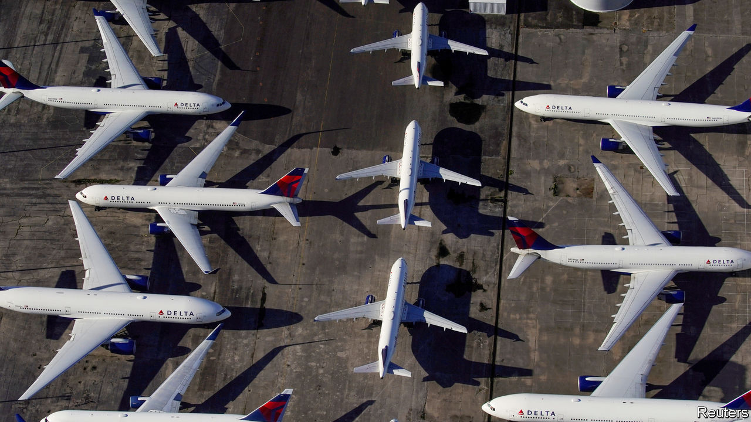

Editor’s note: The Economist is making some of its most important coverage of the covid-19 pandemic freely available to readers of The Economist Today, our daily newsletter. To receive it, register [here](https://www.economist.com/newslettersignup). For more coverage, see our coronavirus [hub](https://www.economist.com/coronavirus)

IN THE PAST month the biggest business handout in history has begun. The goal of helping firms survive temporary lockdowns is sensible, but it is hard not to feel uneasy (see [article](https://www.economist.com/business/2020/04/04/governments-are-once-again-splurging-to-keep-big-companies-afloat)). At least $8trn of state loans and goodies have been promised to private firms in America and Europe, roughly equivalent to all their profits over the past two years. Over half a million European firms have applied for payroll subsidies. Some of these handouts will involve grubby choices: Boeing, embroiled in the 737 MAX crashes, might get billions of taxpayer dollars. Broad rescue schemes could also leave a legacy of indebted, ossified firms that impede the eventual recovery. Speed is essential, but governments also need a clearer framework to organise the jumble of schemes, protect taxpayers and preserve the economy’s dynamism.

That $8trn is a big number, and includes state and central-bank loans, guarantees and temporary subsidies to keep paying inactive workers. The total running costs of all American and euro-zone non-financial firms (excluding payments to each other) are $13.5trn a year, of which $11.6trn is wages. But there is still no guarantee that this mountain of money can prevent chaos. Firms also need to refinance $4trn of bonds in the next 24 months, and debt markets are still wary about racier borrowers. Carnival, a cruise line, has issued bonds at a crushing 11.5% interest rate. The plethora of support schemes—there are at least ten in America, with different eligibility rules—will baffle some firms and exclude others. A quarter of listed Western firms are heavily indebted, and if those facing slumping demand gorge on state loans they may wreck their balance-sheets. For a few giants the potential losses are so big that they alone could impose a significant burden on the state. Volkswagen says it is burning through $2.2bn of cash every week.

Ideally private investors would swoop in—Warren Buffett is sitting on $125bn of spare funds and Blackstone’s funds have $151bn. But the duration of lockdowns is unclear, so they may be reluctant. As a result, alongside widely available cheap state loans, bespoke state bail-outs are starting. America’s latest stimulus package earmarks at least $50bn for the airlines and other firms vital for “national security” (Boeing and chums). Germany has loaned $2bn to TUI, a travel firm, and Singapore’s sovereign fund, Temasek, has bought more shares in Singapore Airlines.

Such bespoke deals are easy to sign but often go sour. Uncle Sam lost over $10bn on the General Motors rescue of 2009 and the Wall Street bank bail-outs left an especially bitter taste. Negotiations can be hijacked by politicians who want pork or sway over firms’ strategies. If bailed-out firms end up indebted and burdened by long-term job guarantees, the economy can become ossified, sapping productivity. And it is unfair to ask well-run firms to compete with state-backed rivals.

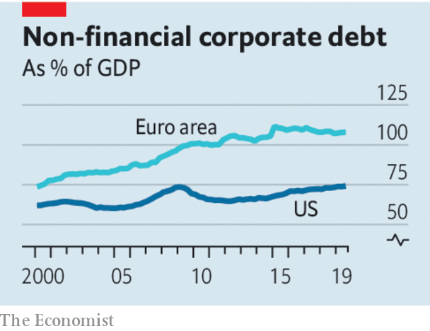

What to do? Governments need to offer support for business in an integrated way. There should be blanket offers to all firms of cheap loans and help in paying the wages of inactive staff for three to six months with few strings attached. This is what the $8trn of loans and guarantees mostly try to do, but there are gaps and doubts about how small firms will get cash. One answer is making sure banks have the resources to lend—even if this means suspending their dividends, as Britain did this week. The goal should be to freeze most of the economy temporarily, until the lockdowns ease.

In time, though, more ruthlessness will be necessary. The cost of extending unlimited credit to all firms is unsustainable and the economy must eventually adjust to new circumstances: for example, e-commerce firms need more workers whereas cinemas may never fully recover (see [Schumpeter](https://www.economist.com/business/2020/04/04/youre-furloughed)). Assistance beyond six months should be limited to firms that provide essential services—such as telecoms, utilities or payments—or are at the centre of critical industrial supply chains. These firms may be eligible for long-term loans but they must come at a price, in the form of equity stakes for the taxpayer. A rough yardstick is that for every $100 of long-term loans, taxpayers should get $10 of equity. If these firms are already heavily indebted there is no point in crippling them further. Instead, creditors must take a big haircut.

Lastly, governments should not interfere in other ways. There will be populist calls to force airlines to give more legroom, car firms to build electric charging-points and manufacturers to build factories in rustbelts. But bail-outs of individual firms are a bad mechanism for dealing with these issues. The one rule that governments should impose is to ban firms getting bespoke deals from paying cash to shareholders through dividends and buy-backs until state loans are repaid.

This year will see state intervention in business on an unprecedented scale. With luck it will not be remembered as the year in which dynamism and free markets died. ■

Dig deeper:  
For our latest coverage of the covid-19 pandemic, register for The Economist Today, our daily [newsletter](https://www.economist.com/newslettersignup), or visit our [coronavirus hub](https://www.economist.com/coronavirus)

This article was downloaded by calibre from <https://www.economist.com/leaders/2020/04/03/bail-outs-are-inevitable-and-toxic>

|  |  |  |  |
| --- | --- | --- | --- |
| Previous | Articles | Sections | Next |

|  |  |  |  |
| --- | --- | --- | --- |
| Previous | Articles | Sections | Next |

#### Winners from the pandemic

# Big tech’s covid-19 opportunity

Tech giants are thriving in the corona crisis. They should seize the moment to detoxify their relationship with society

Apr 4th 2020 |

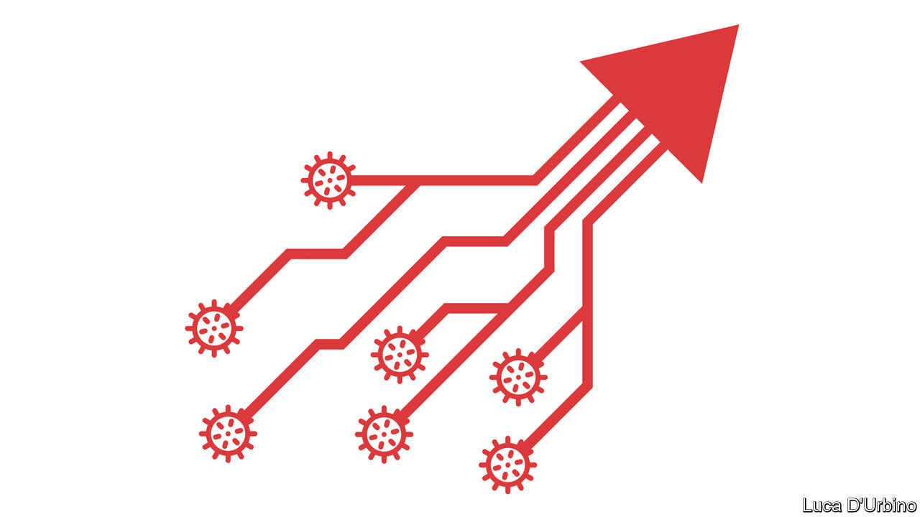

Editor’s note: The Economist is making some of its most important coverage of the covid-19 pandemic freely available to readers of The Economist Today, our daily newsletter. To receive it, register [here](https://www.economist.com/newslettersignup). For more coverage, see our coronavirus [hub](https://www.economist.com/coronavirus)

THE PANDEMIC will have many losers, but it already has one clear winner: big tech. The large digital platforms, including Alphabet and Facebook, will come out of the crisis even stronger. They should use this good fortune to reset their sometimes testy relations with their users. Otherwise big government, the other beneficiary of the covid calamity, is likely to do it for them.

Demand for online services has exploded and the infrastructure behind the internet has proved to be admirably reliable (see [article](https://www.economist.com/science-and-technology/2020/04/04/can-mobile-networks-handle-becoming-stay-at-home-networks)). Newcomers such as Slack and Zoom, which help businesses operate remotely, have become household names. And although some tech supply chains are creaking and online advertising spending has dipped, overall the big five firms are seeing surging demand.

Facebook has said that messaging activity has increased by 50% in those countries hit hard by the virus. Amazon is planning to hire 100,000 new staff to keep up with higher e-commerce orders. The big tech firms are also a bastion of financial stability: together Alphabet, Amazon, Apple, Facebook and Microsoft have $570bn of gross cash on their balance-sheets. Shares in these firms have outperformed the market since late January.

Just as the big firms are standing even taller, many of the tech industry’s younger, smaller firms are being crushed in the worst slump since the dotcom crash 20 years ago (see [Briefing](https://www.economist.com/briefing/2020/04/04/technology-startups-are-headed-for-a-fall)). Even before the coronavirus hit, trouble was brewing in the land of unicorns, as tech startups worth more than $1bn are called. Among many firms catering to consumers, the strategy of growing at all costs, known as “blitzscaling”, had turned out to be flawed. Some firms, particularly those stuffed with capital by SoftBank’s $100bn Vision Fund, had already started laying off people. All this will make it easier for the big firms to hire the best talent. Collapsing firms could be snapped up by the tech giants.

If that happens, the odds are that regulators will do little or nothing to stop a round of consolidation. In America antitrust investigations against Alphabet, Google’s parent, and Facebook have essentially been put on hold, as officials deal with other priorities and refrain from destabilising firms during a crisis. A new federal privacy law seems further away than ever. Even tech sceptics in the European Union want to rethink their approach to regulating artificial intelligence (AI). In an abrupt twist, “surveillance capitalism”, as critics call big tech’s business practices, is no longer seen as exploitative, but essential to tackle the virus. And no one is complaining about Facebook and Google zealously taking down misinformation about covid-19, and increasingly relying on AI to do so. Yet, before the pandemic, such activity would have triggered howls of outrage over censorship and bias.

In fact, more than ever it is clear that big tech firms act as vital utilities. Therein lies the trap, because almost everywhere other utilities, such as water or electricity, are heavily regulated and have their prices and profits capped. Once this crisis passes, startled citizens and newly emboldened governments could make a push for the state to have similar control over big tech.

The companies seem to sense this danger. Their best defence is to propose a new deal to the citizens of the world. That means clear and verifiable rules on how they publish and moderate content, helping users own, control and profit from their own data; as well as fair treatment of competitors that use their platforms. This approach may even be more profitable in the long run. Today the most valuable firm in America is Microsoft, which has been revived by building a reputation for being trustworthy. It is an example that the other big tech platforms—or digital utilities, as they are about to become known—should follow. ■

Dig deeper:  
For our latest coverage of the covid-19 pandemic, register for The Economist Today, our daily [newsletter](https://www.economist.com/newslettersignup), or visit our [coronavirus hub](https://www.economist.com/coronavirus)

This article was downloaded by calibre from <https://www.economist.com/leaders/2020/04/03/big-techs-covid-19-opportunity>

|  |  |  |  |
| --- | --- | --- | --- |
| Previous | Articles | Sections | Next |

|  |  |  |  |
| --- | --- | --- | --- |
| Previous | Articles | Sections | Next |

#### Gas, guns and guerrillas

# Jihadists threaten Mozambique’s new gasfields

The government’s response to a mysterious revolt is cruel and ineffective

Apr 4th 2020 |

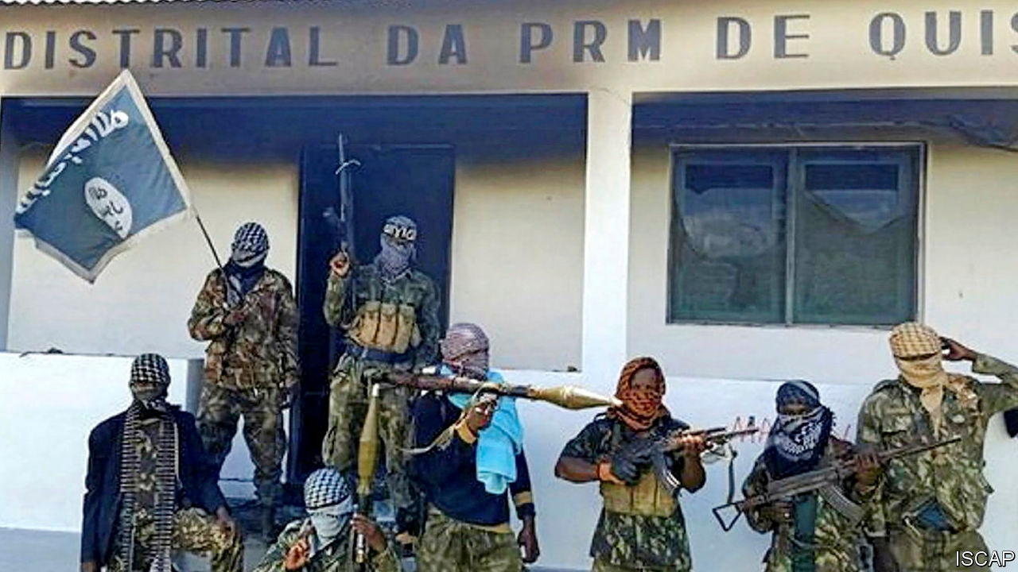

MANY KINDS of misfortune make a country prone to conflict; Mozambique has them all. It is poor. FRELIMO, its ruling party, is predatory and corrupt. Much of its vast territory is barely governed at all. It has a recent history of civil war: a 15-year inferno that ended in 1992 and cost perhaps 1m lives, and a milder six-year uprising involving the same rebel group, RENAMO, which formally ended last year. Into this explosive mix, two blazing matches have been tossed: jihadist terror and the discovery of natural gas.

As we report this week, a poorly understood insurgency is spreading in Cabo Delgado, a province in northern Mozambique (see [article](https://www.economist.com/node/21783217)). So far the conflict has killed more than 1,000 people, aid workers estimate, and forced at least 100,000 to flee their homes. Recent weeks have seen some of the boldest attacks yet. Young men with guns and Islamist slogans are not merely burning villages and beheading people. They have also started to capture towns, albeit temporarily, slaughtering government forces and then retreating to the bush.

On March 23rd they briefly overran Mocimboa da Praia, a transport hub near what may be Africa’s largest-ever gas project. The huge reserves off the coast of Cabo Delgado have attracted pledges of investment worth tens of billions of dollars from multinational firms. Gas gives Mozambique the hope of a more prosperous future—but also a prize worth fighting over. Already insecurity, as well as covid-19 and low oil prices, are slowing exploration. If Mozambique wants to realise its dream of becoming “Africa’s Qatar”, it must pacify Cabo Delgado.

To do so it must be honest. The government describes the uprising as a foreign conspiracy to keep the country poor. That is nonsense. Although there are indeed foreign preachers and fighters among the jihadists, the insurgency is mostly local in origin, born of marginalisation. Muslims are a minority in Mozambique, and the largely Muslim north, which is far from the capital, has long been neglected. It is only in the past year that the jihadists there have formally affiliated to Islamic State, and it is not clear that IS supplies it with much besides inspiration.

The government’s counter-insurgency tactics are inept, too. It has so far relied on ill-trained conscripts, thuggish police and Russian mercenaries. It has rounded up young men on the flimsiest evidence and beaten or summarily shot them, according to Human Rights Watch, an NGO. Such brutality alienates the population. It has locked up journalists who report on the conflict and threatened aid workers who air grievances. This constricts the flow of accurate information. A better approach would involve properly paid and trained troops, who speak local languages and respect human rights, as well as schemes that deal with the province’s poverty and inequality.

Neighbours, especially South Africa, the biggest regional power, and Tanzania, which borders Cabo Delgado, should press the Mozambican government to behave better. They should also share intelligence with it. Right now they are preoccupied by covid-19, but the insurgency will probably outlast the pandemic. A summit about Islamist violence scheduled for May should go ahead, albeit virtually. Western countries should tell Mozambique to let aid agencies and journalists do their jobs.

## Things don’t have to fall apart

Energy firms, which include giants such as ExxonMobil and Total, could do more as well. They have sought to cocoon themselves from the violence by hiring private-security firms. That is not enough. Their projects will remain insecure unless they can show that the benefits of their investments flow to ordinary Mozambicans, not just the FRELIMO elite. If Mozambique were to fall apart again, it would be a tragedy. If jihadism were to take root, it could spread to neighbouring countries, as it has in the Sahel. Mozambique, and Africa, deserve better. ■

This article was downloaded by calibre from <https://www.economist.com/leaders/2020/04/04/jihadists-threaten-mozambiques-new-gasfields>

|  |  |  |  |
| --- | --- | --- | --- |
| Previous | Articles | Sections | Next |

|  |  |  |  |
| --- | --- | --- | --- |
| Previous | Articles | Sections | Next |

#### Rosneft’s sleight of hand

# Why Putin’s favourite oil firm dumped its Venezuelan assets

Russian taxpayers are left holding the can

Apr 4th 2020 |

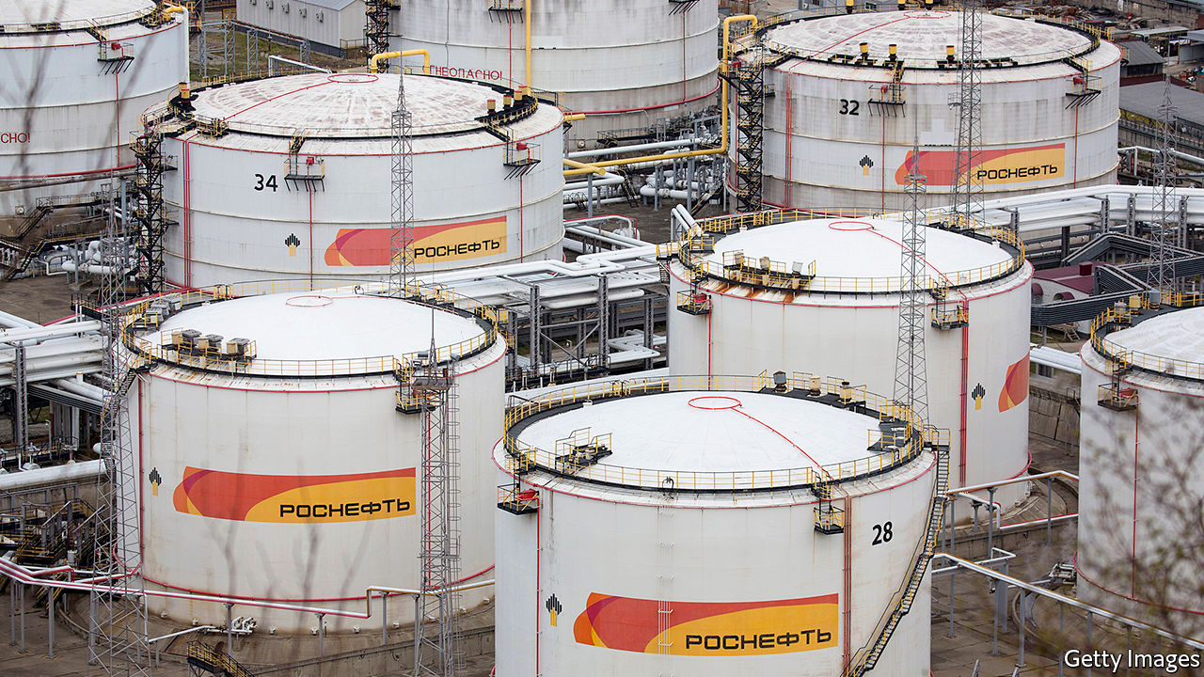

ROSNEFT is responsible for 40% of Russia’s oil output, but it is much more than just another oil firm. A large chunk of its shares are owned by the Russian state. Its boss, Igor Sechin, is one of Vladimir Putin’s closest henchmen. A former spook, like the Russian president, he has been at the big man’s side since the 1990s. In 2004-06 Rosneft gobbled up the remains of Yukos, Russia’s largest private oil firm, which was dismembered after its boss challenged Mr Putin. Since then Rosneft has been both a tool of Kremlin power and a driver of policy in its own right. Bear this in mind when trying to make sense of the announcement, on March 28th, that it has sold all its Venezuelan assets to an unnamed Russian government entity.

For years the Kremlin has propped up Venezuela’s dictatorship, first under Hugo Chávez, then under his protégé, Nicolás Maduro. Russia has supplied loans, weapons and, lately, mercenaries to keep the regime in power, largely to annoy the United States. America, like many democracies, does not recognise the election-stealing Mr Maduro as Venezuela’s president, and has slapped severe sanctions on his country. Last week it unsealed indictments of Mr Maduro and his cronies for alleged drug-trafficking (see [article](https://www.economist.com/node/21783189)). Mr Sechin calculates that, if America supports democracies in Russia’s backyard, Russia should support despots in America’s.

Rosneft’s role in all this has been to practise bare-knuckle petropolitics. It has traded Venezuelan oil to help Mr Maduro get around American sanctions. Rosneft lent his government $6.5bn in 2014-18, to be repaid in oil. At the end of last year it was still owed at least $800m, though the figures are murky.

Thanks to a low oil price, sanctions and the Maduro regime’s spectacular corruption and ineptitude, Venezuela is in no position to repay all its debts. But this is not too much of a problem for Rosneft, since it can dump its Venezuelan assets on to Russian taxpayers. They will no doubt be delighted to hear that they have paid for this with 9.6% of Rosneft’s own shares (worth more than $4bn), thus reducing their stake to just over 40%. The deal gives Mr Sechin ever tighter control of the firm. Minority shareholders, including BP and Qatar’s sovereign-wealth fund, which each hold just under 20%, have yet to comment.

The main aim of the deal, it seems, is to help Rosneft escape the consequences of doing business with a pariah. Over the past two months America has penalised the company’s trading arms for handling Venezuelan oil. These sanctions are global in scope and affect its customers, too. Sinochem International, the trading arm of a Chinese state-owned refinery, has rejected Rosneft’s oil. The Kremlin’s solution is to distance Rosneft from Venezuela while reassuring the Venezuelan kleptocracy that it still has Russia’s backing. “I received a message from brother president Vladimir Putin who ratified his comprehensive strategic support for all areas of our [relationship],” tweeted Mr Maduro.

These shenanigans come at a turbulent time in the oil markets. The price of crude has fallen by half in the past month, as covid-19 has crushed demand and Saudi Arabia has opened its taps to punish Russia for refusing to extend an OPEC deal to curb production. The Kremlin would like cheap oil to drive American shale producers, whose costs are higher, out of business. This is a risky game. Russia has alienated the Saudis, who might draw closer to America as a result. Rosneft can survive oil at $25 a barrel. But under Russian law the royalties it pays to the Russian state fall sharply as the oil price slides. As covid-19 spreads in Russia, Mr Putin will have to draw on the country’s reserves to help ordinary people cope. Mr Sechin’s sleight of hand has solved a problem for Rosneft, but not for Russia. ■

This article was downloaded by calibre from <https://www.economist.com/leaders/2020/04/04/why-putins-favourite-oil-firm-dumped-its-venezuelan-assets>

|  |  |  |  |
| --- | --- | --- | --- |
| Previous | Articles | Sections | Next |

|  |  |  |
| --- | --- | --- |
| Leaders | Sections | Briefing |

Letters

On covid-19, Bolivia, sports, rivers, lichen: Letters to the editor

.

|  |  |  |
| --- | --- | --- |
| Leaders | Sections | Briefing |

|  |  |  |  |
| --- | --- | --- | --- |
|  | Articles | Sections | Next |

#### On covid-19, Bolivia, sports, rivers, lichen

# Letters to the editor

A selection of correspondence

Apr 4th 2020 |



## Coronavirus as a weapon

One aspect has been ignored in The Economist’s and the wider media coverage of covid-19: the national security implications (“[The lockdown and the long haul](https://www.economist.com/briefing/2020/03/19/in-europe-and-around-the-world-governments-are-getting-tougher)”, March 21st). The rapid spread of the virus in Europe and North America and the somewhat confused and erratic response of governments demonstrates how unprepared we are to respond to the threat of biological warfare, despite spending hundreds of billions of dollars on defence.

Drawing on lessons learned from this pandemic, governments should enact legislation that will help us respond to future emergencies. In addition we could stockpile essential equipment such as portable hospitals and testing kits to help public health systems respond effectively. In the context of defence spending, these measures are not particularly expensive. For example, the latest American aircraft-carrier cost $13bn. Perhaps this money could have been better spent preparing us for future bio-warfare threats.

There is no question in my mind that malicious groups are watching this situation with great interest and may be considering how to take advantage of our weaknesses.

ROBERT MORLEY  
Former staff member on the National Security Council  
Richmond, Texas

For comparison, the global influenza pandemic of 1918-20 infected up to 500m people and killed up to 50m. Today we are light years away from these figures and will not reach them because of the global advances in medical research that our technology enables.

What remains inexplicable is how America, the world’s powerhouse, can have been so ill-prepared. All reliable evidence demonstrates that it is near the bottom of Western countries for testing. The federal Centres for Disease Control and Prevention was inept in dealing with what was coming. The system of checks and balances is supposed to ensure that even if a president does not realise the gravity of a situation, institutions like the CDC are ready to spring into action. The CDC’s delayed response may be the gravest mistake so far in combating covid-19 worldwide.

GEORGE ROUSSEAU  
Emeritus professor of history  
Oxford University

The IMF and the World Bank have made $62bn in funding available to combat covid-19. Yet funding for malaria is only half of the $6bn that the World Health Organisation requests each year. I understand the fear of this coronavirus, but malaria infects 228m people each year and kills 400,000. Perhaps if we rebrand malaria as a new phenomenon it will make the headlines and get the funding it deserves.

RACHEL ZWEIG  
Fayetteville, Arkansas

I would like to suggest the use of “physical distancing” rather than “social distancing”. As a sociologist I am stunned at the many ways people have overcome social distancing while having to keep a physical distance.

PROFESSOR PATRICK KENIS  
School of Economics and Management  
Tilburg University  
Tilburg, Netherlands

Quarantine art  
I am 18 years old and was studying for my A Levels in Economics, Mathematics and Latin until the current pandemic arose. I am an aspiring economist and investment banker and I have spent the past two years studying, reading and researching around all aspects of the subject to fully immerse myself in it and expand my knowledge.

While strengthening my university application last year, I subscribed to The Economist to keep on top of current affairs. I had kept all volumes of the magazine from September to December of 2019, and since Britain has been put into lockdown, I decided to make use of them. As well as a keen academic, I also love art and creativity (although I don’t often have time for it) so I took this unique moment of quietness to create a collage of interesting images and words from my collection of Economist magazines. If you look closely many of the words and images are juxtaposed to encourage the viewer to consider new ideas and issues in the world of politics and economics.

I have attached an image of my collage and wanted to send it in to you to share my use of your magazine. Although covid-19 has caused undoubtable pain and disruption to all of our lives, for those of us fortunate enough to be healthy and safe, it is interesting to see the new and innovative things that we spend our time doing in this break from normality.  
  
HANNAH PARKINSON  
Liverpool

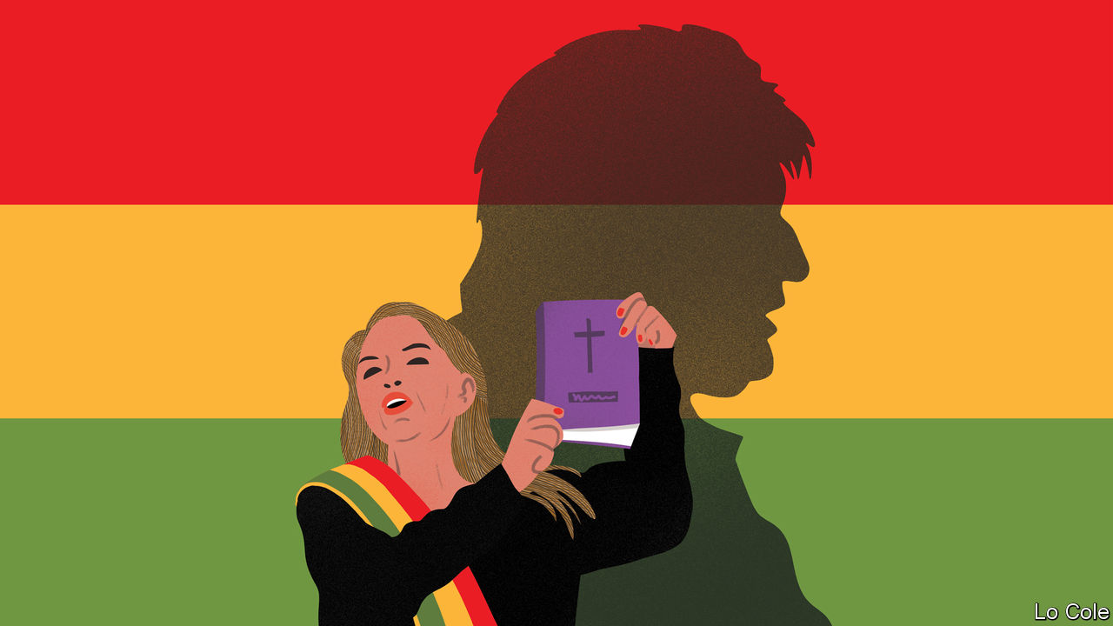

## Not so happy with Evo

In Bolivia we are certainly enjoying the bouquet of freedom after 14 years of Evo Morales ([Bello](https://www.economist.com/the-americas/2020/03/05/bolivia-after-the-ouster-of-evo-morales-a-leftist-strongman), March 7th). The former president never “used natural-gas revenues to build schools, roads and clinics”. Instead, he built football fields with synthetic grass. Today Bolivia is going through a dire public-health situation precisely because of the lack of hospitals and medical equipment in rural areas.

Bolivia under Mr Morales was a dysfunctional democracy that squandered the money it earned from commodities in a blend of corruption, pharaonic projects and short-term social programmes. Those revenues vanished in scandals and vanity projects. Mr Morales built a museum for himself to exhibit his sports outfits. He erected a lavish building that destroyed the colonial aesthetic of the historic centre of La Paz and named it the House of the People, emulating Nicolae Ceausescu in Romania. The largest economic boom became the greatest missed opportunity in Bolivian history.

JAIME APARICIO  
Ambassador of Bolivia to the Organisation of American States  
Washington, DC

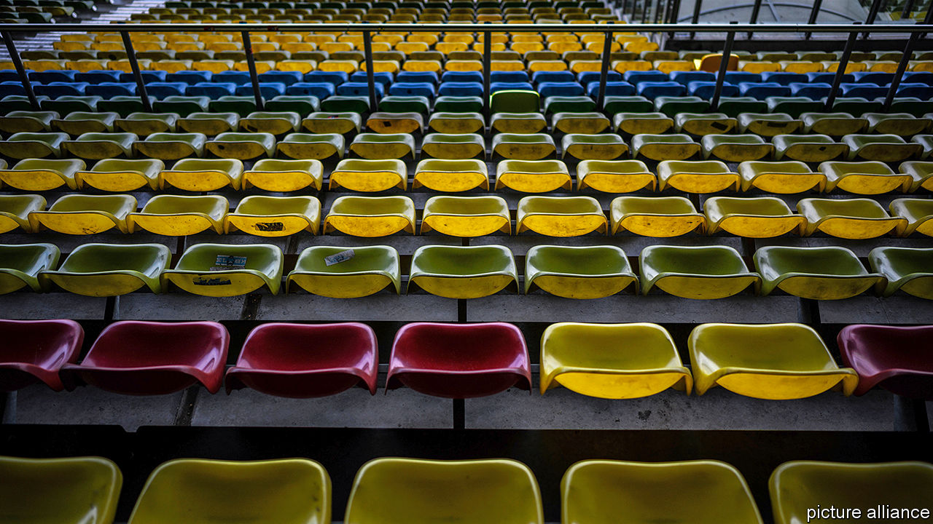

## This sporting life

Your leader lamenting the cancellation of sports fixtures referred to the Romans who understood the importance of bread and circuses, “keeping the public not just fed, but entertained, too” (“[The game’s the thing](https://www.economist.com/leaders/2020/03/21/as-covid-19-causes-sports-cancellations-what-can-be-done)”, March 21st). But although our modern coliseums lie dormant, e-sports beckon like never before. La Liga, Spain’s top-tier football league, recently held an online tournament using EA Sports’ FIFA 20 video game. Some 170,000 people tuned in to watch a player with Real Madrid win the final. That’s more than double the capacity of Madrid’s Santiago Bernabéu stadium. The biggest obstacle to game streaming has been the inability of the sporting establishment to recognise its huge reach. The business world may now finally wake up to its potential, not just to augment but enhance the world of sports entertainment.

JONNY SHAW  
Chief strategy officer  
VCCP New York

Kudos to The Economist for supporting the morale-boosting potential of the return of professional sport, albeit in a reduced capacity. In 2012 I watched a distant Champions League final between Chelsea and Bayern Munich, having just fought in my first battle in Afghanistan with the British army. A sporting event has enormous normalising power. Occasionally, as today, life throws up challenges that ensure you never again take the small things for granted.

ROBIN LYON  
London



## On the straight and narrow

The construction of artificial barriers to restrict the flow of rivers and protect land (“[Putting the wiggles back in rivers](https://www.economist.com/britain/2020/03/05/re-engineering-britains-rivers)”, March 7th) was widespread in the late 19th and early 20th centuries. This was particularly the case for alpine rivers in U-shaped glacial valleys, which carry large amounts of sediment after heavy rainfall. Two such rivers came to public attention in the 1920s and 1930s. James Joyce even alluded to these rivers as “burst” in “Finnegans Wake”.

The first was the Thur with its source in the Swiss Alps flowing through the Zurich Canton that Joyce lived in. The second was the Waiho flowing out of the Southern Alps of New Zealand near Greymouth. One of Joyce’s sisters lived in the Greymouth convent and sent pieces of local interest to her brother that he occasionally used, albeit creatively but recognisably in “Finnegans Wake”. Both rivers have caused destructive flooding after their flows were constrained and slowed a century ago, exacerbating problems caused by large deposits of gravel accumulated over time.

GERALD SMITH  
Wellington, New Zealand



## Fungus fun

“[A little lichen relief](https://www.economist.com/the-americas/2020/03/19/canadas-quest-for-a-national-lichen)” (March 21st) notes that Iceland, Scotland and the Faroe Islands have issued stamps depicting lichen, giving their people a lichen likeness, one might say. I must, however, ask: do they like licking lichen?

KEITH SNIDER  
Alexandria, Virginia

This article was downloaded by calibre from <https://www.economist.com/letters/2020/04/04/letters-to-the-editor>

|  |  |  |  |
| --- | --- | --- | --- |
|  | Articles | Sections | Next |

|  |  |  |
| --- | --- | --- |
| Letters | Sections | United States |

Briefing

Pandemic trade-offs: Hard choices

.

Medical ethical dilemmas: Triage under trial

.

Anatomy of an investing bubble: Exit unicorns, pursued by bears

.

|  |  |  |
| --- | --- | --- |
| Letters | Sections | United States |

|  |  |  |  |
| --- | --- | --- | --- |
|  | Articles | Sections | Next |

#### Between tragedies and statistics

# The hard choices covid policymakers face

Epidemiological models are among their only guides

Apr 4th 2020 | WASHINGTON, DC

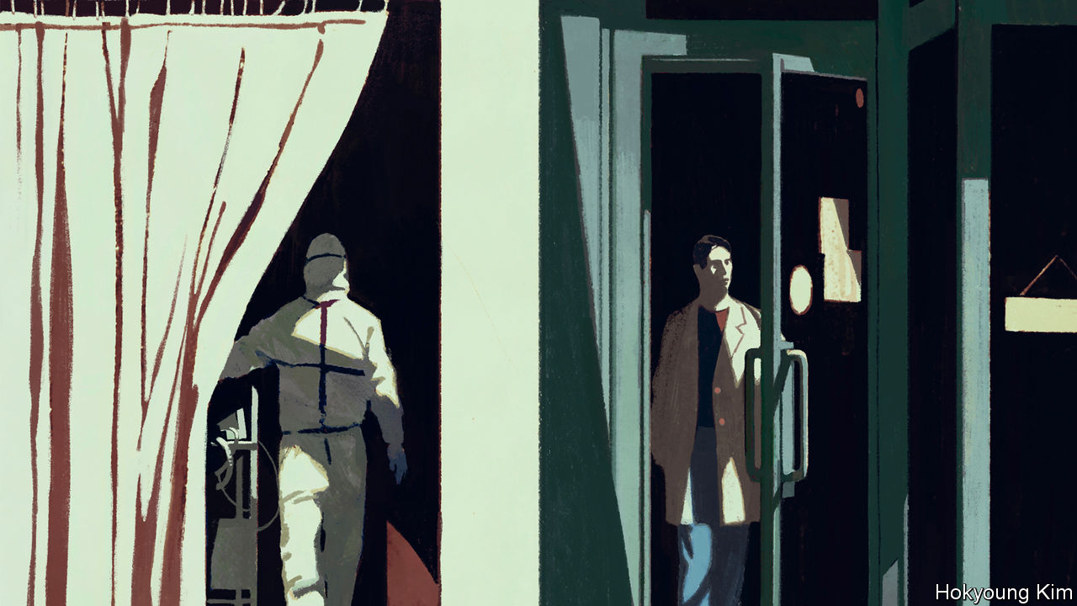

Editor’s note: The Economist is making some of its most important coverage of the covid-19 pandemic freely available to readers of The Economist Today, our daily newsletter. To receive it, register [here](https://www.economist.com/newslettersignup). For more coverage, see our coronavirus [hub](https://www.economist.com/coronavirus)

“WE HAVE NO choice,” said President Donald Trump on March 30th, after announcing that federal guidelines on social distancing would remain in force until the end of April. “Modelling…shows the peak in fatalities will not arrive for another two weeks. The same modelling also shows that, by very vigorously following these guidelines, we could save more than 1 million American lives.”

Epidemiological models are not the only reason why many countries around the world, and many states in America, are now in some form of lockdown. That China, where the outbreak started, pursued such a policy with an abandon never seen before, and subsequently reported spectacular falls in the rate of new infections, is doubtless another reason. So are the grim scenes from countries where the spread of the virus was not interrupted early enough. By April 1st Italy had seen almost four times as many deaths as China.

The power of the models has been that they capture what has just been seen in these countries and provide a quantitative picture of what may be seen tomorrow—or in alternative tomorrows. They have both made clear how bad things could get and offered some sense of the respite which different interventions can offer. Faced with experts saying, quietly but with good evidence, that a lockdown will save umpty-hundred-thousand lives, it is hard for a politician to answer “At what cost?”

What is more, when the epidemiologists reply “Not our department”, the economists to whom the buck then passes are not necessarily much more help. Estimates of the costs of the interventions now in place are all large, but they vary widely (see [article](https://www.economist.com/finance-and-economics/2020/04/04/emerging-market-lockdowns-match-rich-world-ones-the-handouts-do-not)). A proper assessment requires knowing how well the measures will work, how long they will last and how they will be ended—thus returning the question to the realm of public-health policy.

But as time goes on, “at what cost” will become easier to voice, and harder to duck. “We have no choice” will no longer be enough; as the disruptive effects of social-distancing measures and lockdowns mount there will be hard choices to make, and they will need to be justified economically as well as in terms of public health. How is that to be done?

Epidemiological models come in two types. The first seeks to capture the basic mechanisms by which diseases spread in a set of interlinked equations. In the classic version of this approach each person is considered either susceptible, exposed, infectious or recovered from the disease. The number in each group evolves with the numbers in one or more of the other groups according to strict mathematical rules (see chart 1). In simple versions of such models the population is uniform; in more elaborate versions, such as the one from Imperial College London, which has influenced policy in Britain and elsewhere, the population is subdivided by age, gender, occupation and so on.

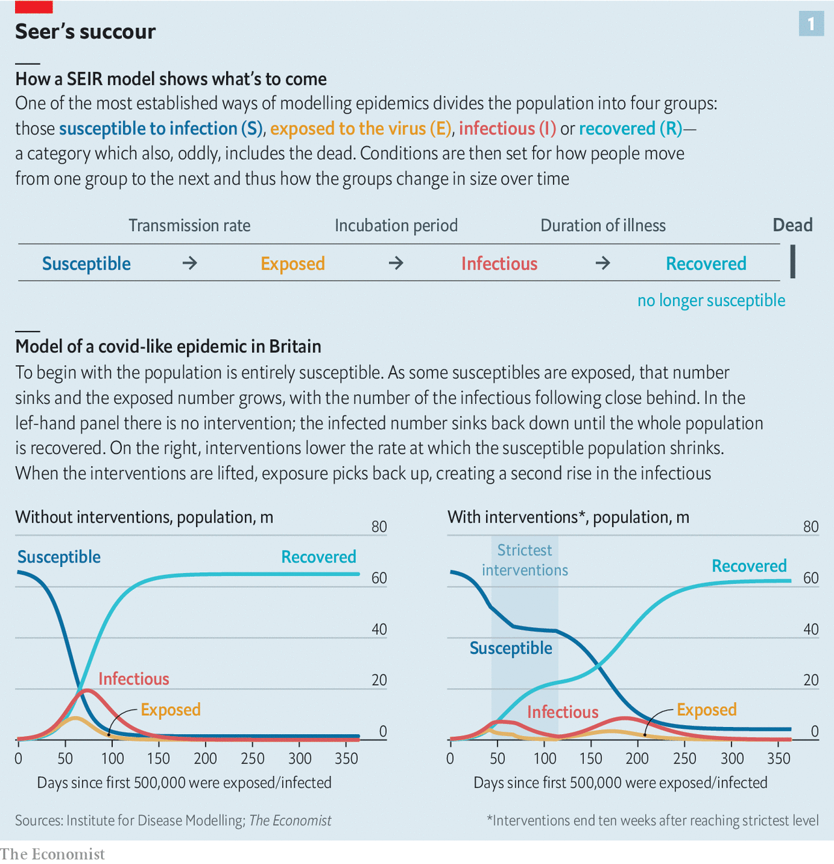

The second type of model makes no claim to capture the underlying dynamics. They are instead based on what is essentially a sophisticated form of moving average, predicting things about next week (such as how many new infections there will be) based mostly on what happened this week, a little bit on what happened last week, and a smidgen on what happened before that. This approach is used to forecast the course of epidemics such as the seasonal flu, using patterns seen in epidemics that have already run their course to predict what will come next. Over the short term they can work pretty well, providing more actionable insights than mechanistic models. Over the long term they remain, at best, a work in progress.

All the models are beset by insufficient data when faced with covid-19. There is still a lot of uncertainty about how much transmission occurs in different age groups and how infectious people can be before they have symptoms; that makes the links between the different equations in the mechanistic models hard to define properly. Statistical models lack the data from previous epidemics that make them reliable when staying a few steps ahead of the flu.

## Obedient to controlling hands

This causes problems. The Dutch started expanding their intensive-care capacity on the basis of a model which, until March 19th, expected intensive-care stays to last ten days. Having seen what was happening in hospitals, the modellers lengthened that to 23 days, and the authorities worry about running out of beds by April 6th. Unsettling news; but better known in advance than discovered the day before.

If more data improve models, so does allowing people to look under their bonnets. The Dutch have published the details of the model they are using; so has New Zealand. As well as allowing for expert critique, it is a valuable way of building up public trust.

As models become more important and more scrutinised, discrepancies between their purported results will become apparent. One way to deal with divergence is to bring together the results of various different but comparable models. In Britain, the government convened a committee of modelling experts who weighed the collective wisdom from various models of the covid-19 epidemic. America’s task force for the epidemic recently held a meeting of modelling experts to assess the range of their results.

Another way to try to get at the combined expertise of the field is simply to ask the practitioners. Nicholas Reich of the University of Massachusetts, Amherst, and his colleague Thomas McAndrew have used a questionnaire to ask a panel of experts on epidemics, including many who make models, how they expect the pandemic to evolve. This sounds crude compared with differential equations and statistical regressions, but in some ways it is more sophisticated. Asked what they were basing their responses on, the experts said it was about one-third the results of specific models and about two-thirds experience and intuition. This offers a way to take the models seriously, but not literally, by systematically tapping the tacit knowledge of those who work with them.

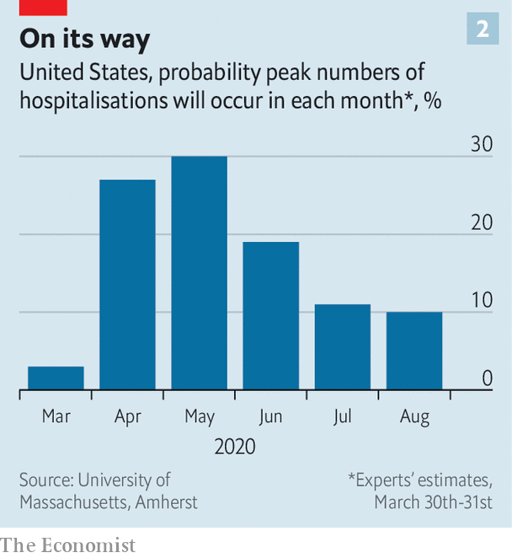

In studies run over the course of two flu seasons, such a panel of experts was consistently better at predicting what was coming over the next few weeks than the best computational models. Unfortunately, like their models, the experts have not seen a covid outbreak before, which calls the value of their experience into at least a little doubt. But it is interesting, given Mr Trump’s commitment to just another month of social distancing, that they do not expect a peak in the American epidemic until May (see chart 2).

Though the models differ in various respects, the sort of action taken on their advice has so far been pretty similar around the world. This does not mean the resultant policies have been wise; the way that India implemented its lockdown seems all but certain to have exacerbated the already devastating threat that covid-19 poses there. And there are some outliers, such as the Netherlands and, particularly, Sweden, where policies are notably less strict than in neighbouring countries.

Attempts to argue that the costs of such action could be far greater than the cost of letting the disease run its course have, on the other hand, failed to gain much traction. When looking for intellectual support, their proponents have turned not to epidemiologists but to analyses by scholars in other fields, such as Richard Epstein, a lawyer at the Hoover Institute at Stanford, and Philip Thomas, a professor of risk management at the University of Bristol. These did not convince many experts.

## April is the cruellest month

Even if they had, it might have been in vain. The argument for zeal in the struggle against covid-19 goes beyond economic logic. It depends on a more primal politics of survival; hence the frequent comparison with total war. Even as he talked of saving a million lives, Mr Trump had to warn America of 100,000 to 200,000 deaths—estimates that easily outstrip the number of American troops lost in Vietnam. To have continued along a far worse trajectory would have been all but impossible.

What is more, a government trying to privilege the health of its economy over the health of its citizenry would in all likelihood end up with neither. In the absence of mandated mitigation policies, many people would nonetheless reduce the time they spend out of the home working and consuming in order to limit their exposure to the virus. (Cinemas in South Korea, where the epidemic seems more or less under control, have not been closed by the government—but they are still short of customers.) There would be effects on production, too, with many firms hard put to continue business as usual as some workers fell ill (as is happening in health care today) and others stayed away (as isn’t).

This is one reason why, in the acute phase of the epidemic, a comparison of costs and benefits comes down clearly on the side of action along the lines being taken in many countries. The economy takes a big hit—but it would take a hit from the disease too. What is more, saving lives is not just good for the people concerned, their friends and family, their employers and their compatriots’ sense of national worth. It has substantial economic benefits.

Michael Greenstone and Vishan Nigam, both of the University of Chicago, have studied a model of America’s covid-19 epidemic in which, if the government took no action, over 3m would die. If fairly minimal social distancing is put in place, that total drops by 1.7m. Leaving the death toll at 1.5m makes that a tragically underpowered response. But it still brings huge economic benefits. Age-adjusted estimates of the value of the lives saved, such as those used when assessing the benefits of environmental regulations, make those 1.7m people worth about $8trn: nearly 40% of GDP.

Those sceptical of the costs of current policies argue that they, too, want to save lives. The models used to forecast GDP on the basis of leading indicators such as surveys of sentiment, unemployment claims and construction starts are no better prepared for covid-19 than epidemiological models are, and their conclusions should be appropriately salinated. But even if predictions of annualised GDP losses of 30% over the first half of the year in some hard-hit economies prove wide of the mark, the abrupt slowdown will be unprecedented.

Lost business activity will mean lost incomes and bankrupt firms and households. That will entail not just widespread misery, but ill health and death. Some sceptics of mitigation efforts, like George Loewenstein, an economist at Carnegie Mellon University, in Pittsburgh, draw an analogy to the “deaths of despair”—from suicide and alcohol and drug abuse—in regions and demographic groups which have suffered from declining economic fortunes in recent decades.

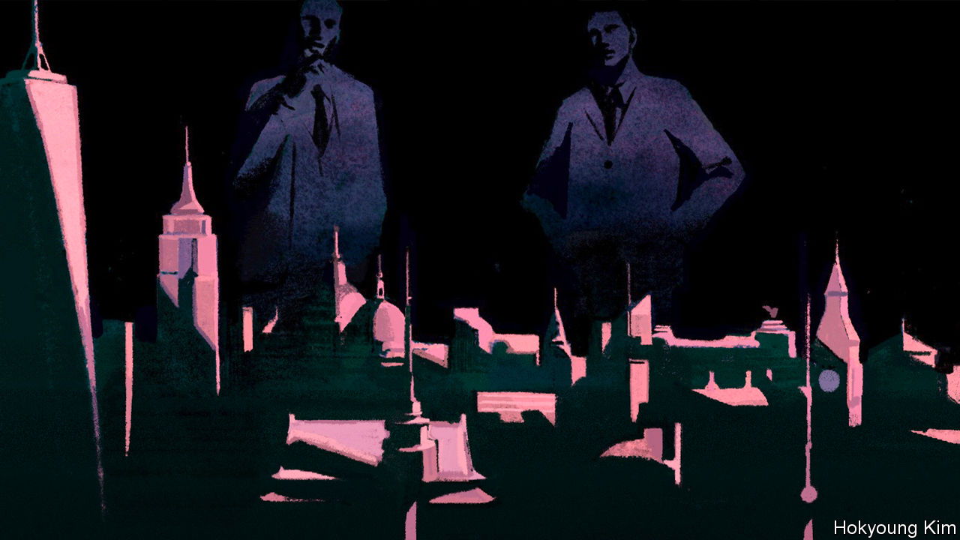

The general belief that increases in GDP are good for people’s health—which is true up to a point, though not straightforwardly so in rich countries—definitely suggests that an economic contraction will increase the burden of disease. And there is good reason to worry both about the mental-health effects of lockdown (see article) and the likelihood that it will lead to higher levels of domestic abuse. But detailed research on the health effects of downturns suggests that they are not nearly so negative as you might think, especially when it comes to death. Counterintuitive as it may be, the economic evidence indicates that mortality is procyclical: it rises in periods of economic growth and declines during downturns.

## And the profit and loss

A study of economic activity and mortality in Europe between 1970 and 2007 found that a 1% increase in unemployment was associated with a 0.79% rise in suicides among people under the age of 65 and a comparable rise in deaths from homicide, but a decline in traffic deaths of 1.39% and effectively no change in mortality from all causes (see chart 3). A study published in 2000 by Christopher Ruhm, now at the University of Virginia, found that in America a 1% rise in unemployment was associated with a 1.3% increase in suicides, but a decline in cardiovascular deaths of 0.5%, in road deaths of 3.0%, and in deaths from all causes of 0.5%. In the Great Depression, the biggest downturn in both output and employment America has ever witnessed, overall mortality fell.

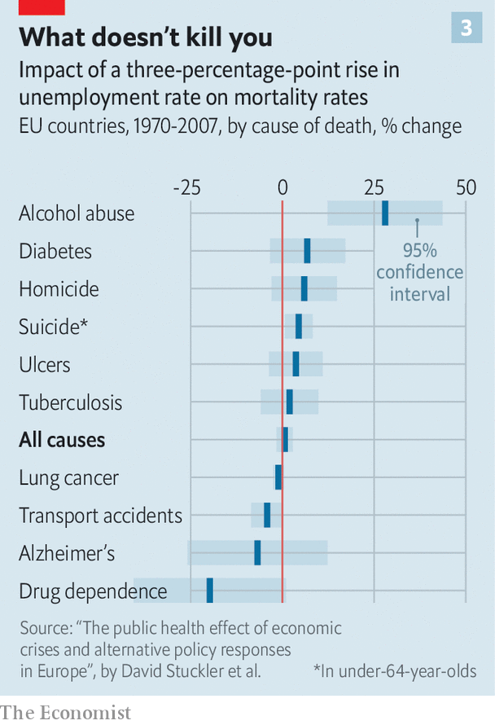

Some research suggests that the procyclical link between strong economic growth and higher mortality has weakened in recent decades. But that is a long way from finding that it has reversed. What is more, the effects of downturns on health seem contingent on policy. Work published by the OECD, a group of mostly rich countries, found that some worsening health outcomes seen in the aftermath of the financial crisis were due not to the downturn, but to the reductions in health-care provision that came about as a result of the government austerity which went with it. Increased spending on programmes that help people get jobs, on the other hand, seems to reduce the effect of unemployment on suicides. The fact that some of the people now arguing that the exorbitant costs of decisive action against covid-19 will lead to poorer public health in the future were, after the financial crisis, supporters of an austerity which had the same effect is not without its irony.

But if the argument that the cure might be worse than the disease has not held up so far, the story still has a long way to go. The huge costs of shutting down a significant fraction of the economy will increase with time. And as the death rates plateau and then fall back, the trade-offs—in terms of economics, public health, social solidarity and stability and more—that come with lockdowns, the closure of bars, pubs and restaurants, shuttered football clubs and cabin fever will become harder to calculate.

It is then that both politicians and the public are likely to begin to see things differently. David Ropeik, a risk-perception consultant, says that people’s willingness to abide by restrictions depends both on their sense of self-preservation and on a sense of altruism. As their perception of the risks the disease poses both to themselves and others begins to fall, seclusion will irk them more.

It is also at this point that one can expect calls to restart the economy to become clamorous. In Germany, where the curve of the disease has started to flatten, Armin Laschet, the premier of North Rhine-Westphalia, Germany’s largest and second-most-covid-afflicted state, has said it should no longer be out of bounds to talk about an exit strategy. Angela Merkel, the chancellor—a role Mr Laschet is keen to inherit—said on March 26th there should be no discussion of such things until the doubling time for the number of cases in the country had stretched beyond ten days. When she was speaking, it was four days. Now it is close to eight.

When the restrictions are lessened it will not be a simple matter of “declaring victory and going home”, the strategy for getting out of the Vietnam war advocated by Senator Richard Russell. One of the fundamental predictions of the mechanistic models is that to put an epidemic firmly behind you, you have to get rid of the susceptible part of the population. Vaccination can bring that about. Making it harder for the disease to spread, as social distancing does, leaves the susceptible population just as vulnerable to getting exposed and infected as it was before when restrictions are lifted.

This does not mean that countries have to continue in lockdown until there is a vaccine. It means that when they relax constraints, they must have a plan. The rudiments of such a plan would be to ease the pressure step by step, not all at once, and to put in place a programme for picking up new cases and people who have been in contact with them as quickly as possible. How countries trace cases will depend, in part, on how low they were able to get the level of the virus in the population and how able, or inclined, they are to erode their citizens’ privacy. How they relax constraints will depend to some extent on modelling.

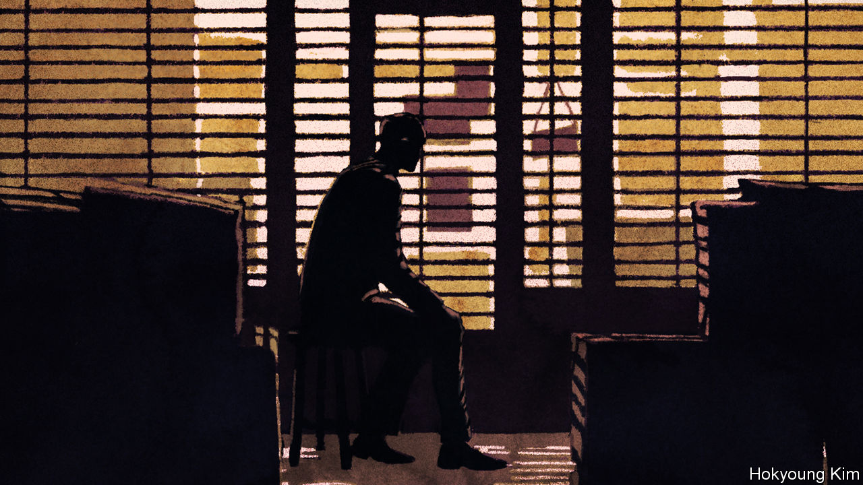

Cécile Viboud of America’s National Institutes of Health argues that if you can make mechanistic models sufficiently fine-grained they will help you understand the effectiveness of different social-distancing measures. That sounds like the sort of knowledge that governments considering which restrictions to loosen, or tighten back up, might find valuable. The ability to compare the outcomes in countries following different strategies could also help. David Spiegelhalter, a statistician at the University of Cambridge, says the differences between Norway, which is conforming to the lockdowns seen in most of the rest of Europe, and Sweden, which is not, provide a “fantastic experiment” with which to probe the various models.

But the fact that it is possible to build things like how much time particular types of people spend in the pub into models does not necessarily mean that the models will represent the world better as a result. For what they say on such subjects to be trustworthy the new parameters on pubs and such like must be calibrated against the real world; and the more parameters are in play, the harder that is. People can change so many behaviours in response to restrictions imposed and removed that the uncertainties will “balloon” over time, says Mr Reich.

## The human engine waits

Some will see this as a reason to push ahead with calibration and other improvements. Others may see it as a reason to put off the risks associated with letting the virus out of the bag for as long as possible. Longer restrictions would give governments more time to put in place measures for testing people and tracking contacts. If they force many companies into bankruptcy, they will give others time to find workarounds and new types of automation that make the restrictions less onerous as time goes by.

Advocates of keeping things in check for as long as possible can point to a new paper by Sergio Correia, of the Federal Reserve Board, Stephan Luck, of the Federal Reserve Bank of New York, and Emil Verner, of MIT, which takes a city-by-city look at the effects of the flu pandemic of 1918-19 on the American economy. They find that the longer and more zealously a city worked to stem the flu’s spread, the better its subsequent economic performance. A new analysis by economists at the University of Wyoming suggests much the same should be true today.

The flu, though, mostly killed workers in their prime, and the service industries which dominate the modern economy may not respond as the manufacturing industries of a century ago. What is more, in some places the pressure to get the economy moving again may be irresistible. According to Goldman Sachs, a bank, Italy’s debts could reach 160% of GDP by the end of the year—the sort of number that precedes panics in bond markets. The euro zone could forestall such a crisis by turning Italian debt into liabilities shared all its members—something the European Central Bank is already doing, to a limited extent, by buying Italian bonds. But resistance from Germany and the Netherlands is limiting further movement in that direction. There could come a time when Italy felt forced to relax its restrictions to someone else’s schedule rather than leave the euro.

There is also a worry that, the longer the economy is suppressed, the more long-lasting structural damage is done to it. Workers suffering long bouts of unemployment may find that their skills erode and their connections to the workforce weaken, and that they are less likely to re-enter the labour force and find good work after the downturn has ended. Older workers may be less inclined to move or retrain, and more ready to enter early retirement. Such “scarring” would make the losses from the restrictions on economic life more than just a one-off: they would become a lasting blight. That said, the potential for such scarring can be reduced by programmes designed to get more people back into the labour force.

In the end, just as lockdowns, for all that their virtues were underlined by the modellers’ grim visions, spread around the world largely by emulation, they may be lifted in a similar manner. If one country eases restrictions, sees its economy roar back to life and manages to keep the rate at which its still-susceptible population gets infected low, you can be sure that others will follow suit. ■

Dig deeper:  
For our latest coverage of the covid-19 pandemic, register for The Economist Today, our daily [newsletter](https://www.economist.com/newslettersignup), or visit our [coronavirus hub](https://www.economist.com/coronavirus)

This article was downloaded by calibre from <https://www.economist.com/briefing/2020/04/03/the-hard-choices-covid-policymakers-face>

|  |  |  |  |
| --- | --- | --- | --- |
|  | Articles | Sections | Next |

|  |  |  |  |
| --- | --- | --- | --- |
| Previous | Articles | Sections | Next |

#### Triage under trial

# The tough ethical decisions doctors face with covid-19

When the concept of trade-offs is all too real

Apr 2nd 2020 |

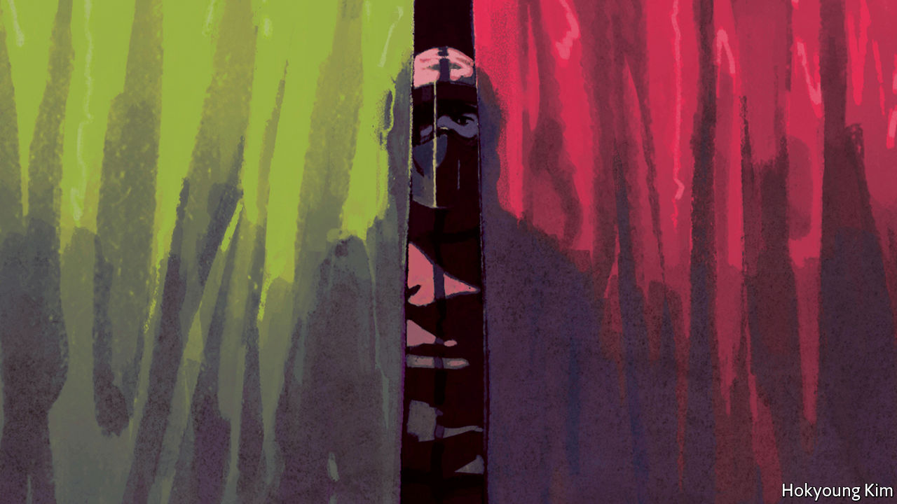

Editor’s note: The Economist is making some of its most important coverage of the covid-19 pandemic freely available to readers of The Economist Today, our daily newsletter. To receive it, register [here](https://www.economist.com/newslettersignup). For more coverage, see our coronavirus [hub](https://www.economist.com/coronavirus)

IT WAS Dominique-Jean Larrey, a rugged French military surgeon in Napoleon’s Grande Armée, who came up with the system of triage. On the battlefield Larrey, who tended to the wounded at the battle of Waterloo, had to determine which soliders needed medical attention most urgently, regardless of their military rank. In doing so he came up with the concept of distinguishing between urgent and non-urgent patients. Triage, from the French trier (“separate out”) remains as useful today as it was in the Napoleonic campaigns.

Yet most doctors today have rarely been in battlefield conditions. The covid-19 pandemic has changed that. In Italy there are reports of doctors weeping in hospital hallways because of the choices they have to make. In America and Europe many doctors are faced with terrible decisions about how to allocate scarce resources such as beds, intensive care, and ventilators. In the Netherlands, for example, hospitals are expected to be at full capacity by April 6th; two patients have already been sent to Germany. In some countries, new guidelines over how to distinguish between patients are being hastily drawn up.

One general solution, proffered by both moral philosophers and physicians, is to make sure that resources—in this case staff, supplies and equipment—are directed to the patients who have the greatest chances of successful treatment, and who have the greatest life expectancy. But beyond such a seemingly simple utilitarian solution lie some brutal decisions.

Take the shortage of ventilators. Many patients hospitalised with covid-19 will need one eventually. Provide it too early, and someone else does without. When it is truly needed, though, it will be needed quickly. A paper in the New England Journal of Medicine says that when ventilators are withdrawn from patients dependent on them, they will “die within minutes”.

The decision over whether or not to ventilate then becomes a decision between life or death. If a young patient arrives needing a ventilator, and none are available, there is a chance that one will be removed from someone else who is identified as being less likely to survive. In extreme situations, it may even be taken from someone who might survive but who is expected to live for a shorter length of time. Such frameworks do not favour older patients or those with health problems.

Ventilation is actually hard for the body to take. It is difficult for older patients to survive on it for two or three weeks—the length of time it would take for them to recover from covid-19. In ordinary situations, an effort would be made to keep the patient alive until it becomes obviously futile. In some hospitals that is no longer possible.

Italian doctors say that it helps if the framework for distinguishing between patients is decided in advance, and patients and families are properly informed. It also helps if someone else, other than front-line doctors, makes the difficult decisions. That leaves doctors free to appeal a decision if they think it has been made in error. In America many states have strategies for rationing resources; this is performed by a triage officer or committee in a hospital.

In some places, preparation of new triage guidelines is under way. In Canada a framework is being developed and vetted by government lawyers and regulators, according to Ross Upshur, a professor at the Dalla Lana School of Public Health in Toronto. In Britain, the development of guidelines has been painful. The National Institute for Health and Care Excellence, a government body, recommends that decisions about admission to critical care should be made on the basis of the potential for medical benefit. Since issuing that advice it has, though, clarified that a generic frailty index included in its guidelines should not be used for younger people or those with learning disabilities. On April 1st the British Medical Association, the doctors’ trade union, stepped into the breach, making clear the trade-offs: “there is no ethically significant difference between decisions to withhold life-sustaining treatment or to withdraw it, other clinically relevant factors being equal.”

Whether on the battlefield or in a crowded ICU, humans tend to be inclined to treat others according to need and their chances of survival. That framework seems broadly morally acceptable. Even so, it will involve many heart-wrenching decisions along the way. ■

Dig deeper:  
For our latest coverage of the covid-19 pandemic, register for The Economist Today, our daily [newsletter](https://www.economist.com/newslettersignup), or visit our [coronavirus hub](https://www.economist.com/coronavirus)

This article was downloaded by calibre from <https://www.economist.com/briefing/2020/04/01/the-tough-ethical-decisions-doctors-face-with-covid-19>

|  |  |  |  |
| --- | --- | --- | --- |
| Previous | Articles | Sections | Next |

|  |  |  |  |
| --- | --- | --- | --- |
| Previous | Articles | Sections | Next |

#### Exit unicorns, pursued by bears

# Technology startups are headed for a fall

The consequences will not all be bad

Apr 4th 2020 | SAN FRANCISCO

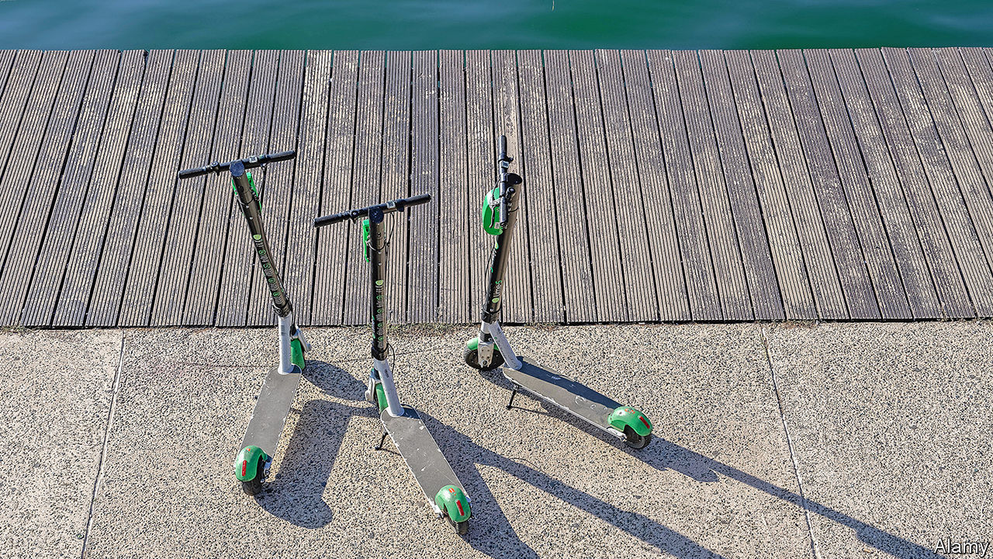

Editor’s note: The Economist is making some of its most important coverage of the covid-19 pandemic freely available to readers of The Economist Today, our daily newsletter. To receive it, register [here](https://www.economist.com/newslettersignup). For more coverage, see our coronavirus [hub](https://www.economist.com/coronavirus)

FOR A SENSE of how covid-19 is affecting the world’s technology “unicorns”, as privately held firms worth $1bn or more have come to be known, consider two of them. Lime, a scooter-rental firm valued at $2.4bn, has halted its services in Europe and America, where most citizens have been told to stay off the streets. DoorDash, a $13bn food-delivery company, has suddenly found itself useful to a self-isolating society as a whole, not just couch potatoes; deliveries have surged.

On the surface, DoorDash stands to benefit from the pandemic, and Lime to suffer. In fact, the coronavirus may prove more indiscriminate than that. It strikes at a time when many of the world’s 450-odd unicorns were looking ropy. Their perpetually loss-making business models—only a small proportion are in the black—were increasingly being questioned. So were their exuberant valuations, which added up to perhaps $1.3trn globally. A reckoning was afoot; some unicorns would “go under”, Dara Khosrowshahi, boss of Uber, a ride-hailing giant which relinquished its unicorn status by going public last year, told The Economist on March 2nd.

Among investors, “fear of missing out” has been giving way to “fear of looking stupid”, says Alfred Lin, a partner at Sequoia Capital, a venerable Silicon Valley venture-capital (VC) firm. Plenty have given up trying to do new deals; instead they are trying to save old ones. One firm is telling its companies to expect 30% less revenue in the next two quarters and to cut costs accordingly. On March 5th Sequoia put out a memo entitled “Coronavirus: The Black Swan of 2020” warning that the outbreak will depress startups’ growth and calling on its portfolio firms (one of which is DoorDash) to rein in costs, conserve cash and brace for capital scarcity.

Most telling, the gospel of growth at all cost has gone out of the window. After years of initial public offerings (IPOs) being done without much focus on profits, “path to profitability” is the new watchword, says Ryan Dzierniejko of Skadden, Arps, Slate, Meagher & Flom, a law firm. “The law of economic gravity has returned as it does every decade or so,” says Michael Moritz, another Sequoia partner. For some unicorns, dispensing with eight flavours of sparkling water and five selections of Thai curry may be a good start, he adds.

The unicorn reality check was under way before America declared a national state of emergency over covid-19 on March 13th. Venture capitalists reckoned that a third of American unicorns would thrive, a third would disappoint and a third would be taken over or die. As investors the world over scurry to safe assets amid a market meltdown, Mr Khosrowshahi’s prediction may come true faster than he thought. Some discern an echo of the dotcom bubble, which burst 20 years ago. Others are more sanguine. Whoever is right, startup pastures that emerge in the aftermath will look very different to today’s.

Unicorns have come a long way since Aileen Lee, founder of Cowboy Ventures, a VC firm, coined the term in 2013, to convey wonder and rarity. Nowadays every startup wants to be one, for bragging rights and to hire the cleverest coders. “For millennials and Gen Zs being a unicorn became a filter,” says Jeff Maggioncalda, CEO of Coursera, a unicorn that offers online learning courses and university degree programmes. A small Austin-based scooter startup called itself, simply, Unicorn; the attempt to leverage nominative determinism failed when the firm went bust in December after spending all its cash on Google and Facebook ads.

For the past decade huge sums from sovereign-wealth funds, mutual funds and hedge funds poured, directly or via VC firms, into startups that were unicorns or, their backers believed, might be one soon. Total annual VC investment in America leapt from $32bn in 2009 to $121bn in 2018. Some $822bn has flowed into American startups since 2010. About as much has gone to those in the rest of the world. Fat cheques allowed cash-burning firms to put off facing the scrutiny of public markets, with their pesky insistence on earnings.

The euphoria began to ebb last year. First, in May, Uber’s blockbuster IPO priced at a 30% discount to what the company’s investment bankers had promised. Today its market capitalisation is $43bn, more than a third below what it was on its first day of trading. Unicorn IPOs of Lyft, Uber’s main rival, and of Slack, a corporate-messaging service, disappointed. Then, in October, WeWork, a supposedly “techie” office-rental group, scrapped its IPO after it became clear that investors had no appetite for shares in a firm that lost as much money as it generated in revenues. Its valuation was cut from $47bn to less than $8bn.

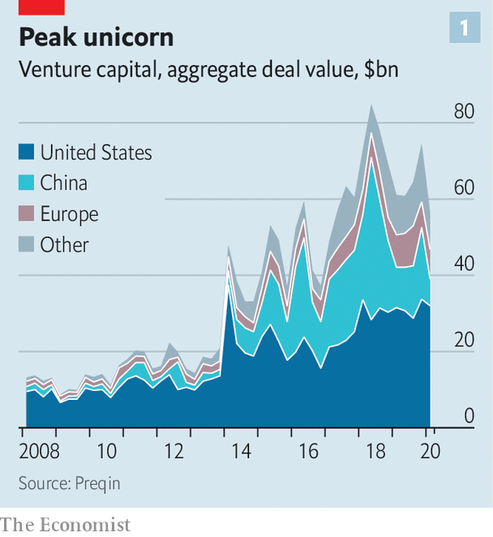

Other debacles followed. Brandless, an online retailer that sold unbranded products for a fixed $3, folded in February. Zume, a firm selling robot-made pizzas, shut its main business in January. Both, as well as WeWork, were backed by the $100bn Vision Fund, the opaque VC vehicle of SoftBank, a Japanese tech conglomerate, and its boss, Son Masayoshi. OneWeb, a British satellite-internet startup formerly valued at $3.3bn and also backed by Mr Son, has filed for bankruptcy.

After the WeWork fiasco smart VC money turned more cautious, particularly with regard to Vision Fund firms: they went from garnering praise to seeming problematic. Now investors, customers and suppliers “think you must be a crappy company” if you were backed by the fund, says the boss of one, who keeps assuring them “we are not the next WeWork”. A Vision Fund spokesperson says: “We’re sorry to hear it. That has not been our experience with our other founders.”

In fact the malaise extends well beyond Mr Son’s empire. In the last quarter of 2019 American venture-backed firms raised 16% less capital than in the previous quarter and big funding rounds—over $100m—fell by a third. Last year China, home to four of the world’s ten most richly valued unicorns, entered a “capital winter”, as investors turned against firms handing out huge subsidies to consumers in a reckless pursuit of customers. Some Chinese unicorns went bust, including Tuandaiwang, a peer-to-peer lender once valued at $1.4bn.

The coronavirus shock comes at a time when most tech unicorns were already exhibiting underlying health problems. Some, most notoriously WeWork, never really deserved the label in the first place. Their businesses had at best a tenuous claim to techiness—and so to the “flywheel” effect behind the likes of Amazon or Facebook, in which a large user base makes them more attractive to more users, and so on. Other companies are bona fide technology firms but, like Uber or Lyft, find that digital flywheels gum up. And too many unicorns rest on shaky and opaque financial structures that may exaggerate their lofty valuations.

Start with “fake tech”. These include capital-intensive firms such as WeWork (where accommodating more customers means leasing more office space) and direct-to-consumer retailers such as Casper, which sells snazzy bedding. “We consider ourselves a tech company first,” declared its co-founder, Neil Parikh, in 2016. Stockmarket investors considered it a mattress retailer. In February it listed at $575m, less than half its $1.1bn private valuation.

## Pie in the sky

Zume, recounts a VC investor close to it, “only used to talk about the robots, never about the pizza”. When its lorries rounded corners, melted mozzarella ran everywhere. “When we ordered a margherita,” the investor remembers, “it tasted bad.”

Some proper tech unicorns nevertheless discovered that in the physical world, where many at least partially reside, flywheels encounter friction. In theory their markets are almost limitless, with nearly half of humanity carrying a smartphone. Their business models, like Uber’s, enjoy certain network effects: demand from more riders in a given city lures more drivers to the platform; more drivers in turn attract more riders by making rides easier and cheaper to hail. And they can lower upfront costs by outsourcing things like accounting and data storage to the cloud.

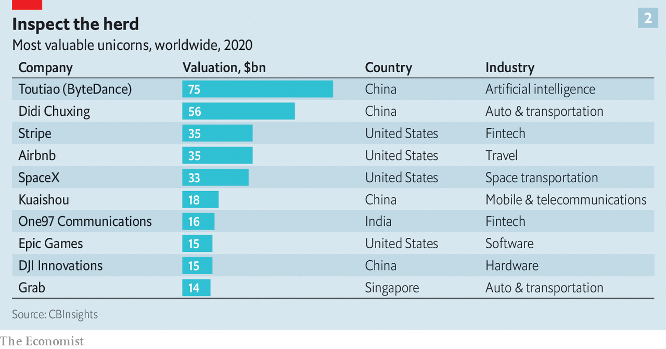

The trouble is that, in practice, variable costs—subsidies paid to drivers to generate business, say—rise with every new customer. People “thought software changes everything”, says Aaron Levie, co-founder of Box, a listed enterprise cloud firm. But in many cases the digital platform is only a small part of the cost structure: “The physical assets stay expensive.”

No network effects means lower barriers to entry for rivals. The flywheel breaks down because riders have no reason to favour an Uber over a Lyft. Most will go for whichever is cheaper—which leads both firms to fight for customers with cut-price rides subsidised by their VC backers’ cash. In the words of Marco Zappacosta, co-founder of Thumbtack, a local-services marketplace, “Some companies ended up selling $1 for 80 cents.”

Randy Komisar of Kleiner Perkins, a big VC firm, offers an alternative rule of thumb. For a unicorn to count as genuinely “tech”—and therefore profitably scalable—its actual product must be technology, he says; “it can’t just be using technology.” Businesses selling physical goods or services often don’t make the cut. Those providing cloud-based services, especially to corporations—like Snowflake (which helps firms warehouse data in the cloud) or PagerDuty (which assists companies’ digital operations)—do. It helps that, like Slack and Zoom, a video-conferencing firm that also went public last year, they are coronavirus-proof. Indeed, lockdowns are boosting their business by pushing firms to move more functions online.

That is not to say that the consumer internet is dead. Airbnb, a home-sharing website, has seen bookings fall by 40% in big European cities as the pandemic halted trips. It may delay its IPO, which was expected to be this year’s biggest. But despite racking up losses of late, it is well-managed, cash-rich and, thanks to an unmatched global reach that puts up a high barrier to entry, likely to make money again once people get back to travelling.

Neil Shen of Sequoia Capital China says that investors still believe in the ability of some Chinese firms, especially $10bn-plus “super-unicorns”, to dominate their giant home market. Meituan-Dianping, a food-delivery firm, and Pinduoduo, an e-commerce site, were criticised for losing money ahead of their IPOs in 2018. Both ex-unicorns have since taken off. On March 30th Meituan even reported a quarterly profit (though it warned of a coronavirus hit in the coming months). One promising candidate to follow in their footsteps is ByteDance, the parent company of TikTok, a hit video-sharing app—and, with a valuation of $75bn, the world’s biggest unicorn (in which the Vision Fund also has a stake).

The complex and opaque financial practices behind the calculation of unicorns’ valuations are the third pre-existing condition that afflicts most of them—including those which pass Mr Komisar’s test, boast solid business models and hold enough cash to tide them over a rough few months or more. These conditions lead firms to overstate their value in two main ways.

The first has to do with ownership structure. A private firm’s headline valuation is the product of the number of shares and the price per share at the last funding round. But shares issued in later rounds often have downside protections such as seniority over other investors and IPO return guarantees. These lower the value of common equity issued in previous rounds. In 2018 Ilya Strebulaev of the Stanford Graduate School of Business examined the legal terms of 135 unicorns’ various share classes and found that firms were overstating their valuations by 48% on average.

The second issue is one of governance. Recent years have seen frequent use of “inside rounds”, in which existing backers stump up more money. These can be a vote of confidence from people who know a business well. But they are also a way for VC firms to mark up their portfolios, generating higher internal rates of return that are more attractive to institutional investors (and form the basis on which many partners get paid). According to Mike Cagney, co-founder of three fintech unicorns, SoFi, Provenance and Figure, an unwritten VC rule advises against a firm which led one investment round in a startup leading the next. That inside rounds have become more common in recent years creates a credibility issue for Silicon Valley, he says.

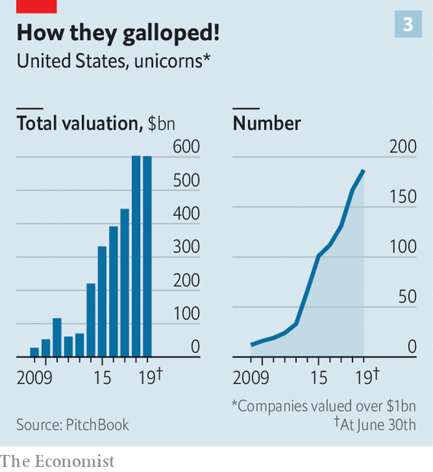

As a result of such finagling, of the roughly 200 American unicorns probably only half merit the moniker, reckons one veteran founder. Although the frequency of “down rounds”, in which valuations fall rather than rise, does not yet appear to have increased, activity in the opaque secondary market for unicorn shares suggests that a repricing is under way.

Sellers in such marketplaces (chiefly company insiders and VC firms seeking an early exit) appear to outnumber buyers in transactions involving such darlings as Grab, a $14bn Singaporean ride-hailing group, and Didi Chuxing, a Chinese rival. Phil Haslett of EquityZen, one such marketplace in New York, revealed in March that shares in many big private startups were changing hands at roughly 25% below their most recent funding round, in part as rank-and-file employees lined up to cash in. The trend has intensified as virus-linked uncertainty pummels risky assets.

These ructions point to one certainty: a shake-out looms. Firms that have most to lose from virus-related measures are shedding workers. Even before covid-19, Lime laid off 14% of its staff and exited a dozen cities. On March 27th Bird, a rival, announced that it was sacking a third of its workers to conserve cash. In all, unicorns have trimmed their payrolls by several thousand people. That is probably not the end of retrenchment. Workers who remain are seeing the value of their shares dwindle and prospects of an IPO windfall recede. Even viable listings are on ice until the markets’ pandemic fever breaks.

In the meantime, the unicorn world is astir with talk of consolidation. SoftBank has reportedly long wanted DoorDash and Uber Eats to merge. A tie-up now looks appetising. The Japanese firm may once again try to combine Grab and Gojek, a rival in Indonesia, where a price war is leading both to lose perhaps $200m a month. In America Uber may try to woo Lyft, whose share price has fallen faster than its own.

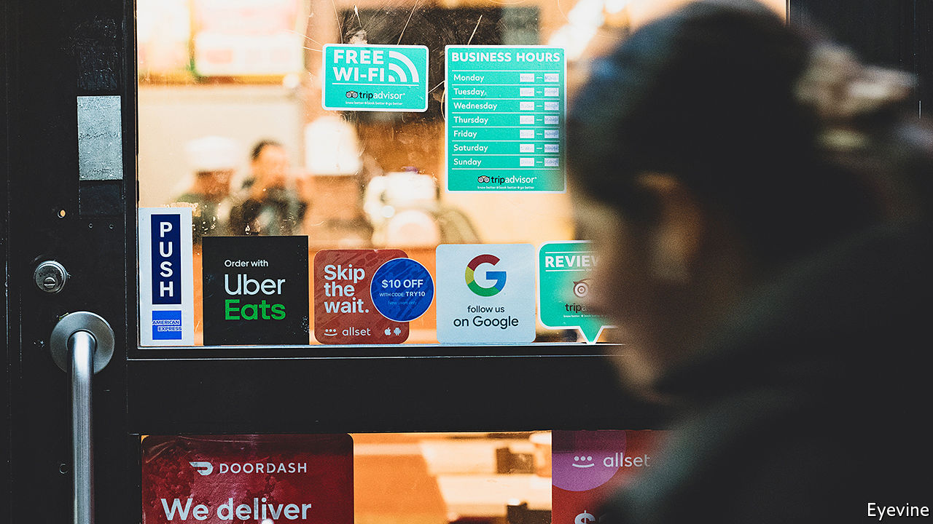

Not so tasty anymore

Selling to strategic buyers offers another way out. In February Intuit, a financial-software giant, bought Credit Karma, a personal-finance portal, for $7bn. Many potential acquirers are, however, hoarding cash until the pandemic passes.

## The uglies are coming

If all else fails, “sell it to one of the big uglies”, says one VC chief. The “uglies” in question—Apple, Microsoft, Alphabet, Amazon and Facebook—are collectively sitting on more than $570bn of gross cash. In normal times regulators would balk at a takeover by one of the tech giants. But these are not normal times. As a painful recession looms, preserving jobs—including not just those of well-paid coders but of the much larger army of gig-economy workers—may override antitrust concerns.

Even if some unicorns are spared—through mergers, acquisitions or just good fortune—the coronavirus is certain to ravage the herd. It will probably put the term itself, which has come to denote excess and broken promises, out to pasture. A new word may be needed, says Mr Khosrowshahi, to describe what is left. ■

Dig deeper:  
For our latest coverage of the covid-19 pandemic, register for The Economist Today, our daily [newsletter](https://www.economist.com/newslettersignup), or visit our [coronavirus hub](https://www.economist.com/coronavirus)

This article was downloaded by calibre from <https://www.economist.com/briefing/2020/04/03/technology-startups-are-headed-for-a-fall>

|  |  |  |  |
| --- | --- | --- | --- |
| Previous | Articles | Sections | Next |

|  |  |  |
| --- | --- | --- |
| Briefing | Sections | The Americas |

United States

Covid-19 and the states: It can happen here

.

Social distancing: Movement Republicans

.

The labour market: Trough to peak

.

Wisconsin’s chaotic elections: Petri-dish democracy

.

The presidential campaign: Reade’s digest

.

Military strategy: Send the marines

.

Lexington: A shadow over the Sunshine State

.

|  |  |  |
| --- | --- | --- |
| Briefing | Sections | The Americas |

|  |  |  |  |
| --- | --- | --- | --- |
|  | Articles | Sections | Next |

#### Uniting the states

# Covid-19 and America’s political system

How will a decentralised country that spans a continent fight what is now the world’s largest outbreak?

Apr 2nd 2020 | NEW YORK AND WASHINGTON, DC

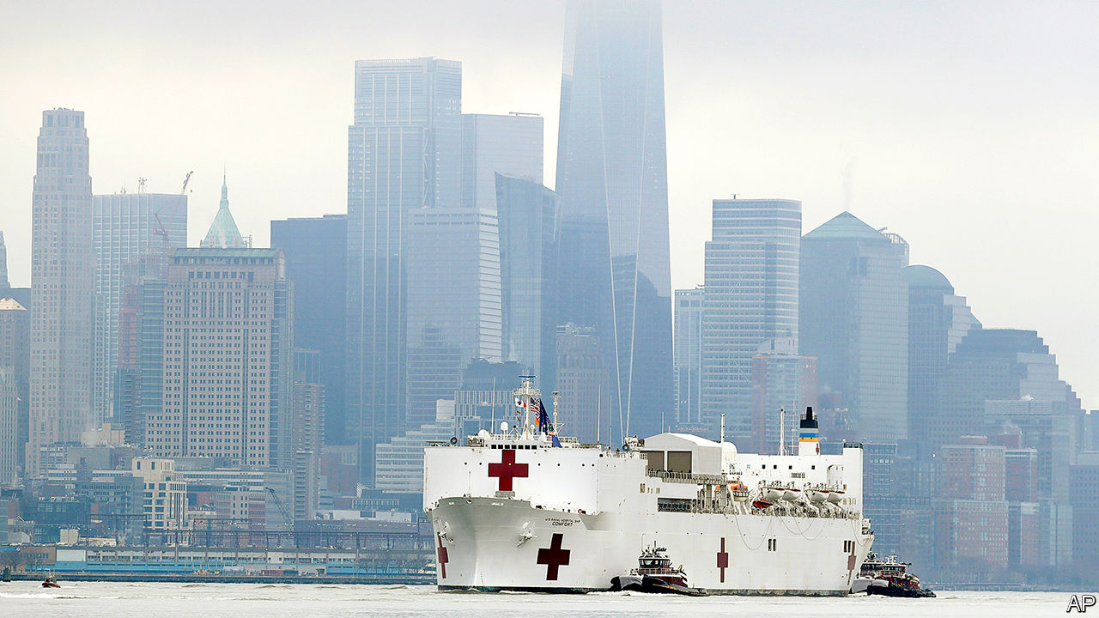

Editor’s note: The Economist is making some of its most important coverage of the covid-19 pandemic freely available to readers of The Economist Today, our daily newsletter. To receive it, register [here](https://www.economist.com/newslettersignup). For more coverage, see our coronavirus [hub](https://www.economist.com/coronavirus)

HAVING SAILED past the Statue of Liberty, the USNS Comfort docked at a pier on the west side of Manhattan. The spot where cruise ships once picked up passengers for the Caribbean now holds a naval hospital ship with the capacity to treat 1,000 patients—all to relieve the hospitals of New York City struggling with rampaging covid-19. Eager passers-by thronged to the shoreline to photograph the Comfort, briefly disregarding the advice to distance themselves from strangers.

New York City has become the desperate centre of the epidemic in America, with a quarter of the country’s cases. Although the caseload is projected to get worse, hospitals are already on the brink. As Eric Wei, the chief quality officer of the state’s public hospitals, says: “The indicators I’m looking at are flashing red.”

On a recent morning, nurses and staff wept as they walked into Elmhurst hospital in Queens, which has been flooded with patients. They fretted about shortages of masks, gloves and ventilators. Some hospitals have resorted to hooking two patients up to the same ventilator, which ought to work but is not what they are designed for. James Gasperino, the head of critical care at Brooklyn Hospital Centre, is discussing rationing care with the ethics committee. One field hospital has been set up in Central Park, another at Flushing Meadows. Kiosks around the empty streets display ads aimed at retired health-care workers, asking them to help. New York University is offering medical students early graduation if they enlist in the effort. About 70,000 such workers have volunteered so far.

Unfortunately these scenes could well be repeated elsewhere in America. New hotspots of infection, with rapidly growing case-counts, include Chicago, Detroit and New Orleans. Smaller towns are not immune either: Albany, New York, and Albany, Georgia, are both struggling with outbreaks. Successful containment will require weeks of lockdown. Whether that will work depends on whether America’s many moving parts—federal agencies, states, cities, school districts and hospital systems—can become more disciplined.

President Donald Trump once suggested that America would be open for business by Easter. Since then, the country has overtaken China and everywhere in the rich world in terms of confirmed cases. The rise has not halted: as of April 1st America had 217,000 positive tests (the true number of cases will be far higher) and 5,140 deaths. Over the past two weeks, confirmed cases and deaths have been growing at a daily rate of 26% and 30%, respectively. The scientists advising the president are now suggesting that between 100,000 and 240,000 Americans will die even if current social-distancing measures are kept in place.

Facing these statistics, Mr Trump extended advice on social distancing for a month. The president, having once claimed that the first 15 cases would soon go “down to close to zero” now says that his administration will have done “a very good job” if deaths are kept below 200,000.

Already, most Americans are taking extraordinary precautions. Three-quarters of the country has been advised to stay at home. Almost all schools are closed. Yet the projections of 100,000 or more deaths over the course of the epidemic are conditional on continuing this effort for weeks, months even. They surge above 1m if restrictions are prematurely relaxed.

All national epidemics are made up of many local epidemics, each with its own trajectory. The Institute for Health Metrics and Evaluation (IHME), a well-respected research group, has forecast that the apex of New York’s cases will come on April 9th, when 11,600 intensive-care beds will be needed (compared with the 718 available in normal times) and when deaths could peak above 800 a day. The worst times for other states will come later. California is projected to experience the greatest number of daily hospitalisations on April 28th; for Virginia, that point would not arrive until May 20th. Though the dragged-out epidemic means longer disruption to the economy and ordinary lives, it also makes the disease easier to fight. Although IHME’s modelling suggests cases in New York will overwhelm its medical capacity several times over, California and Virginia are not, as yet, projected to have such difficulty.

Public-health authority in America is devolved to the states. The federal government provides cash and guidance, but its legal oversight is largely limited to movement between states (such as on aeroplanes). As a result, governors and mayors are the primary deciders on whether to close schools, gyms and museums and when to lift shelter-in-place orders. The decentralised response will mean that some states fare better than others.

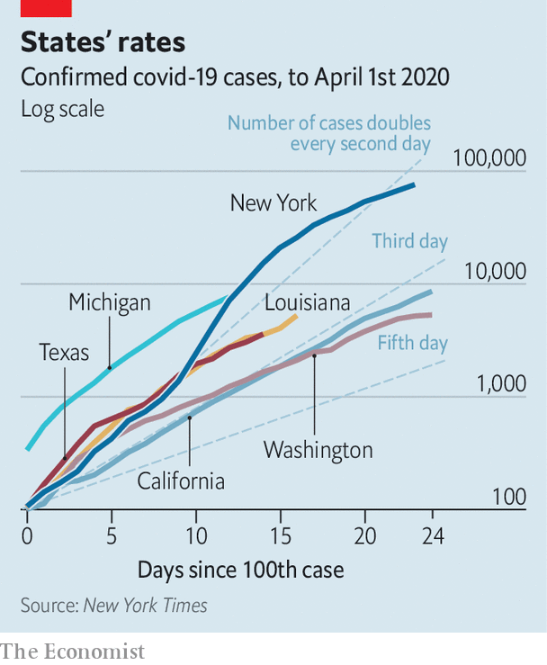

California and Washington, states that saw some of the first cases in the country, installed relatively stringent measures early and have seen a slower growth in caseloads than other states that acted later (see chart). Borders between states are unlikely to be shut. That suggests one shortcoming of the federalised system: laxer controls in one state risk recrudescence in others.

Yet so far the decentralised system has also been a saving grace. Were matters entirely in the hands of the federal government, which botched the initial phase of the epidemic, things could have been much worse. A faulty test design and weeks of bureaucratic red tape blinded public-health authorities at a critical moment. At the same time, Mr Trump was downplaying the risk, and the coronavirus task-force he set up suffered from infighting.

If states like California and Washington had not acted when they did, their hospitals might already be overwhelmed. Even until recently Mr Trump has been squabbling with Democratic governors he sees as insufficiently deferential and grateful, like Gretchen Whitmer in Michigan (“way in over her head”, he tweeted on March 27th ) and Andrew Cuomo of New York (“I think New York should be fine, based on the numbers that we see, they should have more than enough,” Mr Trump said on March 30th). But unlike the pseudo-crises of his administration, this real one cannot be badgered or blustered into submission.

Epidemiologists and, now, the White House think that America will remain closed for at least the next few weeks, its economy mothballed. Before states can relax restrictions, their epidemic curves must be bent. “The best thing we can do for the economy is get the virus under control […] And then we can open the economy back slowly and systematically, and have a much better chance that it remains open,” says Ashish Jha of the Harvard Global Health Institute. There must be sustained declines in new infections over a long period, perhaps two weeks. There must also be enough testing capacity to contain new clusters. After lagging behind, America is now consistently testing 100,000 people a day. Still, three times as many tests may be needed, says Dr Jha, to trace all the contacts of the newly infected and for random sampling. And hospitals must have the capacity to absorb the added demand that relaxation of social distancing could bring. It is possible to do all this in a month. But it is more likely that Mr Trump will have to extend his directives beyond May 1st.■

Dig deeper:  
For our latest coverage of the covid-19 pandemic, register for The Economist Today, our daily [newsletter](https://www.economist.com/newslettersignup), or visit our [coronavirus hub](https://www.economist.com/coronavirus)

This article was downloaded by calibre from <https://www.economist.com/united-states/2020/04/02/covid-19-and-americas-political-system>

|  |  |  |  |
| --- | --- | --- | --- |
|  | Articles | Sections | Next |

|  |  |  |  |
| --- | --- | --- | --- |
| Previous | Articles | Sections | Next |

#### Motion sickness

# Democrats seem to take social distancing more seriously than Republicans

GPS data from mobile phones reveal how Americans are moving

Apr 4th 2020 |

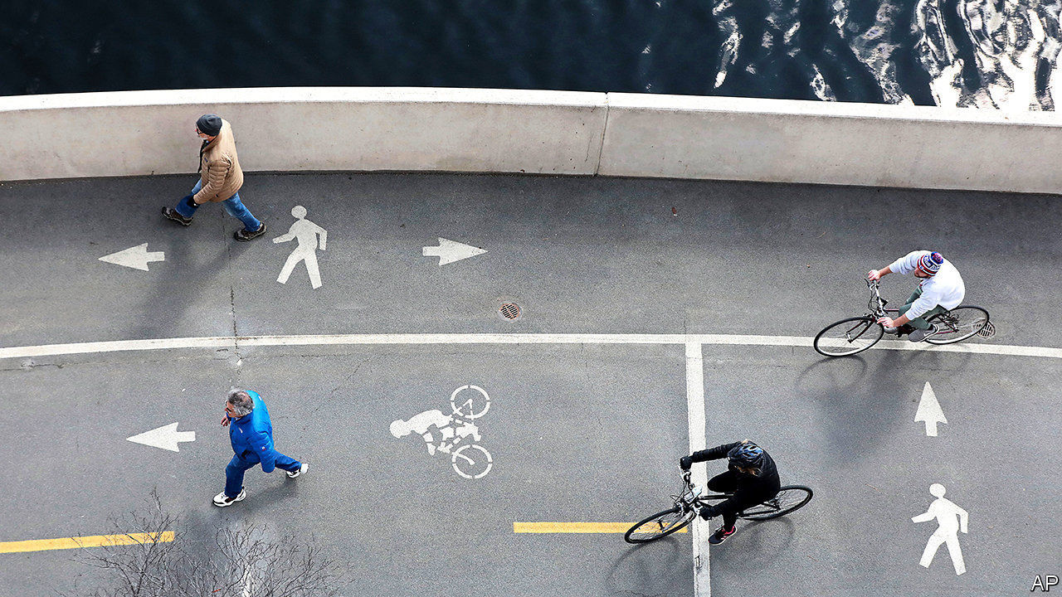

Editor’s note: The Economist is making some of its most important coverage of the covid-19 pandemic freely available to readers of The Economist Today, our daily newsletter. To receive it, register [here](https://www.economist.com/newslettersignup). For more coverage, see our coronavirus [hub](https://www.economist.com/coronavirus)

“AMERICA IS all about speed; hot, nasty, bad-ass speed,” runs a line from a 2006 film, “Talladega Nights”, supposedly quoting Eleanor Roosevelt. Restricting Americans’ freedom of movement was always going to be hard. GPS data show how hard. They also suggest a worrying partisanship.

The evidence comes from a company called Unacast, founded by two Norwegians in New York in 2014. It aggregates location data from mobile phones to track and analyse people’s movements on behalf of retailers and property companies. Such data become available when users download, say, restaurant-finding apps. This makes it possible to measure the total distance logged on mobile phones by county, state and nation.

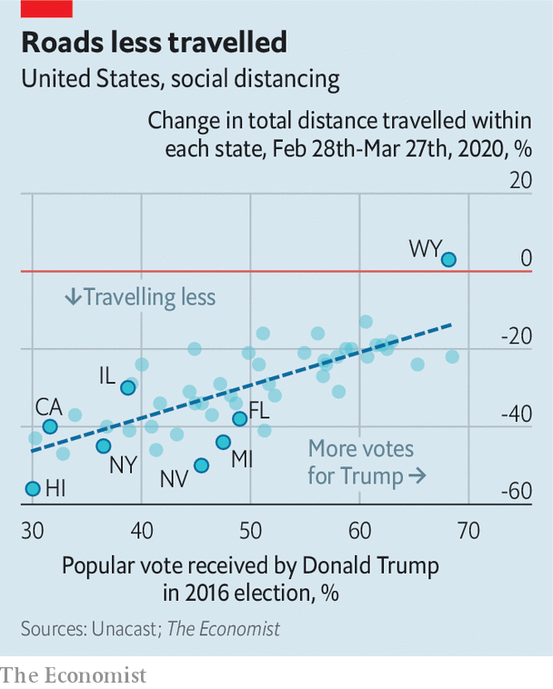

The most interesting data are those from state and county levels. In Nevada people halved the total distance they travelled between February 28th and March 27th. In Wyoming they travelled around more. (The average national reduction was 30%). The biggest declines in distance were in the north-east and Pacific coast. In the South, Midwest and Plains states declines have been modest.

There are several reasons. Midwestern and Plains states have relatively few cases of covid-19. This may make people take the crisis less seriously. They are also sparsely populated. When your nearest neighbour is a mile away, you may think you are self-isolating already.

But the Unacast data suggest that politics is also playing a role. All the states where people have cut travel by more than 44% are Democratic (that is, they voted for Hillary Clinton). Of the 25 states where people have cut back by 29% or less, all but three voted Republican. The pattern is repeated at county level. In Florida, people in Democratic counties on the Atlantic coast, such as Miami-Dade and St. Johns, have restricted their movements more than those in Republican-counties on the Gulf coast and in the Panhandle.

Democrats seem to be taking the crisis more seriously than Republicans. In a poll by the Pew Research Centre, 59% of Democrats said covid-19 is a major threat to the health of Americans; only 33% of Republicans said that. The Unacast data suggest people are acting on their opinions, risking infection from, and spreading, a virus that has killed more Americans than the 9/11 attacks.

Dig deeper:  
For our latest coverage of the covid-19 pandemic, register for The Economist Today, our daily [newsletter](https://www.economist.com/newslettersignup), or visit our [coronavirus hub](https://www.economist.com/coronavirus)

This article was downloaded by calibre from <https://www.economist.com/united-states/2020/04/04/democrats-seem-to-take-social-distancing-more-seriously-than-republicans>

|  |  |  |  |
| --- | --- | --- | --- |
| Previous | Articles | Sections | Next |

|  |  |  |  |
| --- | --- | --- | --- |
| Previous | Articles | Sections | Next |

#### Trough to peak

# How high will unemployment in America go?

The financial crisis looks a better reference point than the Depression

Apr 1st 2020 |



Editor’s note: The Economist is making some of its most important coverage of the covid-19 pandemic freely available to readers of The Economist Today, our daily newsletter. To receive it, register [here](https://www.economist.com/newslettersignup). For more coverage, see our coronavirus [hub](https://www.economist.com/coronavirus)

IN AUGUST 2005 the unemployment rate in Louisiana was 5.4%, close to its all-time low. Then Hurricane Katrina hit. The storm destroyed some firms, while others were forced to close permanently. Within a month, Louisiana’s unemployment rate had more than doubled.

Now America as a whole faces a similar shock. From a five-decade low, early data suggest unemployment is shooting upwards, as the onrushing coronavirus pandemic forces the economy to shut down. Millions of Americans are filing for financial assistance. The jobs report for March, published shortly after The Economist went to press, is a flavour of what is to come—though because the survey focused on early to mid-March, before the lockdowns really got going, it is likely to give a misleadingly rosy view of the true situation. How bad could the labour market get?

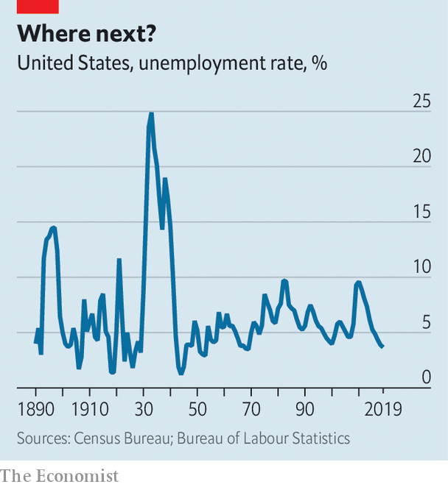

GDP growth and the unemployment rate tend to move in opposite directions. Unemployment hit an all-time high of around 25% during the Great Depression (see chart). The coronavirus-induced shutdowns are expected to lead to a year-on-year GDP decline of about 10% in the second quarter of this year. Such a steep fall in economic output implies an unemployment rate of about 9% in that quarter, based on past relationships, which would be roughly in line with the peak reached during the financial crisis of 2007-09.

But the coronavirus epidemic is not like past recessions. For one thing, hiring could be even lower than is typical. Delivery firms notwithstanding, surveys suggest that firms’ hiring intentions are as low or lower than they were in 2008. And applying for a job is especially difficult with cities in lockdown. Even without a single virus-induced layoff, hiring freezes would lead to sharply rising unemployment. For instance, young people entering the labour market for the first time now would struggle to find work.

The decline in GDP associated with the lockdowns is also particularly concentrated in labour-intensive industries such as leisure and hospitality. Mark Zandi of Moody’s Analytics, a research firm, calculates that more than 30m American jobs are highly vulnerable to closures associated with covid-19. Were they all to disappear, unemployment would probably rise above 20%. Research published by the Federal Reserve Bank of St Louis is even gloomier. It suggests that close to 50m Americans could lose their jobs in the second quarter of this year—enough to push the unemployment rate above 30%.

The numbers will probably not get that bad. In part that is a matter of statistical definitions. To be officially classified as unemployed, jobless folk need to be “actively seeking work”—which is rather difficult in the current circumstances. Some people could end up being counted as “economically inactive” rather than unemployed, which would hold down the official unemployment rate (a similar phenomenon occurred in Louisiana after Katrina).

America’s economic-stimulus bill will be a more genuine check on rising joblessness. The $350bn (1.6% of GDP) set aside for small firms’ costs is enough to cover the compensation of all at-risk workers for perhaps seven weeks, according to our calculations, making it less likely that bosses will let them go. Other measures in the package should support consumption, and thus demand for labour. In a report published on March 31st Goldman Sachs, a bank, argued that unemployment will peak in the third quarter of this year at nearly 15%—an estimate that is roughly in line with those of other forecasters.

A big jump in unemployment is less of a problem if it quickly falls once the lockdown ends. Louisiana offers an encouraging precedent. After a few bad months in late 2005, the state’s unemployment rate dropped almost as sharply as it had risen, falling in line with the rest of the country. Whether the economy will prove so elastic this time is another matter. Travellers and restaurant-goers will be cautious until some sort of vaccine or treatment is widely available; social-distancing rules, even if relaxed, will continue for some time. Goldman Sachs’s researchers reckon that it will take until 2023 for unemployment to fall back below 4%. The lockdowns should be temporary, but the economic consequences will feel much more permanent.■

Dig deeper:  
For our latest coverage of the covid-19 pandemic, register for The Economist Today, our daily [newsletter](https://www.economist.com/newslettersignup), or visit our [coronavirus hub](https://www.economist.com/coronavirus)

This article was downloaded by calibre from <https://www.economist.com/united-states/2020/04/01/how-high-will-unemployment-in-america-go>

|  |  |  |  |
| --- | --- | --- | --- |
| Previous | Articles | Sections | Next |

|  |  |  |  |
| --- | --- | --- | --- |
| Previous | Articles | Sections | Next |

#### Petri-dish democracy

# Wisconsin’s chaotic elections

Local squabbles prefigure a national debate

Apr 4th 2020 | CHICAGO



Editor’s note: The Economist is making some of its most important coverage of the covid-19 pandemic freely available to readers of The Economist Today, our daily newsletter. To receive it, register [here](https://www.economist.com/newslettersignup). For more coverage, see our coronavirus [hub](https://www.economist.com/coronavirus)

FOURTEEN STATES have postponed primaries because of coronavirus. Although voters in Alaska and Wyoming will carry on in April, their primaries now involve only postal ballots. So what’s special about Wisconsin? As The Economist went to press the Badger State was still planning to hold its spring elections as usual, including voting in person, on April 7th. The contests are for the Democratic presidential nominee and also for local offices and the state Supreme Court.

Officials are not blasé about the pandemic. A “safer at home” order from the governor, Tony Evers, is keeping most people in their houses while shutting schools, businesses and more. “When you close bars in Wisconsin, you know it’s gotten serious,” says a parched resident. Nor is it certain the elections will be held. On April 1st a federal judge began hearing a case—combining various lawsuits—that could decide how and when polling happens. An appeal is likely, so a decision could drift towards the eve of voting.

Worsening public-health and practical troubles are overtaking the legal arguments. An assessment on March 30th found that more than half of all the state’s counties lack the required number of staff to run polling stations. The National Guard may have to make up a shortfall of almost 7,000 workers, replacing volunteers who typically are elderly and at risk of infection. In Milwaukee, which is holding a mayoral race, perhaps a dozen polling stations can be manned, not the usual 180. One political observer calls it “an unholy mess”.

What is baffling is how debate about holding the vote has dragged on. Officially Democrats, including Mr Evers, would back postponement of the state’s primary, although some worry that the pandemic could turn out to be worse later. In reality, most would prefer a wholesale switch to postal voting. Mr Evers last week called for officials to send each registered voter an absentee ballot, just in case. More than 1m voters have applied for them anyway, up from 250,000 in the spring election of 2016. The Democratic Party expects a surge in turnout, which, along with early voting, typically helps their side.

But the governor cannot make any change without the nod of Republicans, who run the legislature. They are not affected by the Democratic primary contest but are concerned about elections for hundreds of municipal officials, from county boards to councillors and mayors of cities, and most of all a tantalising election of a state Supreme Court justice. No plan exists for what to do about these if voting were put off. “Election law everywhere has never seriously considered holding an election in the middle of a contagious virus,” says Charles Franklin of Marquette University.

Republicans oppose ending in-person voting, likening any change to poll-rigging. Not coincidentally, they rely on older, small-town and rural voters who, polls suggest, are less fearful of the pandemic. “Our electorate is more likely to show on election day,” says Brian Reisinger, a conservative lawyer. Without them, his party would struggle against Democrats’ expected support from absentee and early voters.

Why does this matter? Interest in the presidential primary has waned, although Joe Biden will be road-testing his strength in blue-collar parts of a crucial swing state. It is the court race that really sets Wisconsin political hearts aflutter. Conservatives have a 5-2 advantage on the bench, but one of their incumbents is up for re-election in a tight race. The equivalent contest last year was decided by fewer than 6,000 votes.

That judicial race is politically important because of two significant cases on the court’s docket. It may rule, possibly before November, on whether 200,000 supposedly out-of-date registered names can be purged from the voting roll, and on what kind of voter IDs should be acceptable at polling stations. Democrats fear this could hurt them. The court will also have a big say on redistricting plans next year. Republicans fret that a new liberal-minded judge might press the court to unpick earlier reforms, perhaps to restore some powers stripped from public-sector unions.

Wisconsin’s experience also sheds light on what it means to campaign and, perhaps, vote in the midst of a pandemic. A battle is looming in many states on how much to extend postal voting. Democrats are keen. Republicans say changes to electoral practice, especially during a campaign, are unacceptable. Ben Wikler, who leads the Democrats in Wisconsin, says Republicans want to “disenfranchise” voters with over-strict rules on postal ballots. His state has long been “a Petri dish for seeing how the GOP behaves” everywhere, he says.

Marquette’s Mr Franklin draws lessons for other states. “Wisconsin is a peek into the future,” he says, a reminder to other states to “make decisions sooner”, to get bipartisan agreement on basic matters like how to run an election and to give officials time and money to print, distribute and count a huge pile of absentee ballots. Parties, too, have to think about how they can reach voters at home when knocking on doors is off-limits. Wisconsin’s Democrats have the additional challenge of rethinking their plans for Milwaukee to host 50,000 people at the party’s national convention in July. The pandemic looks likely to strike down that event, too. ■

Dig deeper:

* For our latest coverage of the covid-19 pandemic, register for The Economist Today, our daily [newsletter](https://www.economist.com/newslettersignup), or visit our [coronavirus hub](https://www.economist.com/coronavirus)
* Sign up and listen to Checks and Balance, our new [newsletter](https://www.economist.com/checksandbalance/) and [podcast](https://www.economist.com/podcasts/2020/02/21/checks-and-balance-our-new-weekly-podcast-on-american-politics) on American politics
* [Explore our guide](https://www.economist.com/united-states/2020/02/26/the-economists-guide-to-the-us-2020-elections) to the US 2020 elections

This article was downloaded by calibre from <https://www.economist.com/united-states/2020/04/04/wisconsins-chaotic-elections>

|  |  |  |  |
| --- | --- | --- | --- |
| Previous | Articles | Sections | Next |

|  |  |  |  |
| --- | --- | --- | --- |
| Previous | Articles | Sections | Next |

#### Reade’s digest

# How to weigh an allegation of assault against Joe Biden

Democrats who thought Brett Kavanaugh should not be on the Supreme Court are ignoring Mr Biden’s accuser

Apr 4th 2020 | WASHINGTON, DC

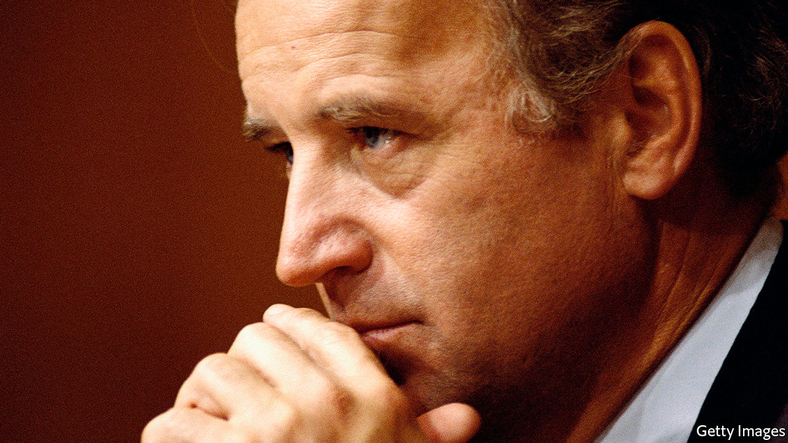

IN MARCH 2019, about a month before Joe Biden began his presidential campaign, a former state representative from Nevada, Lucy Flores, accused him of unwanted kissing, touching and hair-sniffing. Several other women—including Tara Reade, who worked for then-Senator Biden for nine months in 1992 and 1993—subsequently made similar complaints, prompting Mr Biden to release an apologetic video in which he acknowledged that “the boundaries of protecting personal space have been reset and I get it.” Recently, however, Ms Reade has levelled a more serious charge.

In an interview broadcast on March 25th she said that Mr Biden touched her in ways that made her feel “like an inanimate object”. She said that one day a scheduler in Mr Biden’s office told her to bring the senator his gym bag. When she did, he allegedly held her against a wall and put his hands up her skirt. When she pulled away, she says Mr Biden said, “Come on, man, I heard you liked me.” Ms Reade says that she was later moved to a windowless office and frozen out.

Mr Biden’s campaign denies the accusation. Marianne Baker, his executive assistant at the time, says she had “absolutely no knowledge or memory of Ms Reade’s accounting of events, which would have left a searing impression on me.” Sceptics have pointed out inconsistencies in Ms Reade’s testimony (which are not uncommon in stories of sexual assault), her history of floridly praising Russia and Vladimir Putin, and her support for Bernie Sanders.

Ms Reade sought help from the TIME’S UP Legal Defense Fund, which helps victims of sexual harassment. She could not find a lawyer to take her case, and the outfit does not offer public-relations help to accusers without lawyers. Some cite that, and the fact that the PR firm affiliated with the fund is run by a Biden adviser, as evidence of a stitch-up.

The fund replies that the PR firm in question did not know about Ms Reade until journalists started calling. The fund worried about getting involved in a case against Mr Biden because tax-exempt non-profits are barred from political campaigns. And Ms Reade was interested less in going after Mr Biden than in those accusing her of being a Russian agent, which is outside the fund’s purview.

The most striking thing about Ms Reade’s story may be the silence with which it has been greeted—particularly from some of those who argued that a sexual-assault allegation should disqualify Brett Kavanaugh from the Supreme Court. That may stem partly from the difficulty of vetting her story. There were no witnesses, though Ms Reade says she told her brother and a friend. But Mr Biden may have to answer questions eventually. Donald Trump’s supporters may wave away dozens of allegations of sexual misconduct and assault. Mr Biden probably does not have that luxury.

Dig deeper:

* Sign up and listen to Checks and Balance, our new [newsletter](https://www.economist.com/checksandbalance/) and [podcast](https://www.economist.com/podcasts/2020/02/21/checks-and-balance-our-new-weekly-podcast-on-american-politics) on American politics
* [Explore our guide](https://www.economist.com/united-states/2020/02/26/the-economists-guide-to-the-us-2020-elections) to the US 2020 elections

This article was downloaded by calibre from <https://www.economist.com/united-states/2020/04/04/how-to-weigh-an-allegation-of-assault-against-joe-biden>

|  |  |  |  |
| --- | --- | --- | --- |
| Previous | Articles | Sections | Next |

|  |  |  |  |
| --- | --- | --- | --- |
| Previous | Articles | Sections | Next |

#### Send the marines

# The US Marine Corps sheds its tanks and returns to its naval roots

After decades as dirt sailors, the marines are getting back to salt water

Apr 2nd 2020 |

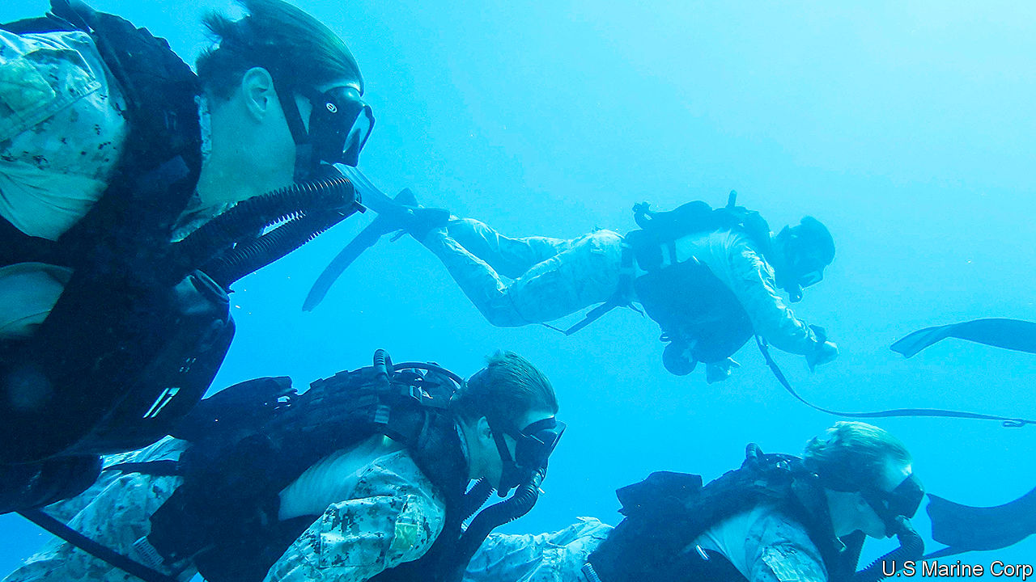

THE OFFICIAL hymn of the United States Marine Corps, a jaunty tune written by Jacques Offenbach in 1867, proudly declares that “From the Halls of Montezuma/ To the shores of Tripoli/ We fight our country’s battles/ In the air, on land, and sea”. But despite their naval origins and ethos, America’s marines have spent most of the past two decades waging war in the deserts, mountains and cities of Iraq and Afghanistan. On March 26th General David Berger, the corps’s commandant, proposed a radical transformation of the force into America’s first line of defence in the Pacific.

The Marine Corps emerged out of the Continental Marines, the naval infantry force raised in 1775 by the American colonies during the revolutionary war against Britain. As soldiers who were deployed at sea, they served as raiding parties and an insurance policy against mutiny by press-ganged sailors. Over the next century they acquired a legendary reputation for far-flung campaigns.

The marines’ publicity bureau, established before the first world war, carefully cultivated an image of an elite force with a macho, Spartan streak. That reputation was bolstered by their starring role in the brutal island-hopping battles against Japan during the second world war.

The image of seafaring, beach-storming warriors blurred after the terrorist attacks of September 11th 2001, when the marines turned from a naval strike force into a duplicate army tasked with weeding out insurgents in grinding land campaigns. The result, says Mark Folse of the US Naval Academy, who served as an enlisted marine in Iraq and Afghanistan, is “an entire generation of marines who have little to no experience of the navy.”

Then the wheels of American strategy turned again. In 2018 the Pentagon published a new national defence strategy which declared that “great power competition” with Russia and China would be the priority. A series of war games showed that China’s precision missiles would make it much harder for America to fight its way into the western Pacific, says General Berger. On becoming commandant in July, he published guidance calling for radical change. “Visions of a massed naval armada nine nautical miles offshore in the South China Sea preparing to launch the landing force...are impractical and unreasonable,” he warned. Junior marine officers, writing in War on the Rocks, a website, pressed their superiors for change.

The ten-year “force design” released last week offers it. It is at once a return to the corps’s naval roots, and a drastic revamp. It aims to cut the corps down to 170,000 personnel while slashing artillery and aircraft, with the number of F-35 jets falling by over a third. Most drastically, marines will get rid of all their tanks. In their place comes a commando-like infantry force with nimbler weapons: drone squadrons will double in number and rocket batteries will triple.

The idea is that in a war with China, America’s hulking aircraft carriers might be pushed far out to sea by the threat of missiles. But groups of 50 to 150 marines, wielding armed drones, rockets and anti-ship missiles, could get up close, fanning out on islands along and inside the chain from Japan to the Philippines. Like a high-tech echo of the insurgents they once fought, they would jump from one makeshift base to another every couple of days to avoid being spotted and targeted, says General Berger. They could identify targets for more distant ships and warplanes, or pepper the Chinese fleet with fire themselves—dispersed, island-hopping warfare to stop any attack in its tracks.

Some worry that this would be a dramatic change for a service that has proudly served as a jack-of-all-trades for presidents in a pinch. Seven hundred marines have been stationed in Norway since 2018 and in January thousands were hurriedly sent to the Middle East amid tensions with Iran.

“The marines used to lean towards versatility as a virtue, covering many middle threats,” says Frank Hoffman of the National Defence University. “This force design is optimised for deterrence in one location. It’s not a force for Donbas, Lebanon or Syria.” General Berger insists that is not so: “We know we never choose the crisis.” Missile-toting commandos dotted around rugged outposts would be “very applicable anywhere”, he argues, from the Arctic to the Strait of Hormuz.

Buy-in from the navy is especially important. The plan depends on tight integration with the marines’ sister service, not least because the corps does not own its own warships. The number of American ships—the navy is set on 355—is less important, notes Chris Brose of Anduril Industries, a former staff director for the Senate Armed Services Committee. Whether a weapon is fired from a marine squad or navy destroyer thousands of miles away is irrelevant, he says, as long as they are integrated and add up to a greater capability.

Congress will also take some persuading. “It won’t be Democrats versus Republicans,” says Mike Gallagher, a Republican congressman and former marine officer who serves on the House Armed Services Committee. “I think it will be entirely generational. The younger members, particularly those who have served, are embracing these changes, and are more than willing to divest ourselves of legacy capabilities, even at the cost to our own districts. The older members…will be loth to embrace change, particularly when it affects things that are produced in their districts.” ■

This article was downloaded by calibre from <https://www.economist.com/united-states/2020/04/02/the-us-marine-corps-sheds-its-tanks-and-returns-to-its-naval-roots>

|  |  |  |  |
| --- | --- | --- | --- |
| Previous | Articles | Sections | Next |

|  |  |  |  |
| --- | --- | --- | --- |
| Previous | Articles | Sections | Next |

#### Lexington

# Ron DeSantis is Donald Trump’s and the coronavirus’s favourite governor

A shadow over the Sunshine State

Apr 2nd 2020 |

Editor’s note: The Economist is making some of its most important coverage of the covid-19 pandemic freely available to readers of The Economist Today, our daily newsletter. To receive it, register [here](https://www.economist.com/newslettersignup). For more coverage, see our coronavirus [hub](https://www.economist.com/coronavirus)

THOMAS JEFFERSON’S dictum that good governance comes “not by the consolidation or concentration of powers, but by their distribution” has never looked more apposite. While the administration has floundered against the coronavirus, most state governors have stepped up.

Andrew Cuomo of New York is the pandemic’s breakout star. His grimly informative press briefings are a reminder of what sanity in high office looks like. His approval rating is nearly 90%. But Jay Inslee of Washington state, Gavin Newsom of California, Larry Hogan of Maryland and Mike DeWine of Ohio, two Democrats and two Republicans, have been similarly impressive. All were shuttering businesses and enforcing social distancing while Donald Trump questioned whether the pandemic was much of a thing.

Mr Newsom’s prompt action may have spared California the level of crisis Mr Cuomo is facing. Mr Hogan, chair of the National Governors’ Association, suggested he would keep Maryland locked down even if Mr Trump ordered him not to: “You can’t put a time-frame on saving people’s lives.” Yet there is an exception to this pattern. In Florida, a state with a large, unusually mobile population and more old people than almost any other, Ron DeSantis seems to have taken his public-health advice from the president.

The image of American hubris against the coronavirus is of Florida’s beaches packed with Spring Breakers. Mr DeSantis had refused to close them—thereby drawing instant comparisons with the mayor of Amity Island in the “Jaws” films. A heat map of the cell-phone signals emitted by a crowd of fun-seekers on Fort Lauderdale beach—almost two months after America had recorded its first coronavirus case—suggests they have since fanned out all across America.

Florida alone had over 7,000 confirmed coronavirus cases at the time of writing and the number was doubling every three-to-four days. But most of its businesses were still free to operate, Mr DeSantis having refused to lock the state down. Under mounting pressure from anxious Floridians, he said he would do so from April 3rd, fully two weeks after Mr Newsom.

To idle millions of workers is no small decision. Yet the 41-year-old Mr DeSantis has denied himself the benefit of the doubt with a wretchedly political performance. His daily messaging has been neurotically in step with the White House, not Florida’s public-health experts. This makes his slowness to act look designed to placate a president who—until this week—was liable to take any economy-dampening measure as a personal affront.

Mr DeSantis meanwhile aped the president’s histrionics by ordering senseless roadblocks to catch infected New Yorkers, warning cruise ships not to land sick “foreigners” and lambasting critical journalists. In one way, his tactics worked. Where Mr Cuomo claims to have received a fraction of the medical supplies he has requested from the federal government, Florida has got every mask and ventilator it has asked for. Even so, Mr DeSantis’s pandemic response has looked increasingly reckless. It also indicates how Mr Trump is—and is not—changing his party.

The contrasting performances of Mr DeWine and Mr DeSantis, both of whom took office last year, are no accident. The 73-year-old Ohioan won election based on a record for pragmatism accrued during four decades in public life. Mr DeSantis entered Florida’s Republican governor’s primary as an undistinguished, little-known congressman. He won it by proclaiming his devotion to Mr Trump, who promptly endorsed him, thereby knocking out the DeWine equivalent, Florida’s respected agriculture commissioner.

Eschewing dull policy talk (to the extent that some questioned whether he even had a platform), Mr DeSantis copied Mr Trump’s campaign tactics, too. He warned Floridians not to “monkey this up” by electing his African-American opponent, Andrew Gillum. He derided Congresswoman Alexandria Ocasio-Cortez, a hate-figure on the right, as “this girl…or whatever she is”. His obsequiousness towards Mr Trump was so extreme that he made a joke of it in a campaign ad that depicted him teaching his infant children Trump slogans, while building a wall out of toy bricks.

Anyone might think he was a diehard economic populist. On the contrary, Mr DeSantis is a pretty standard-issue small-government conservative, albeit with a pragmatic streak of his own. For example, he has sought to redress the environmental vandalism of his predecessor, Rick Scott, by appointing high-level science and climate-resilience advisers and investing in watershed conservation. This has won him plaudits across the political divide—even as Mr Trump has periodically called on him to honour his debt to the president. Last year Mr DeSantis passed legislation to ban havens for illegal immigrants known as “sanctuary cities”. In a state where a fifth of the population is foreign-born, this was divisive—and also unnecessary. There were not any in Florida.

## DeSantis Spiritus

For all the disruption to conservatism he promised, Mr Trump has changed it at an elite level remarkably little. He has promoted opportunists such as Mr DeSantis, willing to ingratiate themselves to him, not populist firebrands. This is at least better than it might have been (remember Steve Bannon?). So, it must be said, is Mr DeSantis: his pre-pandemic governorship was far better than his campaign gave reason to expect. Even so, the virus has exposed the weakness of a patronage system with Mr Trump at its apex.

Mr DeWine is able to compensate for Mr Trump’s shortcomings because he owes him nothing. Mr DeSantis owes him everything—which forces him to accentuate them. Much good may that do him.

Floridians appear to be turning against him. They of all Americans recognise a bungled disaster response. Meanwhile Mr Trump, having at last recognised the disaster America faces, is making nice with all the governors. He says they are America’s front line. This suggests he means to blame them for what is to come.■

Dig deeper:  
For our latest coverage of the covid-19 pandemic, register for The Economist Today, our daily [newsletter](https://www.economist.com/newslettersignup), or visit our [coronavirus hub](https://www.economist.com/coronavirus)

This article was downloaded by calibre from <https://www.economist.com/united-states/2020/04/02/ron-desantis-is-donald-trumps-and-the-coronaviruss-favourite-governor>

|  |  |  |  |
| --- | --- | --- | --- |
| Previous | Articles | Sections | Next |

|  |  |  |
| --- | --- | --- |
| United States | Sections | Asia |

The Americas

Venezuela: Maduro rap

.

Cuban doctors: Mercy and money

.

Bello: Wisdom and witlessness

.

|  |  |  |
| --- | --- | --- |
| United States | Sections | Asia |

|  |  |  |  |
| --- | --- | --- | --- |
|  | Articles | Sections | Next |

#### Maduro rap

# The unintended consequences of indicting Nicolás Maduro

The threat to jail Venezuela’s dictator may make it harder to remove him

Apr 4th 2020 |

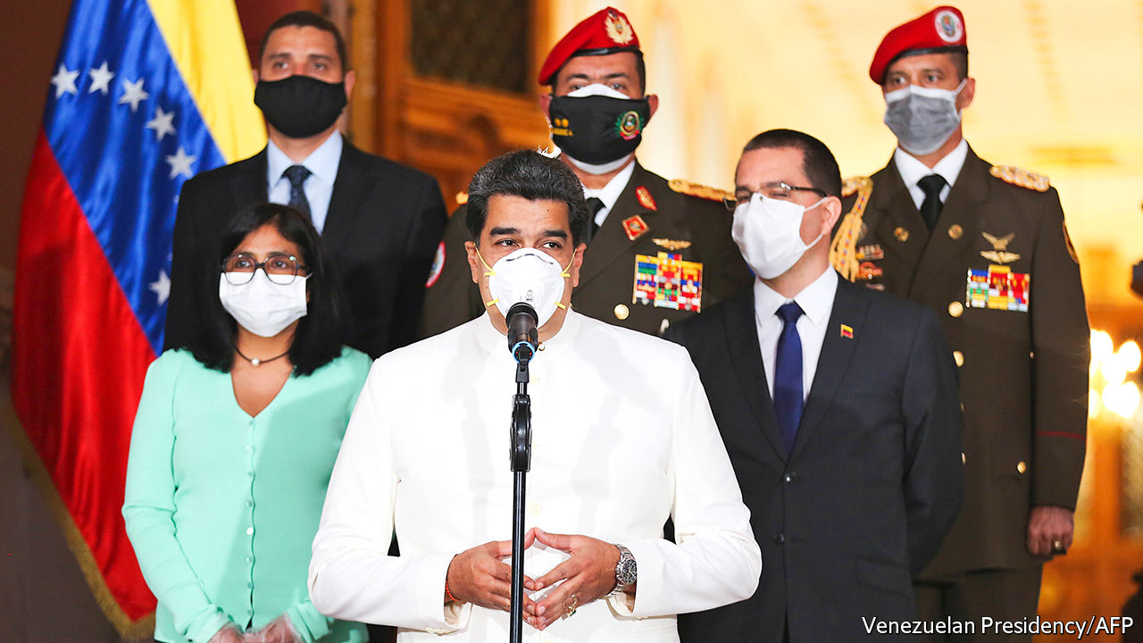

IT WAS, INSISTED William Barr, the United States attorney-general, “good timing”. Amid the covid-19 pandemic and a collapse in global oil prices, on March 26th America’s Department of Justice unsealed indictments on drugs charges of Nicolás Maduro, Venezuela’s dictator, and members of his inner circle. No longer should his regime be seen as merely corrupt and incompetent, argued Mr Barr. Now he has formally labelled it criminal—a drug gang masquerading as a government. The State Department offered rewards for information leading to the arrest of the accused ringleaders: $15m for Mr Maduro, $10m for Diosdado Cabello, the thuggish head of the pro-government “constituent assembly”.

The administration of Donald Trump seems to hope that the indictments will finally remove a regime that has been subject to punishing sanctions since early last year. But branding Mr Maduro a criminal blunts any incentive he might have to relinquish power. On March 31st the Trump administration changed its tone a bit. It suggested a “democratic transition framework” that envisages a role for the regime.

Venezuela’s situation is terrifying. Under Hugo Chávez, who became president in 1999, high oil prices hid the costs of the regime’s economically illiterate policies. But since 2013, when Mr Maduro took over, the economy has shrunk by two-thirds and a seventh of the population, now about 28m, has emigrated. Covid-19 will make things far worse. A nationwide lockdown imposed by the government on March 17th will add to the effects of a plunge in global oil prices. Remittances from Venezuelans living abroad are slumping. Exports of gold and even narcotics are stagnating. Luis Oliveros, an economist based in Caracas, expects the economy to shrink by 15% this year, double the contraction he had forecast before covid-19.

Venezuela has even less scope than other Latin American countries to borrow to soften the effects of the crisis. It has already defaulted on its debts. On March 15th Mr Maduro appealed to the IMF, which the regime has long reviled, for $5bn of assistance. The fund rebuffed him because some members do not recognise the regime as the legitimate government.

So far, Venezuela has had just 144 confirmed cases of covid-19. The economic slump and the regime’s pariah status had prompted airlines to reduce flights to the country, which bought time before the pandemic struck. But without testing and contact-tracing the disease will spread. The health system barely functions. The Global Health Security Index, which was developed by the Economist Intelligence Unit, ranks its preparedness for an epidemic 176th among 195 countries. Half of its 306 public hospitals have no face masks, according to Médicos por la Salud, an NGO.

“We only have running water for half the day,” says a doctor in the main public hospital in the city of San Felipe, the capital of Yaracuy state. Personal protection equipment from China was promised but has not arrived, he says. The state-run El Algodonal hospital, supposedly among the better ones in the capital, has no ambulance, no X-ray machine, no functioning morgue and, for half the week, no water or electricity. On March 30th it was treating two patients with covid-19.

With disaster looming, the regime and the opposition, led by Juan Guaidó, the head of the democratically elected National Assembly, had begun to talk to each other. On March 25th three opposition mayors appeared with Héctor Rodríguez, the pro-regime governor of Miranda state, which includes parts of Caracas, at an event to promote joint public-health measures. Henrique Capriles, who ran against Mr Maduro in an election in 2013, called on the opposition and the regime to face facts: Mr Maduro controls the country while Mr Guaidó, who is recognised by the United States and dozens of other democracies as Venezuela’s interim president, has international support. “This pandemic has to create an opportunity to seek an accord,” he said. Mr Maduro, who has repeatedly said that he is open to “dialogue” with the opposition even as he persecutes it, renewed the offer on March 25th. If the opposition did not want to recognise him as president he would participate “just as Nicolás Maduro”. There was talk of forming a unity government to deal with the pandemic.

Mr Barr may have torpedoed that. The charges allege that in the late 1990s Mr Maduro, Mr Cabello, Hugo Carvajal, a former director of military intelligence, and Clíver Antonio Alcalá, then an officer in the armed forces, founded a drug-running organisation called the Cartel of the Suns, named for an insignia on army uniforms. In league with the FARC, a Colombian guerrilla outfit, the group “sought to flood” the United States with cocaine, say the indictments. Computer discs discovered in a raid on a FARC camp in Ecuador in 2008 allegedly revealed contacts between the group and Chávez’s government, in which Mr Maduro was foreign minister. Separate charges claim that Vladimir Padrino López, the defence minister, conspired to transport cocaine on American-registered aircraft from Venezuela to Central America. Its destination was the United States.

“There’s no doubt that there is widespread corruption and penetration of the Venezuelan state by organised crime, particularly drug-trafficking,” says Geoff Ramsey of the Washington Office on Latin America, a think-tank. But he doubts that all the charges could be proved in court. “Some of the evidence is from witnesses who have...a clear incentive to play along with prosecutors,” he says. Venezuela is a relatively small player in the cocaine trade. In 2018 six times more passed though Guatemala than through Venezuela. Many observers suspect that the Trump administration cares less about dislodging Mr Maduro than about winning Florida, home to many Venezuelan and Cuban exiles, in the American presidential election this year.

The main indictments had been sealed for several years. Pushing for publication were hardline advisers to the president, including Marco Rubio, a senator from Florida. Arguing against was the State Department. It worried that revealing the charges would undermine efforts to persuade Mr Maduro’s associates, including the defence minister, to betray him. The United States has minimum sentences for people convicted of large-scale drug-trafficking, notes Mr Ramsey. Although the constitution bars extradition, “these people now know they could end up in a jail cell in Miami” if the government in Venezuela changes.

Perhaps recognising that the truncheon alone would not work, the State Department has offered a plan that sounds more conciliatory. The National Assembly would choose a transitional government, which would prepare for free elections, under a formula that would give pro-government chavista legislators a say in its composition. Neither Mr Maduro nor Mr Guaidó could lead it. American sanctions would be lifted, which would help Venezuela cope with the pandemic. But nothing in the State Department plan spares Mr Maduro the threat of extradition should he lose power, as he surely would in a free election.

For now, he is using the pandemic to reassert control. He has prohibited public gatherings. In the midst of nationwide fuel shortages, he has given control of petrol distribution to the army, which will cash in on the black market as it now does in food. His threats against Mr Guaidó are more menacing. On March 30th, without naming the opposition leader, he warned that the regime would soon be “coming to knock on your door”. While Mr Maduro and Mr Barr are brandishing handcuffs, the threat from covid-19 can only grow. ■

This article was downloaded by calibre from <https://www.economist.com/the-americas/2020/04/04/the-unintended-consequences-of-indicting-nicolas-maduro>

|  |  |  |  |
| --- | --- | --- | --- |
|  | Articles | Sections | Next |

|  |  |  |  |
| --- | --- | --- | --- |
| Previous | Articles | Sections | Next |

#### Mercy and money

# Cuba’s doctors are in high demand

The communist island’s practice of exporting medical workers has a dark side

Apr 4th 2020 | FLORENCE AND MEXICO CITY

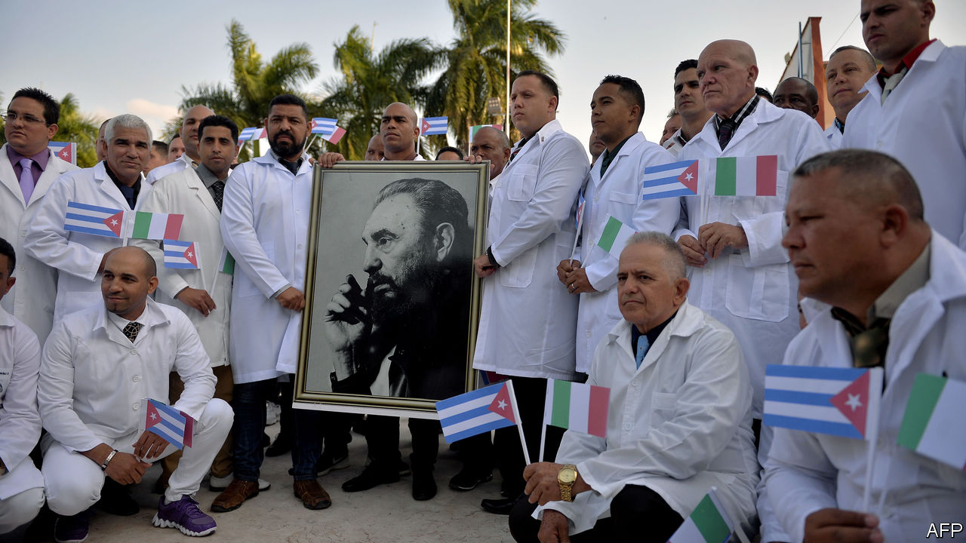

Editor’s note: The Economist is making some of its most important coverage of the covid-19 pandemic freely available to readers of The Economist Today, our daily newsletter. To receive it, register [here](https://www.economist.com/newslettersignup). For more coverage, see our coronavirus [hub](https://www.economist.com/coronavirus)

WHEN THE number of patients mounts but the number of healers does not, whom do you call? That was the question for Giulio Gallera, the health minister in Lombardy, the Italian region worst hit by covid-19. The army was erecting a field hospital with 32 beds in a car park in Crema, 50km (30 miles) south-east of Milan. But what about doctors to attend them? “Someone said to me: ‘Write to the Cuban ministry of health,’” recalls Mr Gallera. Barely a week later, on March 22nd, 52 medics arrived from Havana, waving Cuban and Italian flags. Locals sent them warm clothing and bicycles for their commute.

Cuba’s Central Medical Collaboration Unit, which for six decades has sent doctors across the world, is having a busy month. Some 14 countries, from Angola to Andorra, have received a total of 800 doctors and nurses. Politicians in Buenos Aires and Valencia in Spain, and indigenous groups in Canada, are pressing national governments to request Cuban brigades.

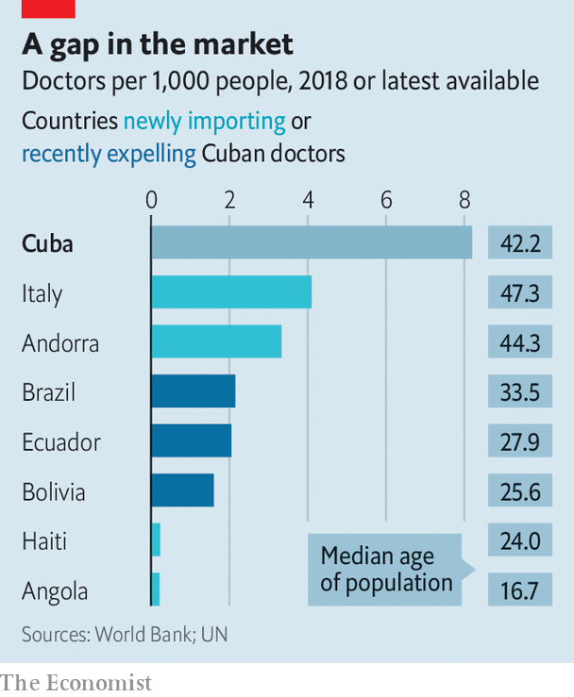

Cuba trains a staggering number of doctors for its size and wealth (see chart). Even though its population of 11m is not young, it has doctors to spare. More than usual are available. In the past 18 months 9,000 have left Brazil, Bolivia, El Salvador and Ecuador, where leftist presidents have recently lost power. According to Granma, Cuba’s state-owned daily newspaper, the number of doctors and nurses abroad fell from more than 50,000 in 2015 to 28,000 in 2020.

Cuba started exporting doctors out of a mix of humanitarianism and a desire for good publicity. Since 2006, when Raúl Castro assumed the presidency from his brother, Fidel, the practice has become a vital prop to the economy. Portugal, which has received Cuban doctors since 2009, pays €50,000 ($55,000) a year for each one. Venezuela has long supplied cheap oil to Cuba in exchange for its 20,000-strong medical contingent. Last year, when Cuba’s government published detailed trade statistics for the first time, medical services made up 46% of exports and 6% of GDP.

Cash-for-carer deals are less good for the doctors themselves. The communist government typically keeps three-quarters of health workers’ salaries (which still leaves them better off than they would be at home). Many complain of horrid working conditions. To discourage defection (or “brain theft”) Cuban officials in host countries confiscate doctors’ passports and withhold part of their share of their salary until they come home. It does not always work. The United States, which damns the programme as human trafficking, offered permanent residency to Cuban doctors in other countries from 2006 to 2017. More than 7,000 accepted. On March 24th the State Department warned countries using Cuban doctors to be on the alert for abuse.

But countries like Italy need help, and Cuba needs cash. Covid-19 has stopped tourism, a big source of income. Remittances from the United States will fall. Even before the pandemic Cuba was in trouble: in October it missed debt payments to creditor countries. One creditor is Italy, which might have accepted medical help as in-kind debt payment, says Rodrigo Olivares-Caminal, a professor at Queen Mary University in London. It is not clear whether all new host countries are paying up. Andorra is, says its finance minister. Cuba generally keeps such details quiet but tends to charge richer countries more, says John Kirk, of Dalhousie University in Nova Scotia.

If it is to send doctors overseas, it will have to avoid a Lombardy-style outbreak at home. It prides itself on prevention. Neighbourhood spies check on whether pregnant women get prenatal care as well as on their loyalty to the Communist Party. Medical students have taken the temperatures of 500,000 elderly Cubans to detect cases of covid-19. Cuba has recorded 212 cases, compared with 1,284 in the Dominican Republic, which has nearly as many people.

With the stakes so high at home, medical adventurism abroad may seem reckless. But the government craves the kudos it brings and hopes no one will notice that it benefits so much more than the medical emissaries. After the release last year of “Chernobyl”, a television mini-series, pundits touted the role of Cuban doctors in treating children for radiation poisoning. Cubans hope that the doctors in Lombardy will one day be seen as covid-19 heroes. ■

Dig deeper:  
For our latest coverage of the covid-19 pandemic, register for The Economist Today, our daily [newsletter](https://www.economist.com/newslettersignup), or visit our [coronavirus hub](https://www.economist.com/coronavirus)

This article was downloaded by calibre from <https://www.economist.com/the-americas/2020/04/04/cubas-doctors-are-in-high-demand>

|  |  |  |  |
| --- | --- | --- | --- |
| Previous | Articles | Sections | Next |

|  |  |  |  |
| --- | --- | --- | --- |
| Previous | Articles | Sections | Next |

#### Bello

# The wisdom and witlessness of Latin America’s leaders

A reward, for now, for those who have acted decisively to fight the pandemic

Apr 4th 2020 |

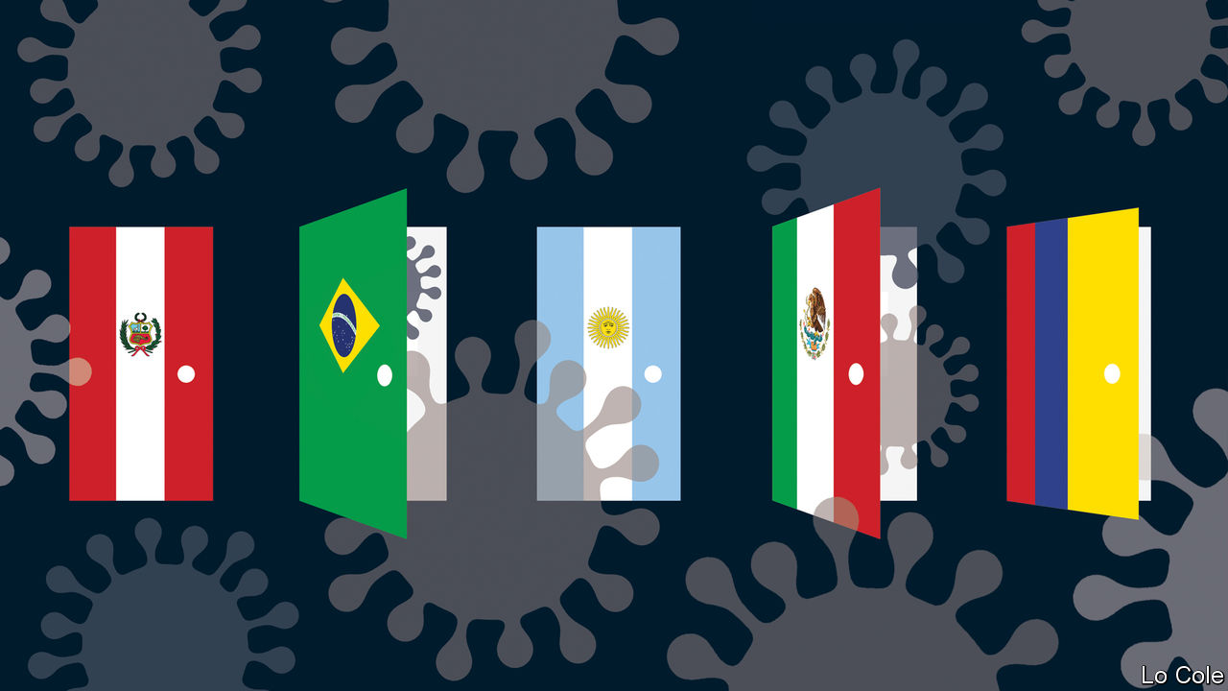

Editor’s note: The Economist is making some of its most important coverage of the covid-19 pandemic freely available to readers of The Economist Today, our daily newsletter. To receive it, register [here](https://www.economist.com/newslettersignup). For more coverage, see our coronavirus [hub](https://www.economist.com/coronavirus)

SINCE HE TOOK over as Peru’s president two years ago Martín Vizcarra, an otherwise nondescript politician, has not flinched from taking bold decisions. He pushed political reforms through by referendum. Faced with a serially obstructive Congress, last year he shut it down, calling a fresh legislative election. Characteristically, he was the first Latin American leader to react to covid-19 by imposing a lockdown and curfew, on March 15th when his country had only 71 reported cases. Peruvians appreciate this restriction on their liberties for the public good. In an Ipsos poll his approval rating soared from 52% to 87%.

That is the pattern in Latin America. In Argentina Alberto Fernández, who took over a politically divided country in December, has seen his popularity rise to over 80% after he imposed a quarantine and sealed borders. In Colombia the new mayor of Bogotá, Claudia López, stole a march over a hesitant national government when she imposed a four-day trial lockdown. Chile’s Sebastián Piñera, whose presidency seemed moribund after protests, has deployed testing and sealed off hotspots. His popularity has crept up, from 10% in December to 21%.

Their approach contrasts with that of the populist presidents of Brazil, Jair Bolsonaro, and Mexico, Andrés Manuel López Obrador, often called AMLO. Both have given priority to protecting weak economies. Both spent weeks denying the seriousness of the virus and refusing to respect social-distancing measures recommended by their health ministries.

In Mexico, according to Alberto Díaz-Cayeros, a political scientist at Stanford University, the government’s caution was rooted in trust in the capacity of the health service to deal with the threat. That approach worked against swine flu in 2009. It underestimated covid-19, which spreads aggressively, with many symptomless cases. On March 24th the government pivoted, shutting schools and banning non-essential activity. Six days later, with the virus out of control, it declared a state of emergency.

AMLO has muddled the message about social distancing. Mr Bolsonaro went further, actively sabotaging efforts to control the virus. In Brazil state governors have imposed lockdowns, including in São Paulo and Rio de Janeiro. These measures are popular. Mr Bolsonaro’s heedlessness is less so. City residents staged pot-banging protests against the president. That prompted a counter-attack. Mr Bolsonaro railed against the governors, issued a video proclaiming “Brazil cannot stop”, and urged supporters to stage cavalcades against quarantines. Only on March 31st, with 201 deaths in Brazil, did he (briefly) recognise the seriousness of the virus, calling for a “pact” against it “to save lives without leaving jobs behind”. He then reverted to his earlier rhetoric.

What political consequences will these actions have? Though he is still popular, AMLO’s approval rating was declining before the virus, because of his failure to halt crime or to revive the economy. That trend seems set to continue. As for Mr Bolsonaro, some think his actions merit impeachment, for threatening the constitutional right to life. His strategy appears aimed at shoring up his base. Polls show he retains the support of a third of respondents. That should be enough to keep his job, depending on how many Brazilians die.

Those who have acted decisively are benefiting from the public’s instinct to rally round their leaders at a time of danger. But sustaining the quarantines in a region where many live precariously will be hard. Take Argentina, where Mr Fernández already faced a stricken economy. His government has made some emergency handouts of money and food in poor areas on the periphery of Buenos Aires, where his Peronist political movement has long run things. Even so, the Peronists “are very worried, they fear a social explosion and losing control”, says Sergio Berensztein, a political consultant. He thinks the government may have to make quarantine more selective and flexible, at the risk of prolonging the epidemic. Much the same goes for Peru.

Covid-19 struck Latin America when its leaders and institutions had fallen into disrepute, because of economic stagnation, corruption and poor public services. Management of the pandemic requires a huge effort to help those in need. It may also offer an opportunity for redemption. Leaders who impose quarantines could save the lives of 2.5m Latin Americans, according to epidemiologists at Imperial College, London. They have to find ways to make citizens remember that, even as economic hardship bites.

Dig deeper:  
For our latest coverage of the covid-19 pandemic, register for The Economist Today, our daily [newsletter](https://www.economist.com/newslettersignup), or visit our [coronavirus hub](https://www.economist.com/coronavirus)

This article was downloaded by calibre from <https://www.economist.com/the-americas/2020/04/04/the-wisdom-and-witlessness-of-latin-americas-leaders>

|  |  |  |  |
| --- | --- | --- | --- |
| Previous | Articles | Sections | Next |

|  |  |  |
| --- | --- | --- |
| The Americas | Sections | China |

Asia

Migration and the virus: Under pressure

.

The occult in Myanmar: A wizard wheeze

.

Thailand’s economy: Sigh-am

.

South Korea and America: Stay-at-home allies

.

Love in Indonesia: Wed first, ask questions later

.

Banyan: The drifters

.

|  |  |  |
| --- | --- | --- |
| The Americas | Sections | China |

|  |  |  |  |
| --- | --- | --- | --- |
|  | Articles | Sections | Next |

#### Under pressure

# Lockdowns in Asia have sparked a stampede home

Many migrant workers face hardship

Apr 2nd 2020 | DELHI AND SINGAPORE

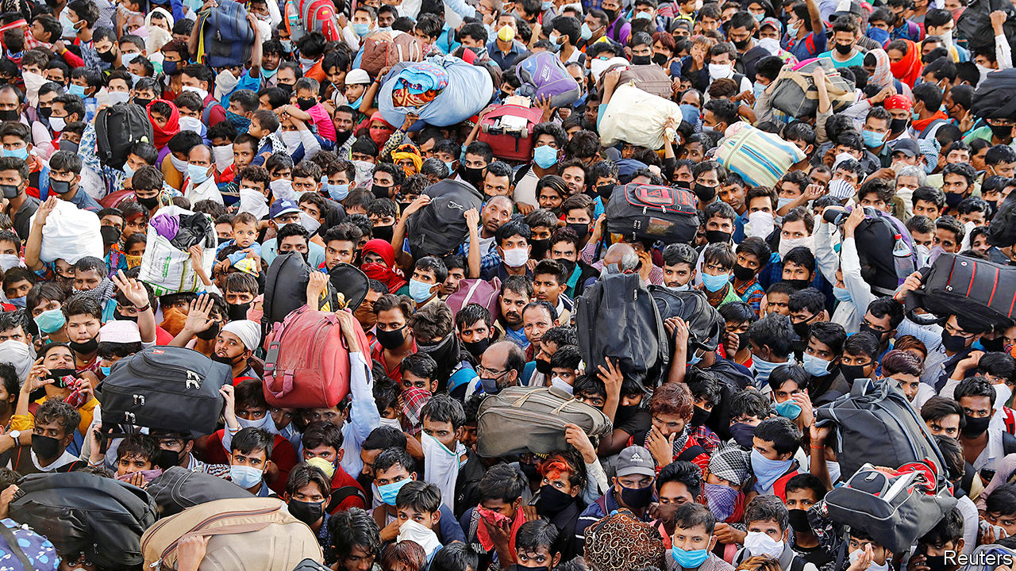

Editor’s note: The Economist is making some of its most important coverage of the covid-19 pandemic freely available to readers of The Economist Today, our daily newsletter. To receive it, register [here](https://www.economist.com/newslettersignup). For more coverage, see our coronavirus [hub](https://www.economist.com/coronavirus)

WHERE DO YOU belong? This is not a metaphysical question. For English-speaking Indians, “belonging” to a place means simply that you come from there, as in, “I live in Delhi but belong to Bengal.” Yet for millions of migrant labourers, not only in India but across Asia, covid-19 has given the question new meaning. A Malaysian worker in a Singapore electronics plant, a Filipina servant in a wealthy household in Bangkok or a Bihari cook in a Delhi restaurant all face a similar dilemma. In a time of mass layoffs, curfews and sharp travel restrictions, where do they belong?

Prosperous expatriates can choose whether to stay or go, and if they are citizens of rich countries, their governments may help to fly them home. But for many the sudden absence of work leaves little choice. It is not just hard to survive in expensive cities without a paycheck. Whether you are one of the estimated 2m international migrants in South-East Asia labouring as servants, or toil in one of hundreds of thousands of small industrial workshops that power such Indian industries as gem-polishing or shoemaking, your place of work is also often where you eat and sleep. Even after years on the job, the minute you step off the treadmill there is nothing for it but to head “home”.

So it was that when Narendra Modi, India’s prime minister, on March 24th announced a snap decision to lock down all the country’s 1.3bn people for 21 days and to suspend rail, road and air transport, the immediate closure of businesses forced a hefty chunk of the workforce into awkward motion. At least 600,000 people, according to the government’s very low estimate, began to move. Despite the daunting distance between bustling cities such as Surat on India’s west coast, and impoverished sources of rural emigration such as the state of Uttar Pradesh, many simply started walking along the empty roads.

Chastened by wrenching television images of the exodus, state governments arranged buses for some of the migrants, and Mr Modi himself apologised for any inconvenience caused. But then the central government changed tack again. The mass flight, it realised, was undoing the very purpose of the lockdown, which was to stop the spread of the virus. In testimony to India’s supreme court, the government claimed—somewhat improbably—that as many as one in three of the migrants could be carrying the disease. So new orders were imposed, obliging state governments to quarantine all incoming travellers. This meant that often penniless and exhausted migrants, who had already braved club-wielding police enforcing the national curfew, then faced incarceration in hastily converted shelters in such places as government schools.

Many will now remain stuck in such places for weeks, while those who turned back or stayed put in the cities where they work face a precarious existence. Delhi’s state government is making plans to supply free food to more than 1m people a day.

Other Asian cities are also coping with jobless stay-behinds. Foreign workers who are now stranded under Malaysia’s Movement Control Order—many from Indonesia—complain that they are living in dangerously crowded quarters and running out of money. Some governments have acted to give stay-behinds some support, but this is unusual. Singapore, where migrants make up 38% of the workforce, has offered businesses a stipend of $35 a night for up to two weeks to accommodate commuters from Malaysia, which has shut its border. Migrants who fall sick from the coronavirus in the city state will not have to pay for treatment.

Sadly, some of India’s migrant workers who did reach their villages have not fared too well, either. One group that made it from Tamil Nadu in the far south all the way back to Bengal have hoisted hammocks, charpoys and mosquito nets into trees. They say they must live in suspension as there is no other way in their village to maintain social distance. Elsewhere, returning workers are held in suspicion as possible carriers of disease, sparking conflict. In one case in Bihar, a man was beaten to death after he pointed police to fellow returnees who should have been quarantined. At Bareilly in Uttar Pradesh, television cameras captured the humiliation suffered by migrants, forced by police to squat in a road as they were sprayed with bleach, supposedly to “disinfect” them.

The fear of migrants being a vector is far from misplaced. Workers who fled Mumbai to escape the 1918-19 Spanish flu pandemic carried it far into Indian provinces, and HIV, the virus which causes AIDS, was also spread along migrant corridors, notes Chinmay Tumbe, the author of a book on Indian migration. Just as Chinese migrant textile workers may have carried covid-19 to Italy, some of the first nodes for the disease in India appear to have been seeded by migrant dairy workers returning from Italy to the Punjab, and workers from the Arab Gulf returning to homes in Kerala.

As if that were not bad enough, some of the poor Indian provincial regions to which the recent wave of migrants has just returned may prove exactly the wrong place to be in an epidemic. The 120m people of the state of Bihar, for instance, must make do with just four testing centres for covid-19. They share a meagre 0.11 hospital beds for every 1,000 people, compared with 1:1,000 in Delhi or 2.4:1,000 in Singapore.

More immediately, what many of the migrants fear is simply financial ruin, or even starvation. And it is not just the migrants themselves at risk. In 2017 international remittances brought Asia an estimated $268bn, much of it flowing to rural economies that have few other sources of investment. The scale of such transfers across India is not known, but economists estimate the total size of the migrant workforce at about 100m people, many of whom send regular transfers “home”.

Whether they service rich, advanced economies such as Singapore’s, or perform the menial drudgery in India, migrant workers are among the most vulnerable to any shocks. At times like this they pay the price for the trait that some of their employers most prize: being invisible.■

Dig deeper:  
For our latest coverage of the covid-19 pandemic, register for The Economist Today, our daily [newsletter](https://www.economist.com/newslettersignup), or visit our [coronavirus hub](https://www.economist.com/coronavirus)

This article was downloaded by calibre from <https://www.economist.com/asia/2020/04/02/lockdowns-in-asia-have-sparked-a-stampede-home>

|  |  |  |  |
| --- | --- | --- | --- |
|  | Articles | Sections | Next |

|  |  |  |  |
| --- | --- | --- | --- |
| Previous | Articles | Sections | Next |

#### A wizard wheeze

# Magical spells are a booming business in Myanmar

Wizards, sidelined under military rule, are making a comeback

Apr 4th 2020 | YANGON



MIN KYAW THEIN is just 26, but he has a commanding presence. In his home in a suburb of Yangon, Myanmar’s biggest city, he sits cross-legged on the floor in front of a shrine festooned with tea lights, flowers and magical diagrams. His family and students gather round and listen intently as he explains how he acquired his powers, among them the ability to cure illnesses, boost profits and repel knife-wielding assailants (with his mind he turns the knife back on them).

Mr Min Kyaw Thein is one of a growing number of devout Burmese Buddhists striving to master occult techniques. Interest in magic has soared in Myanmar over the past few years, says Thomas Patton, author of “The Buddha’s Wizards”. For centuries many Buddhists have believed that extreme piety can confer special powers. Supernatural hermits, after all, help the Buddha himself in the scriptures. In Myanmar weizza, or wizards, are also thought to have protected the faith during periods of calamity, such as during British colonial rule. Today it is common to see shrines to the most powerful weizza in pagodas, where they are venerated for their spiritual purity and their devotion to those in need.

But until recently those purporting to be latter-day weizza had been banished to the margins of Burmese society. Ne Win, the strongman who ran Myanmar from 1962 until 1988, feared and envied secret weizza associations, which had powerful adherents and were so opaque that they were regarded as a “Burmese Buddhist Illuminati”, according to Mr Patton. The dictator is said to have worried that they might overthrow him by, for instance, raising an army of ghosts. He dissolved some of these groups, banned their magazines and books, and had portrayals of weizza scrubbed from films and other media.

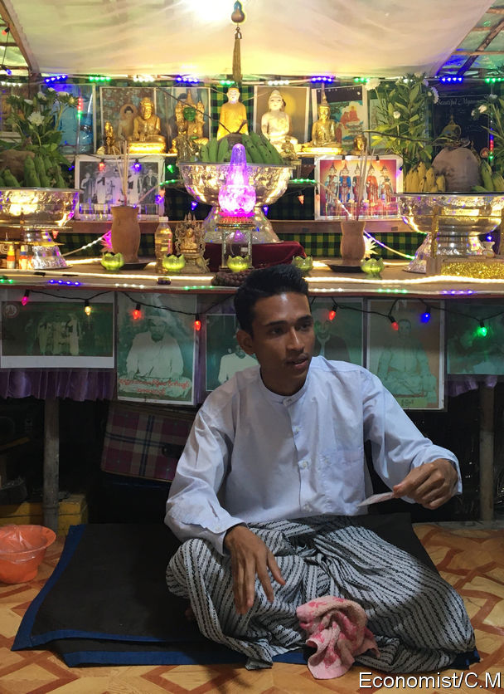

Wizards started to make a comeback about a decade ago, when the army began ceding political power to civilians. Since the abolition of the censorship board in 2012, and particularly in the past couple of years, “there has been an explosion of publications about the wizards,” says Mr Patton. Young, image-conscious weizza market their talents on YouTube and Facebook, where the most popular attract hundreds of thousands of followers. Three weizza to whom The Economist spoke said that they have seen surging numbers of students and clients in recent years.

Their appeal lies in their ability to manipulate the physical world. The greatest wizards can apparently fly, turn base metals into gold and attain immortality—all handy skills. Even the middling ones claim useful powers. Clients come to Saw Lwin, an impish weizza with a ruff of brown hair, to perk up their profits, make them more attractive, banish evil spirits and remove tumours. Myanmar’s health-care system is rickety, and the sick often turn to weizza when doctors fail to heal them.

“Science solves cancer with medicine and surgery,” says Saw Lwin. “We can cure such things in our own ways.” Equipped with his battered book of spells and a laminated red diagram, he dips his index finger in a small pot of perfumed ink. As he does he briefly flashes the faded red tattoos—the source of his healing powers—etched onto his inner forearm. He presses his finger into the palm of your correspondent’s hand, then chants a spell. She has not fallen ill since. ■

This article was downloaded by calibre from <https://www.economist.com/asia/2020/04/04/magical-spells-are-a-booming-business-in-myanmar>

|  |  |  |  |
| --- | --- | --- | --- |
| Previous | Articles | Sections | Next |

|  |  |  |  |
| --- | --- | --- | --- |
| Previous | Articles | Sections | Next |

#### Sigh-am

# Thailand’s economy was suffering before the virus

A once leading country risks falling behind its neighbours

Apr 4th 2020 | SINGAPORE

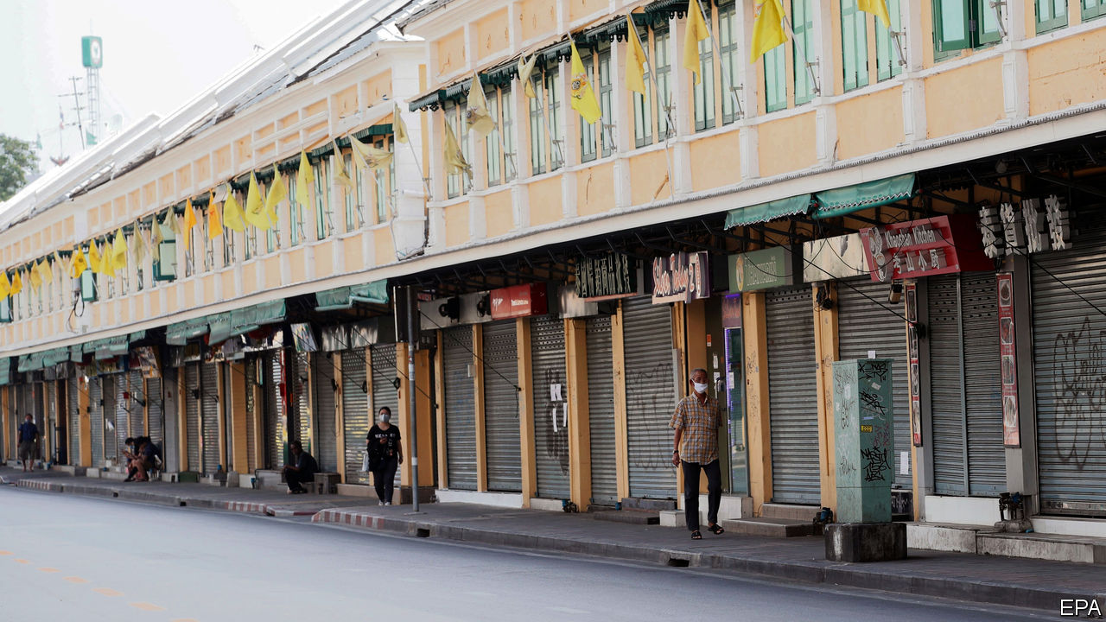

DESPITE COUPS, floods and mass protests, visitors have flocked to Thailand in recent decades. Almost 40m of them arrived last year to blister on its beaches and dance in its discos. But as the globe shuts down because of covid-19 and holidaymakers stay at home, the land of smiles feels glum. Travel and tourism, broadly defined, were worth more than 3.5trn baht ($109bn) in 2018, according to the World Travel and Tourism Council, equivalent to about 20% of the country’s GDP. The Kasikorn Research Centre, a Thai outfit which conducts economic analysis, estimates that if the covid-19 pandemic lasts into September, Thailand’s losses will amount to 400bn baht ($12.1bn).

The country has scrambled to respond to the coronavirus, which has infected at least 1,771 people. But the policies adopted were initially confused. At first foreign visitors were required to present embassy approvals and certificates declaring themselves free of covid-19 before boarding planes to Thailand. Now a state of emergency has been declared and the country’s borders are closed to foreign visitors. Bangkok is under a “soft lockdown”, with entertainment venues and malls shut. The governor of Phuket, normally a tourist hub, declared there is now a curfew in place for visitors between 8pm and 3am.

The economic response to covid-19 has been more robust. On March 10th the government unveiled a stimulus package worth $12.7bn, about 2.5% of GDP, which includes tax deductions for businesses and a 20bn baht fund for workers affected by the pandemic. On March 24th the government promised another 45bn baht in cash handouts. The Bank of Thailand, the country’s central bank, cut its key interest rate by 25 basis points to 0.75% after a special meeting on March 20th. It is also leading efforts to shore up systemic liquidity by offering special credit facilities and support for bond markets, among other measures. More is likely to be needed.

The Thai economy seemed sickly even before the new coronavirus emerged. It grew by just 2.4% last year, the slowest pace since 2014. This year it seems sure to shrink. Growth has been disappointing for more than a decade. From 2009 to 2019, Thailand’s growth rate (3.6% on average) lagged behind poorer neighbours like Vietnam (6.5%) and the Philippines (6.3%), and even richer ones such as Malaysia (5.3%). A small number of huge firms, family-owned businesses and state-owned enterprises dominate the economy. They face little pressure from competitors to innovate.

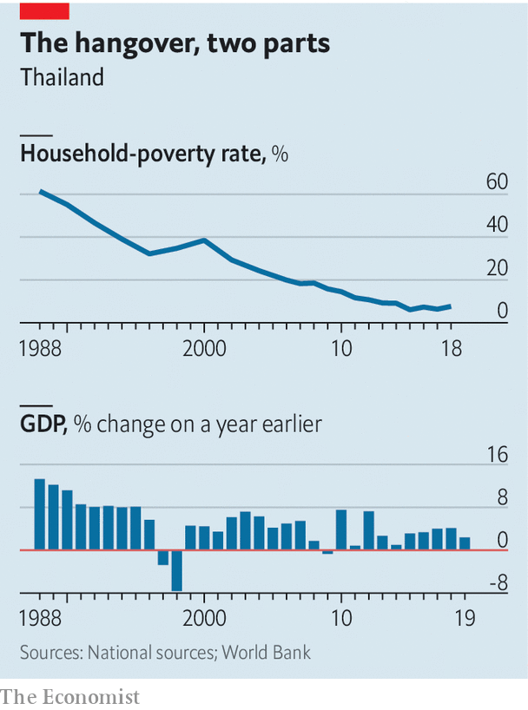

The poverty rate has stagnated for the past few years, having fallen dramatically in the decades before (see chart). About a tenth of the population lives on less than $2.85 a day. Average household consumption declined in 2017-18, while household debt stands at about 80% of GDP, one of the highest ratios in Asia. About a third of the labour force still works in agriculture, which is plagued by inefficiency. Thailand’s most severe drought in decades has cut production of sugar, rice and rubber.

Thailand’s demography is not too appealing to investors either. The country is ageing: its fertility rate is lower than Europe’s. Over a quarter of Thais will be older than 65 by the middle of the century. It took France 160 years for the share of its population aged 65 or above to rise from 7% to 21%; the UN estimates Thailand will do the same in just 35 years. The elderly lack retirement savings—national surveys suggest that eight in ten of them rely on income from their children.

Thailand’s low labour costs once persuaded carmakers, steel producers and others that it was a good place to build factories. But competitiveness had been slipping. Against the dollar the Thai baht was one of the best-performing currencies in Asia last year. The coronavirus has reversed those gains, but Thai workers’ wages still seem expensive when compared with those in places like Vietnam. In December Mazda, a Japanese carmaker, shifted production of its SUVs to Japan. In February General Motors, an American giant, pulled out of Thailand altogether.

This combination of economic ills would test the wisest lawmakers. Thailand’s elites are distracted by internal strife. There have been two coups since 2006. Almost five years of military rule damaged Thailand’s international standing and prevented it from negotiating free-trade agreements with Western countries, argues one Bangkok economist. The government prefers flashy but ineffective schemes like “Thailand 4.0” which includes the Eastern Economic Corridor (EEC), a special economic zone.

There are some small spots of good news as Thailand tackles covid-19. Its universal health-care system means citizens will have greater access to help when ill than many others in developing countries. And the government’s existing welfare scheme means it is ready to funnel money to people through the crisis. Building new infrastructure, such as a new railway and airport planned near Bangkok, would bolster its competitiveness in the long term. But the grim truth is that Thailand’s maladies will outlast the pandemic. ■

This article was downloaded by calibre from <https://www.economist.com/asia/2020/04/04/thailands-economy-was-suffering-before-the-virus>

|  |  |  |  |
| --- | --- | --- | --- |
| Previous | Articles | Sections | Next |

|  |  |  |  |
| --- | --- | --- | --- |
| Previous | Articles | Sections | Next |

#### Base instincts

# South Koreans at US military bases are furloughed

Donald Trump wants allies to pay more to host American troops

Apr 4th 2020 | SEOUL

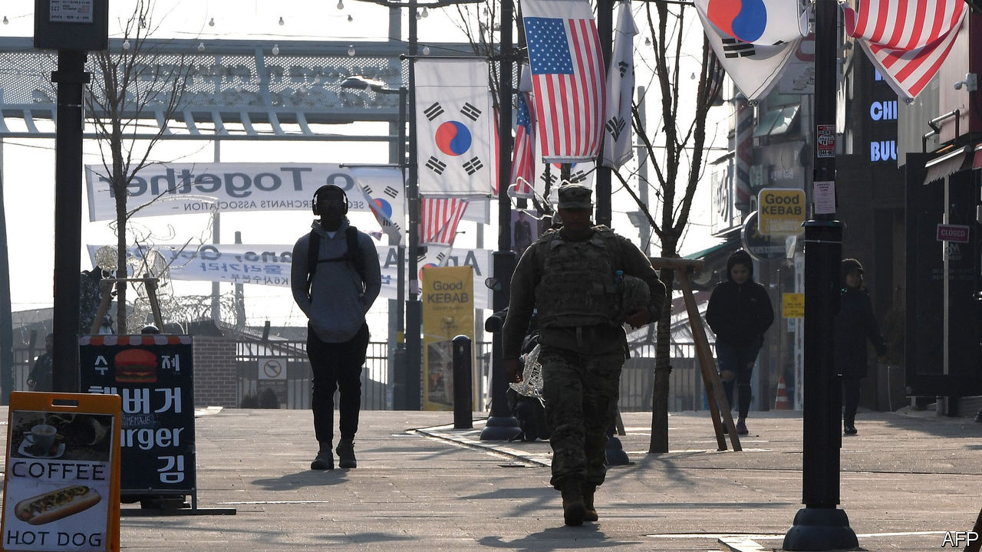

Editor’s note: The Economist is making some of its most important coverage of the covid-19 pandemic freely available to readers of The Economist Today, our daily newsletter. To receive it, register [here](https://www.economist.com/newslettersignup). For more coverage, see our coronavirus [hub](https://www.economist.com/coronavirus)

THE COMMANDER did not mince words. Furloughing half of the 9,000 South Koreans who work for the American military forces in the country for an indefinite period was “unthinkable” and “heartbreaking”, General Robert B. Abrams said in a televised address on April 1st. Yet he had to do it. As of this month thousands of local civilians working at American bases across the country will stay at home, unpaid, for the first time in the history of the alliance.

However heartbreaking it may have been for General Abrams, the decision was evidently no longer unthinkable enough for his superiors to avoid it. The local staff looking after the 28,500 American troops stationed in South Korea provide a range of services including security, catering and electrical installations. Their wages are covered by an agreement that divvies up the cost of hosting the troops between the two allies. The latest version of the agreement expired at the end of 2019. Three months later, emergency funds to cover wages are running low. The workers now on unpaid leave will remain there until the two countries agree on a new deal.

That is precisely what negotiators have failed to do so far, despite months of talks. The reason is Donald Trump. Previous presidents saw America’s alliance with South Korea as an essential part of a broader strategy—keeping the peace in Asia for the benefit of the whole world, including America itself. American troops deterred North Korea from invading again, and reassured Japan, another ally. South Koreans fought side by side with America not only in the Korean war but also in Vietnam. The cost-sharing agreement was extended with little fanfare every five years.

Now, although both sides still regularly insist the alliance is “ironclad”, the words ring increasingly hollow. Unlike his predecessors, Mr Trump sees alliances as an expensive favour to foreigners rather than a strategic necessity. So renegotiating the deal with South Korea has become a fraught annual ritual. Early in 2019 South Korea’s government agreed to an 8% increase in its contribution, to around $920m, avoiding a furlough of the sort that has just happened.

During the current round of negotiations, America has insisted that South Korea pay vastly more than that—maybe as much as $5bn, which is close to the total cost of keeping the troops in the country. South Koreans consider such a demand to be a shameless shakedown.

With less than two weeks to go until elections for the National Assembly, the decision to oppose it has created a rare political consensus between progressives and conservatives. Jeong Eun-bo, South Korea’s chief negotiator, said this week that the two sides had been close to a deal and expressed regret that America went ahead with the furlough anyway, but he did not specify what each side had offered.

The furlough will test an alliance that was already strained. It comes at a time of heightened uncertainty in regional security. North Korea conducted four short-range missile tests in March and is expected to stage further provocations to mark the birthday of Kim Il Sung, its founding dictator, on April 15th. China and America are at loggerheads over trade and, increasingly, over their respective responses to the covid-19 pandemic. General Abrams did not explicitly acknowledge that the furlough would affect military preparedness, but said the US command would do its utmost to minimise the impact on the troops’ readiness to fight.

The most immediate impact, however, will be on workers who have just lost their income. Lim Yoon-kyung of the Pyeongtaek Peace Centre, which represents some of the workers, said the furlough amounted to “daylight robbery”. “These people’s jobs are directly related to their survival,” she says. The South Korean government said that it would try to pass a special bill to compensate the workers for lost salaries. That may curry favour with the public ahead of the election. But with the world economy slumping, America laying off workers will surely hurt its reputation. And with Mr Trump hoping to procure covid-19 test kits from South Korea, now might not be the wisest time to pick a fight.■

Dig deeper:  
For our latest coverage of the covid-19 pandemic, register for The Economist Today, our daily [newsletter](https://www.economist.com/newslettersignup), or visit our [coronavirus hub](https://www.economist.com/coronavirus)

This article was downloaded by calibre from <https://www.economist.com/asia/2020/04/04/south-koreans-at-us-military-bases-are-furloughed>

|  |  |  |  |
| --- | --- | --- | --- |
| Previous | Articles | Sections | Next |

|  |  |  |  |
| --- | --- | --- | --- |
| Previous | Articles | Sections | Next |

#### Got an itch? Get hitched

# Why more Indonesian teens are giving up dating

Wed now to avoid temptation, online conservatives urge

Apr 4th 2020 | JAKARTA

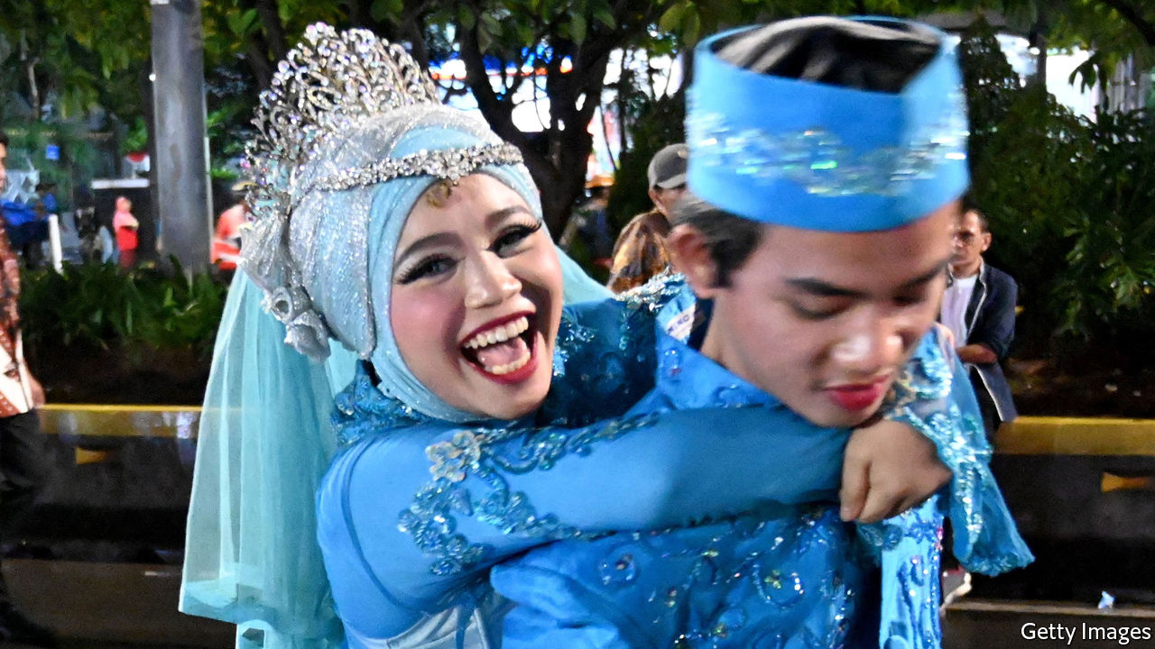

IT WAS LOVE at first like. When Natta Reza, a dashing Indonesian busker, discovered the young woman’s account on Instagram, he knew he’d found the one. He liked one of her posts, and they started chatting. Within hours he had proposed via an Instagram message. They married soon after, in February 2017.

Since then Mr Natta and his wife, Wardah Maulina, have become celebrities on Instagram. They are the poster couple for a social movement sweeping Indonesia, home to the world’s largest population of Muslims. Its champions encourage single Muslims to renounce dating, lest they succumb to the temptations of premarital sex, which is barred by Islamic law. Better to marry young, and swiftly, and leave the matchmaking to a parent, cleric or the Islamic internet. Islam in Indonesia has traditionally been a moderate affair. Yet the eagerness with which teenage and millennial Muslims have embraced abstinence shows how a purist strain of the faith has tightened its grip.

It all began five years ago in a dorm room in a provincial Javanese city. La Ode Munafar was worried about his peers and the state of their souls. Many young Indonesians have no problem with dating, or fooling around; perhaps two-fifths of unmarried adolescents have had sex. So Mr Ode leapt into action. He started an organisation called Indonesia Tanpa Pacaran (ITP) or “Indonesia without dating”, launched a social-media campaign, and invited Muslim singletons to join sex-segregated WhatsApp chat-rooms to give each other succour as they hunted for a spouse.

Mr Ode has been wildly successful. By 2018 ITP had at least 600,000 paying members, according to Magdalene magazine. YouTube videos of teenage girls calling their boyfriends and dumping them have racked up thousands of views, while the Instagram accounts of Mr Natta and Ms Wardah, who are ITP ambassadors, have over 1m followers each. Mr Ode’s message is getting through. Mia, a 20-year-old ITP member, thinks forgoing dating in favour of early marriage is “very noble”. The number of young girls tying the knot is startlingly high; in 2018 11% of women aged between 20 and 24 had married before 18.

Mr Ode is by no means the first Muslim to condemn dating, says Dina Afrianty, of La Trobe University in Australia. What’s new about ITP is its use of social media. Mr Natta and Ms Wardah’s Instagram posts put a rose-tinted filter on the life of a young married couple. Their hip social-media personae make the case for chastity and early marriage far more effectively than any sermon. The ability of Mr Ode and other tech-savvy conservatives to market Islam to young Muslims accounts for the popularity of ITP and hijrah, the broader, grassroots movement to which it belongs. A survey by Alvara, a pollster, conducted in 2019 showed that Indonesians between the ages of 14 and 29 are more likely to possess “ultra-conservative” religious views than their elders.

Hijrah’s popularity is a measure of how much Indonesian Islam has changed in the past two decades. The faith used to be syncretic and undogmatic. But after the dictatorship’s fall in 1998, conservative voices that had been silenced began to be heard. Salafism moved from the margins to the mainstream. Preachers educated in Arab countries set about remaking Indonesian Islam in the mould of its austere Arab cousin. Islam emerged as a political force in 2016, when hundreds of thousands of zealots demonstrated against a Christian politician whom they accused, on the basis of doctored evidence, of having insulted the Koran. He lost an election and was jailed.

Conservative Muslims regard women as “the guardians of the family”, according to Ms Dina, and have looked on with indignation as women have carved out space for themselves. Feminists have won some important legislative victories. Last year for instance parliament increased the legal age of marriage for girls, from 16 to 19, in a bid to curb child marriage (the legal age of marriage for men is 19). But emboldened Islamist lawmakers are doing their best to return women to the hearth and home.

Among the bills to be considered by parliament this year is a “family resilience” bill which requires women to “take care of household affairs”. It has been roundly mocked by the urban elite, who point out that it was drafted by female MPs who cannot often be at home. But behind the ridicule lies fear. “The feminist space at the national level is shrinking,” says Mutiara Ika Pratiwi of Perempuan Mahardhika, an Indonesian women’s organisation.

It has long been under attack at the local level. A study from 2008 showed that 52 districts, out of a total of 470, enacted 45 sharia-inspired laws between 1999-2008. Aceh, a special administrative region governed by Islamic law, prohibits women from straddling motorcycles, playing football and leaving their homes at night. In 2015 officials in Purwakarta, a county in West Java, announced that unmarried couples caught together after 9pm would be required to marry or break up. Mr Ode would surely approve.

His organisation, which encourages women to defer to their male relatives and refrain from arousing male lust, has come under heavy criticism from feminists. They would do well to point out that, for every Mr Natta and Ms Wardah, there is a Salmafina Khairunnisa and Taqy Malik. In September 2017 Ms Salmafina, then an 18-year-old Instagram personality, married Mr Taqy, a 22-year-old heart-throb, even though they had met only two weeks before. Ms Salmafina soon learned that he was thinking about getting a second wife; polygamy in Indonesia is legal and encouraged by radical campaigners like Mr Ode. Mr Taqy soon discovered that his beloved was not the “submissive wife” he had expected. Within three months the couple had divorced. ■

This article was downloaded by calibre from <https://www.economist.com/asia/2020/04/04/why-more-indonesian-teens-are-giving-up-dating>

|  |  |  |  |
| --- | --- | --- | --- |
| Previous | Articles | Sections | Next |

|  |  |  |  |
| --- | --- | --- | --- |
| Previous | Articles | Sections | Next |

#### Banyan

# Abe Shinzo draws closer to declaring a state of emergency

Japan’s leader had hoped to avoid locking down against the virus

Apr 4th 2020 |



Editor’s note: The Economist is making some of its most important coverage of the covid-19 pandemic freely available to readers of The Economist Today, our daily newsletter. To receive it, register [here](https://www.economist.com/newslettersignup). For more coverage, see our coronavirus [hub](https://www.economist.com/coronavirus)

BARELY TWO weeks ago, the notion that Tokyo’s summer Olympic games should be postponed on account of the coronavirus pandemic was taboo among Japan’s ruling elites and the deferential national broadcaster, NHK. So, too, was any suggestion that covid-19 was not under control. But as soon as the prime minister, Abe Shinzo, admitted on March 24th that the games could not go ahead as planned, it was if a dam had burst. Growing alarm at the spread of the virus, notably in the capital, is now at the centre of the political discourse. For ordinary Japanese a turning-point came on March 29th, with the death from covid-19 of a comedian and beloved household name, Shimura Ken.

The alarm is appropriate. Japanese habits of hygiene and removing shoes inside, strong messaging about washing hands, and Mr Abe’s urging in February that schools temporarily close had appeared to be containing the virus. In comparison with Europe and America, Japan’s record is still impressive: just 2,419 confirmed infections and 66 deaths since the first case in January. But in just a few days, the daily number of new infections in Tokyo rose sharply, from 40-odd last week to 66 cases on April 1st.

The government’s policy has been to go after infection clusters and snuff them out. With the number of new cases accelerating, and transmission routes hard to divine, Japanese now worry that they could follow European and American trajectories after all. The government has been accused of concealing new cases to put on a good Olympic face. That seems implausible, but clinging on to the games was a distraction. And this week the government was still balking at the cost to business of stricter measures. Yet even Mr Abe has inferred that isolating clusters is not working. At his Saturday press conference, he admitted that in the event of an explosive rise in new cases “our strategy...will immediately collapse.” He offered no Plan B.

That has fallen to Tokyo’s governor, Koike Yuriko. Blunt and forceful, she warns that a lockdown of the world’s biggest megalopolis is coming. Her direct style has upstaged the prime minister. Her pleas to break the chain of infection have even shut Tokyo’s red-light districts, surely a first since America’s firebombing of the city in 1945. Yet her powers of persuasion have limits. Her call for Tokyoites to remain at home this past weekend was honoured more in the breach—until snow on the Sunday helped her cause.

Much more is needed. Government guidance is too vague. It urges “self-restraint”, with the implication that people face being shamed if they do not conform. It says people should avoid crowded places, or where there is poor ventilation, or where conversation takes place at close quarters. Yet it says nothing about commuter trains that flagrantly breach such conditions. Corporate priorities trump everything else, with barely a sixth of office staff working from home. In much of Japan, pachinko—pinball—parlours are still full. “Social distancing”, even as an imported phrase, does not exist.

Murakami Hiromi, a health policy expert at the National Graduate Institute for Policy Studies in Tokyo, says a full lockdown for Tokyo and surrounding prefectures may now be needed. At last Mr Abe has put someone in charge of the coronavirus response: the minister for economic and fiscal policy, Nishimura Yasutoshi. Others want Mr Abe to go further and declare a national state of emergency. New legislation gives him the power to do so.

It is here that Japan’s old ideological faultlines are playing out over the coronavirus. Conservative allies say the prime minister is dealt a poor hand in comparison with other democracies’ leaders fighting the pandemic. The stigma of Japan’s wartime militarism has rendered state power weak, with Mr Abe able only to exhort, not command. Even the new emergency law delegates powers to prefectures and municipalities—and these may only “request” that citizens follow heavily freighted instructions, with no enforcement mechanisms.

Liberal critics worry that Mr Abe, whose government over the years has harassed the press and chipped away at constitutional constraints on its authority, could use an emergency to widen his powers alarmingly. That is always a risk, given a weak civil society in Japan and given that his Liberal Democratic Party wants a revised constitution. Mr Abe’s inner autocrat might yet be unleashed. But it is striking that so far this year he has shown a paucity of leadership, not an oppressive streak.

Dig deeper:  
For our latest coverage of the covid-19 pandemic, register for The Economist Today, our daily [newsletter](https://www.economist.com/newslettersignup), or visit our [coronavirus hub](https://www.economist.com/coronavirus)

This article was downloaded by calibre from <https://www.economist.com/asia/2020/04/04/abe-shinzo-draws-closer-to-declaring-a-state-of-emergency>

|  |  |  |  |
| --- | --- | --- | --- |
| Previous | Articles | Sections | Next |

|  |  |  |
| --- | --- | --- |
| Asia | Sections | Middle East and ... |

China

The gig economy: Visible and vocal

.

Chaguan: A Chinese mirror

.

|  |  |  |
| --- | --- | --- |
| Asia | Sections | Middle East and ... |

|  |  |  |  |
| --- | --- | --- | --- |
|  | Articles | Sections | Next |

#### Visible and vocal

# Delivery apps have transformed urban life in China

They have also created a new kind of worker

Apr 3rd 2020 | SHANGHAI

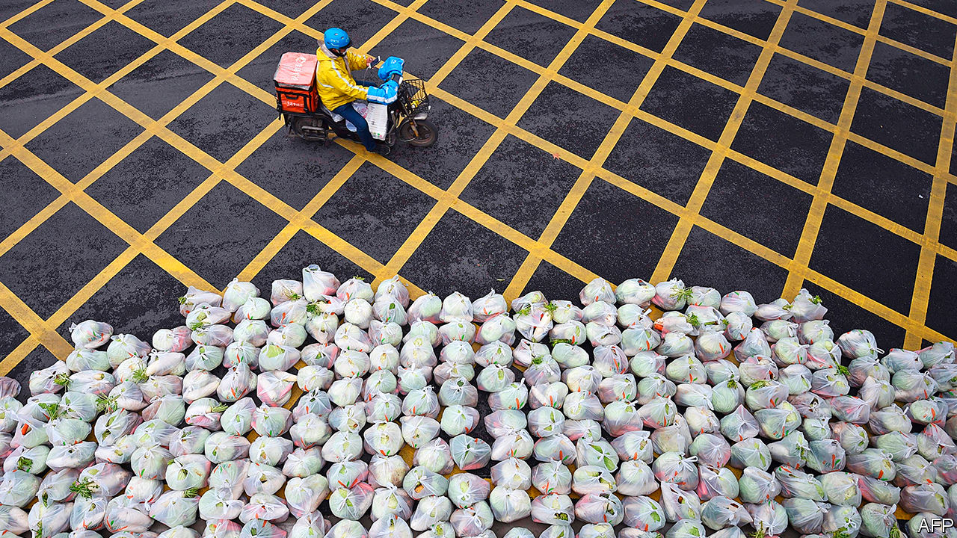

Editor’s note: The Economist is making some of its most important coverage of the covid-19 pandemic freely available to readers of The Economist Today, our daily newsletter. To receive it, register [here](https://www.economist.com/newslettersignup). For more coverage, see our coronavirus [hub](https://www.economist.com/coronavirus)

DURING THE recent peak of covid-19 cases in China, large metal shelving-units appeared at entrances to residential compounds across Shanghai. Outsiders were not allowed in. But somewhere was needed to hold the myriad packages ordered online by the millions of residents who were staying at home. The shelves groaned under the weight of disinfectant and vitamin tablets, sacks of rice and flour, cooking oil and vegetables.

Food-delivery firms played a crucial role in helping people in China endure the lockdown that began in Hubei province in late January, and the less stringent forms of quarantine that were subsequently implemented in cities across the country. Since early March there have been very few newly detected cases of covid-19 except among travellers from abroad. So controls have eased, allowing shops and restaurants to reopen. But many people are playing safe and staying largely housebound. State media have been calling home-delivery workers “heroes”. Few would disagree.

Even before the crisis they were beloved of urbanites. The combination of an abundant supply of cheap labour, a large middle class and near-universal access to smartphones had fostered the growth of online food-delivery services to a degree unmatched in the rich world. People could have everything from coffee to congee whisked to them in under 30 minutes on the back of a scooter, typically by one of the sector’s two titans, Ele.me and Meituan-Dianping. More than 400m people, or about half of the country’s internet users, had encountered a waimai xiaoge, or “takeaway lad” (more than nine in ten are men) at their door. Residents had become so used to receiving hot meals from them that they jokingly compared them to parents.

After the novel coronavirus hit, their services became a lifeline. When officials told firms to stay shut, they allowed exceptions for “essential” services, including those delivering cooked food and groceries. Wary of eating meals prepared by others, many people turned to online supermarkets. Sales of dumpling wrappers and sauces grew more than sevenfold on Meituan’s grocery service—even as takeout orders more than halved, as the giant reported in a downbeat first-quarter forecast. The new joke is that the covid-19 epidemic has turned China into a nation of chefs.

The lives of the xiaoge have changed, too. Zhang Shuai, a 24-year-old from the central city of Zhengzhou who delivers for Meituan in Shanghai, has to wear a mask while working. The firm takes his temperature twice a day, notes it on a card pinned to his jacket and uploads it to the app for users to see. He undergoes many more checks when he picks up orders and carries them into residential compounds, most of which are now open again to outsiders.

Yet the job is still alluring to people like Mr Zhang. Indeed, he signed up with Meituan when infections were mounting. It was just too hard to find any other job, he says. And, at 10,000 yuan ($1,400) a month, his earnings are higher than the average urban wage in Shanghai, partly thanks to subsidies from Meituan and tips from grateful customers. He will quit only when the disease ends. Another migrant worker says he shares his single-room accommodation with five other riders. Is he anxious about living cheek-by-jowl with them? “I’m not afraid of death,” he grins, speeding off.

The gig economy has transformed Chinese cities. Young workers from villages were once largely invisible to urban residents as they toiled on production lines. Now many of them eschew regimented factory work in favour of less structured lives. They have become omnipresent, clad in their firms’ coloured jackets and weaving perilously through traffic. Millions also work for other kinds of app-based transport services, for example as couriers or drivers for ride-hailing companies.

The xiaoge have helped build food delivery in China into a $46bn business, the world’s largest and twice the size of America’s. In 2018 Meituan and Ele.me had about 6m riders between them. Demand for workers is growing fast. Sanford C. Bernstein, a research firm, reckons Meituan will need more than 1m delivery people a day next year, 200,000 more than last year. On average last summer, its yellow-jacketed army handled 20,000 orders a minute.

For migrants from the countryside, the job is an unusually easy ticket to city life. Factory workers must have a skill, and often a home-town peer to vouch for them. But some riders are hired as soon as they upload copies of an identity card and health certificate to an app. The pay is usually better than on an assembly line.

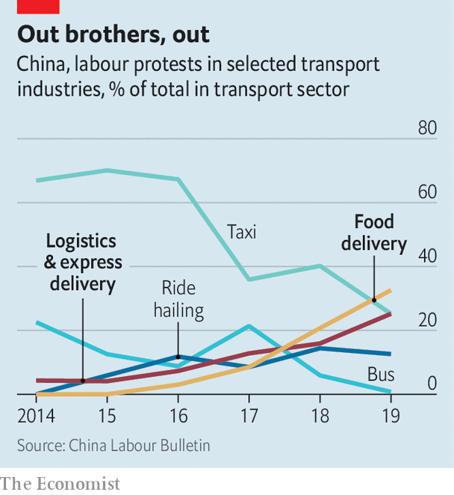

Nearly one-third of Meituan’s riders were once factory hands. Their switch reflects a nationwide trend. In 2018, for the first time, more migrant workers took up jobs in services than in manufacturing.

The epidemic could result in even more of them doing gig work. Many of China’s battered companies are shedding staff, but not food-delivery firms. Freshippo, Alibaba’s e-grocer, has engaged 2,000 staff from 30 idled restaurant chains. Since the start of the epidemic Meituan has hired more than 450,000 new riders, most of them for work in their home provinces because of virus-related travel restrictions.

In recent years gig jobs have given workers a cushion, says Ji Wenwen of the China University of Labour Relations. In Hegang, a coal town by the Amur river on the Russian border, a tenth of takeaway riders were once miners. One of them is Luo Qiong, who makes twice as much with Ele.me as he did down the pit. “I earn more than local civil servants,” he says proudly.

The dreams of today’s migrants are often different from those of factory workers in the earlier years of China’s industrial boom. Many have never worked the land and have no intention of returning to it. They are better educated. A fifth of delivery workers have been to university or vocational college. And they want respect. In surveys, nearly half of riders at Meituan express anxiety about their status. Fewer than one in three at Ele.me feel they are respected enough by customers.

Such frustrations may grow. During the epidemic, firms rolled out contactless delivery systems, with packages being hung on door knobs or, in some big-city office and apartment blocks, placed in dedicated lockers installed by the companies. Face-to-face interaction with waimai xiaoge, once a near-daily feature of city life, ceased. It may never be fully restored.

Food delivery allows migrant workers to choose their own work hours, but the stress is still immense. Many riders are hired by middlemen who impose tough requirements for the job. The pressure is evident: heavily burdened delivery people often run the final distance to drop-off points. The Hong Kong Confederation of Trade Unions, a pro-democracy labour group, describes gig workers as an “immense army of precariats”.

Among the army’s recruits is a lanky 22-year-old in a baggy Ele.me jacket who prefers to be identified only by his surname, Liu. He says that, in his distant home-town near the eastern city of Suqian, he would need to “work as long as the machines” in order to earn as much as he does in Shanghai. He now puts aside 5,000 yuan a month. But he works six days a week, ten hours a day, even in the grimmest weather. Mr Liu says he jumps red lights every day to avoid late-delivery penalties. In the first half of 2019, Shanghai recorded 12 road accidents a week involving food-delivery riders. Many go unreported.

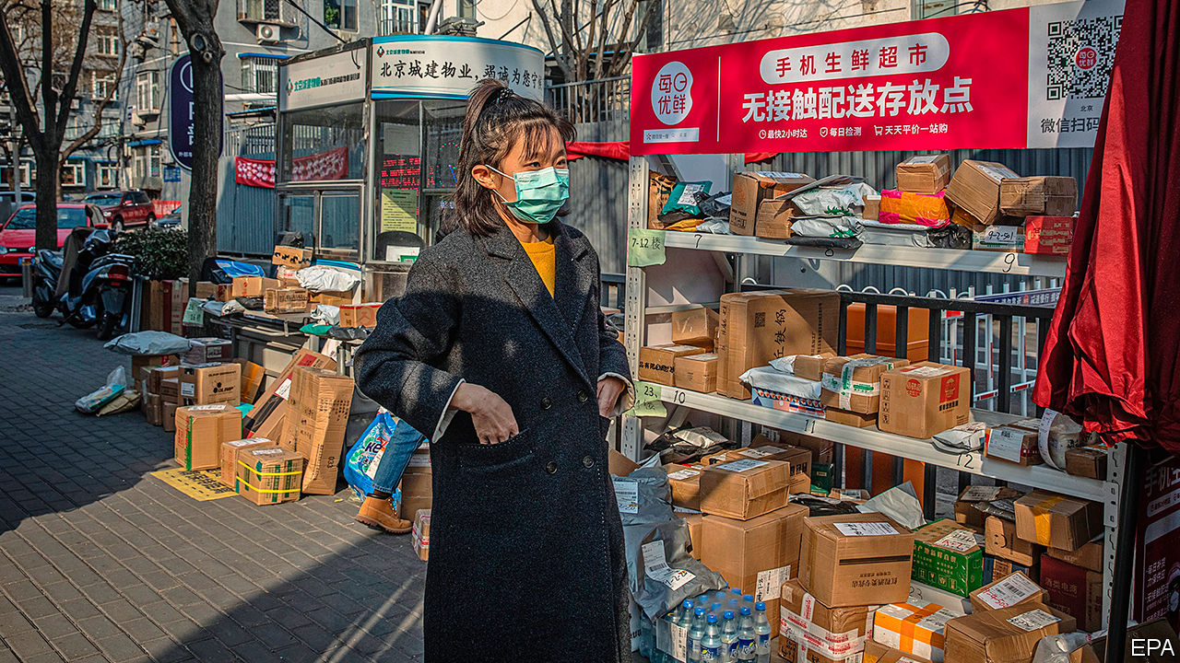

From rider to larder

Over the years, factory workers have used their collective power to press for better pay and conditions. It is harder for dispersed delivery workers to do this, says Geoffrey Crothall of China Labour Bulletin (CLB), an NGO in Hong Kong. If some riders go on strike, algorithms can redirect orders to others still working.

Still, riders use social media to their advantage. They have large chat groups on messaging services such as WeChat and QQ, in which they discuss delivery routes but also employment terms and grievances. Meituan says that two in five of its riders were recommended for the job by home-town friends—recreating, to some extent, the solidarity of the factory. Mr Liu has found a WeChat group filled only with riders from his town. Delivery workers also forge bonds when they congregate, as they often do in areas with good internet connections or near busy food courts.

Such networking enables them to co-ordinate strikes. CLB says the food-delivery industry has become “a major source of worker unrest” (see chart). The NGO recorded the first strike by waimai xiaoge in 2016. The tally is now 121. Protests have been about wage arrears, pay cuts and fines.

Because workers are not formal employees, companies can usually ignore their complaints. In 2018 a rider was banned from Ele.me’s platform for going on strike for two days about low wages. Still, the two biggest firms know well the public’s sympathy for takeaway riders, who formed one section of a national-day parade through Tiananmen Square in October. They would also rather avoid lots of churn in their workforce.

To boost loyalty, Meituan has created a category call lepao, or happy runners, who get paid more for accepting orders in faraway places. It has also helped set up a mental-health hotline for delivery workers. During the epidemic the firm has offered free online counselling to riders. It will pay up to 300,000 yuan in medical fees to those with covid-19.

In the long run, riders are unlikely to be satisfied. Pun Ngai of the University of Hong Kong says they risk becoming “trapped in the middle”—unable to move forward in urban life and unwilling to retreat to a rural one. Asked, pre-covid, why he had recently travelled 1,700km from his home in the western province of Gansu to Shanghai, a newly arrived waimai xiaoge replied, beaming: “Everyone likes a big city.” He paused. “But you can’t do this for ever. You need to do something that gives you a way up.” Contacted recently, he said he had quit. “Too tiring,” he grumbled. ■

Dig deeper:  
For our latest coverage of the covid-19 pandemic, register for The Economist Today, our daily [newsletter](https://www.economist.com/newslettersignup), or visit our [coronavirus hub](https://www.economist.com/coronavirus)

This article was downloaded by calibre from <https://www.economist.com/china/2020/04/03/delivery-apps-have-transformed-urban-life-in-china>

|  |  |  |  |
| --- | --- | --- | --- |
|  | Articles | Sections | Next |

|  |  |  |  |
| --- | --- | --- | --- |
| Previous | Articles | Sections | Next |

#### Chaguan

# China is also an idea, revealing much about Western hopes and fears

Outsiders with views of China are often talking about themselves

Apr 4th 2020 |

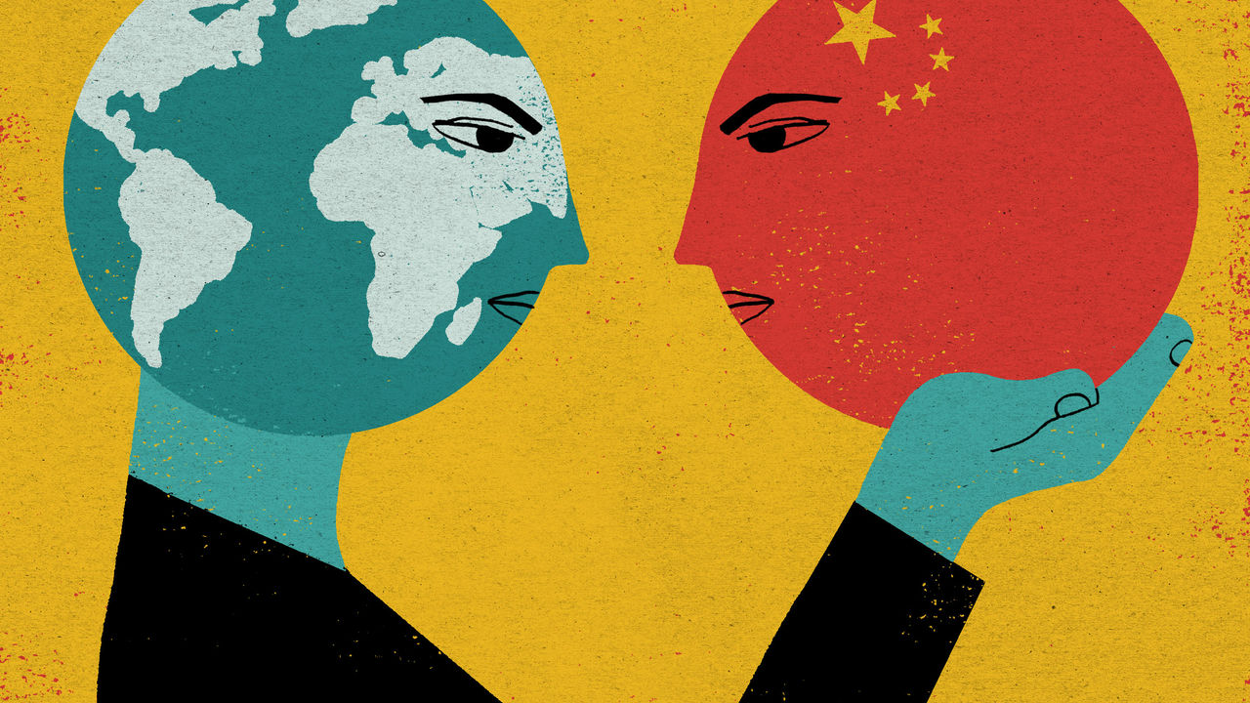

Editor’s note: The Economist is making some of its most important coverage of the covid-19 pandemic freely available to readers of The Economist Today, our daily newsletter. To receive it, register [here](https://www.economist.com/newslettersignup). For more coverage, see our coronavirus [hub](https://www.economist.com/coronavirus)

MARCO POLO is a surprisingly dodgy role model for writers on China. Seven centuries have passed since the Venetian merchant published his account of travels in Asia, including 17 years in the service of Kublai Khan, China’s Mongol overlord. Polo’s China is a ruthless but efficient dictatorship, a market of staggering promise, a land of great cities and tireless workers. At the same time, he describes a China so isolated that three ingenious Europeans—Polo, his father and uncle—can help the Khan win a military campaign by building him a set of giant catapults. It is an early example of technology transfer via joint venture. Polo’s portrait of China, combining wonders, horrors and a dose of Western condescension, set a pattern followed by other authors for 700 years.

In recent years, however, some fine historians have begun to debate whether Polo made his Chinese adventures up, or borrowed his tales from Arab and Persian traders. It is odd that neither Mongol nor Chinese records contain any trace of Polo, though he claims to have governed the city of Yangzhou. It is puzzling that Polo’s memoirs never mention tea, chopsticks, calligraphy, foot-binding or the Great Wall. For all that, the truly striking thing, perhaps, is how little it matters whether Polo went to China.

Long before foreigners commonly travelled or worked in China—an actual country linked to the world by trade and by two-way flows of emigration and return—outsiders have held strong opinions about “China”, an Otherland that is as much an idea as a place on the map. “The Chan’s Great Continent”, a classic history of Western thought about China by Jonathan Spence, catalogues the many influential writers on China who never set foot there.

Enlightenment philosophers, notably, used China as a symbol for all that is good, or bad, about human society. Leibniz praised China as a land of order, Confucian morality and religious toleration—but mostly as a way to rebuke Christian monarchs stirring up sectarian hatreds in Europe. In contrast, to promote the merits of dividing state power between separate branches of government, Montesquieu damned China as a despotic state ruled by fear, whose peoples “can be made to do nothing without beatings”.

On the face of it, imaginary notions of China should not matter much during the covid-19 pandemic, which has left governments wrestling with hard questions about life and death. There is, for instance, nothing very abstract about a propaganda campaign under way inside China to stress that most new infections involve cases imported from abroad. Though almost all of these involve Chinese nationals, curbs on foreigners are tightening. The border has been shut to most of them. On March 27th the government shocked embassies in Beijing by declaring a halt to the issuing of new identity cards for most grades of diplomat. This was apparently in response to the flouting of virus controls by a Western envoy. Embassies, in effect, face a ban on staff rotations until at least mid-May.

Yet listen carefully to Western leaders discussing China in this crisis, and time and again their discussion of Chinese policies is a form of introspection. They are really agonising, aloud, about how they found themselves so dependent on a country like China. On March 29th the Mail on Sunday, a British newspaper, quoted government ministers blaming Chinese secrecy over covid-19 for ruining the world economy. How could Britain not now review Sino-British ties, including deals to let Huawei help build 5G networks, a minister asked. That sounds like an argument about China, but is really a cry of alarm about Britain’s sway in a harsh world.

Pushing back against headlines about China delivering medical supplies to Italy and other European countries, President Emmanuel Macron of France warned against becoming “intoxicated” with the boasts of rival powers (meaning, clearly, China). He noted that France and Germany had also sent substantial aid to Italy. Then Mr Macron let slip what really troubles him about this PR contest with China: that it reveals the limits of European solidarity. “I do not want this selfish and divided Europe,” he lamented.

Germany’s chancellor, Angela Merkel, is said to be wrestling with how to position her country in an age of sharp competition between two self-interested giants, America and China. Her choices have been narrowed by a loss of faith among Germany’s elite in the claim, once touted as “change through trade”, that commerce with China will nudge that country towards openness and democracy. China’s defiantly hardline turn leaves Germany in need of a foreign policy shorn of wishful thinking. That in turn condemns Germany to debate what sort of country it wants to be.

As for President Donald Trump, he won office, in part, with fiery speeches about China growing rich at Americans’ expense. Yet during this pandemic he seems strikingly unmoved by ethical questions about China’s conduct. Asked about Chinese propaganda accusing America of infecting China with covid-19, which his own aides have angrily denounced, Mr Trump shrugged. “Hey, every country does it,” he told Fox News, adding that his earlier insistence that covid-19 was caused by a “Chinese” virus was “very strong against China”.

## China as cause and beneficiary of a crisis of confidence

America’s allies, along with many Trump administration officials and members of Congress, worry about China posing an unprecedented challenge to the post-1945 global order and the norms that underpin it. All evidence suggests that Mr Trump’s concerns are narrower and more domestic. His “China” is a proxy for globalisation, and for the failure of elites to shield American workers from competition. As for the actual autocracy called China, Mr Trump takes its ruthless self-interest for granted, and even praises it.

Western leaders disagree about how to handle China partly because the country has become a larger, more daunting and more assertive competitor. It is also because of a crisis of Western unity. As Marco Polo was the first to demonstrate, foreigners with visions of China are often talking about themselves. ■

Dig deeper:  
For our latest coverage of the covid-19 pandemic, register for The Economist Today, our daily [newsletter](https://www.economist.com/newslettersignup), or visit our [coronavirus hub](https://www.economist.com/coronavirus)

This article was downloaded by calibre from <https://www.economist.com/china/2020/04/04/china-is-also-an-idea-revealing-much-about-western-hopes-and-fears>

|  |  |  |  |
| --- | --- | --- | --- |
| Previous | Articles | Sections | Next |

|  |  |  |
| --- | --- | --- |
| China | Sections | Europe |

Middle East and Africa

Cabo Delgado: Mayhem in Mozambique

.

Chocolate in Africa: Sweet dreams are Congolese

.

States of emergency: Stay home or be whipped

.

A lost year in Saudi Arabia: Stalled

.

Faith and covid-19: Insular, but not isolating

.

|  |  |  |
| --- | --- | --- |
| China | Sections | Europe |

|  |  |  |  |
| --- | --- | --- | --- |
|  | Articles | Sections | Next |

#### Jihad on Africa’s eastern shore

# Mozambique’s mysterious conflict is intensifying

The killing jeopardises Africa’s largest gas project

Apr 4th 2020 | PEMBA

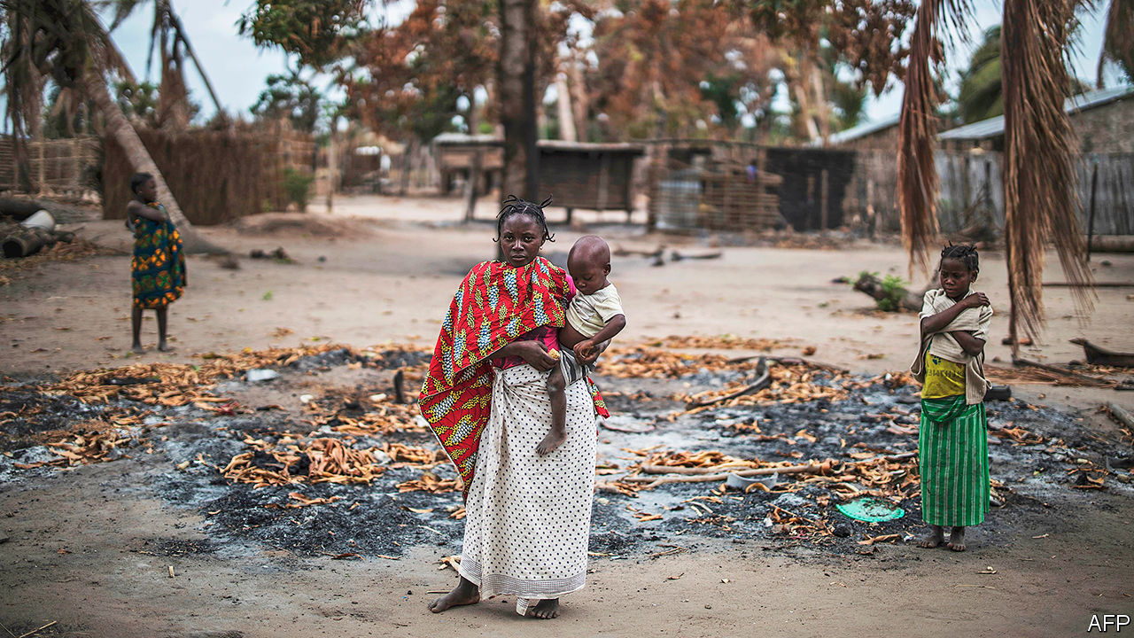

MICHAEL SMELLED trouble before he saw it. In January the 28-year-old from Bilibiza, in the northern Mozambican province of Cabo Delgado, caught a whiff of smoke. A village had been torched nearby. Within hours houses and schools in Bilibiza were burning as 10,000 residents fled.

It was the second time in two years that Michael (not his real name) had run for his life. In 2018 his village was attacked. At least five people were killed. A friend was decapitated. Today Michael, his wife and three young children live in Pemba, the provincial capital. They sleep outside, chicks and pigeons pecking at their feet.

Violence has engulfed Cabo Delgado since 2017. On one side is a poorly understood Islamist insurgency. On the other are the government’s heavy-handed security forces. Aid agencies estimate that more than 1,000 people have died and at least 100,000 have had to leave their homes. On March 23rd the rebels made their boldest move yet, taking the town of Mocimboa da Praia, before retreating. Two days later they took Quissanga, 100km north of Pemba.

Until recently southern Africa had been relatively free from the jihadist attacks that have wrought havoc in the Horn of Africa, Nigeria and the Sahel. No longer. South Africa, in particular, is worried. The uprising also threatens what could be Africa’s largest-ever energy project: the development of gasfields in the Rovuma basin. Before this year analysts forecast that energy firms would spend more $100bn by 2030 to turn Mozambique into “Africa’s Qatar”.

Cabo Delgado has long been the most neglected part of Mozambique. It suffered horribly in the war of independence (1964-74) and the subsequent civil war (1977-92). It has the country’s highest rates of illiteracy, inequality and child malnutrition. It is one of just a few provinces with a Muslim majority, which had long drawn on a moderate Sufi tradition.

That tradition began to be challenged in the 2000s. Muhammad Cheba of the mainstream Islamic Council of Mozambique recalls how some young believers began insisting on wearing shoes in mosques, ostensibly because the Prophet did so. Then around 2008 a sect known as Ahlu Sunnah Wa-Jamo (“adherents of the prophetic tradition”) was set up. In a report last year, IESE, a Mozambican research outfit, noted that the group was heavily influenced by Islamists from east Africa. Mocimboa da Praia lies on a long-standing migration route, near the porous border with Tanzania. Close links were made between the group and cells in Kenya, Somalia, the Great Lakes and Tanzania.

The fundamentalists argued that mainstream Muslim leaders were in cahoots with a corrupt elite made up of criminal bosses and the ruling party, FRELIMO. The result: a closed shop that locks out the province’s Swahili- or Mwani-speaking Muslims from opportunities in both the legal and illegal industries that flourish in Cabo Delgado. Smuggling ivory, rubies, timber and heroin is rampant. These trades reportedly involve close links between organised crime and politicians.

The arrival of international companies is viewed with suspicion, too. Luiz Fernando Lisboa, the bishop of Pemba, questions whether investments by large companies have benefited ordinary people. Farmers and fishermen have been uprooted to make way for mining and energy infrastructure.

There is a deep mistrust of local elites in Cabo Delgado, adds Joseph Hanlon of the London School of Economics. It is believed, for instance, that they cause cholera outbreaks and get lions to eat people.

In its trajectory from sect to insurgency, the region’s guerrilla group resembles Boko Haram, argues Eric Morier-Genoud of Queen’s University Belfast. From around 2013 it began calling itself al-Shabab (“youth”), like the Somali outfit (with which it has no known direct links). Two years later it began military training. In 2017 it attacked for the first time, in Mocimboa da Praia. Today there are believed to be many units in the province, with members from northern Mozambique, Tanzania and Congo, among other places.

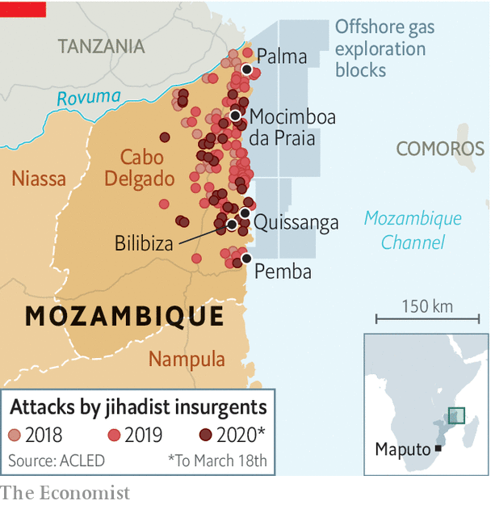

More attacks were carried out in the first quarter of 2020 than in any three-month period since the war began (see map). Raids are occurring farther south. Attacks were once carried out with machetes; now fighters have automatic weapons.

Unlike the publicity-hungry jihadists of Boko Haram, the insurgents of Cabo Delgado have recorded just two videos containing bog-standard demands—the imposition of sharia and the closing of secular schools. “We are not fighting for wealth, we only want Islamic law,” said one fighter.

That is probably not entirely true. Though the insurgents are not holding towns, they appear to retain control over the illegal trade routes that go through them. Some of their funding may come from businessmen involved in smuggling. Young, poor recruits are given money to join. If they do not fight, they risk having their heads chopped off.

The attack of March 23rd also suggested that the group is drawing closer to Islamic State (IS). In July 2019 IS claimed the insurgents as part of its central African franchise. Those who took Mocimboa da Praia carried the black flag of IS. The nature of the most recent attacks—taking but not holding towns—fits with the IS playbook, says Jasmine Opperman, a security analyst.

It is less clear whether attacks are being directed by IS. The video of March 23rd appeared to be aimed at recruiting Mozambicans, points out Mr Morier-Genoud. He adds that while the IS link is strengthening, the insurgency remains locally oriented.

The authorities’ response has been counter-productive. Police have arrested hundreds of “suspects”, holding some without trial. Conscripts dispatched to the north do not speak local languages, lack equipment and have rock-bottom morale.

To bolster his forces President Filipe Nyusi last year enlisted the Wagner Group, Russian mercenaries linked to the Kremlin. Yet they have found it hard going, reportedly losing at least 11 men last year. The role of the Wagner Group, like much else in this conflict, remains murky. Local journalists have been jailed for reporting on the violence. “They don’t want this conflict to be known by the world,” says one.

The energy companies developing the Rovuma basin, such as Total and ExxonMobil, have tried to isolate themselves from the chaos. Security companies are paid more than $1m per month to keep workers safe. These guards get armed escorts from some of the government’s better troops. An airstrip has been built in Palma, the town serving offshore installations.

Since the end of the civil war FRELIMO has shown no sign of caring about the people of Cabo Delgado. But it does care about spoils. And the risk of losing billions of dollars in gas revenues may be reason to rethink its strategy. While it dithers, though, the rebels may be gaining support. A video of the attack of March 23rd seems to show local residents applauding the insurgents. When a government is losing the battle for hearts and minds to murderous jihadists, it really is in trouble. ■

This article was downloaded by calibre from <https://www.economist.com/middle-east-and-africa/2020/04/04/mozambiques-mysterious-conflict-is-intensifying>

|  |  |  |  |
| --- | --- | --- | --- |
|  | Articles | Sections | Next |

|  |  |  |  |
| --- | --- | --- | --- |
| Previous | Articles | Sections | Next |

#### Sweet dreams are Congolese

# A chocolate factory in a conflict zone

Dominique Persoone, a bad boy chocolatier, hopes to save gorillas

Apr 4th 2020 | MUTWANGA

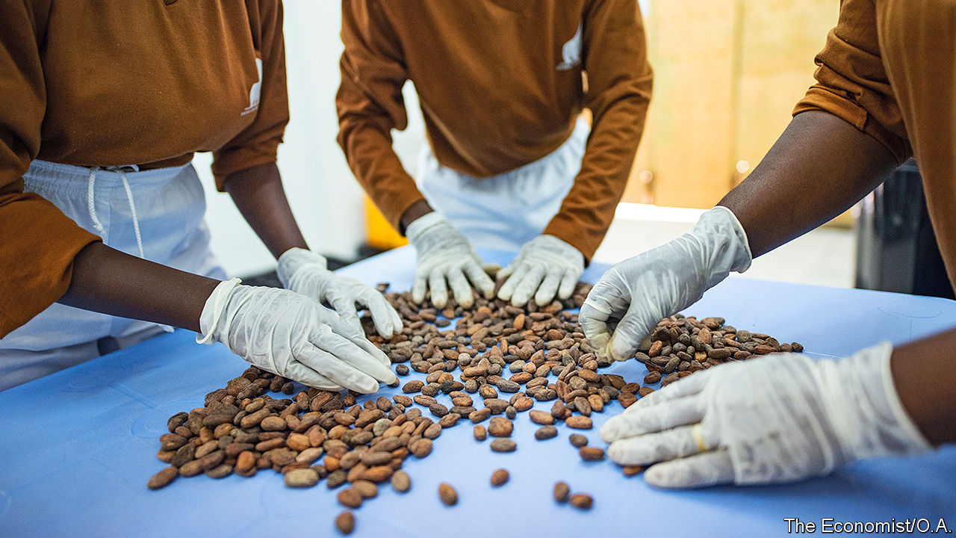

DOMINIQUE PERSOONE, the bad boy of Belgian chocolate, has served powdered chocolate that has been snorted like cocaine at a party for the Rolling Stones and had the sticky stuff drizzled on naked women for a photo shoot. His latest escapade is making chocolate in the jungles of eastern Congo.

The scheme is less madcap than it may sound. The factory is just outside the Virunga National Park, a vast reserve that is home to endangered mountain gorillas and other wildlife. The park is threatened by hundreds of militiamen who poach its animals, and by farmers who sneak in to plant crops. One way of protecting it is to create jobs by making posh chocolate from local cocoa.

The new factory sandwiched between dense rainforests and the Rwenzori mountains will churn out up to 5,000 bars a week. Many will be sold in Mr Persoone’s shops in Antwerp and Bruges.

The factory runs on hydroelectric power generated in the park, as do nearby soap and chia-seed factories. Emmanuel de Merode, the park director, hopes reliable power will attract more investment. “People have perceptions of eastern Congo as a disaster area,” he says. “We can create excellent chocolate and show them it is not.” But the region still faces huge problems. Just after seeing off an outbreak of Ebola, cases of covid-19 are cropping up. Mountain gorillas are susceptible to it, so Virunga has closed its gates to tourists.

At the chocolate factory, Jacqueline Zawadi gossips with two fellow workers as they shell cocoa beans. Her husband was one of the more than 200 rangers who have been killed by poachers or militiamen since 1996. The park has employed her since his death. Three other factory workers peer into a whirring machine. Dark chocolate swirls around as it mixes with sugar and butter. Fresh chilli and ginger are sprinkled into some batches to give the chocolate an extra kick. “It is not quite perfect,” admits Roger Marora, a worker. “But it is very nearly perfect.”

Mr Persoone, who has received test bars in the post, does not yet agree. He will give the signal to export only when the chocolate meets his standards. “I am putting my name on the bars,” he says. “They have to be good.”

This article was downloaded by calibre from <https://www.economist.com/middle-east-and-africa/2020/04/04/a-chocolate-factory-in-a-conflict-zone>

|  |  |  |  |
| --- | --- | --- | --- |
| Previous | Articles | Sections | Next |

|  |  |  |  |
| --- | --- | --- | --- |
| Previous | Articles | Sections | Next |

#### Viral violence

# Some African governments are enforcing lockdowns brutally

Stay home or be whipped

Apr 4th 2020 | JOHANNESBURG

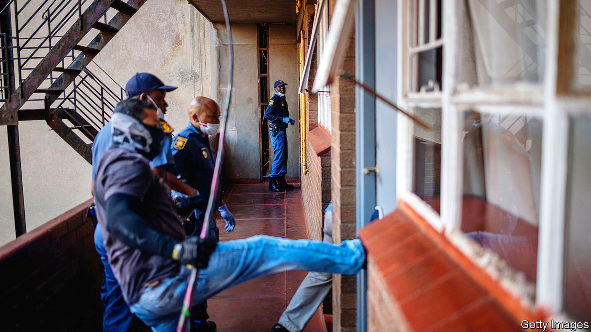

Editor’s note: The Economist is making some of its most important coverage of the covid-19 pandemic freely available to readers of The Economist Today, our daily newsletter. To receive it, register [here](https://www.economist.com/newslettersignup). For more coverage, see our coronavirus [hub](https://www.economist.com/coronavirus)

DURING APARTHEID in South Africa, policemen who wanted to control crowds often reached for the sjambok—a vicious, three-foot-long whip traditionally made of rhino hide. That symbol of brutality was banned in 1989. But it is back in use as police enforce a 21-day lockdown meant to slow the spread of covid-19.

On March 30th in Hillbrow, a gritty part of Johannesburg, an unmarked police car cruised the streets before a plainclothes officer got out and chased residents who were deemed to be defying the rules. He beat them with his sjambok—no questions asked, no warnings given. Asked to explain, the uniformed driver of the vehicle said that people had to be taught to comply. Orders came from “the top”, he claimed.

Many African governments have told their people to stay at home to slow the spread of the virus. On March 22nd Rwanda became the first country in sub-Saharan Africa to impose a nationwide lockdown. Others have followed suit, including Botswana, South Africa and Uganda. On March 30th Nigeria shut down Abuja, the capital, and Lagos, Africa’s largest city.

There is a logic to these measures. Although most of the 49 African countries known to have covid-19 have fewer than 100 confirmed cases, their health systems will buckle if the virus spreads rapidly. Governments also want to stem the flow of people from cities to the countryside, where medical services are especially scarce.

Yet these measures are fiendishly difficult to enforce. Lagos is not London. Roughly half of African city-dwellers live in slums. Most earn a living doing informal work. There is little space to isolate oneself and a persistent need to go out for food, water or work. Policies to replace lost income have been slow in coming.

That would imply security forces ought to tread carefully. Sadly, few are doing so. When not sjambokking pedestrians, South Africa’s police have been firing rubber bullets at shoppers outside a supermarket and even at nurses protesting against a lack of protective gear.

Rwanda’s first fatalities linked to the pandemic came when police shot dead two people, allegedly because they had defied its lockdown. Kenyan police have beaten dozens and set off tear-gas to enforce a dusk-to-dawn curfew. On March 31st they shot and killed a 13-year-old boy who was standing on his third-floor balcony in Nairobi. In Uganda, where the state criminalises gay sex, the police used social-distancing rules to arrest 20 people who were living in an LGBT shelter.

The use of excessive force does not bode well. Lockdowns will not work unless they have public support. And that support will be withheld if governments abuse their poorest citizens in the midst of a pandemic. Covid-19 has many nasty side-effects. The bulldozing of human rights should not be one of them. ■

Dig deeper:  
For our latest coverage of the covid-19 pandemic, register for The Economist Today, our daily [newsletter](https://www.economist.com/newslettersignup), or visit our [coronavirus hub](https://www.economist.com/coronavirus)

This article was downloaded by calibre from <https://www.economist.com/middle-east-and-africa/2020/04/04/some-african-governments-are-enforcing-lockdowns-brutally>

|  |  |  |  |
| --- | --- | --- | --- |
| Previous | Articles | Sections | Next |

|  |  |  |  |
| --- | --- | --- | --- |
| Previous | Articles | Sections | Next |

#### Lakes of unwanted oil

# A lost year in Saudi Arabia

The oil crash and the pandemic have roiled plans to focus on diplomacy and growth

Apr 4th 2020 | BEIRUT

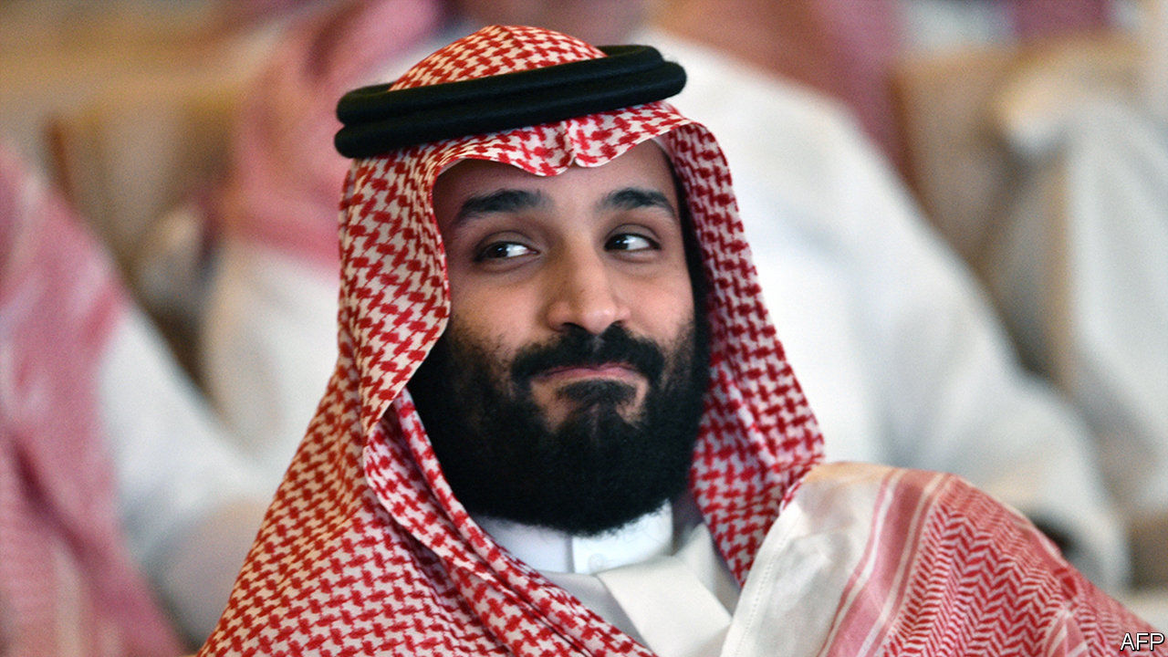

THE YEAR had got off to a good start for Saudi Arabia. After a sluggish stretch the non-oil economy was growing, and officials were eager to lure new investment. The war in neighbouring Yemen seemed to be winding down. The world had largely moved on from the murder of Jamal Khashoggi, a journalist dismembered by Saudi agents in 2018. And the kingdom was set to host the G20 summit in November.

Lately, though, things have not gone to plan. Muhammad bin Salman, the crown prince and de facto ruler, locked up several princes and scores of civil servants in March. Then he started an oil-price war that sent crude to its lowest level since 2003. The plunge upset not only Russia, its target, but also friends from Abu Dhabi to Washington. And now covid-19 has frozen the Saudi economy and left it with lakes of unwanted oil. Far from being a year to charm diplomats and woo investors, 2020 may leave the kingdom in a deeper economic and diplomatic hole.

In different times the arrest last month of Prince Ahmed, the last living full brother of King Salman, might have been bigger news. The police also rounded up Muhammad bin Nayef, a former heir apparent, and dozens of state employees. Saudis close to the royal court accused the detainees of scheming against the crown prince. Yet there is no evidence of any plot. Indeed, some of the alleged plotters have been released. Instead the arrests seem to have been another warning shot by a prince who tolerates no dissent.

Prince Muhammad’s rash persona was on display days later when OPEC and Russia failed to reach a deal on new output curbs. The prince allegedly overruled his half-brother, the oil minister, and ordered Aramco, the state oil company, to boost production. With the market awash with oil, prices crashed below $30 a barrel and may fall further still. Saudi Arabia is tired of playing swing producer, cutting output to prop up prices when others refuse to do the same. Prince Muhammad is also worried about the future of oil in a world trying to wean itself off the stuff.

If prices stay low, however, the kingdom will need to plug a budget shortfall of up to $2bn a week. It has already cut spending by 50bn rials ($13.3bn), the only G20 member to trim outlays during the pandemic. Ministries have been asked to plan even deeper cuts. Construction firms say new contracts have ground to a halt.

Publicly allies have played along. The state oil company of the United Arab Emirates (UAE) pledged to boost its own output from 3m to 4m barrels a day. In private, though, Gulf officials fume about a decision that will blow holes in their budgets. The UAE has tried, so far without success, to bring Russia and Saudi Arabia back to negotiations. So has America. Barely a year ago President Donald Trump was raging against OPEC for high prices. Now he wants the cartel to raise them before cheap crude cripples America’s shale industry. But the Saudis seem unwilling to budge—even as covid-19 destroys global demand.

Saudi Arabia moved faster than many countries to contain the virus. By mid-March, when it had less than 100 documented cases, it had grounded international flights and suspended pilgrimages to Mecca. Thousands of returnees from abroad were quarantined in pleasant hotels at state expense and tested. Quick action seems to have helped. The kingdom has 1,720 confirmed cases, among the lowest per-capita numbers in the region.

Still, the economic consequences will be severe. The effort to switch the Saudi economy away from oil relies heavily on private consumption. More than 426,000 Saudis work in retail, which has ground to a halt. The kingdom started issuing tourist visas in September and hoped to draw hundreds of thousands of visitors in 2020. Few are likely to show up. Investment may stall.

The virus may also force Saudi Arabia to cancel the most important events on its calendar. The haj, the annual pilgrimage to Mecca (a once-in-a-lifetime duty for Muslims), is meant to begin in late July. Last year it drew 2.5m people. Such a crowd is unlikely while covid-19 rages. On March 31st the minister in charge of pilgrimages told Muslims not to make travel plans yet. A government-backed research centre has published a list of past pilgrimages interrupted by war, bandits and disease. But cancelling the haj would have a cost. Mecca is the largest contributor to GDP after oil.

As for the G20, three weeks after the World Health Organisation declared covid-19 a pandemic, the bloc has done little to co-ordinate a response. Its heavyweights, America and China, would rather bicker with each other. Even the G7, a more homogeneous bloc, could not reach a joint statement because of America’s insistence on calling it the “Wuhan virus”, a name to which China objects. The crown prince’s coming-out party may be overshadowed by further feuding. That is, if it happens at all. If the virus roars back in the autumn, as some epidemiologists expect, the summit might end up not in a gilded ballroom, but on Zoom. ■

This article was downloaded by calibre from <https://www.economist.com/middle-east-and-africa/2020/04/04/a-lost-year-in-saudi-arabia>

|  |  |  |  |
| --- | --- | --- | --- |
| Previous | Articles | Sections | Next |

|  |  |  |  |
| --- | --- | --- | --- |
| Previous | Articles | Sections | Next |

#### Insular, but not isolating

# Why covid-19 has spread among Israel’s ultra-Orthodox

Open schools and crowded prayers accelerate contagion

Apr 4th 2020 | BNEI BRAK

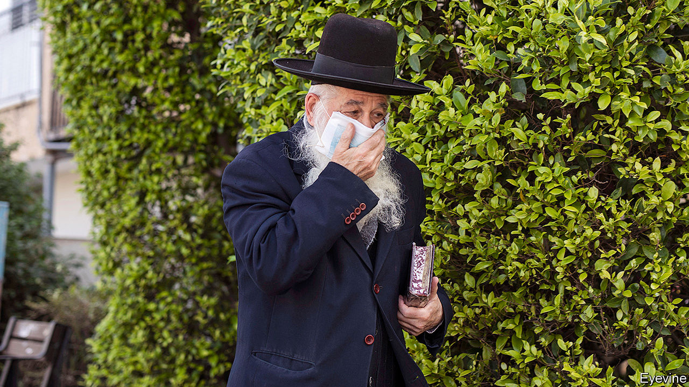

Editor’s note: The Economist is making some of its most important coverage of the covid-19 pandemic freely available to readers of The Economist Today, our daily newsletter. To receive it, register [here](https://www.economist.com/newslettersignup). For more coverage, see our coronavirus [hub](https://www.economist.com/coronavirus)

THIS WAS to be the week when Binyamin Netanyahu, the prime minister of Israel, finally won. After three inconclusive elections in the span of a year, he had all but convinced his bitter rival, Benny Gantz, to join him in government. There were still some things to be worked out, such as how fast to annex parts of the occupied West Bank, and who would lead the justice ministry and thus oversee Mr Netanyahu’s corruption trial. But Mr Gantz’s Blue and White party had already split, with about half its representatives supporting a coalition deal that would leave Mr Netanyahu in office until September 2021, when he would hand over to Mr Gantz.

Alas, the outbreak of covid-19 is getting in the way. On March 30th Mr Netanyahu isolated himself after an aide came down with the virus. Mr Netanyahu tested negative for the disease and left quarantine days later. But he went back into isolation after the health minister was diagnosed with the virus on April 1st. Both the aide and the minister are ultra-Orthodox. The outbreak is raging among their fellows.

Take the ultra-Orthodox city of Bnei Brak, which has the second-most cases in Israel despite being its ninth-largest city. Ultra-Orthodox quarters of Jerusalem also have more infections than neighbouring ones, underlining how the virus is spreading more quickly among this community, which is about 12% of the population.

For weeks after most Israelis began social-distancing at the behest of the government, life continued as normal in ultra-Orthodox communities, which retain a large degree of autonomy. The study of the Torah and Talmud did not stop in ultra-Orthodox schools even though the rest of Israel’s education system shut down on March 12th. Prayers continued in crowded synagogues, despite data showing they were hubs of infection. Only at the end of March did ultra-Orthodox rabbis, who initially said the “Torah protects and saves”, at last stop their followers praying in public.

Other factors made things worse. For example, the ultra-Orthodox are forbidden by their rabbis from owning televisions and radios. They can buy mobile phones, but these are blocked from accessing the internet and messaging apps. That meant that public-health information was slow to arrive. Many failed to receive text messages sent by the government telling them that they had the virus. And it was not hard for the infected to spread the disease. The ultra-Orthodox tend to have large families and often live in cramped quarters. Bnei Brak is Israel’s most crowded city, with 27,000 residents per square kilometre, three times the density of Tel Aviv.

Mr Netanyahu, who relies on the support of ultra-Orthodox parties, was reluctant to close synagogues. Police were sent into ultra-Orthodox areas only after the rabbis themselves ruled that prayers should be held in private. On April 1st the prime minister restricted movement into and out of Bnei Brak. But some in the city are ignoring the government, holding prayers and keeping study halls open.

For decades the ultra-Orthodox have been allowed to run their own affairs, with government funding. Most neither serve in the army nor work. Many Israelis resent this. As the ultra-Orthodox begin using up scarce medical supplies, more questions will surely be asked about their unique position in Israeli society. ■

Dig deeper:  
For our latest coverage of the covid-19 pandemic, register for The Economist Today, our daily [newsletter](https://www.economist.com/newslettersignup), or visit our [coronavirus hub](https://www.economist.com/coronavirus)

This article was downloaded by calibre from <https://www.economist.com/middle-east-and-africa/2020/04/04/why-covid-19-has-spread-among-israels-ultra-orthodox>

|  |  |  |  |
| --- | --- | --- | --- |
| Previous | Articles | Sections | Next |

|  |  |  |
| --- | --- | --- |
| Middle East and ... | Sections | Britain |

Europe

France and covid-19: The new war

.

European agriculture: Farmhands needed

.

Sweden and covid-19: Europe’s outlier

.

Germany’s would-be leader: Söder’s moment

.

Kosovo: A Balkan bust-up

.

Charlemagne: The Orban way

.

|  |  |  |
| --- | --- | --- |
| Middle East and ... | Sections | Britain |

|  |  |  |  |
| --- | --- | --- | --- |
|  | Articles | Sections | Next |

#### Mobilising against a pandemic

# France’s Napoleonic approach to covid-19

The pluses and pitfalls of a centralised approach

Apr 4th 2020 | PARIS

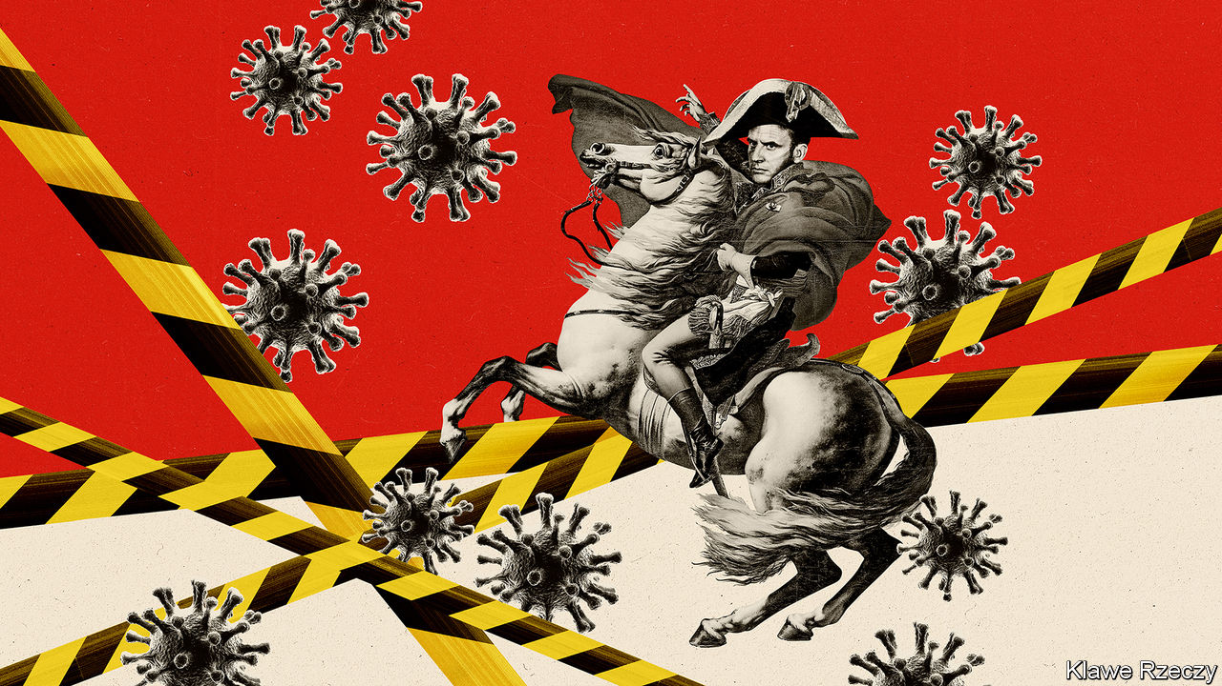

Editor’s note: The Economist is making some of its most important coverage of the covid-19 pandemic freely available to readers of The Economist Today, our daily newsletter. To receive it, register [here](https://www.economist.com/newslettersignup). For more coverage, see our coronavirus [hub](https://www.economist.com/coronavirus)

THE TGV bullet-train that pulled out of Strasbourg railway station on the morning of March 26th made French history, but not for speed. Aboard were 20 patients on life-support machines, transferred onto beds mounted atop passenger seats, four to a carriage. Their railway journey took them from eastern France, the region first overwhelmed by covid-19, to critical-care units in Nantes, Angers and other cities in the west. By April 1st converted TGVs had transferred dozens of patients out of the east, and increasingly from Paris, too. This is the first time France has mobilised its high-speed trains for intensive-care transport, part of a national effort to relieve overloaded regional hospitals struggling with the pandemic.

By April 1st France had recorded 57,763 cases of covid-19 and 4,043 deaths. Its trajectory is less awful than that of Italy or Spain, but deaths are far higher than in Germany. As the country braced for worse to come, the government extended its lockdown until April 15th and warned the French: “We are going to live through a very difficult, very tense, very brutal moment.” France has a long history of central rule, and a powerful administrative machinery to enforce it, dating back to the time of Napoleon, and in part to the kings before him. The crisis is revealing the advantages of such a system—but also its limits.

The ancient French dirigiste reflex can be seen behind the swift geographical dispatch of intensive-care patients that began on March 18th. The department of Haut-Rhin saw an early cluster of cases, centred on a five-day evangelical gathering in Mulhouse. By March 17th, when President Emmanuel Macron put the entire country into lockdown, intensive-care units there were already swamped. It turned out that the SNCF, the state-owned railways, last year tested the conversion of ordinary passenger trains into medical transport during a disaster-planning exercise. Now TGVs are part of a countrywide reallocation system, which also involves the armed forces. The air force has flown patients on life-support from eastern France to hospitals in Brittany, Bordeaux and Marseille, while a Mistral-class naval vessel has transported other critically-ill people from Corsica to Marseille. Neighbouring countries have also taken patients from eastern France.

France’s administrative structure has also enabled it to impose and enforce confinement unapologetically. The day after lockdown was announced, the central bureaucracy had, naturellement, drawn up a new form, which each individual must sign to justify any trip out of the home. Policemen and gendarmes, patrolling the near-empty streets, parks and beaches, have since carried out a staggering 5.8m checks on such paperwork and imposed 359,000 fines. There has been scarcely a murmur at this, nor at the government’s “state of health emergency” law which, among other things, gives it powers to control prices of certain products and requisition stocks. Old habits die hard.

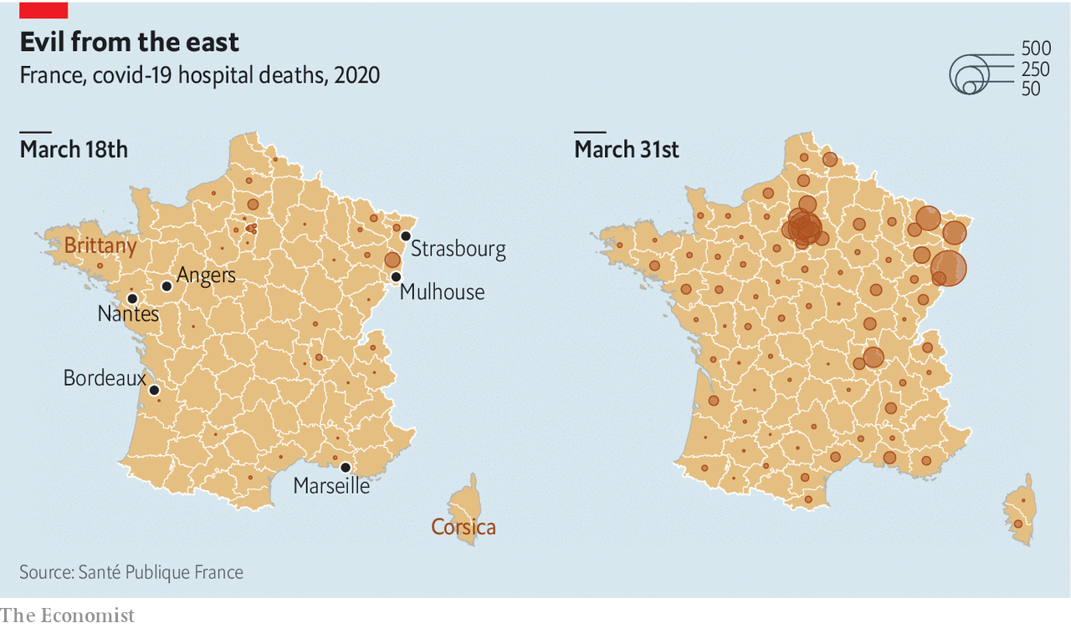

The emergency also makes use of the existing command-lines of a centralised bureaucracy. Among his measures to support workers and businesses, Bruno Le Maire, the finance minister, included a “partial unemployment” scheme to help firms avoid redundancies, under which the state pays 84% of employees’ wages. Despite initial wrinkles, it already covers 3.6m employees. Indeed the French seem to be reconnecting enthusiastically with their inner Jean-Baptiste Colbert, finance minister to Louis XIV. On a visit to a medical-mask factory on March 31st, Mr Macron declared that “the day after won’t look like the days before” and that it was now crucial “to produce more in France”. Even the cosy, unloved Parisian elite, which usually meets over dinner in parquet-floored salons, has become a handy network, as bosses of luxury firms and car-parts makers turn factories over to the health effort.

Yet in other ways France is also discovering the shortcomings of such a system. One is that the centrally made decisions can be wrong. Take the shortage of masks. Back in 2012, thanks to disaster planning, France had a stockpile of 1.4bn medical masks. By the time the covid-19 crisis began, however, that stock had dwindled to just 140m. The reason was a change of strategy, which proved flawed, to rely instead on contracts to import rapidly from China and elsewhere.

Another is that it can hinder local initiative. Next to Germany, for example, the French are lagging on testing. Germany’s decentralised health system seems to have helped encourage the rapid development of tests in different laboratories around the country, as well as their early use. “The Napoleonic question is really important,” says François Heisbourg, of the Foundation for Strategic Research, who was involved in France’s disaster planning 15 years ago: “On testing, we have seen a beautiful centralised system failing abjectly.”

Moreover a centralised administration relies on high levels of trust, since there are few alternative sources of authority. Yet public trust also requires patience, which is hard to manage in an emergency. This has been clear during a row over the use of chloroquine to treat covid-19, advocated by Didier Raoult, a microbiologist in Marseille. Even as the French central health authority expressed doubts, long queues appeared on the pavement outside his clinic. Olivier Véran, the health minister, initially kept to protocol by announcing that chloroquine would not be approved before undergoing full clinical tests. As public impatience mounted, on March 26th he decided to authorise its use for covid-19 patients in certain circumstances anyway.

It is a sobering moment for a country with a first-class health system and one of the highest life expectancies in the world. France is hoping that confinement will begin to slow the rate of admissions to intensive care to a manageable level while orders of extra equipment, including much-needed ventilators, come through. In the meantime, hospitals are doing what they can. And Paris, where the streets are as empty as intensive-care units are full, is steeling itself for the worst. ■

Dig deeper:  
For our latest coverage of the covid-19 pandemic, register for The Economist Today, our daily [newsletter](https://www.economist.com/newslettersignup), or visit our [coronavirus hub](https://www.economist.com/coronavirus)

This article was downloaded by calibre from <https://www.economist.com/europe/2020/04/04/frances-napoleonic-approach-to-covid-19>

|  |  |  |  |
| --- | --- | --- | --- |
|  | Articles | Sections | Next |

|  |  |  |  |
| --- | --- | --- | --- |
| Previous | Articles | Sections | Next |

#### Farmhands needed

# When borders close, who will pick the crops?

Lockdowns to curb covid-19 disrupt Europe’s food supply

Apr 4th 2020 | BEELITZ AND WARSAW

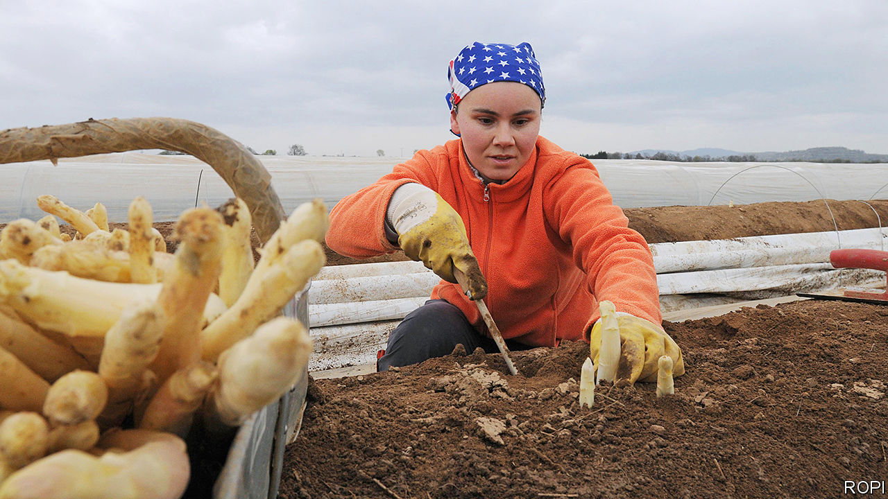

Editor’s note: The Economist is making some of its most important coverage of the covid-19 pandemic freely available to readers of The Economist Today, our daily newsletter. To receive it, register [here](https://www.economist.com/newslettersignup). For more coverage, see our coronavirus [hub](https://www.economist.com/coronavirus)

NO SONG CAPTURES the mood of Germany in spring quite like the 1930 hit “Veronika, the spring is here”: “The girls are singing tra-la-la, the whole world is enchanted. Veronika, the asparagus is sprouting!” April in Germany is Spargelzeit, or “asparagus time”. Purists race to farm stalls to buy the freshest stalks (white, unlike the green summer variety), and serve it up with sliced ham and hollandaise sauce or with breadcrumbs and butter. But this year much of the crop will rot in the fields. Border restrictions to fight covid-19 are keeping the eastern European agricultural workers who help to pick it at home.

Germany normally employs 30,000 seasonal farmhands for the asparagus harvest, with 5,000 in the state of Brandenburg alone. So far in Brandenburg only about half that number have arrived. Germany’s border is open for Poles working in critical sectors, but Polish farm workers hesitate to cross it because their government says any who do will be quarantined for 14 days on their return. In late March, desperate asparagus farmers chartered a plane to fly in 190 Romanians. They nearly failed to get in: on March 25th Germany barred seasonal workers from countries that do not belong to the Schengen border-free zone.

Asparagus is just the tip of a problem that European farmers will soon face. Germany will need almost 300,000 seasonal farmhands this year. France, where strawberry season is approaching, needs 200,000 in the next three months; between a third and two-thirds usually come from abroad. The Netherlands is Europe’s biggest agricultural exporter, but most of the workers who pick tomatoes and cucumbers in its greenhouses are from eastern Europe, and many will not come this year.

Some industries can be put on hold, but not agriculture. On March 30th the European Commission laid out principles to make sure crucial employees, including seasonal farm workers, can cross borders. But Bulgarians and Romanians travelling to western Europe would normally go through Hungary, which shut its border with Romania in mid-March. (It has reopened, but mainly for freight and commuters who live near the frontier.) Even where borders are open, many workers are not coming, worried about contracting covid-19 abroad or being quarantined when they return.

Staying at home means hardship. Nitfie Salimova, a Bulgarian, had planned to go to Belgium in May to pick berries, a job that last year earned her €150 ($160) per day. That is almost half the Bulgarian minimum monthly wage. Her earnings paid for smartphones for her daughters and a Black Sea holiday. The head of a Bulgarian agency that sends 500 workers per year to Germany, Austria and Britain says no one is going now; in fact, scores are heading home.

In Poland the problem is not just loss of jobs in Germany, but a shortage of the Ukrainians who work on Polish farms. Jakub Sztandera, who grows mushrooms in Siedlce, employs 200 workers in his climate-controlled sheds, 90% of them Ukrainian. When Poland closed its borders on March 14th, Ukrainians rushed to leave, and Mr Sztandera is not sure how to replace them. Around 1.3m Ukrainians were estimated to be working in Poland before the border closed. The head of the country’s farmer’s union says that without them the food supply will be at risk.

Some countries hope to limit the damage by letting workers who are already there stay longer. Belgium has lengthened work-permits for foreign farmhands, and Germany has extended the period in which they can work without paying local social security taxes. In the Netherlands a collapse of demand for flowers has left workers who came to pluck tulips with little to do; some have gone to vegetable farms.

Another solution is to recruit locals idled by the shutdown. In Germany a website for farm jobs received thousands of postings on its first day. France’s agricultural umbrella organisation, the FNSEA, says its new jobs site has 150,000 subscribers. An online jobs market in the Netherlands called “Help Us Harvest” has 2,500 openings. But it is not clear how many jobs have actually been filled.

Europe’s farmers would rather not rely on first-timers. Edwin Veenhoeve, an asparagus farmer in the Netherlands, says that in the past 40 years perhaps ten Dutch people had ever applied to work the harvest on his family farm. This month alone 30 have applied. Still, compared with experienced Poles, Romanians and Bulgarians, they are not ideal farmhands, he adds: “Dutch people are used to working Monday to Friday, nine to five. But the asparagus keeps growing seven days a week.” ■

Dig deeper:  
For our latest coverage of the covid-19 pandemic, register for The Economist Today, our daily [newsletter](https://www.economist.com/newslettersignup), or visit our [coronavirus hub](https://www.economist.com/coronavirus)

This article was downloaded by calibre from <https://www.economist.com/europe/2020/04/04/when-borders-close-who-will-pick-the-crops>

|  |  |  |  |
| --- | --- | --- | --- |
| Previous | Articles | Sections | Next |

|  |  |  |  |
| --- | --- | --- | --- |
| Previous | Articles | Sections | Next |

#### The Swedish exception

# Why Swedes are not yet locked down

For now, they can go to bars. That may change soon

Apr 4th 2020 | STOCKHOLM

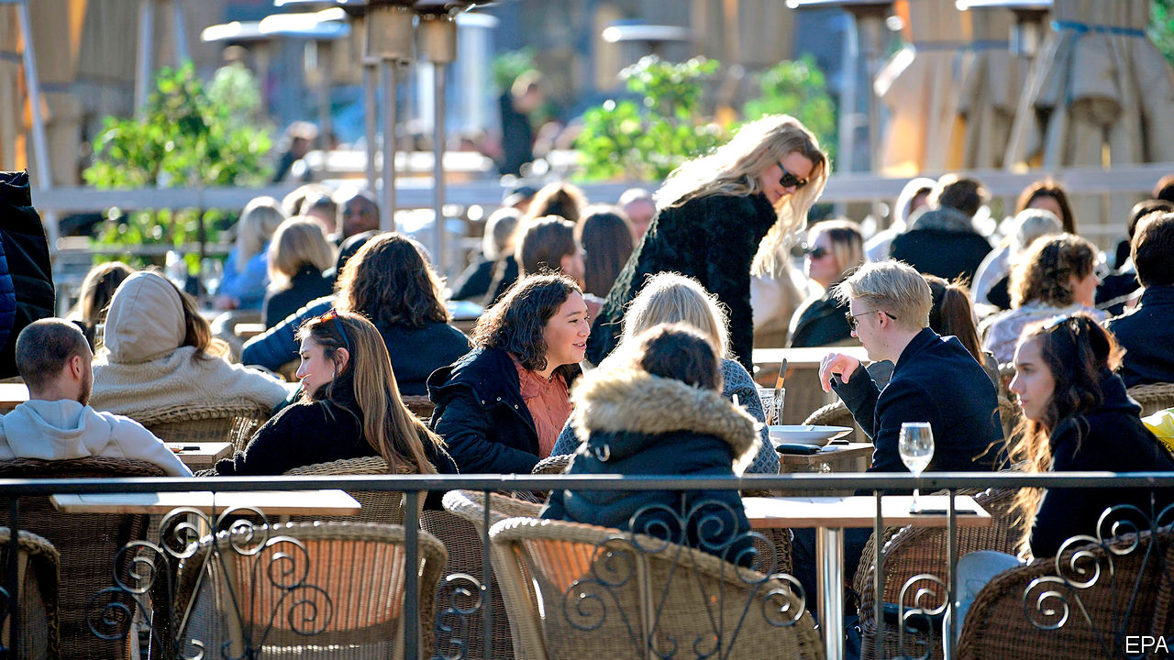

Editor’s note: The Economist is making some of its most important coverage of the covid-19 pandemic freely available to readers of The Economist Today, our daily newsletter. To receive it, register [here](https://www.economist.com/newslettersignup). For more coverage, see our coronavirus [hub](https://www.economist.com/coronavirus)

WHILE SWEDEN’S fellow Scandinavians and nearly all other Europeans are spending most of their time holed up at home under orders from their governments, Swedes last weekend still enjoyed the springtime sun sitting in cafés and munching pickled herrings in restaurants. Swedish borders are open, as are cinemas, gyms, pubs and schools for those under 16. Restrictions are minimal: the government recommends frequent handwashing for all, working from home for those who can, and self-isolation for those who feel ill or are older than 70. That includes King Gustaf and his wife Silvia, who are self-isolating in a castle. Only on March 29th did Sweden ban gatherings of more than 50.

Britain had a similarly relaxed approach until March 23rd, but then the government imposed a national lockdown. As the number of reported infections and deaths among the 10m Swedes rose to 4,947 and 239 respectively as of March 31st, many predict that Sweden will soon follow the rest of Europe’s example. Some fear it may have wasted precious time.

Inherent in Sweden’s social contract is trust in the state, trust by the state in its citizens and trust among citizens, explains Lars Traghardt, a historian. Swedes can be relied on to adhere to rules voluntarily and to self-regulate. Moreover, jokes Carl Bildt, a former prime minister, “Swedes, especially of the older generation, have a genetic disposition to social distancing anyway.” Over half of Swedish households consist of just one person, the highest number of single-person households in the world. The country is sparsely populated. And Swedes do not kiss or hug as much as southern Europeans tend to do.

Business leaders have been more vocal in their opposition to a national lockdown than in other countries. Jacob Wallenberg, chairman of Investor, an investment company, warned about social unrest, violence, dramatic unemployment and great suffering if the covid crisis goes on for long in an interview with the Financial Times. Johan Torgeby, chief executive of SEB, a bank, worries about creating a banking crisis on top of an economic and health crisis.

So far the policy of Stefan Lofven, the prime minister, has been guided by the independent Public Health Agency. Anders Tegnell, the agency’s chief epidemiologist, advised the government to let the virus spread as slowly as possible while sheltering the vulnerable until much of the population becomes naturally immune or a vaccine becomes available.

Yet some experts worry that Mr Lofven is prioritising the health of the economy over that of the public. A petition signed by more than 2,000 scientists and professors, including Carl-Henrik Heldin, the chairman of the Nobel Foundation, called on the government to introduce more stringent containment measures. It is too risky to let people decide how to behave, argues Joacim Rocklov, an epidemiologist at Umea University.

During other pandemics, such as the outbreak of cholera at the end of the 19th century or the AIDS pandemic in the 1980s, Sweden imposed more stringent restrictions than its neighbours. So far the public is supportive of Mr Lofven’s contrarian strategy—but once the death toll rises this may quickly change. ■

Dig deeper:  
For our latest coverage of the covid-19 pandemic, register for The Economist Today, our daily [newsletter](https://www.economist.com/newslettersignup), or visit our [coronavirus hub](https://www.economist.com/coronavirus)

This article was downloaded by calibre from <https://www.economist.com/europe/2020/04/04/why-swedes-are-not-yet-locked-down>

|  |  |  |  |
| --- | --- | --- | --- |
| Previous | Articles | Sections | Next |

|  |  |  |  |
| --- | --- | --- | --- |
| Previous | Articles | Sections | Next |

#### Bavaria’s action man

# Markus Söder makes his mark

Might he bid to be Germany’s chancellor?

Apr 4th 2020 | MUNICH AND NEUBEUERN

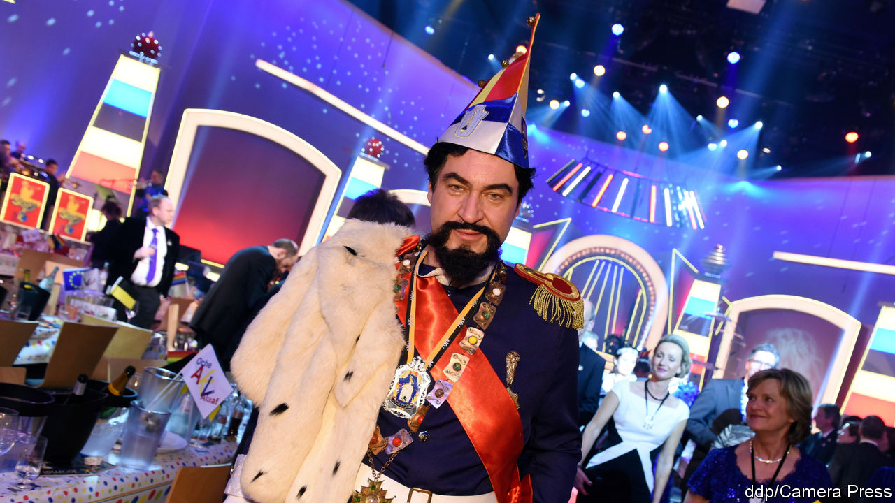

Editor’s note: The Economist is making some of its most important coverage of the covid-19 pandemic freely available to readers of The Economist Today, our daily newsletter. To receive it, register [here](https://www.economist.com/newslettersignup). For more coverage, see our coronavirus [hub](https://www.economist.com/coronavirus)

THE CHATTER is flowing almost as freely as the beer at the Stammtisch (regulars’ table) in Neubeuern, a pretty Bavarian town near the Austrian border. Supporters of the Christian Social Union (CSU), a conservative party that runs the state, have gathered to take stock ahead of local elections. Asked if Markus Söder, the CSU chief and state premier, is doing well, all ten put a hand up. Asked if he would be a good chancellor, the tally falls to six; he would struggle to hold Germany together, says a dissenter. This informal poll was taken before Mr Söder imposed some of Germany’s strictest social-distancing rules. His performance since may have convinced some of the doubters.

Bavaria, a big, rich, swaggering state, has more covid-19 cases than any other. But Mr Söder is having a good crisis. He closed schools early; when other states followed it seemed as if Munich rather than Berlin was driving policy. He inserted himself into national economic debates and left other state premiers, such as Armin Laschet in North Rhine-Westphalia, who has said Germany must think about easing restrictions, looking flat-footed or naive. As others catch up, Mr Söder finds new hobby-horses: his current obsession is ramping up the production of face-masks.

Mr Söder’s elevation to Germany’s de facto corona-chief has surprised many, including his own supporters. Sceptics were legion when he took over in Bavaria two years ago, says Ursula Münch at the Tutzing Academy for Political Education. His ambition, honed for years in the mudpit of Bavarian politics, seemed too raw. He started silly culture wars. In October 2018 he lost the CSU its long-held majority, having tilted rightward in a vain bid to squeeze the populist Alternative for Germany. (He now governs with a smaller party, the Free Voters.)

Yet in the spirit of the outlandish costumes he loves to don in carnival season, Mr Söder simply adopted a new identity. Detecting Germans’ growing climate concerns, he broadcast his love for bees and trees. He found a statesmanlike tone with wide appeal, stressing the economy and technology. Mr Söder hopes to maintain the CSU as a broad church, emulating the party’s other great leaders, Edmund Stoiber and Franz Josef Strauss. “We have gone through a tough process of transformation,” says Markus Blume, the CSU’s general secretary. It seems to have paid off. As Angela Merkel’s Christian Democrats (CDU) slid in the polls, the CSU, its sister party and national coalition partner, stabilised.

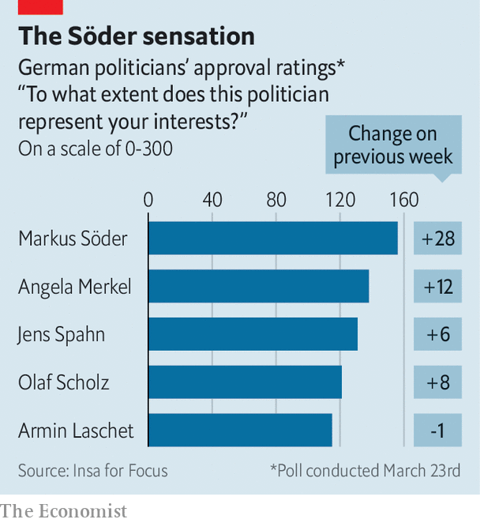

Then came covid-19, which gave state leaders, who run health care and public order, a chance to shine. Germans used to viewing Bavarians with a blend of scorn and envy discovered an unfamiliar feeling of respect. “I’m slowly becoming a Söder fan,” says a bewildered TV-watcher in a recent Berlin newspaper cartoon, fearing he has contracted the fever. In a recent poll Mr Söder emerged as Germany’s most popular politician—even outpacing Mrs Merkel.

No wonder people are asking if he might seek the biggest job of all. Mrs Merkel will leave the chancellery at the next election, in autumn 2021, and at some point the CDU/CSU must anoint a joint candidate to replace her. The victor of the CDU’s agonising leadership contest—once due to be settled in late April, but now on pause—would be the obvious choice. But the weakness of the field (which includes Mr Laschet) and Mr Söder’s success running Bavaria had already begun to turn CDU heads. His recent efforts have turned more.

Mr Söder has always insisted he has no interest in quitting Munich for Berlin. Now, when lives are at stake, he dismisses the speculation as indecent. Messrs Strauss and Stoiber both ran, but failed, to become chancellor. Yet the longer Mr Söder outshines his rivals, the more Germans will wonder if he might seek to break that Bavarian losing streak. ■

Dig deeper:  
For our latest coverage of the covid-19 pandemic, register for The Economist Today, our daily [newsletter](https://www.economist.com/newslettersignup), or visit our [coronavirus hub](https://www.economist.com/coronavirus)

This article was downloaded by calibre from <https://www.economist.com/europe/2020/04/04/markus-soder-makes-his-mark>

|  |  |  |  |
| --- | --- | --- | --- |
| Previous | Articles | Sections | Next |

|  |  |  |  |
| --- | --- | --- | --- |
| Previous | Articles | Sections | Next |

#### A Balkan bust-up

# Did America help oust Kosovo’s reformist government?

A fissile corner of the Balkans just got less stable

Apr 4th 2020 |

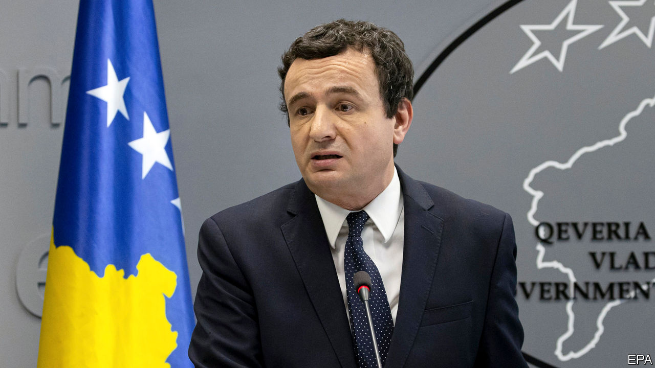

IT WAS ONLY 51 days old, but covid-19 was used to kill it. On March 25th a big majority of deputies in Kosovo’s parliament voted to snuff out the government of Albin Kurti, a radical reformer. They may have been doing America’s bidding. Donald Trump’s administration wanted the truculent prime minister out of the way in order to claim peace in Kosovo as a (rare) foreign-policy success in the run-up to America’s presidential election. Its friends have provided.

Mr Kurti spent more than 20 years as a protest leader. After last October’s election months were spent cobbling together a coalition with the parliament’s second-largest party, the Democratic League of Kosovo. Meanwhile his long-standing enemy, President Hashim Thaci, was talking to Serbia’s leader, Aleksandar Vucic, about a deal to make peace between Kosovo and Serbia. Kosovo, whose people are mostly ethnic Albanians, was a province of Serbia until the Balkan wars of the 1990s. Serbia has never recognised its independence, though most EU countries and a majority of UN members have done so.

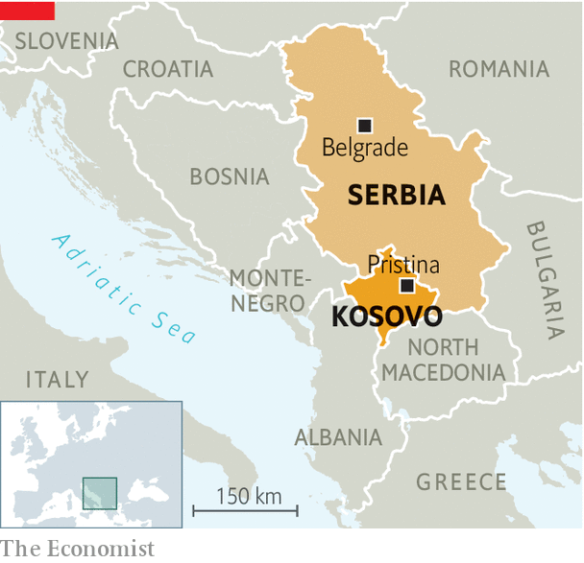

Once in power Mr Kurti announced that he would now take charge of the talks and that he was against any territorial exchanges with Serbia, which Mr Thaci is thought to have discussed as the price of peace. Mr Vucic then said he would do a deal only if tariffs on Serbian goods were lifted. Mr Kurti agreed to that, but only on the basis of “reciprocity”, meaning that goods from Serbia would, instead of tariffs, be subject to a non-tariff barrier in the shape of a ban if those same types of goods are banned from sale in Serbia. Lifting these bans on Kosovar produce is unacceptable to Serbia, as it believes that doing so would imply recognition of the country. So the proposal was swiftly rejected by Richard Grenell, the acting American intelligence head, who is overseeing the peace talks. American financial aid was suspended. (Mr Thaci and the Americans both deny favouring any land swaps.)

Last week Mr Kurti’s government was voted out in parliament, in a procedure ostensibly provoked by a row over the declaration of a state of emergency owing to covid-19, which would have given the president many exceptional powers. Mr Kurti’s supporters are bitter. They believe he was their only chance to rid the country of the corrupt leaders and warlords of the past.

Weeks of wrangling will now follow. If it were not for the virus a snap election could have been called. A divided and unstable corner of Europe has just become a little more precarious.

This article was downloaded by calibre from <https://www.economist.com/europe/2020/04/04/did-america-help-oust-kosovos-reformist-government>

|  |  |  |  |
| --- | --- | --- | --- |
| Previous | Articles | Sections | Next |

|  |  |  |  |
| --- | --- | --- | --- |
| Previous | Articles | Sections | Next |

#### Charlemagne

# How Hungary’s leader, Viktor Orban, gets away with it

He takes near-dictatorial powers, while the EU does nothing

Apr 2nd 2020 |

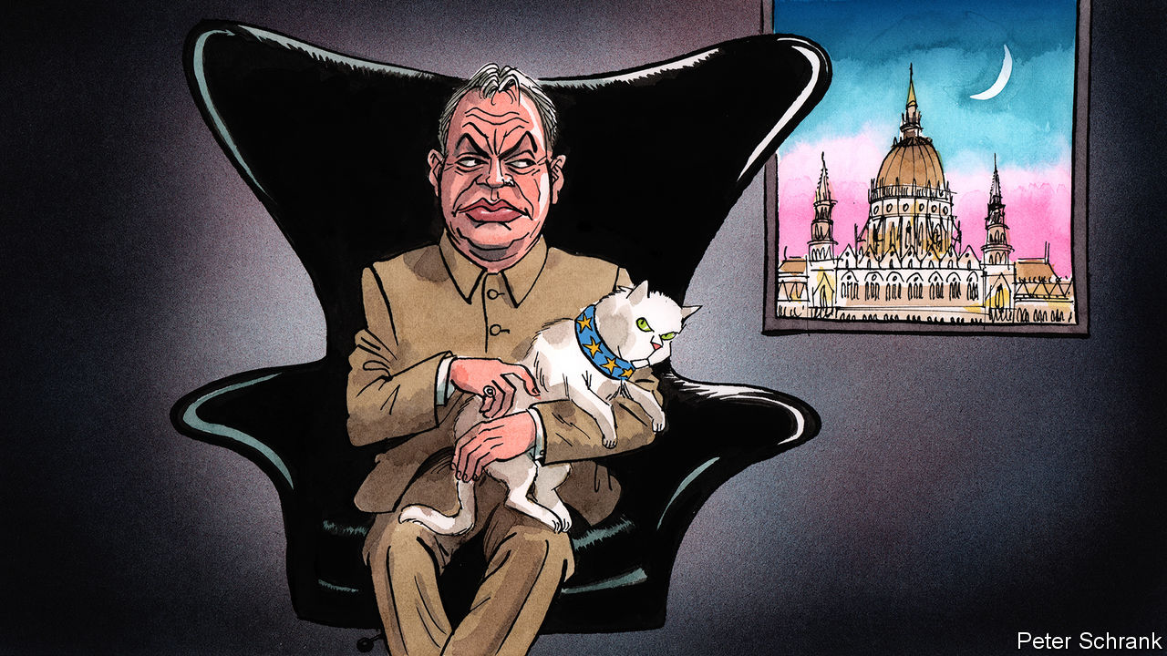

LIKE A BOND villain, Viktor Orban cannot resist revealing his plans. The Hungarian prime minister has never hidden his desire to entrench himself in power. Before taking office in 2010, he remarked ominously: “We have only to win once, but then properly.” True to his word, when handed a big enough majority by Hungarian voters, Mr Orban hollowed out the Hungarian state, rewriting its constitution, purging the country’s courts and nobbling the media. In 2013 he told an interviewer: “In a crisis, you don’t need governance by institutions.” Again, he has followed through. A law enacted on March 30th means Mr Orban can rule by decree—bypassing parliament—until the coronavirus crisis is over. In films the villain is thwarted after revealing his hand. But Mr Orban is up against the European Union, not James Bond, so he succeeds.

No one can say there was no warning. Mr Orban’s career—which has encompassed everything from anti-Soviet liberalism to right-wing nationalism via Christian Democracy—has been dedicated to the accumulation and maintenance of power, rather than the pursuit of principle. Those who knew him well saw what was to come. In 2009 Jozsef Debreczeni, the author of a critical biography, warned: “Once he is in possession of a constitutional majority, he will turn this into an impregnable fortress of power.” A combination of careful strategy, political cunning and a dash of luck have made this prediction come true.

To the frustration of those who have spent the past decade trying to stop him via legal means, Mr Orban is more astute than they think. His “reforms” tend to reach the edge of legal acceptability, but no further. If Mr Orban ever does hit an obstacle, he surrenders some gains, while keeping the bulk of them. (The Hungarian leader even has a name for this legal waltz: the peacock dance.) Opposition figures, civil-rights monitors and commentators around the globe have denounced the latest move as a big step towards dictatorship. Yet, so far, the European Commission has pledged only to examine it. This mealy-mouthed response stems from the fact that its lawyers see little glaringly wrong with the act as it is composed. On paper, Hungary’s parliament can end the state of emergency if the government oversteps the mark. In practice, this probably would not happen. Mr Orban’s Fidesz party—over which he has had near-absolute control for nearly three decades—has two-thirds of the seats in parliament. It is in this gap between legal theory and political reality that Mr Orban thrives.

Luck plays its part in Mr Orban’s success. Hungary is a small country. For EU officials, the erosion of the rule of law in Poland, with its 40m citizens, matters far more in practice if not principle. Mr Orban has consequently been free to attack the EU institutions that bankroll his country to the tune of up to 6% of GDP in some years without generating a fatal backlash from Brussels. Hungary slips down the order of business when leaders are busy with other things, such as a pandemic. Mr Orban has also been fortunate in his opponents. In 2006, while Mr Orban sat in opposition, the then Hungarian prime minister was recorded slating his own government. (“Obviously we have been lying our heads off for the past one-and-a-half, two years.”) A mammoth majority for Mr Orban followed. Hungary’s opposition parties have failed to coalesce. When they do manage to rub along, they succeed. Opposition parties won local elections in Budapest last year.

If Mr Orban is lucky in his enemies, he is even luckier in his allies. Fidesz is still a member of the powerful European People’s Party, a group of centre-right parties across Europe that carves up top jobs in the EU. The commission’s president, Ursula von der Leyen, belongs to the same family, as does Angela Merkel. Under the EPP’s umbrella, Mr Orban was treated as an unruly teenager while rearranging the Hungarian state, rather than a tumour in Europe’s body politic. (At one summit, the then European Commission president, Jean-Claude Juncker, joshingly called him “dictator”.) Fidesz was suspended in 2019, when Mr Orban’s contempt for the rule of law became too brazen, but the EPP grandees stopped short of kicking him out. The collapse of centre-right parties in Italy and France mean Fidesz’s delegation of MEPs is the joint third-largest in the group. Political winds are blowing in Mr Orban’s favour. Bluntly, Mr Orban has not been removed because a majority of the group were keen to keep him. It was the EPP’s dwindling band of liberals who winced at Mr Orban’s actions. Now they are outnumbered by a nationalist strand, who broadly agree with Mr Orban on things like shutting out refugees. The Hungarian leader is less of an outlier in the EPP than he first appears.

## No happy ending

The tsunami of international criticism, in which Mr Orban has been labelled everything from an autocrat to a latter-day Hitler, will not bother the Hungarian leader or his acolytes. It is a fight they want to have. In their minds, the coming crisis is another chance to prove their critics wrong. They put such arguments in the same bracket as those who criticised Mr Orban’s government for erecting a fence and beating back—often literally—migrants and refugees at Hungary’s border during the migration crisis in 2015. Since then, similar hard-nosed policies have been adopted across the EU (usually minus the beating). Mr Orban does not mind being called a dictator. As long as he stops short of outright tyranny, he can paint foes as hysterical. He can also point out that other democracies grant the government extra powers during an emergency, and pretend his intentions are no different.

Reining in Mr Orban will be hard, but not impossible. “The only language he understands is power and money,” says Andras Biro-Nagy of Policy Solutions, a research institute. Brussels has little legal power to stop Mr Orban, but it does have money. Stemming the flow of EU cash to Mr Orban’s government would hurt. So the EU should do it. And after a decade of ignoring his sins, the EPP should stop providing a figleaf of legitimacy to the bully of Budapest.■

This article was downloaded by calibre from <https://www.economist.com/europe/2020/04/02/how-hungarys-leader-viktor-orban-gets-away-with-it>

|  |  |  |  |
| --- | --- | --- | --- |
| Previous | Articles | Sections | Next |

|  |  |  |
| --- | --- | --- |
| Europe | Sections | International |

Britain

Innovation: Move fast and try not to break things

.

Life under lockdown: Home comforts

.

Testing: Negative result

.

Policing a lockdown: Booby on the beat

.

The army: War, or something like it

.

Rough sleeping: Shelter from the storm

.

The steel industry: Braced for trouble

.

Call centres: Please hold

.

Bagehot: The return of the opposition

.

|  |  |  |
| --- | --- | --- |
| Europe | Sections | International |

|  |  |  |  |
| --- | --- | --- | --- |
|  | Articles | Sections | Next |

#### Government

# How covid-19 is driving public-sector innovation

Change is coming at an unprecedented pace

Apr 4th 2020 |

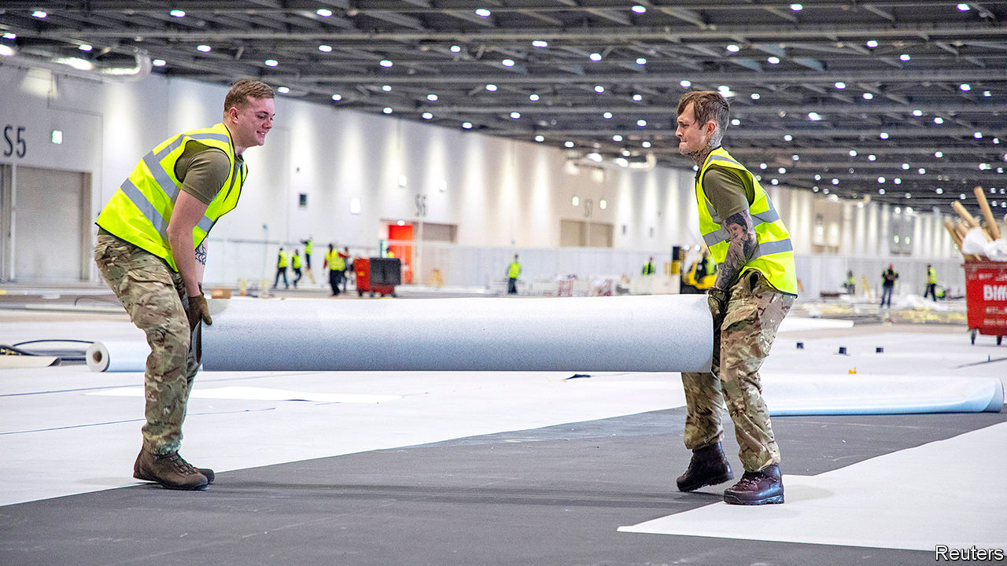

Editor’s note: The Economist is making some of its most important coverage of the covid-19 pandemic freely available to readers of The Economist Today, our daily newsletter. To receive it, register [here](https://www.economist.com/newslettersignup). For more coverage, see our coronavirus [hub](https://www.economist.com/coronavirus)

THE GOVERNMENT is readying for calamity. Boris Johnson has written to every household warning that “things will get worse before they get better.” The number of deaths from covid-19 continues to rise, with 2,357 recorded as The Economist went to press. As the peak of the pandemic looms ever closer, ministers pray the National Health Service (NHS) will cope. On April 1st, London’s EXCEL Centre (pictured) reopened as a 4,000-bed hospital, the first of four conference centres and a stadium being repurposed. Ashleigh Boreham, a colonel who has served in Afghanistan and Iraq, oversaw the army’s involvement. “My grandfather was at the Somme,” he said. “I’m just at a different battle.”

Covid-19, just like war, is forcing innovation on a scale and at a pace that no government would normally contemplate. Across the public sector, what was previously unthinkable is happening. This overhaul of decades or even centuries of procedures and habits is being driven from the centre. As one Treasury official notes, his department has switched from being one that “looks for reasons to say no, to one that looks for ways to make things work”.

New relationships are being formed, with lines between private and public sectors blurred. As well as building new hospitals, the NHS struck a deal at cost price with private hospitals for beds, ventilators and clinicians. It has enlisted Palantir, a firm founded by Peter Thiel, an American venture capitalist, among others, to improve its data analysis. It needs software that allows it to predict when and where the caseload will overwhelm the capacity of a hospital. The government is working with a consortium including Ford, Siemens and the McLaren and Mercedes Formula 1 teams to build new ventilators, which are due to arrive next week.

The need for speed means normal rules are being ripped up. Regulators have been sidelined; league tables and targets forgotten. Power has both been centralised (with the state assuming vast new responsibilities) and diffused (with officials left to get on with solving problems). Outsourcers as well as government departments have got their skates on: according to Rupert Soames, chief executive of Serco, the company has cut the time it takes to hire a worker from a month to four to five days. The firm, which runs call centres for various bits of government, has moved 600 call handlers, or more than a third of its total, to home-working positions in the past few weeks, a 20-fold increase. Before the crisis, allowing call-handlers to work at home was not on the agenda.

Plenty of these innovations are simply about getting through the next couple of months. The new field hospitals will hold more than 10,000 additional patients. But some of these changes may outlast the current crisis. In the NHS, critics of video consultations are being won over. Martin Marshall, chair of the Royal College of General Practitioners, estimates that nine in ten GP appointments happened face-to-face before the crisis. Now, as GPs seek to keep patients away from germ-filled surgeries, he reckons that maybe as many as nine in ten are happening remotely. Doctors are pleasantly surprised by the time freed up.

Reforms that had languished are suddenly being implemented. In 2016 the government launched what it claimed was the most ambitious courts modernisation programme in the world. More than 100 courts were sold to finance a vast digitisation of justice. But by the time pandemic struck, little had changed. One pilot to test video courts involved only 11 hearings. Only a few sorts of cases, such as small claims, operated at a distance. Lawyers complained that existing technology regularly failed.

Then, on March 19th, Ian Burnett, the Lord Chief Justice, told judges that “we will be using technology...which even a month ago would have been unthinkable.” Some courts remain open for essential face-to-face hearings; jury trials will not take place remotely. But many other hearings are now using technology. The bespoke video software the courts service had been developing for use in trials is not ready, so judges, lawyers and clients have simply turned to off-the-shelf platforms, such as Skype. Before the crisis about 200 cases a day were being heard at least partially via conference call or video-link. By March 31st that had risen to around 1,800. The Supreme Court now exists entirely online.

Concerns remain about holding substantive rather than administrative hearings by video-link; indeed, evidence suggests judges are less likely to offer bail when not receiving evidence in person. But the move to online working has been smoother than many expected. Richard Susskind, who has been evangelising for online courts since 1981, thinks their moment has finally come. From self-isolation, he has noticed a sudden spike in sales of his book, “Online Courts and the Future of Justice”. The pandemic is a human tragedy but it is also, he says, “one big testbed for these ideas”.

Some parts of the state are struggling to keep up. Firms are due to receive state subsidies for workers they have furloughed this month, but the self-employed will not receive their support until June. In Germany, by contrast, such payments have already landed. The vast numbers of Britons unable to wait for the money risk overwhelming the benefits system. One bottleneck is Verify, a private system through which users confirm their identity.

There are also problems in the health system, such as a lack protective equipment for medics, with distribution difficulties to blame. The government is struggling to ramp up testing (see article). Other services have no choice but to continue as before: there is not yet a way to collect the bins remotely. But where innovation is possible, in patches, it is happening at a staggering pace.

Dominic Cummings, the prime minister’s chief aide, and an advocate of revolution in government, has written of how a “beneficial crisis” can drive change. It seems improbable that even he would have chosen this route to reform. But as Nigel Edwards, chief executive of the Nuffield Trust, a think-tank, notes: “When we review all of this...we’ll find that some of the processes and systems that got in the way were not all that necessary.” Epidemiologists will undoubtedly learn lessons from the outbreak. So should Whitehall.■

Dig deeper:  
For our latest coverage of the covid-19 pandemic, register for The Economist Today, our daily [newsletter](https://www.economist.com/newslettersignup), or visit our [coronavirus hub](https://www.economist.com/coronavirus)

This article was downloaded by calibre from <https://www.economist.com/britain/2020/04/03/how-covid-19-is-driving-public-sector-innovation>

|  |  |  |  |
| --- | --- | --- | --- |
|  | Articles | Sections | Next |

|  |  |  |  |
| --- | --- | --- | --- |
| Previous | Articles | Sections | Next |

#### Life under lockdown

# How British family life is going back to the 1950s

Households are settling into a way of life that in many ways resembles a timewarp

Apr 4th 2020 |

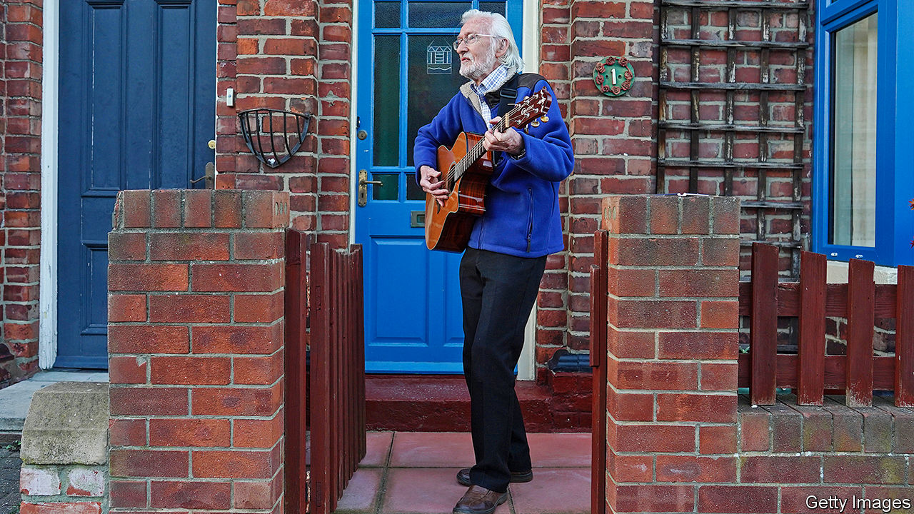

Editor’s note: The Economist is making some of its most important coverage of the covid-19 pandemic freely available to readers of The Economist Today, our daily newsletter. To receive it, register [here](https://www.economist.com/newslettersignup). For more coverage, see our coronavirus [hub](https://www.economist.com/coronavirus)

“FRITTATAS, scrambled eggs, omelettes...” The crisis is no reason to let diets slip, reckons Eleanor Jaskowska. As panic buying took off and lockdown loomed, she bought three rescue hens. Saved from an untimely end in the slaughterhouse, Maggie Hatcher, Roberta and Ginger are now free to roam around her sunny garden in Bristol. In return, their eggs make for delicious suppers.

As Britain hunkers down in week two of self-isolation, families are settling into a timewarp that lies somewhere between the mid-21st century and the 1950s. Aside from working virtually and binge-watching Netflix, they are keeping chickens, playing board games, baking bread and knitting sweaters. Queues for the shops, recalling postwar rationing, are encouraging people to grow or cook their own. The British Hen Welfare Trust rehoused 2,000 ex-battery hens in the week to March 29th; it has had requests for 20,000 more. One poultry breeder says she has been bombarded with requests for hens that are “ready to lay”.

Bread-making is back in vogue, after being sent into decline in 1961 when scientists developed a way of making bread 40% softer, that also reduced its cost and doubled its life. Supermarket shoppers are hoarding baking ingredients as well as loo paper. Some are abandoning food-delivery apps and experimenting with new recipes. On one community WhatsApp group, families offer to drop off samples of their latest creations on neighbours’ doormats. But many are eschewing traditional cookbooks, and learning the modern way. Matthew Jones, owner of Bread Ahead in London’s Borough Market, is live-streaming daily baking classes on Instagram. Judging by the figures, the nation thinks Mr Jones’s sessions are the best thing since, well, sliced bread. His account amassed 30,000 new followers in two days.

Many young people have scarpered from cities to lockdown with their parents, hunkering down with younger siblings who are off school. Of an evening, they gather in their living rooms to make their own fun, just as it used to be. Board games are making a comeback, with sales jumping by 240% during the first week of lockdown. Perhaps it is not surprising that Monopoly Classic is the most sought-after game: it is the closest that most Londoners are likely to get to Pall Mall or Leicester Square for some time. With gyms closed and people hungry for exercise, bicycles are also rolling off the shelves at speed.

Slow-burning activities like learning an instrument are educational and kill time, too. The Sound Garden, an independent music shop in north London, has sold out of all entry-level acoustic guitars. Ukuleles are also popular. Karen Davis and her 12-year-old son have taken it up. “We strum away badly, sing terribly and bring joy into the monotony of lockdown,” she says. “Self-isolation is forcing us to rethink family time. You don’t want your evenings to become what they used to be, slumping in front of the sofa and watching Netflix.” And the 21st century can help with 1950s pastimes: their ukulele tuition is being provided by a local music school, via Zoom. ■

Dig deeper:  
For our latest coverage of the covid-19 pandemic, register for The Economist Today, our daily [newsletter](https://www.economist.com/newslettersignup), or visit our [coronavirus hub](https://www.economist.com/coronavirus)

This article was downloaded by calibre from <https://www.economist.com/britain/2020/04/04/how-british-family-life-is-going-back-to-the-1950s>

|  |  |  |  |
| --- | --- | --- | --- |
| Previous | Articles | Sections | Next |

|  |  |  |  |
| --- | --- | --- | --- |
| Previous | Articles | Sections | Next |

#### Testing

# What’s gone wrong with covid-19 testing in Britain

The government’s policy clearly isn’t working; how to get it right is less clear

Apr 4th 2020 |

Editor’s note: The Economist is making some of its most important coverage of the covid-19 pandemic freely available to readers of The Economist Today, our daily newsletter. To receive it, register [here](https://www.economist.com/newslettersignup). For more coverage, see our coronavirus [hub](https://www.economist.com/coronavirus)

UNTIL RECENTLY, hospitals that could test for covid-19 were instructed to save their tests for patients and not to test staff. That changed on March 27th. Over the following weekend, a small sample of tests were carried out on NHS workers. The results were explosive: only around one in seven of those self-isolating actually had the virus, which meant that many who had been staying at home could in fact safely work. Failure to test, thus, had greatly exacerbated the hospital staff shortage.

Until two weeks ago, the government’s priority was not to contain the virus but to protect the vulnerable, so testing was not that important. But as the virus has spread, so the need for more testing, especially of health workers, has increased. Two weeks ago, Boris Johnson promised that Britain was “moving up to 25,000 [tests] a day” and was aiming for 250,000 a day, but Britain is still only carrying out around 10,000 a day. Altogether, it has tested 153,000 people, compared with 500,000 a week in Germany. It lags most other rich countries too.

Exactly what has gone wrong is unclear. Michael Gove, chancellor of the Duchy of Lancaster, says there is a shortage of chemical ingredients. According to Chris Hopson of NHS Providers, a membership organisation, with enough swabs and solution the health service’s pathology laboratories could carry out around 100,000 tests a day.

Others say that the problem lies not with the supply of chemicals, which are commonplace, but with the initial decision to centralise work in a dozen laboratories run by Public Health England (PHE), a government agency. Greg Clark, chair of the House of Commons science and technology committee, has criticised this approach, arguing that more work could be done in hospitals and universities.

Downing Street has since taken control of the operation, on the grounds that PHE and the medical regulator, the normal channel for approval, are too slow, and a number of new labs are being set up to ramp up testing swiftly; but a lack of communication between Number 10 and PHE means a lot of confusion. “There are parallel structures,” says Deenan Pillay, professor of virology at University College London. “They don’t talk to each other.”

As the disease spreads through the population, another sort of testing will become increasingly important: for antibodies, whose presence shows whether someone has ever had the virus. The government has promised a test will arrive soon, but Britons should not hold their breath.

Antibody testing is particularly susceptible to false positives and false negatives, so needs to be carefully validated. A bunch of Chinese companies produce antibody testing kits, and have been churning them out. They are in high demand. The British government is in negotiations to buy millions of them, but business sources say that countries that demand less validation data than Britain—such as Russia, Spain and the Gulf states—have been snapping them up. The swifter countries risk getting dodgy tests; the slower ones risk getting hold of kits too late. ■

Dig deeper:  
For our latest coverage of the covid-19 pandemic, register for The Economist Today, our daily [newsletter](https://www.economist.com/newslettersignup), or visit our [coronavirus hub](https://www.economist.com/coronavirus)

This article was downloaded by calibre from <https://www.economist.com/britain/2020/04/04/whats-gone-wrong-with-covid-19-testing-in-britain>

|  |  |  |  |
| --- | --- | --- | --- |
| Previous | Articles | Sections | Next |

|  |  |  |  |
| --- | --- | --- | --- |
| Previous | Articles | Sections | Next |

#### Law and order

# Policing in a lockdown

Cops have new powers to tackle the pandemic. Some are too keen to use them.

Apr 4th 2020 |



Editor’s note: The Economist is making some of its most important coverage of the covid-19 pandemic freely available to readers of The Economist Today, our daily newsletter. To receive it, register [here](https://www.economist.com/newslettersignup). For more coverage, see our coronavirus [hub](https://www.economist.com/coronavirus)

BRITONS LOVE a chuckle at the expense of puffed-up officials. The villain of “Dad’s Army”, an air-raid warden, is forever instructing the residents of wartime Walmington-on-Sea to “put that light out!” In a famous sketch by Rowan Atkinson, a constable charges a suspect with “walking around with an offensive wife”.

The lockdown has provided satirists with plenty of material. Cops have taken to patrolling parks to break up gatherings and tape off outdoor gyms, as if they were crime scenes. Drivers are being questioned on their reasons for leaving home. A police force ticked off Stephen Kinnock, a Labour MP, for visiting his parents, even though he only went as far as the front garden. Bobbies in Derbyshire released a drone video of visitors to the Peak District walking dogs and taking photographs, activities they deemed “not essential”. The force also dyed a turquoise lake black (pictured) to deter potential swimmers (a local official insists that it does so every year).

Overzealous tactics have prompted equally overblown reactions. Jonathan Sumption, a retired Supreme Court judge, pronounced the measures “disgraceful”. “This is what a police state is like,” he said. But many are uneasy about the enthusiasm with which some officers have taken up their new powers, which allow them to issue fines of £60 for most gatherings of more than two people in public or evading the lockdown without good reason.

The problem is less the jackboot instincts of the constabulary than a lack of regulatory clarity. The distinction between advice and legal restrictions is muddy. Police complain that they were expected to uphold Boris Johnson’s edict on March 23rd that the country should go into lockdown as soon as he announced it, even though the relevant legislation was not published for three days. Ministers have made up their own rules on the hoof, telling people not to exercise more than once a day or for more than an hour, neither of which are stipulated in law. Cops were initially bombarded with calls from taxi drivers asking if they could continue to work and divorced parents worried about sharing parental responsibilities, says Kerrin Wilson, assistant chief constable of Lincolnshire Police. “It was so grey.”

Britain’s diffuse policing structure does not help. Some of England and Wales’s 43 police forces have yet to issue any fines; others have taken a hard line. A woman in Tyneside was arrested and fined £660 after she refused to tell police officers her name and explain why she was at a railway station. Even the National Police Chiefs Council, an umbrella group for chief officers, seems confused. In a conference call it hosted, a journalist asked whether residents in the Peak District could drive to go for a walk in a quiet spot. One senior cop answered “yes” just as the other said: “The point is, how do you guarantee there’s nobody there?”

Restrictions elsewhere are far more draconian. In South Korea, an app alerts the authorities if citizens stray from their quarantine. The French must carry a written declaration of their reasons for going out. The fuss in Britain may be particularly acute precisely because its cops normally use such a light touch. Most officers are unarmed. Fatal shootings trigger automatic inquiries. And, says Lawrence Sherman of Cambridge University, “there is an absolute cultural dedication to proportionate policing”. Long may it last.■

Dig deeper:  
For our latest coverage of the covid-19 pandemic, register for The Economist Today, our daily [newsletter](https://www.economist.com/newslettersignup), or visit our [coronavirus hub](https://www.economist.com/coronavirus)

This article was downloaded by calibre from <https://www.economist.com/britain/2020/04/04/policing-in-a-lockdown>

|  |  |  |  |
| --- | --- | --- | --- |
| Previous | Articles | Sections | Next |

|  |  |  |  |
| --- | --- | --- | --- |
| Previous | Articles | Sections | Next |

#### The army

# British soldiers struggle to maintain social distance

The army is essential in a crisis, but keeping soldiers apart is tricky

Apr 4th 2020 |

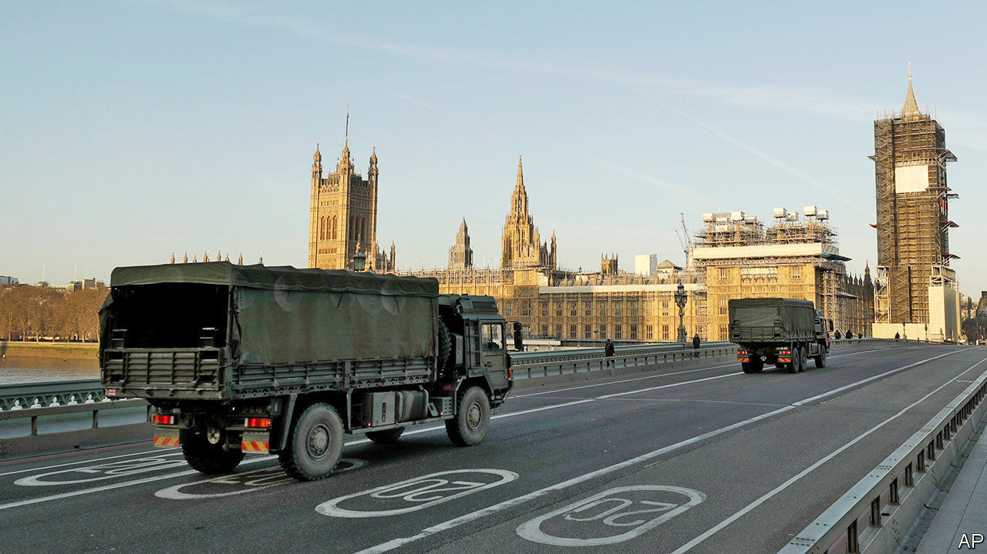

Editor’s note: The Economist is making some of its most important coverage of the covid-19 pandemic freely available to readers of The Economist Today, our daily newsletter. To receive it, register [here](https://www.economist.com/newslettersignup). For more coverage, see our coronavirus [hub](https://www.economist.com/coronavirus)

A GENERATION OF British troops who cut their teeth in Helmand and Basra are now seeing action in east London. In contrast to several continental neighbours, Britain’s army is not enforcing the lockdown, but troops are being put to use in other ways.

Army engineers and medics have helped turn the EXCEL convention centre in London’s Docklands into a hospital, with more to follow. Troops are driving oxygen tankers and delivering medical equipment. Logisticians, accustomed to moving tanks into war zones, are helping to get biscuits to pensioners. Though gun-toting soldiers will not confront citizens exceeding their allotted bout of once-daily exercise, they will be used as guards to free up armed police for other duties.

The armed forces have over 10,000 personnel in the Defence Medical Service, including combat medics and reservists. Yet only a fraction may be available due to overseas deployments, failed fitness tests or parental leave. Doctors have already been recalled from exercises in Europe, but it is trickier to pull medics back from deployments in Iraq and Afghanistan. On April 1st Britain called up 3,000 reservists, though it was careful to avoid pulling out those who work as civilians in the NHS.

Amid this heightened attention, the army has been keen to show how unaffected it is by covid-19. In a promotional video, Drill Sergeant Rae of the 1st Battalion Scots Guard wields a 76cm pace stick, before striding three paces (2m and a bit) across the parade ground, the stick flicking up behind him. “There you have the perfect demonstration for social distancing,” he says turning toward the camera.

Squaddies are less than convinced. Documents seen by The Economist suggest that orders have hardly been uniform. Fill Your Boots, an online forum on which troops share their troubles, has been inundated with complaints. At Catterick, a military town in North Yorkshire that is the largest British Army garrison in the world, one soldier says that training is carrying on as normal. A senior soldier was overheard telling others to “crack on”, saying that “it’s just the flu—if we get it then we get it”. More scrupulous commanders have told soldiers to attend parades on Skype, so that officers can check on whether squaddies have washed and shaved without getting too close for comfort.

Sandhurst, Britain’s officer academy, is also drawing much flak from trainees. The military school has claimed that all physical training is cancelled, but photographs sent to Fill Your Boots show cadets carrying out close-contact mock casualty evacuations. “It’s a bit of a clusterfuck,” says Alfie Usher, a former paratrooper who runs the forum. “Commanding officers are taking it on themselves to interpret the rules.”

The Ministry of Defence insists that its training follows Public Health England guidance and that service personnel who experience symptoms are moved to separate parts of their camp. Cadets have been barred from leaving at weekends and team sports and gym use have been cancelled.

Unlike the Pentagon, British officials will not say how many cases of covid-19 have been found in the ranks. At least five personnel at Britain’s military base in Cyprus have tested positive. But even as the virus pulls soldiers to the home front—troops have been ordered back from exercises in Europe and operations in Iraq—there is no let-up on traditional duties.

Russian bombers probing near British and Irish airspace sent Royal Air Force jets scrambling twice last month, and on March 26th the Royal Navy said it had deployed nine vessels to shadow a flotilla of Russian warships in the English Channel and North Sea. Britain’s armed forces will need to stay in tip-top health.■

Dig deeper:  
For our latest coverage of the covid-19 pandemic, register for The Economist Today, our daily [newsletter](https://www.economist.com/newslettersignup), or visit our [coronavirus hub](https://www.economist.com/coronavirus)

This article was downloaded by calibre from <https://www.economist.com/britain/2020/04/04/british-soldiers-struggle-to-maintain-social-distance>

|  |  |  |  |
| --- | --- | --- | --- |
| Previous | Articles | Sections | Next |

|  |  |  |  |
| --- | --- | --- | --- |
| Previous | Articles | Sections | Next |

#### Rough sleeping

# How the pandemic has helped Britain’s rough sleepers

Councils have found homes for thousands

Apr 4th 2020 |

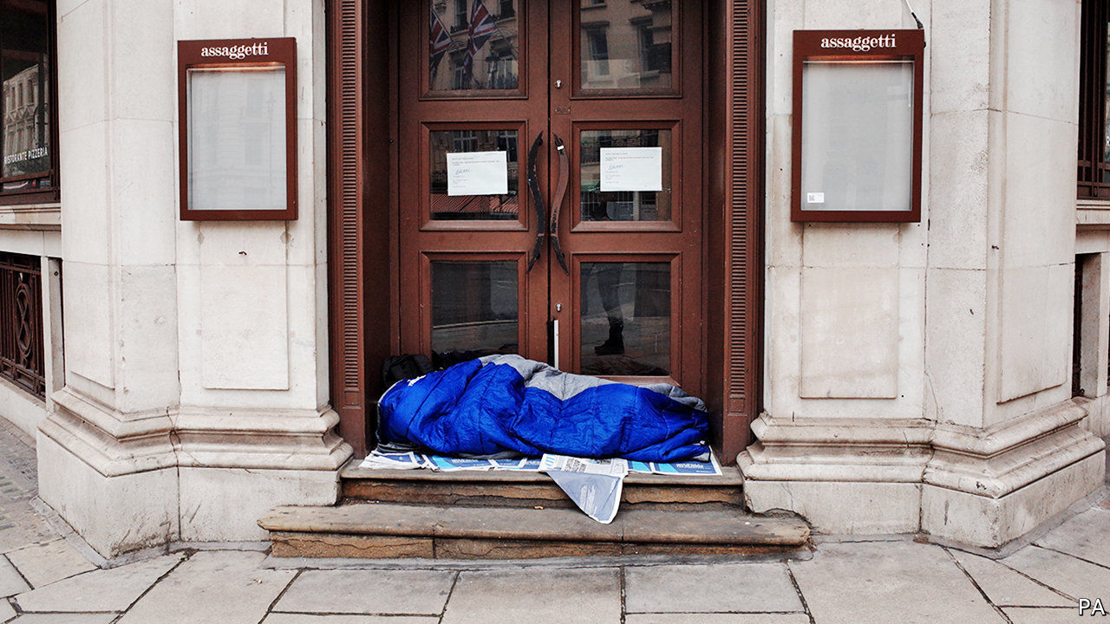

Editor’s note: The Economist is making some of its most important coverage of the covid-19 pandemic freely available to readers of The Economist Today, our daily newsletter. To receive it, register [here](https://www.economist.com/newslettersignup). For more coverage, see our coronavirus [hub](https://www.economist.com/coronavirus)

ANYBODY WALKING past the British Library over the past week—admittedly a small number of people—would have noticed something missing. It is not just the harried commuters, the hungry scholars and the suitcase-toting tourists that have vanished, but a more reliable presence. Many of the homeless people who bed down for the night along this stretch of the Euston Road have disappeared as well. Where did they go?

On March 26th the government wrote to local authorities asking them to move homeless people “into appropriate accommodation by the end of the week”. Thousands remain on the streets, but impressive progress has been made. Some 4,000-odd rough sleepers in England have already been housed in hotels where “they are being brought three meals a day, have a warm comfortable bed and are being supported by professional staff”, says Matthew Downie, who heads policy for Crisis, a homelessness charity, adding that “the government target to end rough sleeping moved from 2024 to ‘by the weekend’.”

Much work remains to be done. Nearly 4,300 people were found to be sleeping rough on a single night last autumn, but many more stay in night shelters, where people share space and are at high risk of infecting each other. Homeless people are particularly vulnerable to the virus: according to Pathway, an organisation that works on health care for the homeless, they are 2.5 times as likely to have asthma as the general population, and 34 times likelier to have tuberculosis, conditions that often make covid-19 fatal. Homeless men have a life expectancy of 44, half the national average.

Charities and local authorities face their own challenges. About a tenth of staff at St Mungos, London’s biggest provider of beds for the homeless, are off sick, says Howard Sinclair, its boss, who is himself recovering from the disease. Night-time patrols by staff have been slashed as deserted streets are deemed unsafe. And putting people in hotels is not as straightforward as it sounds. “It is ponderous getting people who are not used to living indoors to live indoors,” says John Bird, who slept rough before founding Big Issue, a social enterprise working with homeless people.

Despite the difficulties, charities are looking at the crisis as an opportunity. Once it is over, “it would be a tragedy to say ‘off you go’,” says Mr Sinclair. But for now, the focus remains on ensuring the streets of London—and Britain—become just a little bit more deserted.

Dig deeper:  
For our latest coverage of the covid-19 pandemic, register for The Economist Today, our daily [newsletter](https://www.economist.com/newslettersignup), or visit our [coronavirus hub](https://www.economist.com/coronavirus)

This article was downloaded by calibre from <https://www.economist.com/britain/2020/04/04/how-the-pandemic-has-helped-britains-rough-sleepers>

|  |  |  |  |
| --- | --- | --- | --- |
| Previous | Articles | Sections | Next |

|  |  |  |  |
| --- | --- | --- | --- |
| Previous | Articles | Sections | Next |

#### Propping up firms

# Britain’s steel industry is braced for trouble

A failing industry looks like falling through the gaps of government support

Apr 4th 2020 |

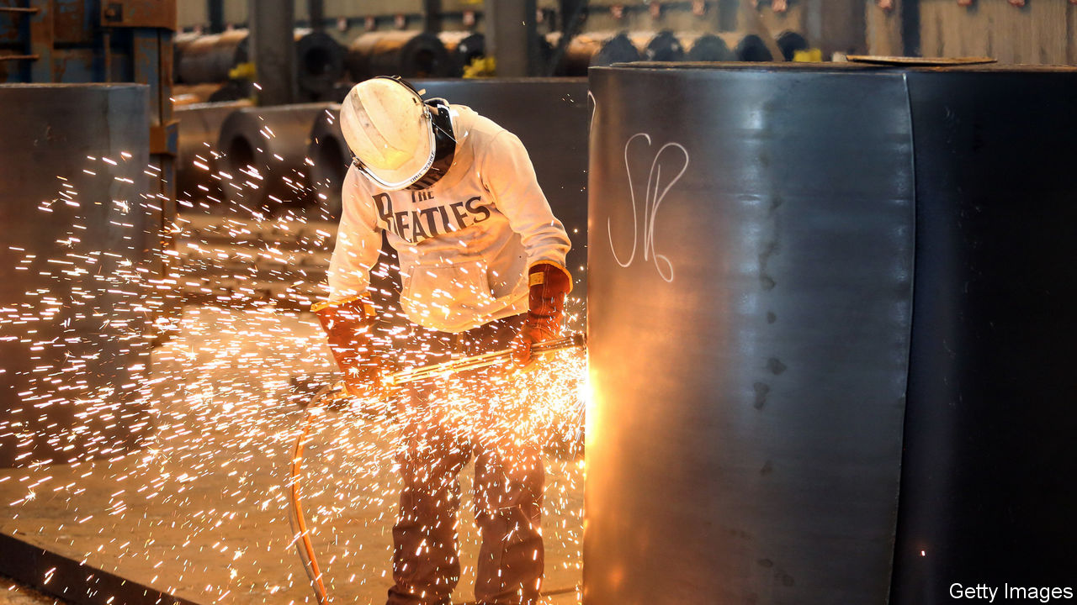

ON MARCH 9TH Britain’s steel industry received some rare good news when Jingye Group, a Chinese firm, completed its purchase of British Steel, saving some 3,000 jobs in Scunthorpe and Teesside. But a lot has changed in three weeks. “That feels like three years ago,” says an industry insider. “In three weeks’ time I’m worried Britain won’t really have a steel industry.”

Steelmakers have seen demand fall by as much as 40% since car production shut down and most construction projects were suspended. Firms report that the drop is similar to the one experienced in the banking crisis of 2008. But that shock came after years of buoyant growth, when company balance-sheets were in ruder health. This time the industry faces an imminent liquidity crunch, but with cash levels already dangerously low.

The Treasury has put in place a package of support for firms across the economy built on two core ideas: access to cheap finance to tide firms over, and support for wage bills to maintain employment in a downturn. Treasury officials are keen to stick to the principle of broad support for businesses, rather than to bail out specific companies. Firms have been quick to praise the government’s efforts, but there is growing frustration that a “one size fits all” approach may leave too many gaps.

Rishi Sunak, the chancellor, has announced up to £330bn ($410bn) of government loan guarantees (worth 15% of GDP) for firms, but none of that is likely to reach the steel industry. The government is running two lending schemes. The first, delivered through banks, covers firms with annual turnover of up to £45m and is meant to support small- and medium-sized enterprises. The second, administered via the Bank of England, is aimed at larger firms but is open only to investment-grade borrowers. The main British steel firms’ turnover is too high for the SME scheme but they lack the credit rating to use the larger version. Many high-street retailers find themselves in a similar quandary.

The jobs-retention scheme too causes problems. Closing steel plants temporarily is not something that is often done. It can take 8-12 weeks safely to mothball a blast furnace, “It’s not just a last resort, it’s often terminal,” says one boss. In common with other businesses, the industry would prefer a more flexible furlough arrangement in which workers’ hours can be cut, with the government helping cushion the blow to incomes.

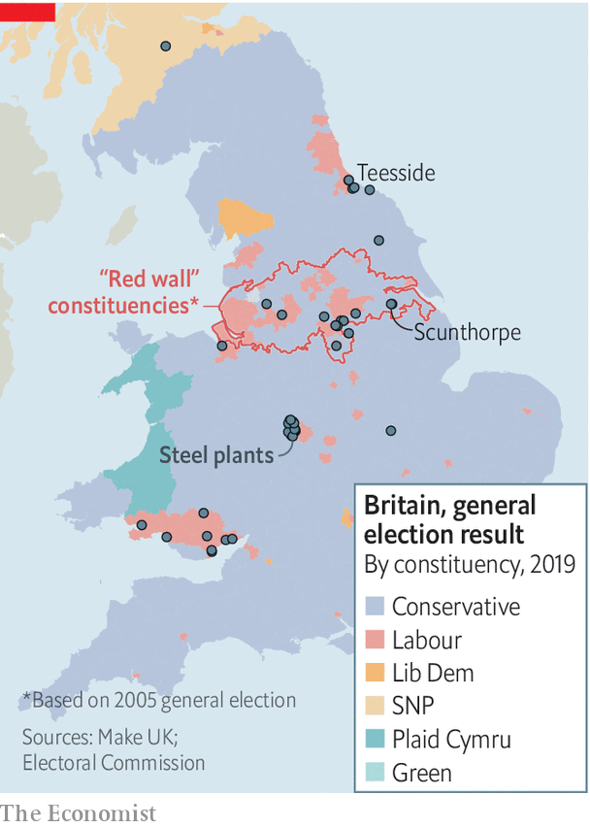

Steel may directly employ only 32,600 workers, fewer than the pub chain JD Wetherspoon. But the jobs are clustered together and the workers tend to earn around one-third more than others in their localities. Britain’s new political geography may offer some hope (see map). Much of existing steel employment is concentrated in and around former “red wall” seats that switched from Labour to Conservative at the last election. Even the chair of the All-Party Parliamentary Group on Steel is now a Tory. Steel may be the latest industry arguing its case for more support, but it is unlikely to be the last. ■

This article was downloaded by calibre from <https://www.economist.com/britain/2020/04/04/britains-steel-industry-is-braced-for-trouble>

|  |  |  |  |
| --- | --- | --- | --- |
| Previous | Articles | Sections | Next |

|  |  |  |  |
| --- | --- | --- | --- |
| Previous | Articles | Sections | Next |

#### Customer service

# Britain’s call centres are overwhelmed and overhauling how they work

Operators are getting over their hang ups and dialling up home-working

Apr 4th 2020 |

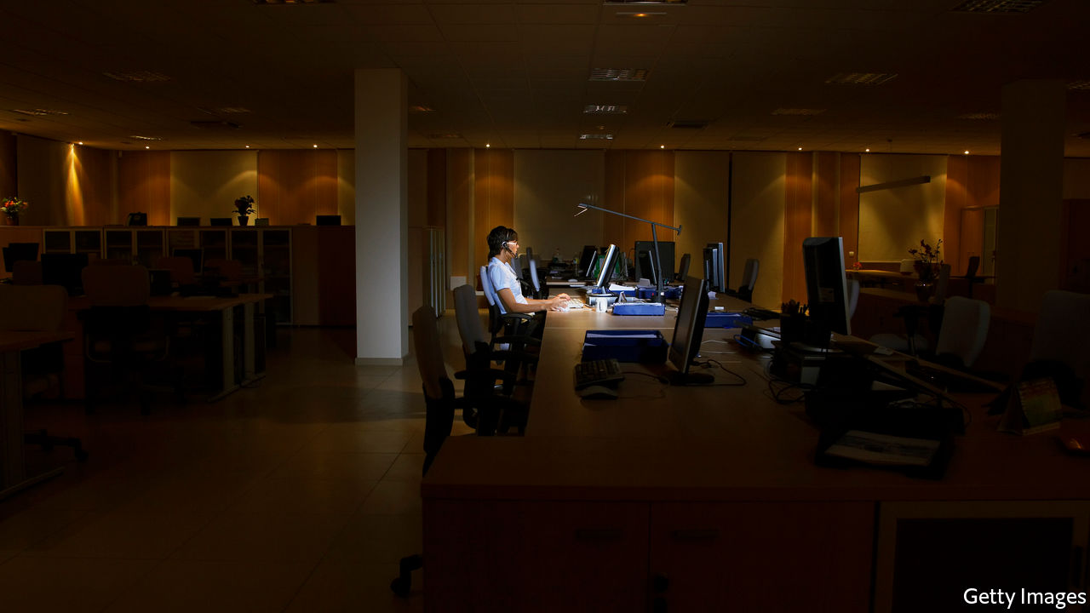

Editor’s note: The Economist is making some of its most important coverage of the covid-19 pandemic freely available to readers of The Economist Today, our daily newsletter. To receive it, register [here](https://www.economist.com/newslettersignup). For more coverage, see our coronavirus [hub](https://www.economist.com/coronavirus)

GOOD LUCK trying to get in touch with a company these days. Those calling British Airways about a refund will find themselves hung up on by an automated system, immediately after they hear the words, “we appreciate your understanding at this time”. Virgin Media emailed its 5.5m cable and broadband customers to ask them to avoid calling. Banks, insurance companies and this newspaper have issued similar requests to customers seeking support, directing them online instead.

While call numbers have shot through the roof, call centres are closing. Coronavirus has put the industry, which employs some 1.3m Britons, or about 4% of the workforce, in a particularly tight spot. Only 10-20% of call-centre employees typically work from home, reckons Ann-Marie Stagg of CCMA, an industry body. Many call centres take payments, making home-working risky from a legal perspective. Yet if an on-site employee catches coronavirus, hundreds more may be taken offline, at least for a while. A Sky call centre in Cardiff was closed for a day after one worker was diagnosed with it in March.

In February Virgin had a dozen call centres. Now five overseas centres—in India and the Philippines—are closed. The rest, in Britain, remain open, but staff numbers fluctuate as workers fall ill or take time off to care for their families. Abby Thomas, who runs customer service for Virgin, says that the company just doesn’t have as many people as it needs to answer calls. Last month it announced 500 new jobs to supplement its 2,350 domestic call-centre workers. Meanwhile, the firm has redeployed resources: sales calls have been suspended, agents who normally handle customer retention have been assigned service jobs. Staff have been spread out across several floors, every second desk is kept empty and the cafeteria has been closed (workers are brought lunch at their desks instead).

Running homeworkers is tricky. “How do you manage home agents effectively when you have no direct visibility?” asks Charlie Mitchell of Call Centre Helper. Other obstacles include security concerns around customer information; complying with rules for payment processing; and caring for staff who might be taking call after call with no breaks.

But it is not impossible. Sensée, as an entirely work-from-home call centre operator, has several financial firms as clients, and also works for the government. It keeps an eye on staff with webcams, demands that workers’ desks be kept clear, and commandeers their computers so that no screenshots or prints can be made. Its staff has grown from 700 in February to 1,100 last week and “probably 1,500” in the next few days, says Mark Walton, its boss.

Other operators are reconfiguring their processes, often overnight. Serco, a big contractor for the public sector, has moved more than a third of its call-centre workers to home-working. Ascensos, a Scottish firm with 1,200 employees in Britain had ten such positions a month ago; now 600 employees work from home. Virgin has 1,800 laptops ready to go for when it is forced to send employees home. Ms Stagg says several insurance firms she has spoken to are preparing for 100% home-based call centres, even if it means providing fewer services over the phone. “They are having to make the choice: do we give no service or do we give some service,” she says. The future of the industry is on the line.■

Dig deeper:  
For our latest coverage of the covid-19 pandemic, register for The Economist Today, our daily [newsletter](https://www.economist.com/newslettersignup), or visit our [coronavirus hub](https://www.economist.com/coronavirus)

This article was downloaded by calibre from <https://www.economist.com/britain/2020/04/04/britains-call-centres-are-overwhelmed-and-overhauling-how-they-work>

|  |  |  |  |
| --- | --- | --- | --- |
| Previous | Articles | Sections | Next |

|  |  |  |  |
| --- | --- | --- | --- |
| Previous | Articles | Sections | Next |

#### Bagehot

# Labour’s new leader should beware of “war socialism”

Contrary to the belief of many in the party, the pandemic will not favour the left

Apr 4th 2020 |

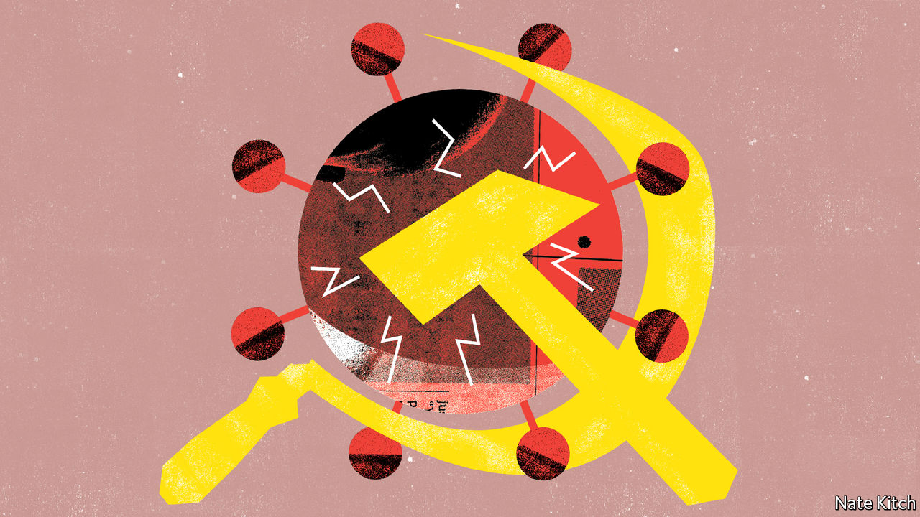

Editor’s note: The Economist is making some of its most important coverage of the covid-19 pandemic freely available to readers of The Economist Today, our daily newsletter. To receive it, register [here](https://www.economist.com/newslettersignup). For more coverage, see our coronavirus [hub](https://www.economist.com/coronavirus)

THE LABOUR leadership contest began in one world and is ending in another. The candidates have swapped crowded halls for Zoom conference calls. Supporters conduct their debates in virtual chat rooms rather than crowded pubs. The new leader will be announced in a round-robin email rather than, as had been planned, at a Westminster rally with full razzmatazz.

The email will be sent on April 4th, after The Economist goes to press, but, barring an earthquake, the new leader will be Sir Keir Starmer, the party’s Brexit spokesman. Sir Keir has led by a country mile in every stage of the contest from nominations by MPs to support from trade unions and local constituencies. Most opinion polls have pointed to a decisive victory. The winner of the (separately elected) deputy leadership is likely to be Angela Rayner, who is currently self-isolating with symptoms of the coronavirus.

Sir Keir, if indeed it is him, will enjoy two substantial advantages from the get-go. The first, and most important, is that he’s not Jeremy Corbyn. Mr Corbyn has been the party’s most disastrous leader ever—not just useless like George Lansbury and Michael Foot, who led the party to electoral disaster in 1935 and 1983 respectively, but positively malign. His failure to throw his party’s weight behind the Remain campaign contributed significantly to Britain’s decision to leave the EU, which most of the membership opposed. His refusal to meet Theresa May half-way during the dying days of her administration killed off any chance of a soft Brexit. His extreme politics and sanctimonious style drove traditional Labour voters into Boris Johnson’s arms.

The second is that the Labour Party is tired of failing. The less-awful-than-expected defeat of 2017 persuaded the faithful that what they needed was more effort rather than fresh thought. The catastrophic failure of 2019 dispelled that illusion and reconciled all but fanatics to the idea that politics is the art of the possible. Sir Keir’s sustained lead means that he has been able to avoid making pledges to various factions and will take over with a blank sheet of paper and a powerful mandate.

There’s a widespread view that the epidemic has provided Sir Keir with a third advantage: a political environment that is shifting sharply leftward. The government’s decision to pump money into the economy and nationalise key industries is not only demonstrating the vital importance of the state in coping with a disaster, the argument goes. It is moving the boundaries of what is politically acceptable. How can the Tories make fun of “magic money trees” when they have discovered a forest of them? How can they argue against “picking winners” when they are choosing companies to make ventilators? Mr Corbyn says that the government’s response to covid-19 proves that he was “absolutely right” to call for higher public spending. Some prominent Labour politicians, such as Ian Lavery and Rebecca Long-Bailey, have been overheard arguing that the crisis contains opportunities for the left. Such views are echoed outside the party: several Cabinet ministers have expressed concern that they won the election only to find themselves implementing Labour’s policies.

The sense that the wind is blowing leftwards is not confined to Britain. “The corona crisis is not without its advantages,” says Ulrike Herrmann, a German anti-capitalist. Thinkers such as Thomas Piketty, Naomi Klein and Grace Blakeley are hanging all their favourite policies on covid-19 like baubles on a Christmas tree: a radical redistribution of wealth here, a green new deal there and, posed on top, the angelic vision of a universal basic income.

Yet the notion that covid-19 is the herald of a socialist nirvana is not entirely convincing. True, massive external shocks such as the current pandemic can certainly shake-up political allegiances, particularly when they are as weak as they are at the moment. And in some ways, the left is having a good crisis: institutions to which it is wedded, such as the BBC and the National Health Service, are more admired than ever. Right-wing blowhards such as Donald Trump are more reviled, in Britain at least.

But the current expansion of the state does not represent a philosophical conversion to the case for revolution. It is a pragmatic response to a unique set of problems: a combination of Keynesian demand management to boost the economy, time-limited intervention to prevent industries from collapsing and a basic income for workers who are temporarily laid off. This debt-fuelled expansion will certainly lead to higher taxes in the long term but it will also put a constraint on the state’s future ambitions.

Talk about a new settlement comparable with that under Labour in 1945 is particularly far-fetched. Scientists are confident that they will find a cure for the virus eventually, perhaps within a year. When that blessed day comes, voters will desire nothing so much as a “return to normalcy”, just as they did in the 1920s after the first world war and the Spanish flu. They will see the covid era not as a time of ideological renewal but as a temporary crisis that involved a weird combination of admirable collectivism and irritating restrictions on personal freedom.

## Do not adjust your belief set

The job of leading the opposition during a national crisis is arguably the worst in the world. Britons are rallying around the government: one poll shows the Conservatives leading Labour by 28 points and 72% of voters saying that they are satisfied with Mr Johnson’s performance as prime minister. Sir Keir’s best chance of success lies in playing to his strengths as a post-ideological pragmatist. In public he should ask practical questions about the government’s performance in producing ventilators and covid tests or getting economic help to the vulnerable, while avoiding the impression that he’s sniping. Behind the scenes he should prepare for normal times by clearing out Mr Corbyn’s most scrofulous followers. If he bets on a new era of big-government socialism, he will waste his political capital. ■

Dig deeper:  
For our latest coverage of the covid-19 pandemic, register for The Economist Today, our daily [newsletter](https://www.economist.com/newslettersignup), or visit our [coronavirus hub](https://www.economist.com/coronavirus)

This article was downloaded by calibre from <https://www.economist.com/britain/2020/04/04/labours-new-leader-should-beware-of-war-socialism>

|  |  |  |  |
| --- | --- | --- | --- |
| Previous | Articles | Sections | Next |

|  |  |  |
| --- | --- | --- |
| Britain | Sections | Business |

International

Covid-19 and mental health: Only connect

.

Self-improvement: Net benefits

.

|  |  |  |
| --- | --- | --- |
| Britain | Sections | Business |

|  |  |  |  |
| --- | --- | --- | --- |
|  | Articles | Sections | Next |

#### Only connect

# How will humans, by nature social animals, fare when isolated?

Covid-19 will harm people’s mental health

Apr 4th 2020 |

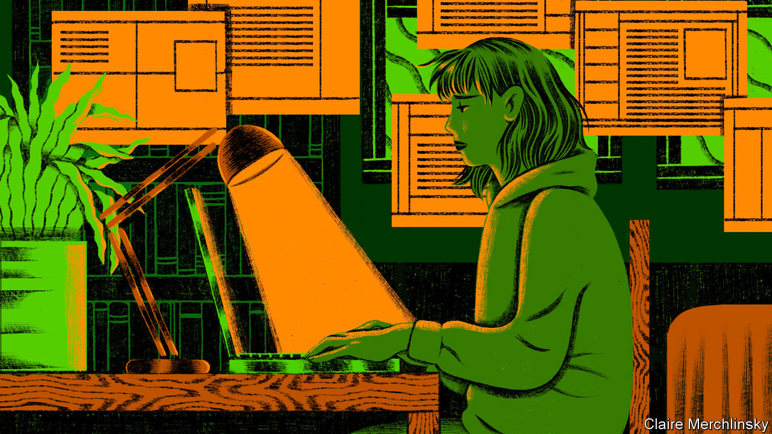

Editor’s note: The Economist is making some of its most important coverage of the covid-19 pandemic freely available to readers of The Economist Today, our daily newsletter. To receive it, register [here](https://www.economist.com/newslettersignup). For more coverage, see our coronavirus [hub](https://www.economist.com/coronavirus)

IN MANY WAYS Claudia (not her real name), a 33-year-old art dealer, feels prepared for the covid-19 lockdown in London. As a recovering alcoholic who has had a “mental breakdown or two”, she has spent time in rehab. Her movements there were restricted. She had to follow a strict routine, waking and eating her meals at the same time each day. That routine is now serving her well. Along with the rest of Britain, she is in lockdown as the country battles to slow the spread of covid-19. Its inhabitants are allowed out of their homes only in the most limited circumstances. The government has told people to avoid meeting anyone they do not live with, even family members.

“On difficult days I tell myself to make the bed, have a shower and eat,” says Claudia. Each morning she writes down things that she is grateful for: she no longer lives in a “sober house” with 12 other women, but in a flat on her own; her sister’s new baby, whom she has not yet met, is healthy. She also avoids social media. Even so, she is anxious: “I worry that in a week or two I will feel like screaming.”

Traumatic events, from natural disasters to war, can damage people’s mental health. The covid-19 pandemic is no different. It has brought the fear of contagion and of loved ones falling sick. It has created huge uncertainty about every aspect of life. And with a fifth of the world under lockdown, protracted isolation is also bringing loneliness, anxiety and depression. Quarantines and “social distancing”, policy measures needed to slow the spread of the novel coronavirus that causes covid-19, are against human nature. Touch and social networks are essential for both people and non-human primates: female baboons who have more grooming partners, or friends, exhibit lower levels of cortisol, a stress hormone.

It has been less than a month since the Italian government imposed a national quarantine, but the strain on people’s mental health is starting to show. More than 13,100 people there have died from covid-19; at least two nurses who were working in intensive-care units where they were treating patients suffering from the disease have killed themselves. The Italian national nursing federation said that one of the nurses who committed suicide, Daniela Trezzi, had been off work ill and that Ms Trezzi was deeply worried that she had infected patients (though the local health authority said she had not tested positive). In Germany, which imposed restrictions after Italy, the finance minister of the state of Hesse, who was said to be deeply worried about the economic impact of the pandemic, killed himself on March 28th.

Awareness of the strain on people’s mental health is growing. In Britain Public Health England, a government agency, along with the Duke and Duchess of Cambridge, released a set of guidelines on “the mental health and well-being aspects of coronavirus” on March 29th. In the same week, 62% of Britons said that they were finding it harder to be positive about the future compared with how they felt before the outbreak, according to Ipsos MORI, a pollster. “People are struggling with the emotions as much as they are struggling with the economics,” said Andrew Cuomo, governor of New York, America’s hardest-hit state, on March 21st. Four days later he set up a free hotline for those whose mental health was suffering.

Some are particularly susceptible to stress during a pandemic. Health-care workers are most exposed to the virus. The sense of camaraderie and of being part of a team that is helping people can buoy their spirits. But many doctors and nurses are being forced to isolate themselves away from their families because they may be infectious, which adds to their strains, points out Dhruv Khullar, a doctor in New York.

The lack of personal protective equipment for medics in many countries will only make that stress worse. Nicholas Christakis, now at Yale, worked as a doctor in the 1990s during the HIV/AIDS epidemic. There was a “lot of fear among health workers that if you looked after an AIDS patient you would contract the disease,” he recalls. But back then they had enough protective equipment. That made the risk of infection, which comes with the job, more bearable. Covid-19 is much easier to catch. “The current situation is like sending a fireman into a building naked,” he says.

Among the population at large, some may be especially worried. Those who have lost their jobs, who now number in the millions, may have lost not just their income, but also their identity, routine and much of their social network, says Jan-Emmanuel De Neve, head of the Wellbeing Research Centre at Oxford University.

Single people who once whiled away their days with friends, or those who live separately from their partners, suddenly find themselves spending most of their time alone. Many who exercise in teams or groups—or simply enjoy spending time outside—have to make do with a cramped living room and online classes. Mike, a 29-year-old Briton who works in finance in Brussels, is relieved that so far he is still allowed out for runs (though police move him along if he sits down to catch his breath): “Otherwise I’d just feel like Robinson Crusoe with Netflix.” Isolation will affect the mental health of even those who appear to be in less danger from the virus: 67% of Britons between the ages of 18 and 34 said they were finding it hard to remain upbeat, compared with 54% of those between the ages of 55 and 75.

If lockdowns stretch on for months, old people will suffer particularly acutely. Even before they were confined to their homes, they were more likely to feel lonely. Elderly women in Europe are more than twice as likely as men to live on their own. They rely on seeing family and friends to keep up their morale, or simply for a routine. Alfredo Rossi, an 80-year-old in Casalpusterlengo, one of the first areas of Italy to be put under lockdown in February, says that what upsets him most about the restrictions is being unable to see his grandchildren who live just 16km (ten miles) away in Piacenza across the River Po.

Domestic violence, already endemic everywhere, rises sharply when people are placed under the strains that come from confined living conditions and worries about their security, health and money, says Phumzile Mlambo-Ngcuka, the head of UN Women, a UN agency. Based on early estimates, she thinks that in some countries under lockdown, domestic violence could be up by about a third.

The scale of the lockdowns is unprecedented. But research into previous traumatic events and other types of isolation offers some clues about the likely mental-health fallout. According to a rapid review of the psychological effects of quarantines, published on March 14th in the Lancet, a British medical journal, some studies suggest that the impact of quarantines can be so severe as to result in a diagnosis of post-traumatic stress disorder (PTSD). The condition, which may include symptoms such as hyper-vigilance, flashbacks and nightmares which can last for years, became a formal psychiatric diagnosis in 1980, when veterans were still experiencing stress from the Vietnam war, which ended in 1975.

One study from 2009 looked at hospital employees in Beijing who in 2003 were exposed to severe acute respiratory syndrome (SARS), which, like covid-19, is caused by a coronavirus. The authors found that, three years later, having been quarantined was a predictor of post-traumatic-stress symptoms. Another study, from 2013, used self-reported data to compare post-traumatic-stress symptoms in parents and children who had been quarantined because they lived in areas affected either by SARS or the H1N1 outbreak in 2009, with those who had not. It found that the mean post-traumatic-stress scores were four times higher in children who had been isolated. Among the parents who had been quarantined, 28% reported symptoms serious enough to warrant a diagnosis of a trauma-related mental-health disorder. For those who had not been in isolation, the figure was 6%.

The longer a quarantine goes on, the greater the effect on people’s mental health. Another study, which also looked at the impact of SARS, found that those who were quarantined for more than ten days were significantly more likely to display symptoms of PTSD than those confined for fewer than ten days.

Cynthia Dearin, a consultant in Australia who spent four years in Iraq between 2006 and 2010 in various military camps that restricted her movement, said that whenever she returned to Iraq after a “decompression break”, she felt an “instant Baghdad depression”. Living in a war zone is very different from living through a pandemic, but she sees parallels in the loss of freedom and the sense of danger. “We also had the choice to leave the lockdown,” she reflects. “What is different now is that nobody can escape.” In Iraq many of her contemporaries turned to alcohol to numb the boredom and the fear. Increased sales of alcohol suggest that many are doing the same today. In Britain they were up by two-thirds in the week to March 21st compared with 2019, according to Nielsen, a market-research firm.

Those who have willingly isolated themselves in less traumatic circumstances may provide examples of how to ease the current crisis. In addition to the loneliness they experience, astronauts, who spend prolonged periods away from their loved ones or indeed any other human beings, suffer from disturbed sleep, heart palpitations, anxiety and mood swings. Cooped up together, they may also fall out with their fellow crew members.

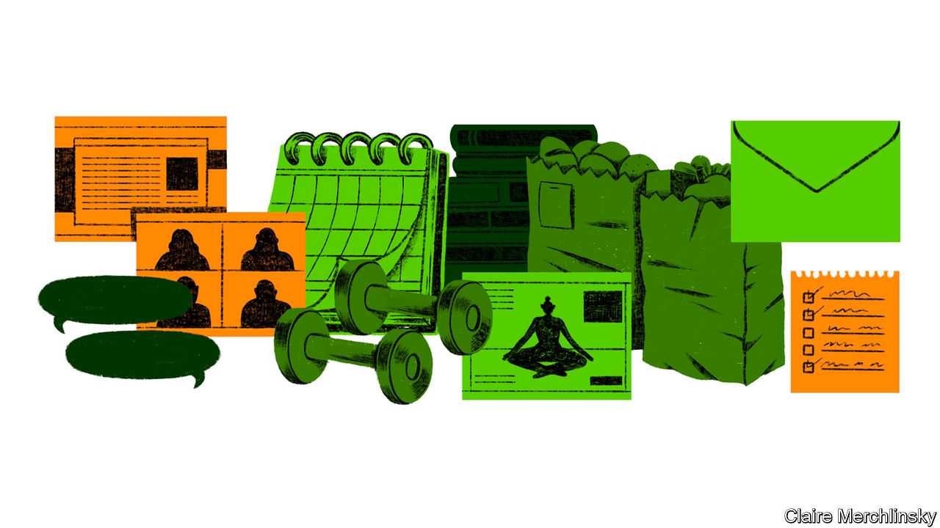

Couples who suddenly find themselves in enforced proximity may sympathise. There are reports that some cities in China, such as Xi’an and Dazhou, have seen a spike in divorce proceedings since the lockdown was lifted in parts of the country in early March. Writing in the New York Times, Scott Kelly, a former astronaut who spent a year on the International Space Station, suggested that keeping a routine and writing a journal can help ease loneliness. He also encouraged people to get outside, if they could. He found that after “being confined to a small space for months, I actually started to crave nature—the colour green, the smell of fresh dirt, and the feel of warm sun on my face.”

Even under the tightest restrictions, people find ways to cope. “People are rediscovering that they live in roads full of people,” says Robin Dunbar, an anthropologist and evolutionary psychologist at Oxford University. Neighbours can be irritating, but in a crisis they can also be a comfort.

Groups have formed in many places to support local vulnerable people. According to Julianne Holt-Lunstad, an expert in loneliness at Brigham Young University, studies have shown that those who feel they have “supportive people” in their social networks are less likely to react to stressful circumstances than those who do not. Simply knowing you have others on whom you can rely can reduce spikes in blood pressure and heart rate, she says.

## Live in fragments no longer

Abigail, a 32-year-old charity worker in Brussels, says that her student neighbours used to get on her nerves because they played loud music. But as she spends the lockdown alone, she has got to know them. She now welcomes their music: “They bring the party.” In Belgium, Britain, Italy and the Netherlands people have started to clap and bang pans from their windows and doors to thank medics and other essential workers.

Talking to friends and family over video calls helps, too—though the clunkiness of much of the software makes them an imperfect substitute for an encounter in person. A pixelated version of spending time with a friend merely slows down the “rate of decay” of that relationship, says Professor Dunbar, but will never be able to replace the experience of seeing someone in the flesh. “You have to see the eyeballs—the whites of the eyes—and be able to physically hold on to them,” he says, in order to maintain a friendship and feel a social bond. For Claudia that moment will come when her football team, which for her is both exercise and a kind of group therapy, can meet up once more, rather than just chat virtually. “It is going to be beautiful,” she says. ■

Dig deeper:  
For our latest coverage of the covid-19 pandemic, register for The Economist Today, our daily [newsletter](https://www.economist.com/newslettersignup), or visit our [coronavirus hub](https://www.economist.com/coronavirus)

This article was downloaded by calibre from <https://www.economist.com/international/2020/04/04/how-will-humans-by-nature-social-animals-fare-when-isolated>

|  |  |  |  |
| --- | --- | --- | --- |
|  | Articles | Sections | Next |

|  |  |  |  |
| --- | --- | --- | --- |
| Previous | Articles | Sections | Next |

#### Net benefits

# With millions stuck at home, the online wellness industry is booming

Fitness, cooking and meditation can all be taught remotely

Apr 4th 2020 |



Editor’s note: The Economist is making some of its most important coverage of the covid-19 pandemic freely available to readers of The Economist Today, our daily newsletter. To receive it, register [here](https://www.economist.com/newslettersignup). For more coverage, see our coronavirus [hub](https://www.economist.com/coronavirus)

“UP OFF YOUR chairs and just start lifting those feet,” chirps a woman sporting green leggings as she marches energetically. Diana Moran, a fitness expert known as the Green Goddess, was a staple of 1980s British breakfast television. Now in her 80s, she is making a comeback. In a new morning slot she is encouraging older people, many of whom are in isolation to avoid infection, to stay active. As lockdowns force the world to stay at home indefinitely, many are turning to their screens to stay sane.

Meditation apps, digital fitness classes and online cookery courses are booming. Zoom, a videoconferencing service now worth around $40bn through which many such classes are broadcast, has become one of the most important “social wellness” companies, reckons Beth McGroarty of the Global Wellness Institute, a research group. Those stuck inside are desperate for company.

On YouTube average daily views of videos including “with me” in the title—convivial baking, studying and decluttering are all available—have increased by 600% since March 15th compared with the rest of the year. Last week DJ D-Nice, an American disc jockey, drew over 100,000 virtual partygoers to his “Club Quarantine” on Instagram Live.

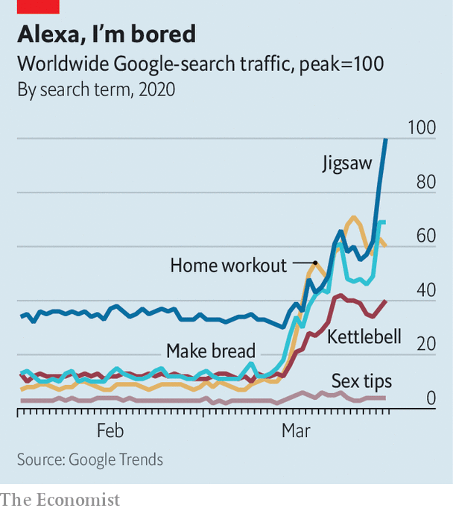

The stuck-at-home are also keen to improve themselves (see chart). Downloads of the top five recipe apps doubled in China during February’s lockdown. In Britain John Lewis, an upmarket department store, has reported a five-fold increase in sales of its Marcato pasta machine compared with typical sales for this time of year. Kettlebells and yoga mats are selling like toilet paper. Joe Wicks, a trainer who posts workout videos online, saw subscriptions to his channel more than double after he launched live physical-education lessons for kids no longer able to burn off their energy at school. During the first week of classes 15m viewers joined in.

The popularity of live group activities challenges the idea that you have to be physically present to be together. People who work out in groups are more committed and get more health benefits than those doing so alone. It is also showing just how much can be “experienced” from the comfort of the couch, raising the bar for experiences such as concerts and classes in the post-covid world.

Even before the pandemic, fitness fans wondered whether paid-for online platforms such as Peloton, a home exercise-bike company, could replace gyms. That debate will pump up further if gyms go bust because of the shutdowns.

It seems more likely that the strange but temporary state of lockdown will boost sectors that were already growing. Mental-health apps were flourishing before covid-19. Downloads of the five most popular “mindfulness” apps grew by 85% in 2018. In the last week of March Headspace, a meditation app, saw a 19-fold jump in users completing a calming exercise and a 14-fold surge in those doing a “reframing anxiety” session.

Dig deeper:  
For our latest coverage of the covid-19 pandemic, register for The Economist Today, our daily [newsletter](https://www.economist.com/newslettersignup), or visit our [coronavirus hub](https://www.economist.com/coronavirus)

This article was downloaded by calibre from <https://www.economist.com/international/2020/04/04/with-millions-stuck-at-home-the-online-wellness-industry-is-booming>

|  |  |  |  |
| --- | --- | --- | --- |
| Previous | Articles | Sections | Next |

|  |  |  |
| --- | --- | --- |
| International | Sections | Finance and ... |

Business

Corporate rescues: Great white night

.

Boeing: Up in the air

.

Show business and the pandemic: Aaaaand cut!

.

Huawei: Indestructible

.

Bartleby: Just the job

.

Schumpeter: You’re furloughed!

.

|  |  |  |
| --- | --- | --- |
| International | Sections | Finance and ... |

|  |  |  |  |
| --- | --- | --- | --- |
|  | Articles | Sections | Next |

#### Great white night

# Governments are once again splurging to keep big companies afloat

Authorities ponder which companies to bail out—and how

Apr 4th 2020 |

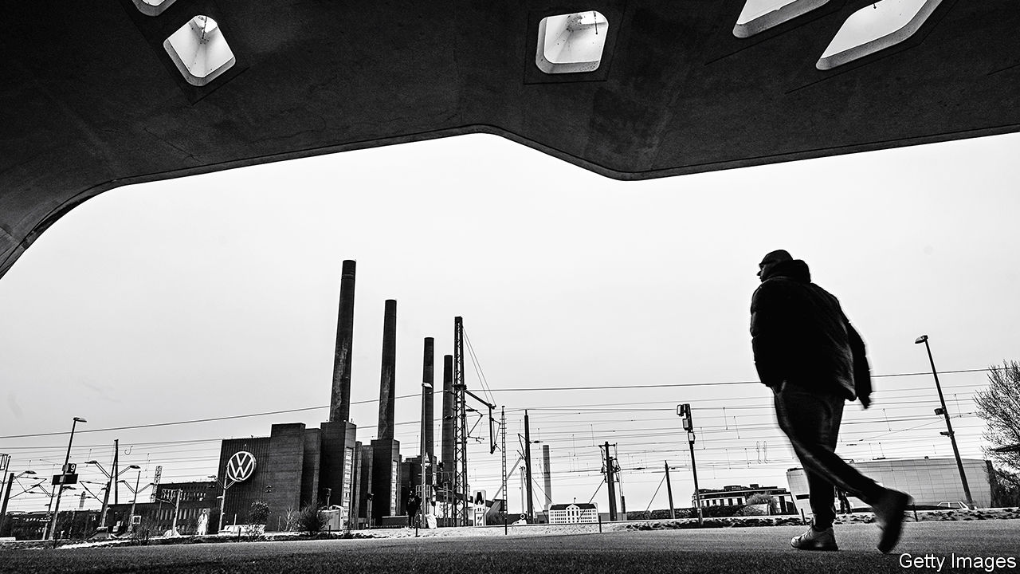

Editor’s note: The Economist is making some of its most important coverage of the covid-19 pandemic freely available to readers of The Economist Today, our daily newsletter. To receive it, register [here](https://www.economist.com/newslettersignup). For more coverage, see our coronavirus [hub](https://www.economist.com/coronavirus)

MANAGERS ARE encouraged to set enough aside for a rainy day. The covid-19 cloudburst means even the most prudent companies are rapidly exhausting their cash. Many will need a bigger umbrella that only the state can proffer.

The size of antiviral economic measures agreed so far is breathtaking. On March 27th President Donald Trump signed off on a record $2trn stimulus, which includes loan guarantees that could fund more than twice as much in corporate borrowing. Britain, France, Germany, Italy and Spain have their own “bazookas”, worth hundreds of billions. Who exactly will need help, how much and in what form is not yet entirely clear. But the contours of arguably the biggest corporate rescue in history are taking shape.

Some industries are seeking bespoke packages. First up, airlines. Those with stronger balance-sheets, such as Australia’s Qantas and IAG, owner of British Airways, would be just as happy if weaker rivals disappeared. But the International Air Transport Association, the global trade body, warns the pandemic will cut industry revenues in 2020 by $252bn, or 44%, relative to last year’s. Its members have cancelled 2m flights. Roughly 35-45% of airline costs are fixed, and so cannot be cut quickly, reckon analysts at Citigroup, a bank. Delta, an American carrier, says it is losing around $50m a day.

Some flag-carriers have already been bailed out: Alitalia has been nationalised (again), Dubai has rescued Emirates and Singapore Airlines raised equity with the backing of Temasek, the city-state’s sovereign-wealth fund. TUI, a German tour operator with its own aeroplanes, received €1.8bn ($2bn) in state-backed loans.

In America, where two-thirds of global airline profits are made, vigorous lobbying helped carriers secure their own tailored package. A $50bn mix of loans and grants has been earmarked to keep them aloft. They will be eligible for support worth six months of payroll, far more than other businesses. American Airlines said it was expecting $12bn from the government. Carriers have agreed to retain staff until October, slash salaries of top brass and halt shareholder payouts until late 2021. Some may have to give the government a slice of shares (or securities that convert into them) in exchange for cash, though precise terms have yet to be spelled out.

The only other American businesses entitled to their own pot of cash were those deemed “critical to maintain national security”. That sounds like a euphemism for Boeing, America’s troubled aircraft-maker (see [article](https://www.economist.com/business/2020/04/04/boeing-ponders-its-bail-out-options)). But other industries will no doubt claim the “critical” label for themselves. Oil producers, reeling from low crude prices, are said to be trying.

Elsewhere, some carmakers are liable to make a similar case. Like airlines, they are household names that sit at the heart of complex ecosystems with millions of employees. Governments ignore their pleas, should these come, at their peril. And come they may: demand for cars may slide by around a sixth this year and is unlikely to recover fast. Germany’s Volkswagen says it is losing €2bn a week. Like Renault of France and others, it has furloughed workers through state schemes. Car companies have 4-10 weeks of cash on hand, maybe double that if they tap credit lines, according to Jefferies, a bank. That may not be enough to ride out the crisis unaided.

The financial sector is the other traditional, if less beloved, candidate for state support. Insurers’ liability to covid-19 is, for instance, still unclear. Politicians in America are urging insurance firms to indemnify holders of policies protecting against business interruptions. The companies say these do not cover pandemics, and claim they could be on the hook for losses nearing $400bn a month if forced to do so. States including Ohio and Massachusetts are mulling bills that would compel payouts (see [article](https://www.economist.com/finance-and-economics/2020/04/04/what-missed-rent-and-mortgage-payments-mean-for-the-financial-system)). These would have to be accompanied by a rescue package. At least banks look more solid, thanks to regulations enacted in the wake of the financial meltdown in 2007-09. For once they may be part of the solution, not the problem: governments are using them as a conduit for state-guaranteed loans.

Support which banks, and any other business, will readily accept is coming in the form of relaxed regulations. Lenders are being offered capital relief in Europe and America. Countries from France to South Korea have banned investors from betting on share-price falls, to many a CEO’s delight. Some environmental regulations in America have been waived. European airlines get to keep valuable slots at airports even though they are not using them as required. Steven Mnuchin, America’s treasury secretary, has said the aid is predicated on three months of stoppages. It is anyone’s guess if that will be enough.

Much of the government largesse will be spread among millions of small businesses. Shuttered pizza joints, gyms, florists and the like are facing months of lost revenue. Few voters object to public money being used to pay laid-off or furloughed workers directly, as in Europe, or, as in America, to provide grants for firms that keep staff (see [Schumpeter](https://www.economist.com/business/2020/04/04/youre-furloughed)).

In fact, programmes which authorities have sold as a way to save mom-and-pop shops may also help big business. In Germany Adidas, a giant maker of sports gear, tried to use a measure designed to tide over small firms to suspend rental payments for some of its shops (it reversed course after the news leaked). American hotel chains won the right to treat each location as a separate business—and with it access to bail-outs designed for firms with fewer than 500 employees.

Many stronger firms would prefer a private-sector rescuer. Those with solid balance-sheets in Europe and America raised $316bn from investment-grade bonds in March, according to Dealogic, a data provider. Although some racier blue-chip firms must pay high coupons, for many yields remain reasonable (see chart).

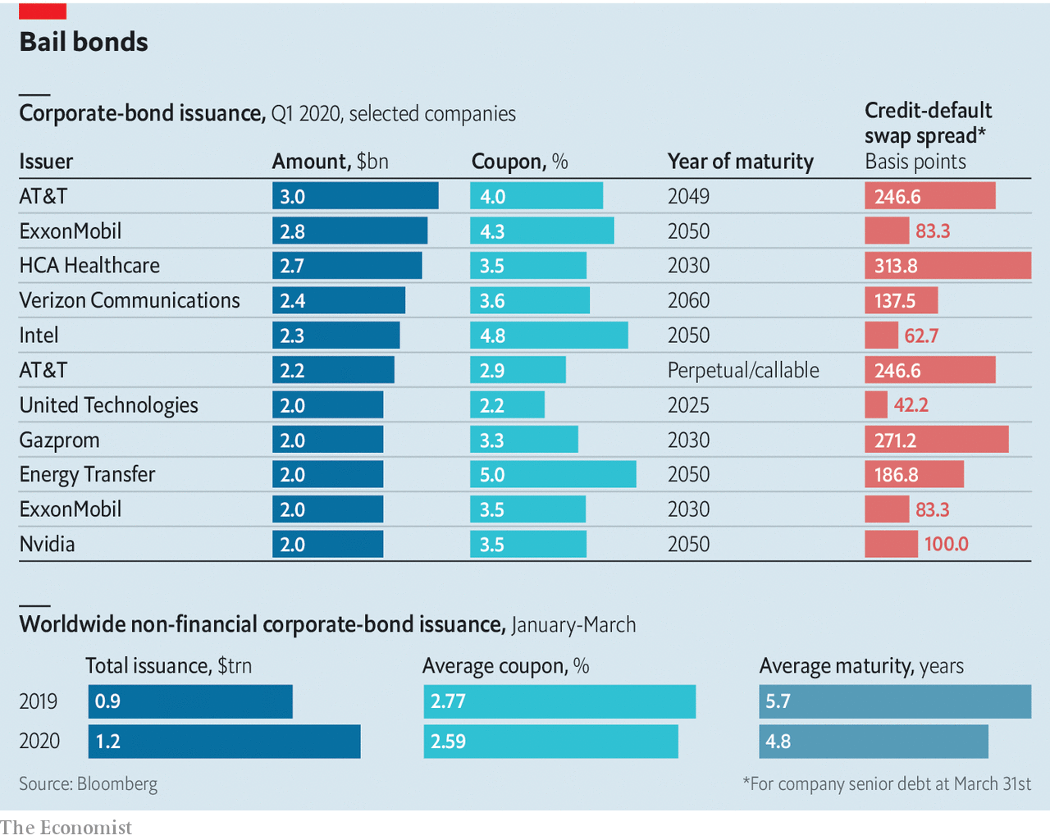

Some companies with iffier prospects can get their hands on cash, too. Carnival, a cruise-line operator whose share price is down by 83% this year, is raising $4bn through a sale of bonds (in part by mortgaging its ships) as well as fresh equity. Markets are charging a hefty price for this support. So long as they remain willing to shore up corporations on the brink, taxpayers may be spared big payouts—and governments, blushes for helping out unloved big business.■

Dig deeper:  
For our latest coverage of the covid-19 pandemic, register for The Economist Today, our daily [newsletter](https://www.economist.com/newslettersignup), or visit our [coronavirus hub](https://www.economist.com/coronavirus)

This article was downloaded by calibre from <https://www.economist.com/business/2020/04/03/governments-are-once-again-splurging-to-keep-big-companies-afloat>

|  |  |  |  |
| --- | --- | --- | --- |
|  | Articles | Sections | Next |

|  |  |  |  |
| --- | --- | --- | --- |
| Previous | Articles | Sections | Next |

#### Up in the air

# Boeing ponders its bail-out options

The aircraft-maker can survive for now but will eventually need to raise cash

Apr 4th 2020 |

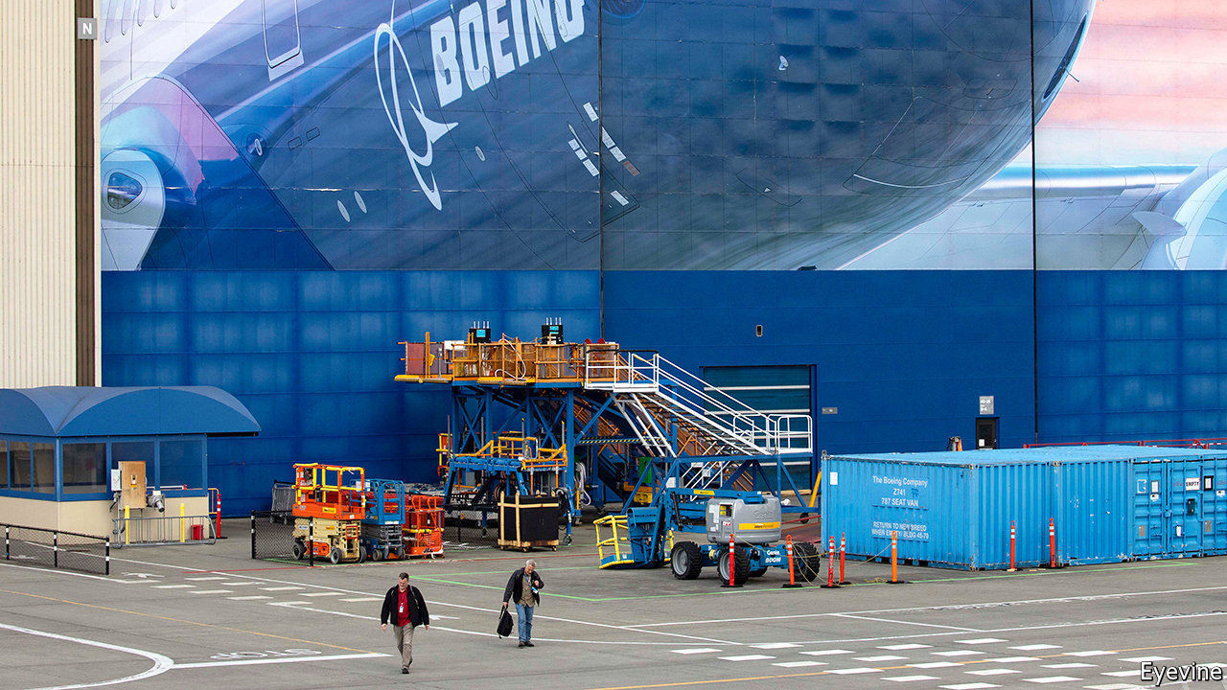

Editor’s note: The Economist is making some of its most important coverage of the covid-19 pandemic freely available to readers of The Economist Today, our daily newsletter. To receive it, register [here](https://www.economist.com/newslettersignup). For more coverage, see our coronavirus [hub](https://www.economist.com/coronavirus)

THE CORONAVIRUS laid many of Boeing’s airline customers low—literally, for many have suspended flights. Fears about the giant’s fate, already uncertain because of the year-long grounding of its best-selling 737 MAX jet after two fatal crashes, became so rife that last month Goldman Sachs, a bank, felt compelled to stress that it “will remain a going concern”. The company itself insists likewise. It is probably right—the question is not whether it will survive but how.

Boeing has a safety net. A third of revenues in 2019 came from its defence arm, which, with its services division, will bring in $5bn in profits this year, reckons Bernstein, a research firm. It has cash on its balance-sheet, the balance of a $14bn credit line and has suspended its dividend. Dave Calhoun, Boeing’s new boss, says that the firm has $15bn in liquidity.

Jefferies, a bank, estimates that the company burns through $4.3bn of cash a month with a complete suspension of deliveries. So it may need government help if the crisis drags out. Lucky, then, that Congress folded its plea for assistance for American aviation into a $2trn stimulus package. This includes $25bn for carriers and $17bn for firms “critical to maintaining national security” (ie, Boeing). The terms are unclear and talks ongoing. But Steve Mnuchin, the treasury secretary, has hinted that help would come with strings—including an equity stake for the state.

Boeing is unwilling to entertain this (for now). It may prefer to try to tap $454bn set aside in the stimulus for loans and guarantees to big firms, which would not involve giving up equity. Mr Calhoun says his company can raise money in the market. But the terms would be onerous. Despite recent improvements, its ten-year bonds trade below par and the cost of insuring its debt against default remains high.

Boeing hopes that business will bounce back quickly; it has been reluctant to furlough workers, notes Ken Herbert of Canaccord Genuity, a bank. It intends to restart making the 737 MAX in May (slowly at first). Goldman Sachs reckons that even if it delivers only half the planes planned for this year it will have the liquidity to cover a “deeply negative” cashflow. But airlines may not return to normal service for months, depressing sales. Mr Calhoun may have to pick between a bitter market rescue and an unsavoury government one.■

Dig deeper:  
For our latest coverage of the covid-19 pandemic, register for The Economist Today, our daily [newsletter](https://www.economist.com/newslettersignup), or visit our [coronavirus hub](https://www.economist.com/coronavirus)

This article was downloaded by calibre from <https://www.economist.com/business/2020/04/03/boeing-ponders-its-bail-out-options>

|  |  |  |  |
| --- | --- | --- | --- |
| Previous | Articles | Sections | Next |

|  |  |  |  |
| --- | --- | --- | --- |
| Previous | Articles | Sections | Next |

#### Aaaaand cut!

# Disney and its rivals star in a real-life disaster movie

And you thought streaming wars were disruptive

Apr 2nd 2020 |

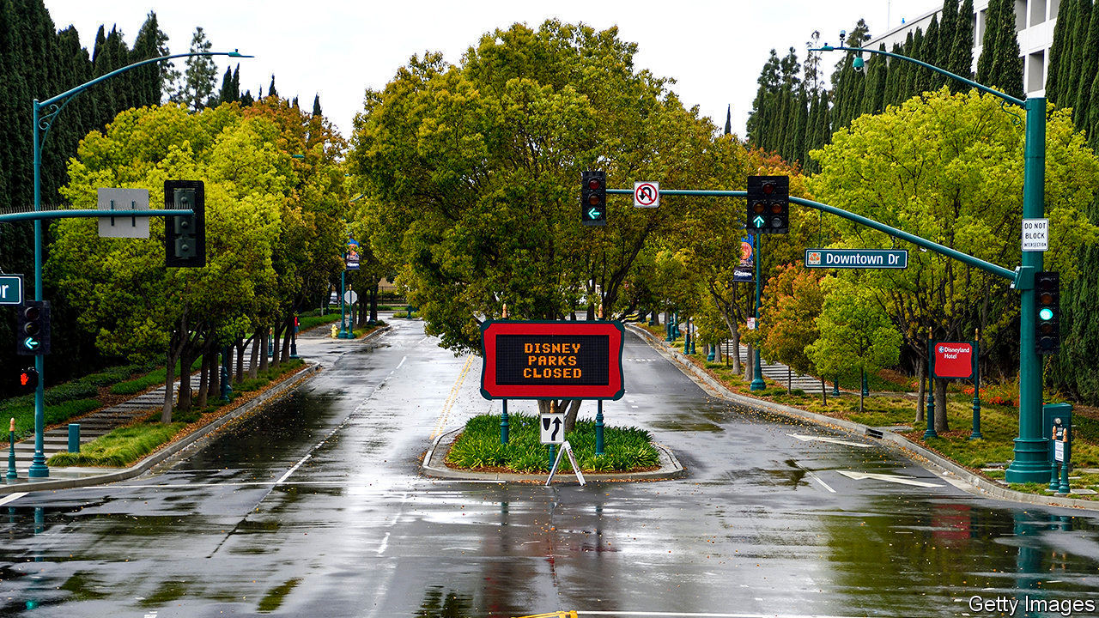

Editor’s note: The Economist is making some of its most important coverage of the covid-19 pandemic freely available to readers of The Economist Today, our daily newsletter. To receive it, register [here](https://www.economist.com/newslettersignup). For more coverage, see our coronavirus [hub](https://www.economist.com/coronavirus)

THE EMPTY freeways of Los Angeles look like a scene from a disaster movie. For many Hollywood bosses, that is how things feel. With one in three people in the world subject to social-distancing rules, boxoffice takings in 2020 have collapsed. Television is bracing for revenue-starved advertisers to rein in spending. Shooting on productions slated for 2021 has ceased, portending an unpleasant sequel next year.

Covid-19 comes at a tumultuous time for show business. A five-year, $650bn investment binge was already reshaping it for the age of video-streaming. Debts taken on by giant media groups such as AT&T, Comcast, Disney and ViacomCBS—which owe more than $350bn between them—look less sustainable now that their sales have sunk. Even Netflix, whose streaming-only offering is less vulnerable to lockdowns, is not immune. The pandemic will leave scars. It may claim a few victims, too.

Theatrical releases, which studios use to recoup blockbusters’ vast production costs, have all but stopped. Disney’s “Onward”, out on March 6th, has grossed one-fifth of its hoped-for $500m worldwide. Many premieres have moved partly or wholly online. Comcast’s NBCUniversal will start streaming “Trolls World Tour” on April 10th, the same day it opens in the few unshuttered cinemas. Paramount Pictures (part of ViacomCBS) has sold “The Lovebirds”, once scheduled for a cinema run, to Netflix. Releases held until the pandemic ends may find fewer cinemas to screen them. AMC, the world’s largest chain, which lost money in two of the past three years as audiences chose their couch over a night out, is teetering. Cineworld, the second-biggest, has said that in the (“unlikely”) worst-case scenario it may fold.

The small screen has its own problems. Nielsen, a research company, finds that in past lockdowns, such as during Hurricane Harvey, time spent in front of the TV rose by up to 60%. In parts of Italy quarantine boosted TV ratings, according to Auditel, another research firm. Yet this may not help networks. For one thing, they too face a drought of content. ITV, Britain’s biggest commercial broadcaster, has stopped filming its soap opera, “Coronation Street”, and is airing three episodes a week, not the usual six. American networks have built up an inventory fearing a writers’ strike this year, but it will only last until the summer.

Even if people tune in to reruns TV finances will be under strain. As their own revenues evaporate and their customers cannot shop, advertisers are pulling commercials. Ad bonanzas have been postponed (Olympics) or cancelled (Wimbledon). Suspension of live sport has deprived pay-TV operators such as Disney’s ESPN and Sky, a European giant belonging to Comcast, of their last big remaining attraction. Some firms, like Sky, have allowed customers to pause sports subscriptions or offered access to other paid programming in their place. ESPN is airing repeats of classic matches, plus offbeat fare like dodgeball and arm-wrestling. Neither tactic is likely to arrest the slide in the share of households with pay-TV, down from almost 90% in 2010 to 65% in America.

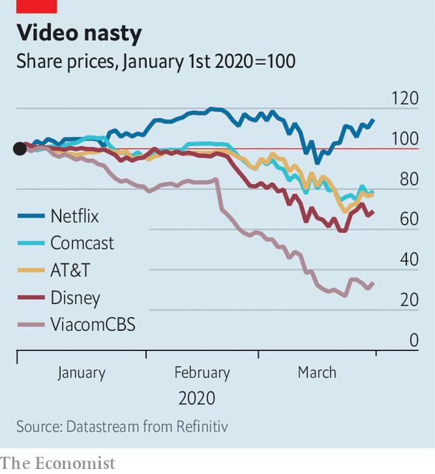

Streaming offers some respite. Netflix’s share price, up by 15% this year, looks buoyant amid a market rout. It claims to have enough fresh content to last a few months. Subscription growth for all the big streamers has soared by double digits from week to week since lockdowns kicked in, estimates Antenna, a data company. After its European launch in March Disney’s new platform, Disney+, was downloaded more than 5m times in just days. AT&T and Comcast hope for similar success when they launch (paid) HBO Max and (ad-supported) Peacock, respectively, later this year.

But an uptick in streaming revenue may not offset the losses from other businesses. Netflix, which has none, is running out of new eyeballs to attract in the West; nearly half of American households already subscribe. Keeping those it has may require serving up new shows—which it cannot produce. Lockdowns are unlikely to bring in new viewers in poorer countries, where streaming remains a luxury, especially as mass joblessness looms.

The revenue squeeze also comes after a period of heavy borrowing by media firms, as they raced to create or buy spectacular content. At the end of last year AT&T was on the hook for some $190bn, including $17bn which comes due this year and next. Comcast owed more than $100bn, Disney $47bn and ViacomCBS $21bn. With outstanding debt of $16bn, or nearly six times gross operating earnings, Netflix is even more leveraged. In March Disney raised $6bn in a new debt offering, for “general corporate purposes”, including paying down debts. ViacomCBS has announced a $2.5bn bond to shore up its balance-sheet. AT&T has put off a planned $4bn share buy-back.

Most firms have warned of adverse effects on business, without putting a figure on it. AT&T and Comcast, which own not just content but the “pipes” through which it is delivered, can count on revenues from self-isolating broadband users, many of whom are upgrading to faster speeds. A pipeless Disney faces the biggest broadside: to the box-office, ESPN, its stores and theme parks.

This has led to speculation of a takeover. Bernie McTernan of Rosenblatt, a financial-services firm, has suggested that Apple, with some $200bn in gross cash, might buy Disney, whose market value has sunk to about $180bn. The tech giant might like the look of Disney assets such as Lucasfilm (which makes “Star Wars”) and Marvel, says Rich Greenfield of LightShed Partners, a research firm, to complement its lacklustre Apple TV+ library. But, he adds, a buy-out would also land it with businesses in which it has little interest, such as theme parks, gift shops and television networks. The drama that plays out in media markets in the next year may turn out to be more exciting than the blockbusters not hitting screens near you. ■

Correction: This article originally stated that Disney’s closure of its parks alone by mid-April would make it suffer an operating loss of over $1bn. In fact it would only cut more than $1bn off its gross operating income. Sorry.

Dig deeper:

For our latest coverage of the covid-19 pandemic, register for The Economist Today, our daily [newsletter](https://www.economist.com/newslettersignup), or visit our [coronavirus hub](https://www.economist.com/coronavirus)

This article was downloaded by calibre from <https://www.economist.com/business/2020/04/01/disney-and-its-rivals-star-in-a-real-life-disaster-movie>

|  |  |  |  |
| --- | --- | --- | --- |
| Previous | Articles | Sections | Next |

|  |  |  |  |
| --- | --- | --- | --- |
| Previous | Articles | Sections | Next |

#### Indestructible

# Huawei reports resilient results

Neither American sanctions nor covid-19 seem able to slow its rise much

Apr 4th 2020 | NEW YORK

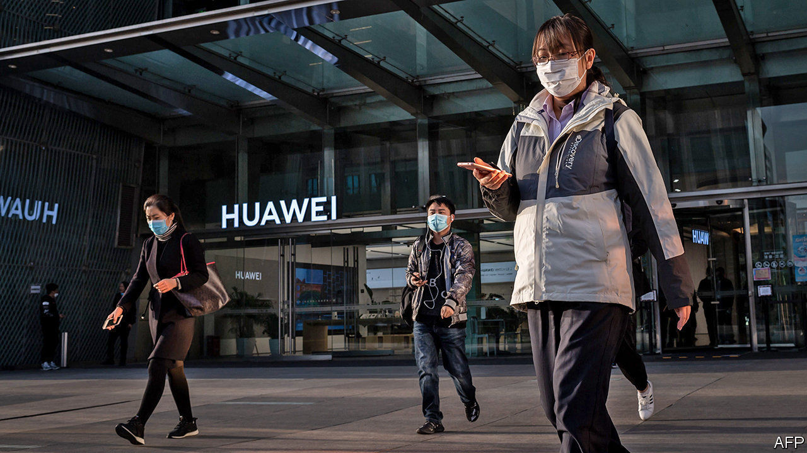

Editor’s note: The Economist is making some of its most important coverage of the covid-19 pandemic freely available to readers of The Economist Today, our daily newsletter. To receive it, register [here](https://www.economist.com/newslettersignup). For more coverage, see our coronavirus [hub](https://www.economist.com/coronavirus)

ERIC XU, ONE of Huawei’s three rotating chairmen, did not hold back. “Nonstop pressure from the US government, in a deliberate attempt to spread disinformation, has put our company under the spotlight,” he wrote in the firm’s annual report, released on March 31st. This was meant to explain why the telecoms-equipment giant missed its revenue target of $135bn by $12bn.

America has barred exports of some American technology to the Chinese champion. It is threatening to impose further sanctions soon and has tried, with mixed success, to strong-arm American allies to reject Huawei’s next-generation 5G-networking kit.

For all Mr Xu’s outrage, the results were rather impressive. Revenues rose by 19% year on year. They have more than doubled in four years. Net profit rose by nearly 6% to 63bn yuan ($8.8bn). The firm’s cashflow from operations rose by 22% year on year, to 91bn yuan.

The firm responded to America’s assault by redoubling its efforts at “indigenous innovation”, through which it sources and invents as much as it can in China. This will not be easy. Though its premium smartphones now have fewer American parts, its overall use of American inputs actually rose last year to nearly $19bn, from $11bn in 2018.

On the bright side, its kit remains popular outside America. Although American measures limited its use of Google’s Android smartphone operating system, its consumer-business group increased sales by 34%, to 467bn yuan, owing to strength in China and emerging markets. Its 5G gear is more advanced and less costly than offerings from European rivals, Ericsson and Nokia. Huawei now boasts over 90 5G contracts worldwide, half of them in Europe.

Duncan Clark of BDA China, a consultancy, likens Huawei to the villainous robots in “Terminator” films: not just indestructible but “able to rebuild itself after any attempt to take it down”. Even covid-19 may not slow it down. As more people Zoom to work, governments everywhere covet the sort of zippy mobile networks Huawei helps build.

Dig deeper:  
For our latest coverage of the covid-19 pandemic, register for The Economist Today, our daily [newsletter](https://www.economist.com/newslettersignup), or visit our [coronavirus hub](https://www.economist.com/coronavirus)

This article was downloaded by calibre from <https://www.economist.com/business/2020/04/03/huawei-reports-resilient-results>

|  |  |  |  |
| --- | --- | --- | --- |
| Previous | Articles | Sections | Next |

|  |  |  |  |
| --- | --- | --- | --- |
| Previous | Articles | Sections | Next |

#### Bartleby

# Jobs for jailbirds

Getting prisoners into work seems to reduce reoffending

Apr 4th 2020 |

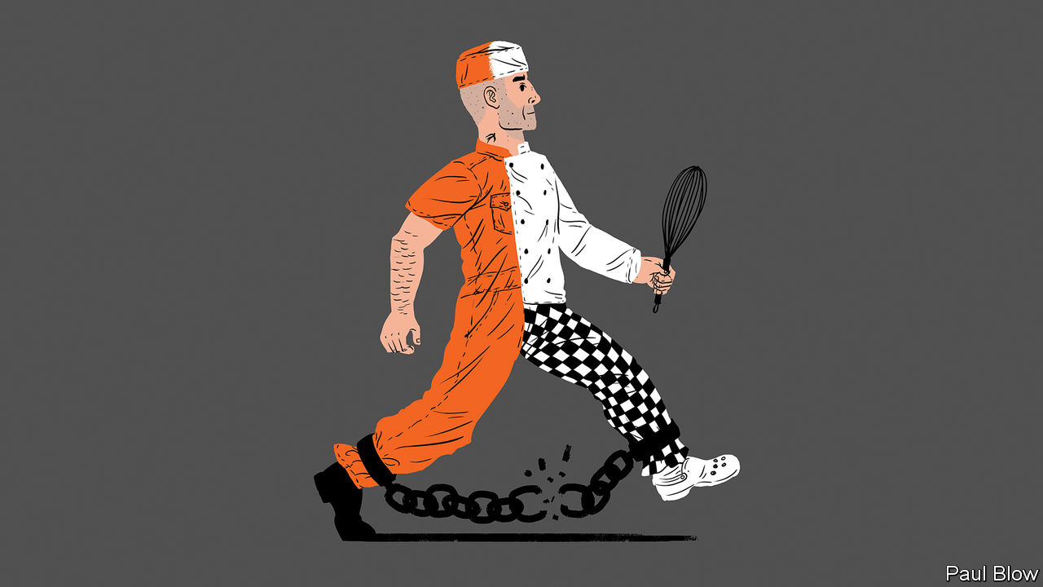

A CONVICTED THIEF is sent to prison and struggles to adjust to his new environment until his culinary talents are discovered. By a very roundabout route, his kitchen skills lead to his rehabilitation. That is the plot of “Paddington 2”, a family film from 2017. It might also serve as the template for Clink. The charity trains prisoners in hospitality and catering, and ran five restaurants and cafés in Britain before the national lockdown brought about by the covid-19 pandemic. It trained 441 prisoners last year. They achieved 225 educational certificates. Over 280 employers have agreed to hire Clink graduates. Some ex-convicts have gone on to become head chefs at hotels.

Prisons are in the news because of the threat covid-19 poses to people locked up in a confined space. Some have been released early. But in normal times, which will one day return, getting prisoners back to work is one of the best ways to help their rehabilitation. A study by the Justice Data Lab, a British government body, conducted between 2009 and 2016 showed that 15% of Clink alumni reoffended, compared with 22% for other jailbirds with similar records.

Clink is not alone. Take Ali Niaz, a former drug dealer who managed to get an A-level in business during his time in prison. After his release, and a course at Madingley Hall in Cambridge, he became a business and life coach. He also runs a social enterprise helping ex-offenders and set up the Feel Good Bakery, where ex-prisoners make sandwiches for office workers (or did until the pandemic, though it is still paying its staff).

Mr Niaz received help from the Responsible Business Initiative for Justice (RBIJ), a transatlantic charity run by Celia Ouellette, a former death-row lawyer in America. She points out that 2.2m Americans, the population of a large metropolis, are locked up. America also has perhaps 5m ex-offenders. RBIJ helps businesses trying to employ both groups.

One of those is Televerde, a call-centre operator from Arizona. Ron Bell, its founder, was involved in prison administration and got a contract with the state of Arizona to provide work and training for female inmates. Now the company operates seven call centres in women’s correctional facilities, focusing on business-to-business marketing and sales. The women work 40 hours a week: part of their wage goes toward their upkeep, part can be spent in prison and the rest goes into a savings account for when they get out.

Around 40% of people at the Televerde corporate office are ex-prisoners. Some released on Friday start work there the next Monday. One former inmate, Michelle Cirocco, who has been with the company for 21 years, has held high executive positions, in charge of marketing and corporate social responsibility.

Not everyone who worked for Televerde while inside will find a job at headquarters when they leave. But the skills they learn are still useful; a study by Arizona State University shows that 94% of ex-Televerde workers have jobs after five years, earning 3.7 times the average wage for former convicts. In Ohio Dan Meyer runs Nehemiah Manufacturing, which was created ten years ago specifically to hire what he calls “second-chance citizens”—not just prisoners but people with a history of drug and alcohol abuse, and those from homeless shelters. The company licenses small brands from multinationals such as Pampers Kandoo, a line of products for toddlers. It employs 180 people, of whom 130 are in the “second chance” category.

Mr Meyer found that getting a job is not the only challenge for those released from prison. They also need help with housing and child care, which is why Nehemiah has employed three social workers. New staff are initially hired for three to six months and around 30-40% drop out in that period. But once they are hired full-time, the turnover rate is only 15%, which he says is low by industry standards. Many of the workers have drug-related problems and the company operates random drug-testing. If employees fail a test, they are offered rehab.

Nehemiah cannot employ all of Ohio’s second-chancers. So Mr Meyer created the Beacon of Hope business alliance. In total, the alliance has 80 members, including Kroger, a supermarket chain. Collectively, they have hired 600 vulnerable people.

Writing individuals off for life is not just callous. It also is economically inefficient. Society will be better if more jailbirds find jobs—be they those released early because of covid-19 or those still serving time.

This article was downloaded by calibre from <https://www.economist.com/business/2020/04/04/jobs-for-jailbirds>

|  |  |  |  |
| --- | --- | --- | --- |
| Previous | Articles | Sections | Next |

|  |  |  |  |
| --- | --- | --- | --- |
| Previous | Articles | Sections | Next |

#### Schumpeter

# From “you’re fired” to “you’re furloughed”

Should American job cullers become more European in the crisis?

Apr 4th 2020 |

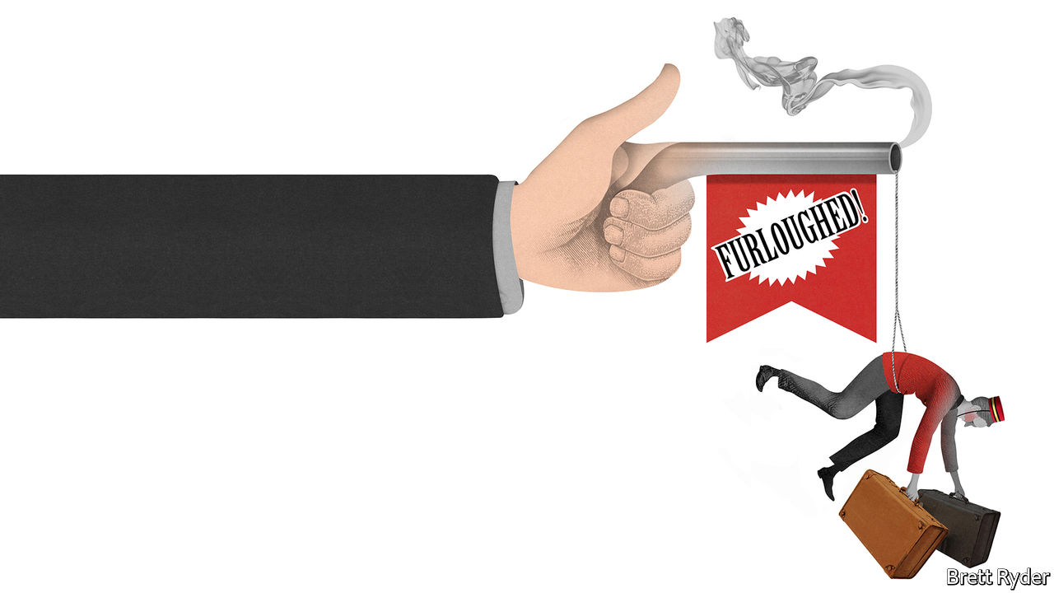

Editor’s note: The Economist is making some of its most important coverage of the covid-19 pandemic freely available to readers of The Economist Today, our daily newsletter. To receive it, register [here](https://www.economist.com/newslettersignup). For more coverage, see our coronavirus [hub](https://www.economist.com/coronavirus)

IN MID-FEBRUARY Hilton, a hotelier, and its employees had something to celebrate. For the second year running the company came top in Fortune magazine’s list of best American companies to work for. The perks provided to its 62,000 direct employees in America included extended parental leave, Under Armour-branded uniforms and facilities to let travelling staff ship breast milk home. A mere six weeks later, on March 26th, tens of thousands of those pampered employees were given notice that they would be thrown out of work because of the covid-19 pandemic. That was the day weekly jobless claims in America spiked by 1,000% to 3.3m.

The stratospheric surge of Americans seeking unemployment benefits contrasts with the situation in western Europe. Companies there are struggling just as hard but many are keeping workers on the books at reduced pay. That is a familiar story. In times of economic upheaval, European firms rely extensively on schemes in which the government picks up part of the wage bill, such as Germany’s Kurzarbeit, France’s chômage partiel and Italy’s cassa integrazione. Traditionally, America has shunned such feather-bedding. From frontier days its labour laws have given employers leave to cull jobs almost at will. Not for nothing did the country elect a president whose catchphrase was “You’re fired!”

In the current crisis it may seem fair to ask American firms to take a more European approach. After all, business activity has collapsed not because of slothful work habits, but because governments have ordered people to stay at home. This is not a slump that needs to be fixed with an orgy of creative destruction in the jobs market. And however deep the downturn, the rebound could be relatively quick. If so, it makes sense for companies and employees to maintain ties, so that production can resume briskly when things improve.

Yet one feature of this crisis in fact makes it all the more important to maintain flexible labour practices: the jobs market has bifurcated. In industries that bring people together, such as hotels, airlines, casinos and restaurants, demand for workers has collapsed. Those that provide access to health care (such as hospitals), staples (supermarkets) or services catering to those stuck at home (e-commerce) are clamouring for more staff. For all the merits of Europe’s labour-support programmes, the risk is that they last too long and dissuade workers from switching to industries where their help is badly needed.

Already the response of American firms to the jobs crisis is taking an unfamiliar route. Though many of the small businesses that provide about half of private-sector employment in America were quickly forced to let workers go to survive, the government has stepped in to ease the pain. Its $2trn support programme has temporarily increased unemployment benefits. A $350bn lifeline to small businesses within the stimulus package encourages them to cling on to staff if they can.

Some bigger American firms, such as Hilton, its rivals like Hyatt and Marriott, and retailers such as Macy’s and Gap, are taking a different tack. Instead of sacking staff, they have announced that tens of thousands of their employees will be furloughed, which in America means being put on unpaid leave. Crucially, the furloughed workers get to keep their company health insurance. They can also, in most cases, claim unemployment benefits. To ease resentments, those who remain in work, including executives, will suffer pay cuts.

The use of furloughs represents a change from previous slumps, says Sandra Sucher of Harvard Business School. Common in Europe during the financial crisis of 2007-09, they were barely used in America. Since then, however, many American firms who laid off workers found subsequent rehiring so difficult that they are loth to suffer the ordeal again, she says.

Another difference with past recessions is the way American firms are encouraging inactive workers to switch jobs to fill temporary vacancies in other industries. Hilton, for instance, is helping its suspended workers to apply for jobs at e-commerce firms like Amazon. This may help keep the labour market relatively fluid at a time of severe stress. (Amid employee absences and increased orders, some workers at Amazon, for instance, are demanding better conditions.) It is also well-suited to the time horizons of the pandemic. As social-distancing measures recede, some of the disease-specific demand for labour will ebb, enabling workers to return to their old jobs.

## From pulling pints to pulling up potatoes

This is where Europe could learn something from America. Some industries have far too many workers, whereas others do not have enough. Airline employees are needed to work in hospitals, and rural bar staff could helpfully be dragooned into farmwork amid a shortage of migrant labour. But European countries’ schemes for subsidising the wages of furloughed workers often do not make it easy for them to take new jobs, even temporarily, and sometimes discourage it. As Giuseppe Moscarini of Yale University says, support for workers should not preclude labour mobility, even if it encourages them to maintain ties with their existing employers.

Both American and European labour policies have their pros and cons. In America rapid shake-outs in jobs markets help good firms grow and bad firms shrink, promoting dynamism. In Europe worker protections can reduce the devastating toll on employees and their families caused by slumps, but can slow the pace of recovery. American left-wingers believe that more European-style treatment of workers is long overdue—and will cheer examples of companies volunteering to furlough workers rather than fire them. But if America and Europe want to ensure that hospitals are staffed, deliveries are made and food is on the table, they must remember that flexibility, as well as some security, is essential. ■

Dig deeper:  
For our latest coverage of the covid-19 pandemic, register for The Economist Today, our daily [newsletter](https://www.economist.com/newslettersignup), or visit our [coronavirus hub](https://www.economist.com/coronavirus)

This article was downloaded by calibre from <https://www.economist.com/business/2020/04/03/from-youre-fired-to-youre-furloughed>

|  |  |  |  |
| --- | --- | --- | --- |
| Previous | Articles | Sections | Next |

|  |  |  |
| --- | --- | --- |
| Business | Sections | Science and ... |

Finance and economics

Emerging economies: Stringent but stingy

.

Projecting uncertainty: Economists’ forecasts for GDP growth in 2020 vary widely

.

Squeezed incomes in America: Bills, bills, bills

.

Buttonwood: Advantage Norway

.

Allianz: Lonely work

.

Free exchange: Chinese rate trap

.

|  |  |  |
| --- | --- | --- |
| Business | Sections | Science and ... |

|  |  |  |  |
| --- | --- | --- | --- |
|  | Articles | Sections | Next |

#### Stringent and stingy

# Emerging-market lockdowns match rich-world ones. The handouts do not

Few emerging-economy governments can afford a generous fiscal response

Apr 4th 2020 | HONG KONG

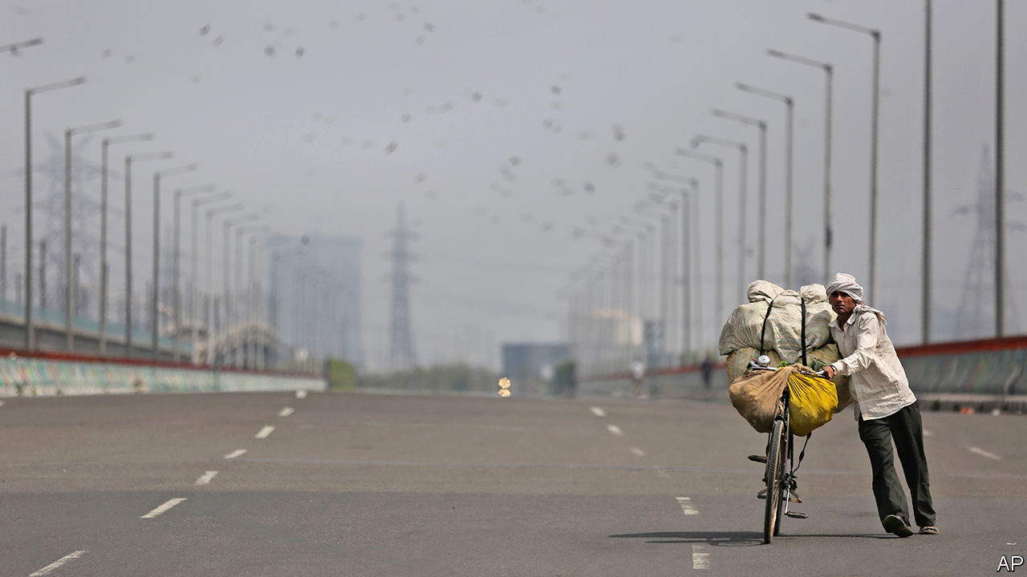

Editor’s note: The Economist is making some of its most important coverage of the covid-19 pandemic freely available to readers of The Economist Today, our daily newsletter. To receive it, register [here](https://www.economist.com/newslettersignup). For more coverage, see our coronavirus [hub](https://www.economist.com/coronavirus)

WHEN THE global financial crisis struck emerging economies in 2008, two kinds of exodus ensued. Footloose capital fled their financial markets and migrant labour left their cities for the bosom of their hometowns and villages. Since the “coronacrisis” struck, the first exodus has recurred on an unprecedented scale: foreigners took over $83bn out of emerging-market shares and bonds in March, according to the Institute of International Finance, a banking association, the largest monthly outflow on record. But the exodus of labour has been hampered by governments’ efforts to shut down transport and lock down populations, in order to slow the spread of covid-19.

At least 27 emerging economies have imposed nationwide restrictions on movement, according to a tally kept by Thomas Hale and Samuel Webster of the Blavatnik School of Government at Oxford University. Vietnam became the latest candidate for the list, requiring its citizens to stay home until April 16th. Pakistan’s prime minister, Imran Khan, once warned that a lockdown would bring hunger and ruin. But even Pakistan “has swiftly moved from we can’t afford lockdown, to we can’t afford not to lock down,” notes Charlie Robertson of Renaissance Capital, an investment bank.

All countries have spared “essential” goods and services from restrictions. But what counts as essential? India’s list, derived from a law passed in 1955, at first failed to mention feminine-hygiene products, causing confusion. South Africa scrambled to add toothpaste and baby products to a list of “basic goods” that had omitted them. There have been errors of inclusion too. Days into its lockdown, South Africa’s government discovered that some pubs had been mistakenly awarded certificates to operate.

Even industries deemed essential can suffer from broader restrictions. One pharmaceutical plant in northern India says it can produce, but not ship, its wares. A maker of medicine capsules eventually won approval to keep operating. But by then some of its employees had left town and others were scared to return to work.

Whereas previous crises have imposed a financial constraint on economic activity, this disaster has imposed a “physical constraint”, points out Alberto Ramos of Goldman Sachs, a bank. He expects Latin America to suffer its worst contraction since the second world war, exceeding even its debt crisis of the 1980s. Much depends on how long the lockdowns last. India’s is due to be lifted on April 15th, but restrictions may linger in states with high numbers of infections, points out Priyanka Kishore of Oxford Economics. Several of those states, including Maharashtra and Karnataka, are among the biggest contributors to India’s economy. If 60% of the country remains locked down until the end of April, she calculates, up to 10% of India’s GDP in the second quarter could be lost.

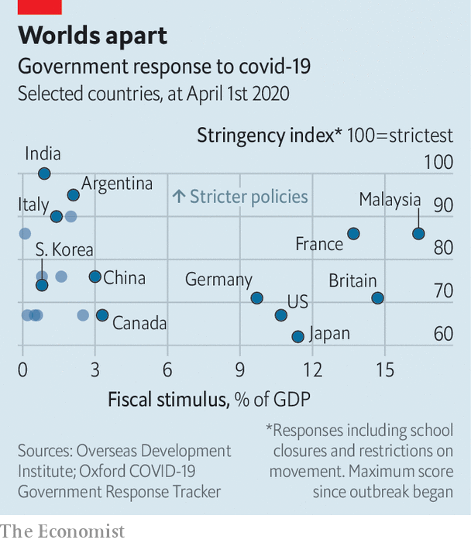

The lockdowns in many emerging markets are as tough as in the rich world, or more so, suggests an index created by Mr Hale and Mr Webster measuring the “stringency” of a government’s response to the pandemic. But unlike their richer counterparts, few emerging-economy governments can match this stringency with an equally generous fiscal response, according to numbers collated by Sherillyn Raga of the Overseas Development Institute, a think-tank (see chart).

Malaysia may be one exception. It has unveiled a relief package with a face value of over 16% of GDP, including loan guarantees, wage subsidies and even free internet during the period of social distancing. Not many other emerging economies can enact anything similar. India, for example, has announced a plan to help the poor worth 1.7trn rupees ($23bn), only about 0.8% of GDP. Even that includes previously budgeted outlays that will merely be spent sooner. South Africa’s fiscal response has been inhibited by rising borrowing costs. Last week Moody’s became the last of the big three credit-rating agencies to strip it of its investment-grade status, calculating that the government’s budget deficit this fiscal year would exceed 8% of GDP and that its debt, including its guarantees to state-owned enterprises, would rise from 69% of GDP to 91% by 2023.

Central banks have been a little more adventurous, cutting interest rates despite the slump in emerging-market currencies. Some, including those in Colombia and South Africa, will emulate America’s Federal Reserve by buying government bonds in the open market to reduce volatility. Indonesia will cut out the middleman: new rules allow its central bank to, in extremis, buy bonds directly from the treasury.

But no emerging market, almost by definition, can afford to ignore its exchange rate entirely. Russia’s central bank, for example, recently refrained from cutting interest rates because the rouble has tumbled so dramatically in the wake of the country’s oil-price war with Saudi Arabia. The tussle caused oil prices to dip below $20 a barrel this week, according to America’s benchmark, for the first time since 2002.

In some countries (such as Argentina), governments still have substantial foreign-currency debt. In others, companies do (Turkey). And in still others (South Africa), a large share of local-currency debt is held by foreigners, who will be reluctant to roll over their holdings if the currency becomes unmoored.

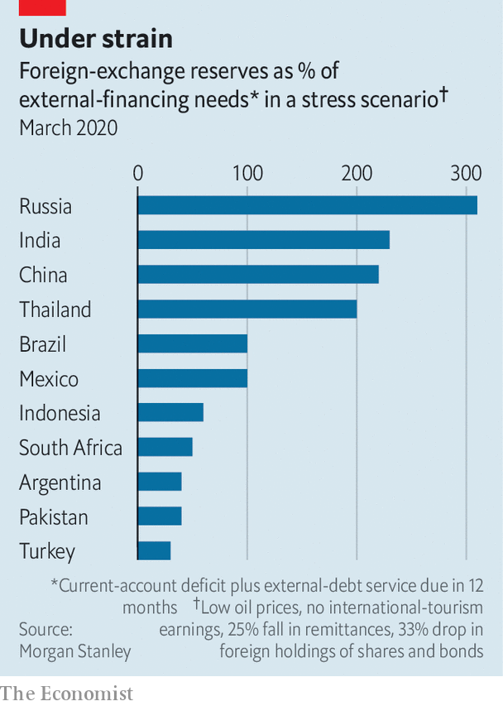

In order to measure countries’ vulnerability, analysts at Morgan Stanley, a bank, have calculated the amount of hard currency emerging economies would need to service their foreign debt this year and cover their trade balance, if oil prices remain low, remittances from overseas workers drop by 25%, export earnings from tourism and travel disappear, and foreigners dump a third of their holdings of shares and bonds. They then compare this amount to these countries’ foreign-exchange reserves (see chart). Many emerging economies would lack enough reserves to meet their needs, leaving them reliant on further foreign borrowing in hostile markets.

In such circumstances, some emerging economies will turn to the IMF. Indeed the fund says over 80 countries have already asked for some form of help in recent weeks. Others may extend their lockdowns into the financial realm. In a report published on March 30th the United Nations Conference on Trade and Development argued that some countries should impose capital controls, with the IMF’s blessing, to “curtail the surge in outflows”. Having prevented labour from moving freely within their borders, some overstretched emerging markets may now be tempted to stop capital moving freely across them. ■

Dig deeper:  
For our latest coverage of the covid-19 pandemic, register for The Economist Today, our daily [newsletter](https://www.economist.com/newslettersignup), or visit our [coronavirus hub](https://www.economist.com/coronavirus)

This article was downloaded by calibre from <https://www.economist.com/finance-and-economics/2020/04/03/emerging-market-lockdowns-match-rich-world-ones-the-handouts-do-not>

|  |  |  |  |
| --- | --- | --- | --- |
|  | Articles | Sections | Next |

|  |  |  |  |
| --- | --- | --- | --- |
| Previous | Articles | Sections | Next |

#### Doom and gloom

# Economists’ forecasts for GDP growth in 2020 vary widely

But all expect a dreadful year

Apr 4th 2020 |

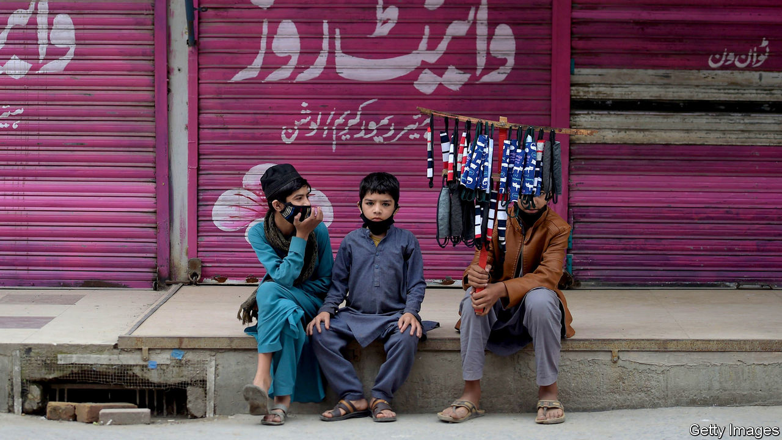

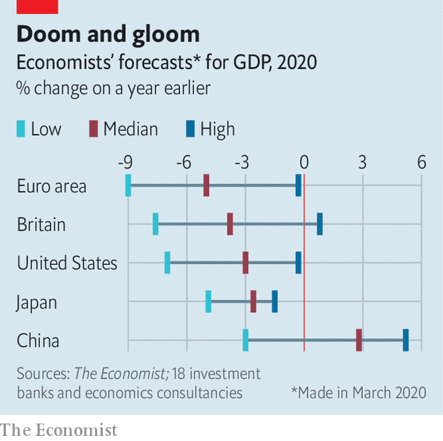

ECONOMISTS cannot revise down their forecasts of GDP growth for the effects of the coronavirus pandemic fast enough. All agree that 2020 will be dreadful, but some expect recovery to take longer than others, making for a much grimmer year.■

This article was downloaded by calibre from <https://www.economist.com/finance-and-economics/2020/04/03/economists-forecasts-for-gdp-growth-in-2020-vary-widely>

|  |  |  |  |
| --- | --- | --- | --- |
| Previous | Articles | Sections | Next |

|  |  |  |  |
| --- | --- | --- | --- |
| Previous | Articles | Sections | Next |

#### Bills, bills, bills

# What missed rent and mortgage payments mean for the financial system

April 1st was payday—and the day that big bills were due

Apr 4th 2020 | NEW YORK

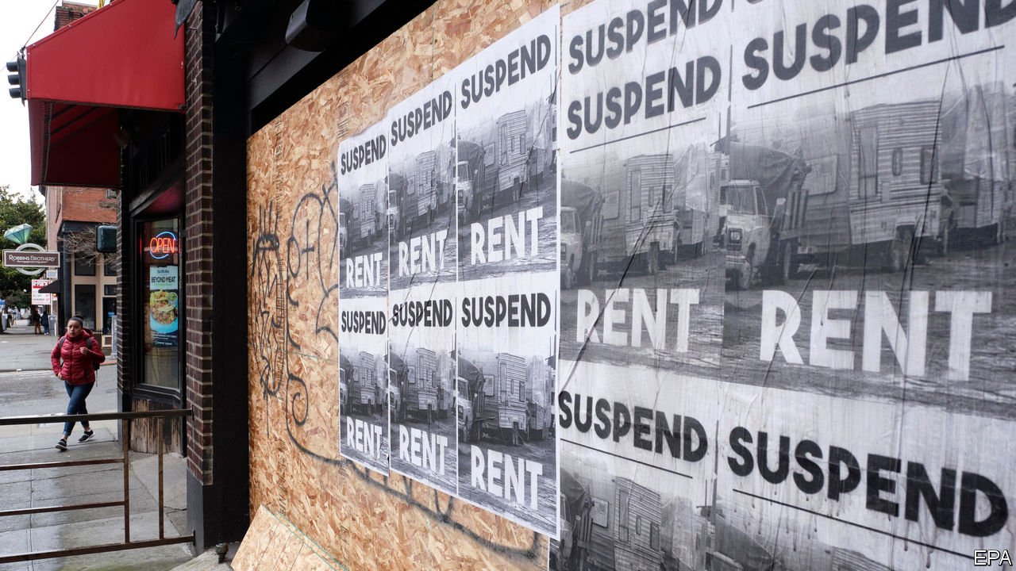

Editor’s note: The Economist is making some of its most important coverage of the covid-19 pandemic freely available to readers of The Economist Today, our daily newsletter. To receive it, register [here](https://www.economist.com/newslettersignup). For more coverage, see our coronavirus [hub](https://www.economist.com/coronavirus)

TO MOST WORKING Americans, the first of the month brings both joy and sorrow. It is payday, but also when rent and mortgage payments—their biggest bills—are due. Businesses must shell out wages and rent from revenues earned over the past month. This April 1st is likely to have been even crueller than usual. The government’s efforts to contain the spread of covid-19 have forced retailers to close shop and led to millions of workers losing their jobs. Many households and firms will struggle to pay what they owe. If rent and mortgage payments stop, the financial system risks seizing up.

The bill is huge. Around two-thirds of America’s 120m households own their homes. Together they owed around $11trn in mortgages at the end of 2019. Their monthly payments depend on their deposits and their interest rates, but using national averages as a guide suggests that around $52bn might have been due on April 1st. Another 43m households rent. Zillow, a property firm, estimates that they paid $43bn a month to landlords in 2019.

Few firms own their offices or shops, instead renting from commercial landlords. Green Street Advisors, a property-research company, estimates that total office rent exceeds $10bn a month. Monthly retail rents are worth another $20bn, according to Marcus & Millichap, a commercial-property services and consulting firm.

All told, households and firms owe around $125bn. How much of that might go unpaid? It seems likely that the 3.3m workers who signed up for unemployment benefits in the week to March 21st will have also sought relief from their landlords or their banks. Economists at the University of Chicago reckon that two-thirds of Americans cannot work entirely from home. Many may lose some pay as a result.

Some businesses might be able to keep earning even while their offices are shut. Retailers less so. A slew have already said that they won’t cough up. Nike, a sportswear-maker, says it will service half its rent this month. The Cheesecake Factory, a restaurant chain, plans to pay nothing at all.

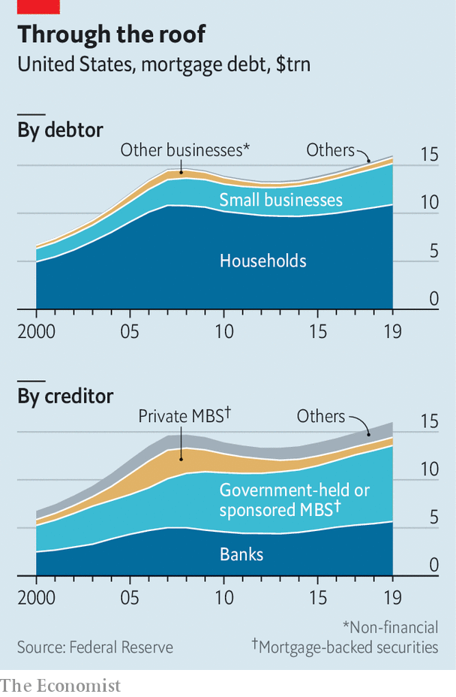

The damage done to the financial system depends in large part on how flexible landlords and creditors can be. Government intervention should allow many households to postpone payments. The vast majority of residential mortgages are held, or backed, by government-sponsored entities (GSEs), like Fannie Mae and Freddie Mac (see chart). The government has ordered these to grant forbearance to homeowners, and has imposed a moratorium on foreclosures. The Federal Reserve will buy unlimited quantities of mortgage-backed securities (MBS) issued by GSEs. Small residential landlords should also be well-supported by such measures. These own the majority of rental properties and owe $4.3trn in mortgages.

The commercial sector, though, has less flexibility. Most mortgages for retail and office spaces, which are worth a combined $3trn, are taken out by professional landlords. They are usually owed to one of four groups: banks, life insurers, the holders of commercial MBS or real-estate investment trusts (REITs). Renegotiating payments with banks and insurers, which lend using their balance-sheets, might be manageable. But a quarter of commercial mortgages are owed toMBS holders and to REITs, which are less flexible. The commercial MBS market is governed by rigid rules; REITs are highly leveraged and will quickly suffer if payments stop.

Some middlemen are also being affected in unforeseen ways. For instance, mortgage-service providers—which originate loans and collect payments from homeowners for a fee—complain that they are running short of cash. They typically bet on rising interest rates by short-selling MBS, thereby hedging the risk they take when locking in rates for new customers. But as part of its response to the pandemic, the Fed is buying MBS so quickly that the providers are facing margin calls on the losses on their hedges, before the loans for which they have locked in the rates can be issued. With help from the Fed and the government, many homeowners will be able to delay repayments. Some of the corporate links in the chain may not be so lucky. ■

Dig deeper:  
For our latest coverage of the covid-19 pandemic, register for The Economist Today, our daily [newsletter](https://www.economist.com/newslettersignup), or visit our [coronavirus hub](https://www.economist.com/coronavirus)

This article was downloaded by calibre from <https://www.economist.com/finance-and-economics/2020/04/03/what-missed-rent-and-mortgage-payments-mean-for-the-financial-system>

|  |  |  |  |
| --- | --- | --- | --- |
| Previous | Articles | Sections | Next |

|  |  |  |  |
| --- | --- | --- | --- |
| Previous | Articles | Sections | Next |

#### Buttonwood

# The departing boss of Norway’s oil fund on building an asset manager

Norges Bank Investment Management is the world’s single largest owner of equities

Apr 4th 2020 |

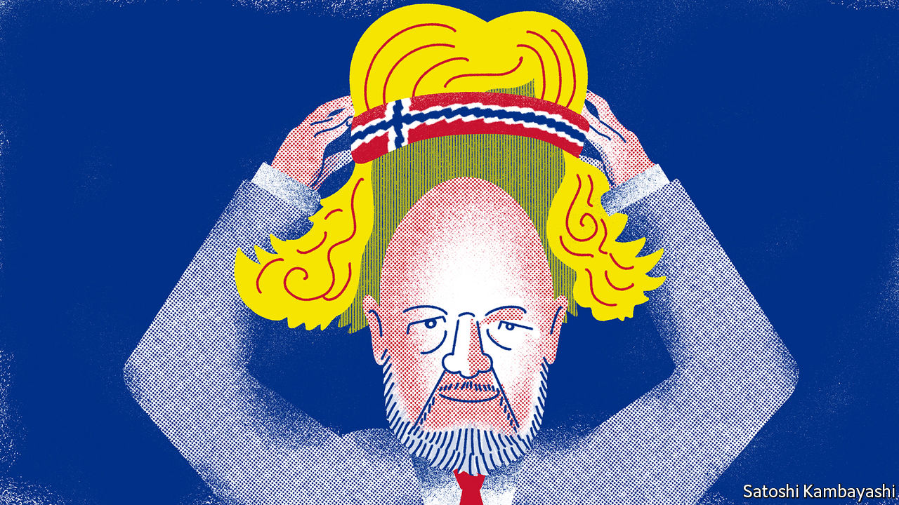

THERE IS A point in a conversation with Yngve Slyngstad when he invokes Bjorn Borg, the Nordic tennis star of the 1970s. The Borg approach—make sure you don’t lose; above all, be solid—is one Mr Slyngstad has instilled in Norges Bank Investment Management (NBIM), the organisation he has run since 2008 from within Norway’s central bank. Its target, to beat a benchmark by 0.25 percentage points a year, is modest. But meeting it has led to immodest wealth.

Mr Slyngstad is to step down later this year when Nicolai Tangen, a London-based hedge-fund manager, takes his place in Oslo. The departing boss resigned in October, 50 years to the day after Norway first struck oil. The same day Norway’s oil fund passed Nkr10trn ($900bn) in value. It is the world’s largest single owner of equities. On average it owns 1.5% of every listed firm globally.

This seemed improbable when Mr Slyngstad joined in 1998. The price of oil was falling towards $10 a barrel. The idea of an oil-reserve fund seemed risible. Yet Mr Slyngstad left a well-paid job in the private sector. What attracted him was autonomy. He and his senior colleagues used it to build a fund manager based on sound principles. Discipline, solidity, minimising errors—these Borg-like tenets are difficult to follow when managing a portfolio. But they are key to investing success.

Norway’s oil fund was set up in 1996. Its founding stemmed from an awareness that oil-producing countries run into trouble. One trap is the “resource curse”, the corruption that mineral wealth often fosters. Another is “Dutch disease”—currency appreciation that then retards the progress of other export industries. The fund is primarily a means to smooth the effect of volatile oil revenues on the government’s budget. All oil revenue is paid into it. It then makes a steady contribution to the budget. A decade-long oil boom created a windfall. The fund came to be seen in a new light, as an endowment for future generations. At its peak last year, it was worth around three times Norway’s annual GDP.

Its wealth is also the fruit of judicious investment. Mr Slyngstad was brought in to build the fund’s equities arm; until then all the money had been in bonds. In principle, a long-horizon investor should tilt towards riskier shares. But even the best principles can be hard to follow. This became clear soon after Mr Slyngstad was made boss. The fund had raised the equity share of its portfolio from 40% towards 60% during 2008. The timing looked bad. The stockmarket crashed in the autumn. A rally in the fund’s bond holdings limited the damage. Still, the fund lost 23%.

There was then a tough decision to make. The principles of the fund called for rebalancing: selling bonds that had gone up in value to buy shares that had become cheaper, thus reaching the 60% equity weight. It takes stomach to buy assets that others are fleeing from. Some funds suspended their rebalancing rules. Was there hesitation? “Yes, of course,” says Mr Slyngstad. It was a big political risk. If the stockmarket did not revive, there would be a reckoning. Even so, the finance ministry gave its blessing. “We ended up buying $175bn of equities, 0.5% of the market, during a huge crisis.” This set the fund up nicely for the ten-year bull market that followed. Rebalancing is now hard-wired into its processes. There are times, such as now, when shares have again fallen a long way and it is easy to lose your nerve. It is usually the worst time to do so.

The fund’s long-term focus means it can be bold during crises. But there are also constraints that do not apply to other investors. The need for transparency rules out dabbling in private-equity funds. NBIM has been a pioneer in socially responsible investment. This might look like Nordic do-goodery and a sop to posturing politicians. But the approach is hard-headed. A lot of decisions to exclude stocks are taken with an eye to long-term returns. Coal shares, for instance, are out because the business does not appear to have a lasting future. Companies in emerging markets that do not pass muster on corporate governance are avoided. In general this has been a way to improve returns.

The tennis analogy is: stay on your baseline; eliminate basic errors; be solid first—and only then, be smart. You will win in the long term. A lot of fund managers see a risk to their careers in looking too far into the future. They may lose clients in the meantime. Things are different at Norway’s oil fund. “The career risk”, says Mr Slyngstad, “is not to implement the strategy.”

This article was downloaded by calibre from <https://www.economist.com/finance-and-economics/2020/04/04/the-departing-boss-of-norways-oil-fund-on-building-an-asset-manager>

|  |  |  |  |
| --- | --- | --- | --- |
| Previous | Articles | Sections | Next |

|  |  |  |  |
| --- | --- | --- | --- |
| Previous | Articles | Sections | Next |

#### Lonely work

# How Allianz is dealing with market turmoil

Europe’s largest insurer is exposed through its life-insurance and its asset-management arms

Apr 4th 2020 | BERLIN

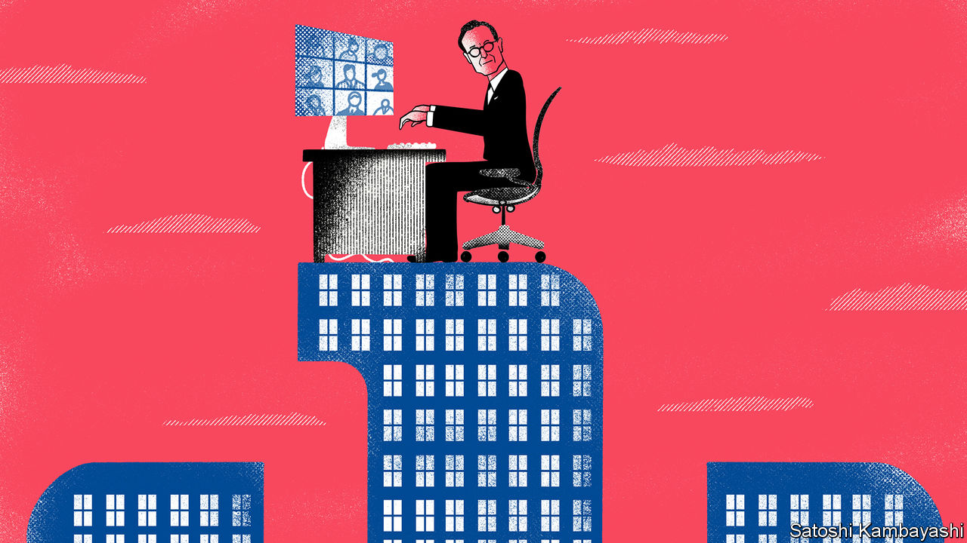

Editor’s note: The Economist is making some of its most important coverage of the covid-19 pandemic freely available to readers of The Economist Today, our daily newsletter. To receive it, register [here](https://www.economist.com/newslettersignup). For more coverage, see our coronavirus [hub](https://www.economist.com/coronavirus)

OLIVER BÄTE still goes to his office every day on Munich’s Königinstrasse, next to the English Garden, but it is mostly empty. “You are always alone as a CEO,” says the boss of Allianz, who took the reins of the 130-year-old insurance giant in 2015. And never more so than during a pandemic, when you are in charge of 147,000 employees in over 70 countries, who are looking after hundreds of thousands of customers, many of whom are in financial despair because of covid-19. “Italy is overwhelmed,” says Mr Bäte. Only 30 of its several thousand employees in Milan are at the office.

The company will support clients wherever it can, says Mr Bäte. He is frequently on the phone with officials in Brussels and Berlin, discussing ways to help governments marshal money for programmes to support small and midsized companies.

Thousands of firms are looking to their insurers, as well as the state, to cover some of the costs of shutting down. But neither property-and-casualty nor life-insurance policies generally cover pandemics. This is mainly because the risk is huge and unpredictable, but also because such policies were not until now much in demand. Allianz covers certain elements of a pandemic, such as business interruption for two weeks. But it can only underwrite slices of the risk, says Mr Bäte. Otherwise even the strongest insurer would go bust.

Legal wrangles over policy exclusions loom over the industry. State lawmakers in America (where insurance is regulated at state level) have proposed new laws to force insurers to pay billions of dollars for business interruptions related to mandatory shutdowns. The issue is simmering in Europe, too—though fewer cases are likely to end up in court. Politicians are also urging insurers to lower premiums in other business lines, for instance car insurance, or to divert profits from these to help stricken corporate policyholders. Insurers can make more money than usual from motor policies during lockdowns, since quieter roads mean fewer accidents.

Allianz has many more immediate concerns. As the owner of Euler Hermes, a big provider of credit insurance—which firms buy to protect receivables from loss—Allianz is directly exposed to rising corporate defaults. Mr Bäte vows to try to keep small businesses going by not making drastic cuts to the credit lines it offers with such policies. France is set to offer a reinsurance backstop to limit potential losses for credit insurers that help keep covid-stricken firms afloat; Germany may follow suit.

Allianz’s huge asset-management arm—the world’s second-largest active fund manager—is heavily exposed to the carnage, too. The business, which comprises PIMCO, a bond-fund giant, and the smaller Allianz Global Investors, oversees some $2.3trn and generates up to a quarter of group profits. It had a very good January and February, but in March it was “like turning a light switch off”, says Jackie Hunt, who leads the division. Clients rushed to redeem funds, especially in fixed income, after stockmarkets plummeted (Mr Bäte says Allianz beat an “early” retreat from American equities). Hedging has become more difficult. The cost of protection for a book of variable annuities, for instance, “shot through the roof”, says Mr Bäte. “It’s a hundred million here, a hundred million there.”

Allianz is exposed to markets both in its life-insurance business, as an investor of clients’ premiums, and as an earner of fund-management fees. Ms Hunt thinks the crisis will speed up the move from active to passive management in equities and squeeze fee margins. Yet she insists that this is a time when active managers prove their value, especially in fixed income.

When time allows, Mr Bäte says, he is pushing on with a plan to slim Allianz down and increase efficiency by embracing AI and machine learning. He estimates that up to half of his working day is taken up with covid-related issues. The outlook is unclear: for now, he says, he is not pondering a profit warning. He is preparing for an annual general meeting on May 6th, which for the first time will take place virtually. It will be a lonely day for the gregarious former McKinsey consultant. ■

Dig deeper:  
For our latest coverage of the covid-19 pandemic, register for The Economist Today, our daily [newsletter](https://www.economist.com/newslettersignup), or visit our [coronavirus hub](https://www.economist.com/coronavirus)

This article was downloaded by calibre from <https://www.economist.com/finance-and-economics/2020/04/03/how-allianz-is-dealing-with-market-turmoil>

|  |  |  |  |
| --- | --- | --- | --- |
| Previous | Articles | Sections | Next |

|  |  |  |  |
| --- | --- | --- | --- |
| Previous | Articles | Sections | Next |

#### Free exchange

# What China’s interest-rate muddle says about its financial system

Ask a Chinese economist what the benchmark rate is, and brace yourself for an avalanche of numbers

Apr 4th 2020 |

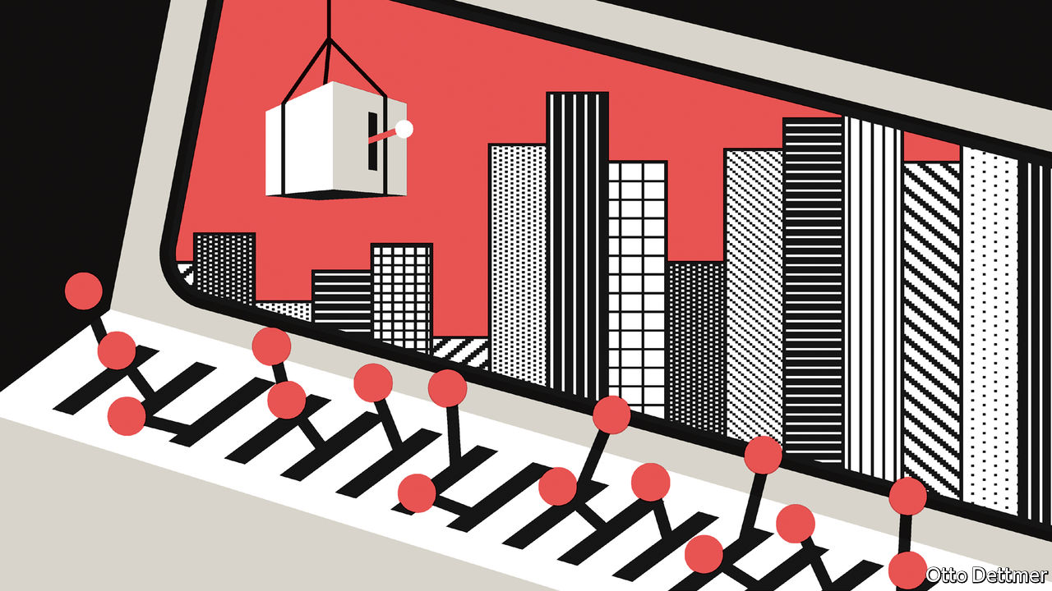

IN 1979, WHEN Paul Volcker started jacking up interest rates to quell inflation in America, China launched a radical experiment of its own: it created commercial banks. Deng Xiaoping was trying to steer the country away from central planning. Four decades on, Mr Volcker’s job long done, China’s transition is still unfolding. For evidence of this, look at its interest-rate muddle amid the coronavirus-induced slowdown. Ask a Chinese economist what the benchmark rate is today—a simple question in most countries—and brace yourself for an avalanche of acronyms and numbers.

There are, to name the main contenders, the one-year deposit rate (now 1.5%), the seven-day reverse-repurchase rate (known as the DR007, 2.2%), the medium-term lending facility (MLF, 3.15%) and the one-year loan prime rate (LPR, 4.05%). Each, depending on one’s focus, has a claim to benchmark status. Sorting through all these rates is not merely an exercise in banking esoterica. It is a window into how China manages its financial system.

Start with the basics. China’s central bank is highly interventionist, by design. For years it set loan quotas for banks, told them what sectors to support and dictated the rates at which they took deposits or extended loans. To varying degrees, it still wields these powers. But with the economy ever bigger, Chinese officials know such a broad remit is untenable. So their goal, first declared a quarter-century ago, is interest-rate liberalisation: to let banks make their own decisions. In a fully liberalised system, the People’s Bank of China would focus on a single rate that anchors the economy, adjusting it as needed—the Platonic ideal of any central bank.

Over the past few years China seemed to make strides in this direction. The central bank began phasing out its fixed lending and deposit rates. In their place it emphasised more flexible rates. It developed a wide corridor for guiding rates, anchored by the DR007 (the rate at which banks lend to each other) and the MLF (a monthly open-market facility). Meanwhile the LPR, the rate for lending to prime customers, became the new standard for all loans. Its pricing was based on the MLF, which in turn reflected the DR007. It might sound like a right mess. But squint hard enough and it looks like modern central banking: the People’s Bank keeps interest rates within a target range by managing the level of cash in the financial system.

Yet the covid-19 crisis has shown that this is only part of the story. The central bank has cut its newer, more flexible rates to lower lending costs. But the current debate, fuelled by the central bank itself, is over when it will cut the benchmark deposit rate—that is, one of the traditional fixed rates. That makes it clear that interest rates in China are not yet liberalised. The central bank still has a firm grip on rates paid to savers (the benchmark deposit rate) and a strong, if more nuanced, hold on lending rates (the DR007-MLF-LPR alphabet soup).

Why is it so hard for the government to let go? The explanation can be found in two striking facts about Chinese interest rates. First, they are much lower than one would expect for an economy growing so quickly, coronavirus notwithstanding. The real one-year deposit rate is negative. This is not new. China has long been an exemplar of financial repression, limiting savers’ returns in order to make cheap funds available to finance sky-high investment.

Second, despite the low interest rates, Chinese banks are immensely profitable. According to the latest data, they account for 17% of the market capitalisation of the domestic stockmarket but 39% of the profits of all listed firms. The secret of their success is the spread between what they pay savers and charge borrowers, or the net interest margin. It is not that they are so brilliant at managing their books. Rather, the lack of true rate liberalisation assures them a net interest margin of two percentage points.

## Thank a banker

Their giant profits mean that banks are often a lightning-rod for criticism in China (evidence that in these troubled times, more still unites the world than divides it). In a report in February, the People’s Bank mounted a defence. Fully 60% of banks’ profits go to replenishing their capital, which lets them extend more loans to businesses and households. Everyone thus benefits, it argued.

In the Chinese context it has a point. Where banks go, so goes the economy. Banks’ assets are worth 175% of GDP, more than in any other country, according to a core measure used by the World Bank (see chart). Many analysts think that China’s banks can expand their loans by about 10% a year while making big enough returns to preserve their capital buffers. In a normal year these new loans would be expected to generate economic growth of about 6%, with a mild rise in total indebtedness. The link between lending and growth is a closed loop that works, assuming no major capital outflows and no sustained declines in asset quality.

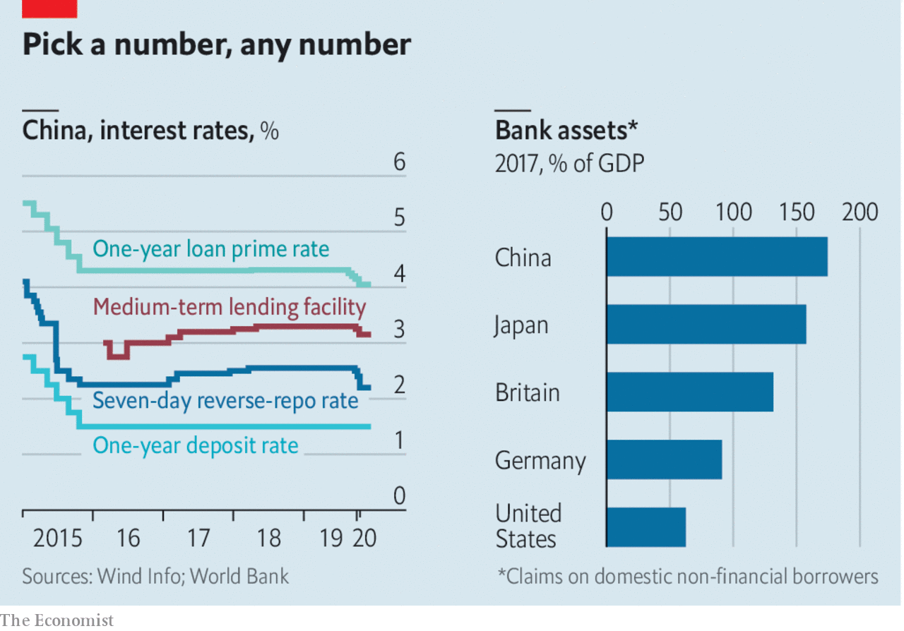

Even the coronavirus shock need not break this loop. Of course growth has suffered. But because credit demand is determined by the volume of investment approved by the government, and not animal spirits, loans might accelerate. Such state-led lending is likely to lower efficiency, but that is a long-term problem.

True rate liberalisation constitutes a bigger short-term threat. China got a taste of that over the past decade. The rise of more investment options for savers, such as online money-market funds, forced banks to compete more for deposits. They got around rate caps by marketing investment products with higher yields. But higher funding costs led them to find riskier clients and to increase their own leverage. The dangers were made plain last year when the government helped to rescue three overextended, if peripheral, banks.

So in the name of financial de-risking, regulators have steadily pushed banks back towards the plain-vanilla business of taking deposits and extending loans. Hence the pressure on the central bank to cut deposit rates at the same time as it lowers lending rates. This way, the closed loop—from new loans to new deposits to bank profits, and around to new loans again—will remain intact. And the liberalisation of China’s banking system can wait for a sunnier day, as it always has—and, as a cynic might say, always will. ■

This article was downloaded by calibre from <https://www.economist.com/finance-and-economics/2020/04/04/what-chinas-interest-rate-muddle-says-about-its-financial-system>

|  |  |  |  |
| --- | --- | --- | --- |
| Previous | Articles | Sections | Next |

|  |  |  |
| --- | --- | --- |
| Finance and ... | Sections | Books and arts |

Science and technology

The coronavirus pandemic: Testing’s testimony

.

Treating patients: A racing chance

.

Overloaded telecoms: Breaking the net

.

|  |  |  |
| --- | --- | --- |
| Finance and ... | Sections | Books and arts |

|  |  |  |  |
| --- | --- | --- | --- |
|  | Articles | Sections | Next |

#### The coronavirus pandemic

# An antibody test for the novel coronavirus will soon be available

Use it wisely

Apr 2nd 2020 |

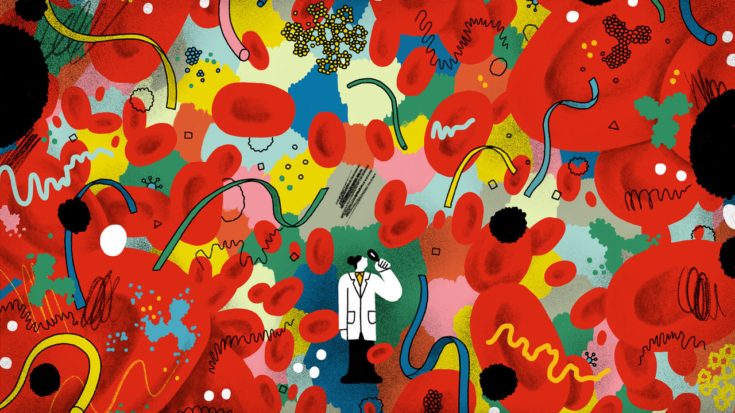

Editor’s note: The Economist is making some of its most important coverage of the covid-19 pandemic freely available to readers of The Economist Today, our daily newsletter. To receive it, register [here](https://www.economist.com/newslettersignup). For more coverage, see our coronavirus [hub](https://www.economist.com/coronavirus)

Editor’s note: The Economist is making some of its most important coverage of the covid-19 pandemic freely available to readers of The Economist Today, our daily newsletter. To receive it, register [here](https://www.economist.com/newslettersignup). For more coverage, see our coronavirus [hub](https://www.economist.com/coronavirus)

WHEN A NEW virus invades the human body, the immune system leaps into action. First to the scene are antibody molecules of a type called immunoglobulin M (IgM). These bind with proteins on a virus’s surface, disabling it and marking it for destruction by cells called macrophages. A few days later the system produces a second type of antibody, immunoglobulin G (IgG), to continue the fight. IgMs are short-lived. They stick around in the bloodstream for three or four weeks before disappearing. IgGs, however, are the basis for a much longer-term form of immunity. This can last for many years, or even a lifetime.

Kits that test for these two types of antibodies when they have been raised specifically by SARS-CoV-2 should soon become available. The virus causing the covid-19 is already being detected with genetic tests, which look directly for current signs of infection in nasal or throat swabs. Tests to detect antibodies will also be able to identify those who have had infections in the past and may now be immune. In the short term, this will be important because it will permit the authorities to identify who may return to their jobs without risk of infecting others. That is particularly valuable in the cases of doctors, nurses and the numerous other health-care workers needed to look after those who are seriously ill. It will also help in the longer run, by revealing how far the virus has spread through a population, and thus whether or not herd immunity is likely to have built up. Herd immunity is the point where insufficient infectible individuals remain in a population for a virus to be able to find new hosts easily, and it is therefore safe to lift social-distancing and stay-at-home rules.

SARS-CoV-2 antibody tests have already been deployed in limited numbers in China, Singapore and South Korea. Several Western governments, including those of America and Britain, have been buying up millions of surplus antibody tests from China for use in their own countries. Several other types of these tests have also been developed by companies around the world. None, however, has yet been approved for widespread use—for, though such tests are reasonably easy to manufacture, ensuring that they give useful and reliable results is taking a lot of effort.

Each different design of test uses its own recipe of chemicals and processes. Physically, however, many resemble the self-contained plastic sticks employed in the version made by Biopanda Reagents, a British firm. A user first pricks a fingertip. Then he or she introduces a few drops of blood into an opening at one end of the stick. Inside, the blood goes through a series of chemical processes that can identify particular antibodies. It takes around 15 minutes to get a result, and this is displayed in a similar fashion to that used by a typical pregnancy test—the positive identification of an antibody resulting in a coloured line next to its label on the test stick.

There are three interesting signals. A solitary positive for IgM means the person has had a very recent (potentially current) infection. Positives for both IgM and IgG mean the user was infected some time within the past month. A positive for IgG alone means that the infection occurred more than a month ago, and the user should now be immune to a repeat of it. (A negative result probably means no infection, though it could also mean that it is too early in the course of an infection for antibodies to have appeared, since the first IgMs typically turn up only 7-10 days after an infection has begun.)

Before regulators can approve a test for widespread use, they need to validate it. How useful it is can be summarised by two numbers determined during this validation: its sensitivity and its specificity.

A test’s sensitivity refers to how good it is at detecting the thing it is meant to detect—in this case the IgM and IgG antibodies associated with SARS-CoV-2. A sensitivity of 95% means that, from 100 blood samples known (by other means, such as previous genetic testing) to be infected, the test will reliably tag 95 correctly as having the pertinent antibodies. The remaining five would be identified as having no antibodies present—in other words they would be false negatives.

The other significant number, a test’s specificity, measures how good that test is at detecting only the antibodies it is meant to detect. There are seven human coronaviruses and, ideally, a test would detect only antibodies produced in response to SARS-CoV-2. A test with 98% specificity means that, of 100 known uninfected blood samples, 98 will come back (correctly) as negative and the final two will come back (falsely) as positive. Such false positives could have many causes. A common one is cross-reaction, in which a test responds to the wrong antibodies.

To work out a test’s sensitivity and specificity, it needs to be checked against hundreds of samples of known status. Given the novelty of SARS-CoV-2, and therefore the lack of easy access to relevant blood samples, this takes time. The British and American authorities are assessing several tests, but have released no validation data as yet, and have been tight-lipped about when they will do so.

## Sense and specificity

An ideal test would be 100% sensitive and 100% specific. In reality, there will always be a trade-off between the two. Make a test acutely sensitive, so that it gives a positive signal with even the tiniest amounts of a relevant antibody present, and it will get less specific. This is because such a fine chemical hair-trigger is likely to be set off by antibodies similar to, but not identical with the target. And vice versa.

This trade-off is not always a bad thing, for it allows different sorts of test to be used in different circumstances. For example, if the intention of testing is to identify doctors and nurses who have antibodies to SARS-CoV-2, so that they can safely return to work with infected patients, because they are themselves now immune to infection, then the most important thing is for a test to have a low rate of false positives. In other words, it needs a high specificity.

By contrast, if the idea is to gather transmission data, sensitivity is the priority. If someone were identified as having had an infection, further tests could trace which of that person’s acquaintances were also infected, or had once been infected and were now immune. In these circumstances, a few false positives would not be a disaster. They would probably show up eventually, because those around the allegedly infected individual would not be infected as often as expected. A false negative, though, would mean lost information and a consequent lack of contact-tracing. That would be significant.

Testing of this sort will let doctors understand how a local cluster of infections grows, and therefore what action to take in order to break the chain (meaning, in practice, who needs to be quarantined). This kind of contact-tracing and isolation has been employed to great effect in South Korea through the use of genetic tests for the virus. Antibody tests will enhance the process, by capturing data on those infected in the past as well as the present.

Children are another group who could profitably be monitored using antibody tests. It is now well established that they are less likely than adults to present the symptoms of covid-19, and rarely suffer severe disease. It remains unclear, though, to what degree they are being infected “silently”, and are thus able to pass the infection on to others around them while apparently remaining healthy themselves. Antibody tests will reveal a fuller picture.

Antibody tests will no doubt also be in demand from members of the public wanting to know their immune status—for their peace of mind if nothing else. This might be cause for conflict. Even when they are cleared for general use it will take time for manufacturers to ramp up the production of tests, and those working in health care and one or two other important areas, like teaching, policing and delivering groceries to stores and markets, will surely be at the head of the queue to be tested. It is therefore hardly surprising that unvalidated kits, purportedly for domestic use, are already being offered for sale by unscrupulous online suppliers. Britain’s medical regulator, for one, has had to take down several fraudulent websites and is warning people not to use any home-testing kits they find being sold online.

Even when more kits do become available (and with due acknowledgment to the different putative uses of different sorts of test) the next goal for most countries after protecting crucial members of the workforce will be population-level surveillance. This will, as a by-product, provide information to individual members of the public. But its primary purpose will be to track how the epidemic is progressing.

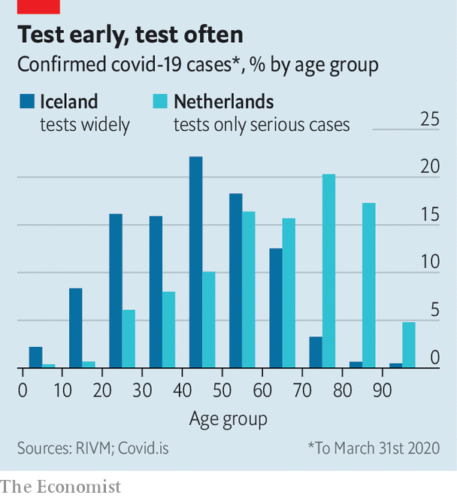

One of the most important elements of this analysis will be determining the rate of silent infection—with all the implications that brings for herd immunity. Comparing recent test data from the Netherlands and Iceland hints at the gap in current knowledge of just how much silent infection there may be. Both countries use genetic testing for the virus, but the Netherlands only tests those with severe symptoms of covid-19, whereas Iceland has been testing widely, even people without symptoms. Unsurprisingly, but crucially, the Icelandic approach has revealed far more infections in younger people than the Dutch one (see chart). Moreover, according to Kari Stefansson, who is leading the Icelandic project, 50% of those who have tested positive reported no symptoms.

## Silence is not golden

Mass testing will be laborious. It will mean taking regular blood samples from millions of people, even though the actual analysis will be done by robots in centralised high-throughput laboratories. To save effort, such projects might piggyback on a country’s blood-transfusion services, for donated blood is already subject to rigorous screening for pathogens.

German scientists have announced plans to start, this month, a reasonably large-scale surveillance project. It will monitor blood samples taken regularly from 100,000 participants. Those proving immune may be given a certificate exempting them from restrictions on working or travelling. If nothing else, that would certainly be an incentive to sign up. ■

Dig deeper:  
For our latest coverage of the covid-19 pandemic, register for The Economist Today, our daily [newsletter](https://www.economist.com/newslettersignup), or visit our [coronavirus hub](https://www.economist.com/coronavirus)

Dig deeper:  
For our latest coverage of the covid-19 pandemic, register for The Economist Today, our daily [newsletter](https://www.economist.com/newslettersignup), or visit our [coronavirus hub](https://www.economist.com/coronavirus)

This article was downloaded by calibre from <https://www.economist.com/science-and-technology/2020/04/01/an-antibody-test-for-the-novel-coronavirus-will-soon-be-available>

|  |  |  |  |
| --- | --- | --- | --- |
|  | Articles | Sections | Next |

|  |  |  |  |
| --- | --- | --- | --- |
| Previous | Articles | Sections | Next |

#### The coronavirus pandemic

# Formula 1 comes up with a breathing machine for covid-19 patients

Racing-car engineers are applying their expertise to medicine

Apr 4th 2020 |

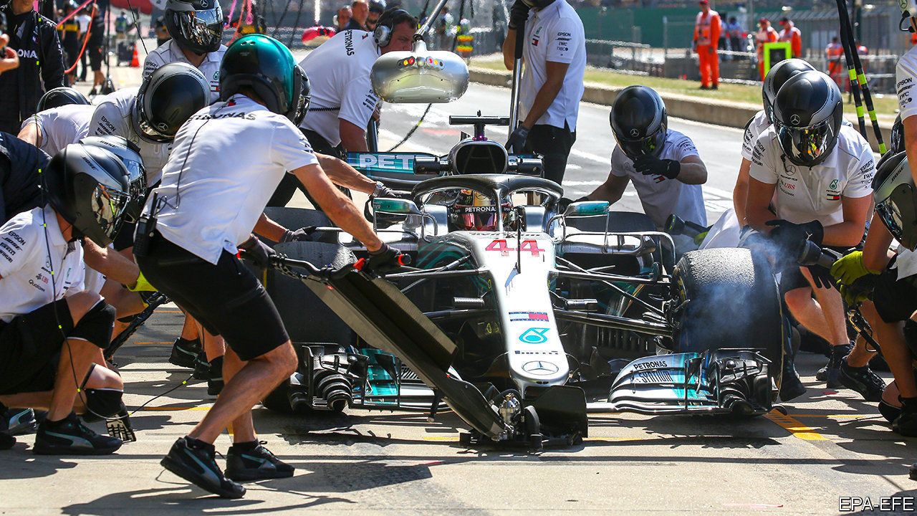

Editor’s note: The Economist is making some of its most important coverage of the covid-19 pandemic freely available to readers of The Economist Today, our daily newsletter. To receive it, register [here](https://www.economist.com/newslettersignup). For more coverage, see our coronavirus [hub](https://www.economist.com/coronavirus)

THE SEVEN Formula 1 teams in Britain have high-tech engineering centres stuffed with the latest production equipment. And they employ hundreds of staff with the talent to use this gear to design, test and manufacture parts rapidly, in the days between races. With the season suspended, they have been collaborating on ways to help produce ventilators, which are needed urgently to treat patients suffering from covid-19. This week one team, Mercedes-AMG, obtained approval for a device which it can quickly manufacture by the thousand.

The machine is not a ventilator, but a breathing aid of a type known as a continuous-positive-airway-pressure (CPAP) device. These are typically used to assist people who have breathing problems to sleep more soundly. The machine delivers air at slightly above atmospheric pressure via a mask placed over the nose and mouth. This helps keep open the alveoli of the lungs. (These are the sacs from which blood absorbs oxygen, and into which it dumps carbon dioxide.) That reduces the effort of breathing. Additional oxygen can also be added. According to reports from Italy, around half of patients given CPAP treatment have avoided the need for invasive mechanical ventilation, in which a tube is inserted down a patient’s throat.

Mercedes-AMG worked with a team at University College, London, to take apart, copy and improve an off-patent CPAP machine in a matter of days. As it was based on an existing design the British government’s medical regulator was able to fast-track approval. The team also worked with Oxford Optronix, a small British firm that makes oxygen monitors. The first 100 devices have now been delivered to University College Hospital and other London hospitals for clinical trials. These are expected to take three or four days. If they are successful, the team reckons it can make 1,000 of the CPAP machines a day at its base near Northampton, and distribute them thence to other hospitals around the country.

“The speed with which the team developed the device is remarkable,” reckons Duncan Young, a professor of intensive-care medicine at Oxford University, who is not part of the project. Patients too unwell for simple oxygen masks, but not ill enough to need a ventilator, can be treated with a CPAP machine, says Dr Young. This could, he adds, save lives by freeing up ventilators for those in urgent need of them.

Dig deeper:  
For our latest coverage of the covid-19 pandemic, register for The Economist Today, our daily [newsletter](https://www.economist.com/newslettersignup), or visit our [coronavirus hub](https://www.economist.com/coronavirus)

This article was downloaded by calibre from <https://www.economist.com/science-and-technology/2020/04/03/formula-1-comes-up-with-a-breathing-machine-for-covid-19-patients>

|  |  |  |  |
| --- | --- | --- | --- |
| Previous | Articles | Sections | Next |

|  |  |  |  |
| --- | --- | --- | --- |
| Previous | Articles | Sections | Next |

#### Covid-19 and telecoms

# Can mobile networks handle becoming stay-at-home networks?

Or will rapidly increasing demand overwhelm them?

Apr 4th 2020 |

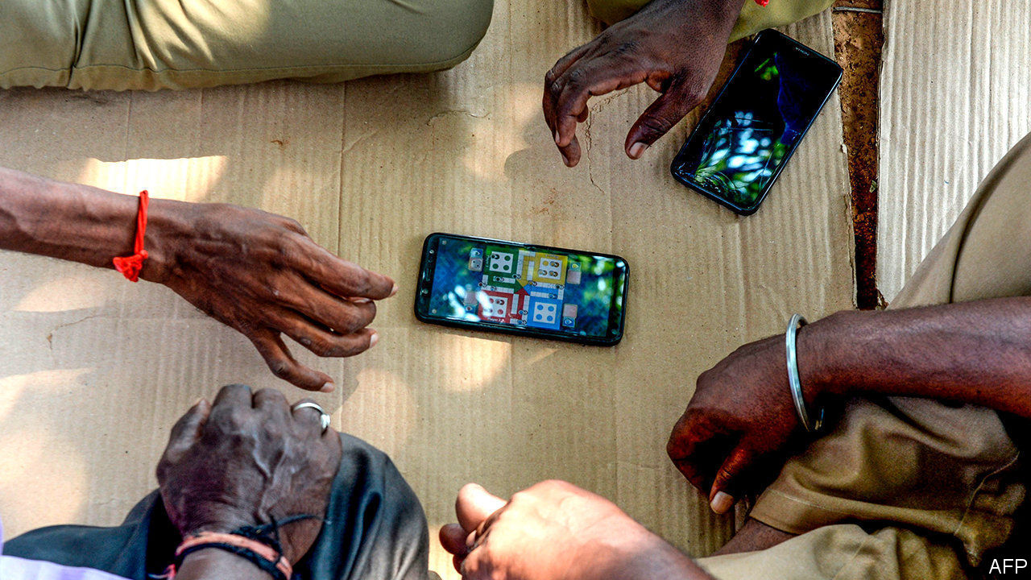

Editor’s note: The Economist is making some of its most important coverage of the covid-19 pandemic freely available to readers of The Economist Today, our daily newsletter. To receive it, register [here](https://www.economist.com/newslettersignup). For more coverage, see our coronavirus [hub](https://www.economist.com/coronavirus)

AS COUNTRIES ACROSS the rich world placed themselves under restriction over the course of March, journalists there turned to the question on everyone’s lips: “will the coronavirus break the internet?” For them, the answer in the main is “no”. Most broadband networks are built for peak evening usage, when lots of people settle in for a session of HD streaming. Even widespread, daylong videoconferencing and online gaming do not come close to that level of data consumption. The internet, as one infrastructure provider puts it, was “built for this”.

Such sangfroid does not, however, apply if your internet connection is mobile. And in the poorer parts of the planet that is generally the case. Indeed, most of the 4bn or so people who use the internet today do so via mobile connections rather than land-lines. As countries such as India, South Africa and those in South-East Asia start staying at home they are turning to their phones for entertainment, for communication and for work. With little fixed-line capacity to fall back on, the load on local mobile networks is immense.

A mobile-data connection runs as a radio signal from a phone to the local base-station. Thence it links up, via optical fibre or a microwave connection, with the network’s core, which is connected to the wider internet. If too many people try to connect simultaneously to the same base station, that station will be overwhelmed, causing calls to drop, data-transfer speeds to slow and tempers to rise.

Even some rich countries are suffering in this regard. According to James Barford of Enders Analysis, a British research firm, Telefonica Spain has seen a 30% surge in data traffic and Telecom Italia reports a 10% rise. Download speeds in Italy have also declined, according to OpenSignal, a network-analytics firm.

Elsewhere, things are worse still. Some networks have seen internet use rise by as much as 80% says Bhaskar Gorti of Nokia, which makes networking equipment and helps operators manage their systems. Mobile networks are constantly being upgraded, and have assumptions of double-digit growth baked into them. But those assumptions are for growth over the course of months or years, not days.

So far, network operators have proved equal to the task. But things could deteriorate. Routine maintenance will suffer as engineers go off sick or are forced to self-isolate. There will be less capacity for emergency maintenance. Far-off base stations will become harder to reach. And on top of all this, demands on networks will probably rise. More people will discover video chatting. As television broadcasters struggle to provide fresh entertainment, people will turn to streaming in ever greater numbers. All of these things will add to congestion. The longer that stay-at-home orders remain in place, the more likely it is that some networks will fall over.

Mobile operators and regulators are not standing around waiting for such failures, though. In several countries, including Spain, mobile operators have asked users to reduce their data consumption. Others are trying novel ideas. Kenya has fast-tracked Google’s Loon project, which will provide 4G signals from high-altitude balloons. In India, where data consumption is up 30% and speeds down 20%, operators are contemplating joining forces, to ease each other’s peaks. European and other regulators have asked the big streaming services—Netflix, Amazon, YouTube—to reduce the quality of their videos, in a bid to free up capacity. America has granted its networks additional radio spectrum on a temporary basis, and several other countries are in the process of doing the same.

Around a third of the planet’s inhabitants are now stuck at home. That is bad enough—for morale, for businesses and for countries’ economies. For those people to lose in addition what is, for many of them, their only connection to the wider world just makes it worse. ■

Correction (April 2nd 2020): A previous version of this piece spelled Mr Gorti's name incorrectly.

Dig deeper:  
For our latest coverage of the covid-19 pandemic, register for The Economist Today, our daily [newsletter](https://www.economist.com/newslettersignup), or visit our [coronavirus hub](https://www.economist.com/coronavirus)

This article was downloaded by calibre from <https://www.economist.com/science-and-technology/2020/04/03/can-mobile-networks-handle-becoming-stay-at-home-networks>

|  |  |  |  |
| --- | --- | --- | --- |
| Previous | Articles | Sections | Next |

|  |  |  |
| --- | --- | --- |
| Science and ... | Sections | Economic and ... |

Books and arts

Geopolitics: The victor’s curse

.

New fiction: Secrets and lies

.

Pandemics of yore: How to understand a plague

.

Creatures of the deep: Rich and strange

.

Johnson: Corona-speak

.

“I, Claudius”: A family affair

.

All-in together: Gambling with the future

.

|  |  |  |
| --- | --- | --- |
| Science and ... | Sections | Economic and ... |

|  |  |  |  |
| --- | --- | --- | --- |
|  | Articles | Sections | Next |

#### The victor’s curse

# America won the cold war. What went wrong?

Three contrasting books examine a superpower’s malaise

Apr 4th 2020 |

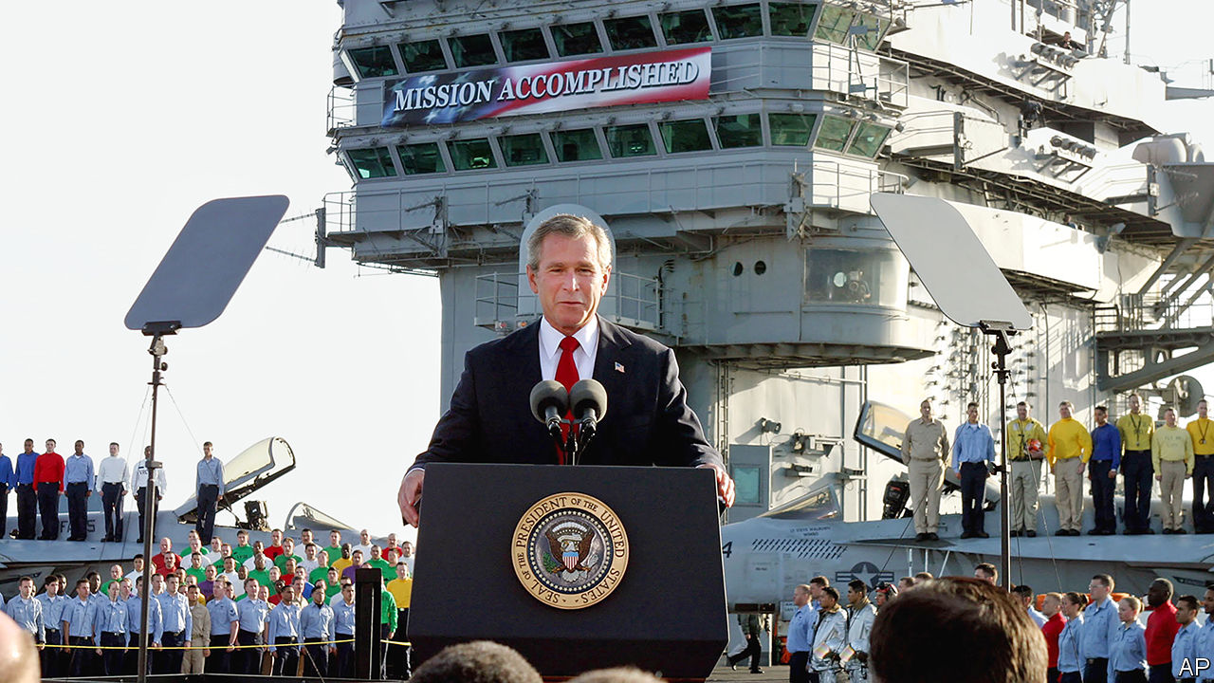

Do Morals Matter? By Joseph Nye. Oxford University Press; 268 pages; $24.95 and £18.99.

The Abandonment of the West. By Michael Kimmage.Basic Books; 368 pages; $32 and £25.

The Age of Illusions. By Andrew Bacevich.Metropolitan Books; 239 pages; $27.

THE UNITED STATES, Andrew Bacevich writes near the start of his account of post-cold-war America, is like the man who won the Mega Millions lottery: his unimagined windfall holds the potential for disaster. Things are not quite that bad. But almost three decades after America watched the Soviet Union fall apart, victory feels like a disappointment.

The end of the cold war established America as the most powerful country in history. Its armed forces were unmatched and its governing philosophy seemingly had no rival. Yet it has struggled either to prevail against illiterate tribesmen and tinpot dictators or to get to grips with a newly assertive Russia and a rising China. In a pandemic its allies might have expected America to co-ordinate a planet-wide response. Instead, it has turned inward. Just as startlingly, America itself fell prey to bitterness and division, culminating in the presidency of a man who won office by rejecting many of the values which had helped bring about that original victory.

This is the sombre backdrop for three very different books about America’s place in the world. Joseph Nye, a former dean of the Kennedy School at Harvard, looks at how presidents have struggled to embody their country’s moral leadership. Michael Kimmage, a fellow at the German Marshall Fund, teases out the contradictions in the idea of an American-led “West”. And Mr Bacevich, a professor emeritus at Boston University, depicts the construction (and then, he argues, the demolition) of a post-cold-war doctrine of American power.

None of these books is the last word on an important question. But each offers tantalising insights into how victory soured.

## The worried West

Before getting to the moral conduct of each president, starting with Franklin D. Roosevelt, Mr Nye takes on the argument of his book’s title: “Do Morals Matter?” His target is foreign-policy “realists” who claim that, however they dress it up, countries are amoral and put their own interests first.

Mr Nye is surely right to counter that most American leaders have contrasted themselves to cynical, balance-of-power Europeans. He quotes Theodore Roosevelt: “Our chief usefulness to humanity rests on combining power with high purpose.” Mr Nye—a thinker who in the 1980s formulated the doctrine of soft power—is also right to stress that this high purpose is itself a vital component of American influence. The international order the United States constructed depends on legitimacy, he explains, and legitimacy depends on values.

Every president has had his blemishes, of course. Mr Nye has seen too much of the world to have illusions about that. But—and here you suspect is the real purpose of this book—none has abandoned the rhetoric or the practice of right and wrong in foreign policy quite as shamelessly as President Donald Trump. No president has so enthusiastically embraced both autocrats and the Hobbesian idea that might is right. Only Mr Trump and his officials have sought to dismantle the international order that his predecessors built and maintained, but which the Trump White House sees as “Gulliverising” America.

Mr Nye takes the underpinnings of America’s moral leadership as read. Not so Mr Kimmage. For him the West is not a place, so much as a set of ideas articulated at the end of the 19th century in America as it prepared to take on the mantle of a great power. At its best, the West has stood for capitalism, science, the Enlightenment, the rule of law and human rights, all of which a mythologised Christopher Columbus had introduced from Europe, laying the foundation of what was to become the transatlantic alliance.

In “The Abandonment of the West”, Mr Kimmage argues that, on the left, “the West” long ago came to be seen as a source of hypocrisy and racism. Columbus was recast as a conqueror and plunderer. Martin Luther King pointed out the irony of the White House advocating free elections in communist eastern Europe when large parts of America did not enjoy them. Edward Said, a professor at Columbia University of Palestinian origin, condemned “terrible reductive conflicts that herd people under falsely unifying rubrics like ‘American’, ‘the West’ or ‘Islam’.”

And Mr Kimmage describes how, once it was no longer protected by rivalry with the Soviet Union, the notion of “the West” fell out of favour as an ideological rallying point. The left has increasingly regarded it as “too white, too male in its history, too elitist, too complicit in the Euro-American aggressions of less enlightened eras”. The American right likes the idea of the West’s cultural heritage, but is uncomfortable with the reality of Europe as an essential component of it, “too seemingly divorced from nationhood, too invested in the welfare state, too pacifist, too secular”. As China and Russia challenge democracy and the canon of Enlightenment texts disappears from university reading lists, Mr Kimmage says, the idea of the West is not just wavering; it may be doomed.

Mr Bacevich takes a different tack. He is not interested in the hollowing out of the West’s ideas in universities and think-tanks, but in their grandiose inflation among the political elite. He quotes George W. Bush telling West Point cadets in 2002 that: “The 20th century ended with a single surviving model of human progress, based on non-negotiable demands of human dignity, the rule of law, limits on the power of the state, respect for women and private property and free speech and equal justice and religious tolerance.”

Put like that, it is hard to fault Mr Bush’s sentiments. However, in “The Age of Illusions”, Mr Bacevich’s gloss is that the country’s military, political and commercial elites came to believe American motives were beyond reproach, and that their world-view was sure to prevail. They therefore took it upon themselves to become global enforcers. They built a new operating system designed to cement American primacy, based on globalisation, military dominance, the individualistic pursuit of fulfilment and an imperial presidency.

## The enemy within

Yet this system, Mr Bacevich argues, has been plagued by unintended consequences. Globalisation was meant to create wealth, but many Americans complain of inequality; military dominance sucked the country into never-ending wars that sacrificed the children of lower-income families (but, for the most part, no one else’s); the pursuit of fulfilment led to the withering of duty and a selfish, atomised society; and the supremacy of the presidency became a recipe for voters’ disappointment.

All this culminated in the election of Mr Trump. The president’s critics, this book argues, overestimate him even as they underestimate the importance of his victory. Mr Trump is “a mountebank of the very first order”, Mr Bacevich writes, but his presence in the Oval Office is a rejection of the post-cold-war operating system and all it stands for. The elites’ focus on Mr Trump’s wickedness, he maintains, spares them the pain of having to acknowledge how pitifully their own project failed.

It is telling that three such different books all try to understand what went wrong after the Soviet collapse not by looking overseas but within, at the nature of America itself. In their various ways, they all condemn Mr Trump. Mr Nye doubts his morality. Mr Kimmage sees him as the first anti-“West” president. Most interesting is Mr Bacevich, who warns that, although Mr Trump offered no definition of post-cold-war America, just a rejection, there is no going back. That is a lesson for Joe Biden, the presumptive Democratic nominee, who gives the sense that going back is what he would most like to do. ■

This article was downloaded by calibre from <https://www.economist.com/books-and-arts/2020/04/04/america-won-the-cold-war-what-went-wrong>

|  |  |  |  |
| --- | --- | --- | --- |
|  | Articles | Sections | Next |

|  |  |  |  |
| --- | --- | --- | --- |
| Previous | Articles | Sections | Next |

#### Secrets and lies

# Prejudice and revelations in “Love After Love”

But amid all the sorrow, Ingrid Persaud’s debut novel is a delight

Apr 4th 2020 |

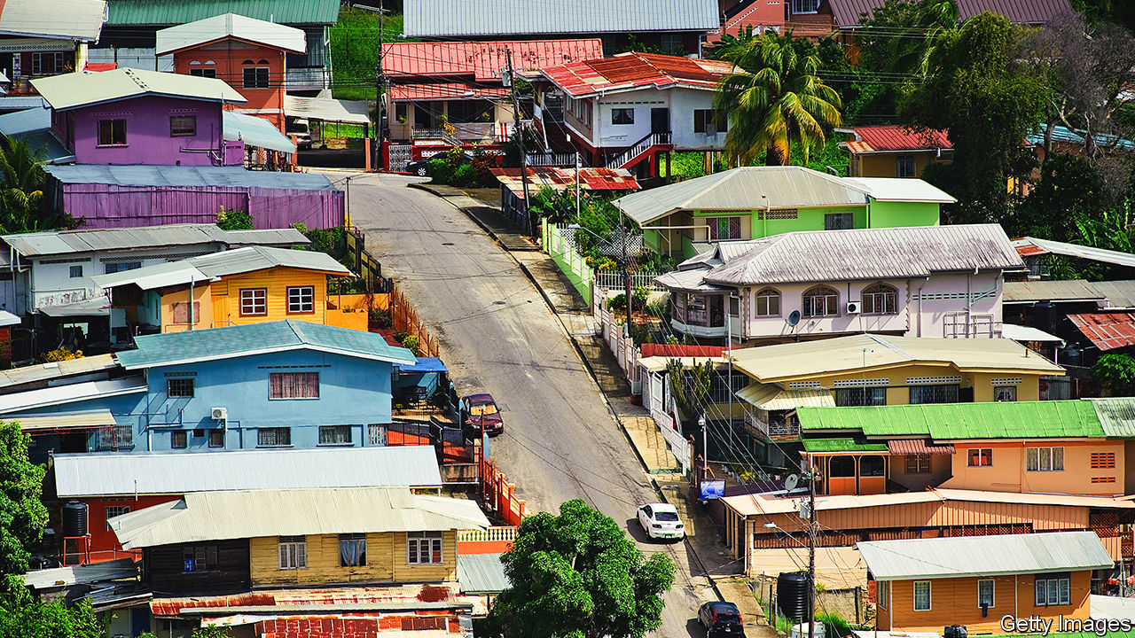

Love After Love. By Ingrid Persaud. One World; 336 pages; $27. Faber & Faber; £14.99.

INGRID PERSAUD’S engaging and vibrant novel begins in violence. In a story set in the author’s native Trinidad, Betty, her son Solo and Mr Chetan all encounter the dark side of that island’s culture. Betty’s vicious husband, Sunil, assaults her. “My arm was in a cast when we buried Sunil a week later,” she recalls. Mr Chetan’s landlord is the victim of a brutal robbery, and he must find somewhere else to live. He ends up lodging with the widowed Betty and Solo, and the trio create an unlikely yet happy family. But nothing is as simple as it seems.

Ms Persaud trained as a lawyer; she has won prizes for her short stories, but “Love After Love” is her first novel. It is narrated in the lively voices of her three main characters, braiding their stories and perspectives together and revealing their secrets to the reader.

For this is a book of revelations. It is easy to guess the truth Betty elides at the beginning of the story: her husband’s death was not accidental. As for Mr Chetan: he and Betty hit it off, and she hopes their relationship will go further. Perhaps he does, too. But in a scene both hilarious and moving, the author depicts in graphic detail Betty’s inability to wake his “sleeping soldier”.

Finally, he confesses to her what the reader has already learned: Mr Chetan is gay. The repercussions of this admission, and of Solo’s accidental discovery of the cause of his father’s death, shape the story, as these warm and loving characters struggle to come to terms with their own feelings, and the feelings—and deeds—of others.

These personal traumas are also political. Ms Persaud confronts the homophobia at large in Trinidad (where homosexuality was only decriminalised in 2018), of which Mr Chetan has been a victim all his life. For his part, Solo ends up travelling to America to stay with an uncle in New York. There he must navigate a hostile and frightening immigration system while struggling with his burdensome inheritance.

Amid all the sorrow, though, Ms Persaud’s novel is a delight. It is written in a lilting patois that sings from the page, and it is full of warmth and beauty. Mr Chetan—as good as a father to Solo—wants the best for the boy: “He mustn’t go through life being ’fraidy ’fraidy.” Mr Chetan has learned that himself the hard way; it is a lesson for the reader, too.

This article was downloaded by calibre from <https://www.economist.com/books-and-arts/2020/04/04/prejudice-and-revelations-in-love-after-love>

|  |  |  |  |
| --- | --- | --- | --- |
| Previous | Articles | Sections | Next |

|  |  |  |  |
| --- | --- | --- | --- |
| Previous | Articles | Sections | Next |

#### How to understand a plague

# Five books of science and history that cast light on covid-19

From the pestilence in London in 1665 to the Spanish flu and beyond

Apr 4th 2020 |

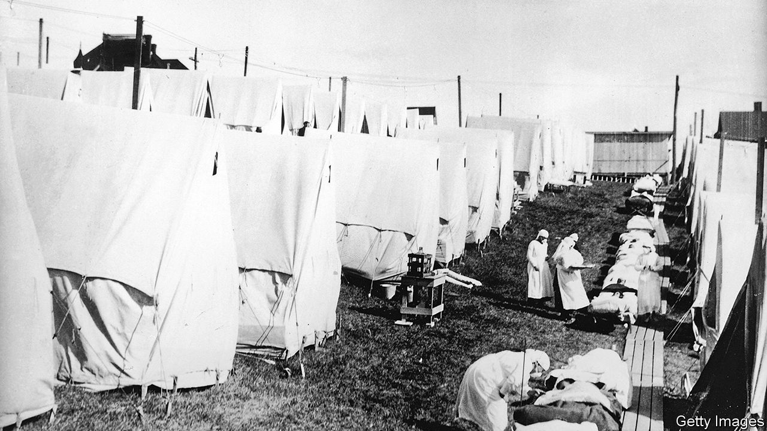

Editor’s note: The Economist is making some of its most important coverage of the covid-19 pandemic freely available to readers of The Economist Today, our daily newsletter. To receive it, register [here](https://www.economist.com/newslettersignup). For more coverage, see our coronavirus [hub](https://www.economist.com/coronavirus)

Pale Rider. By Laura Spinney (Public Affairs; Vintage)

The Spanish flu pandemic that began in 1918 killed around 50m people in a few years—more deaths than in the preceding four years of world war. Young adults seemed to perish disproportionately from what was an especially virulent strain of the influenza virus. Doctors could do very little about the sickness, so countries closed their borders and blamed each other. This book tells the story not only of the devastation at the time, but also of the century of scientific detective-work that was required to understand why the episode was so deadly.

Spillover. By David Quammen (W.W. Norton; Vintage)

Some of the outbreaks of disease that have caused most distress among human beings have come from animals. Other, non-human primates were the source of HIV; influenza transferred from birds, and coronaviruses from bats. When the human immune system is newly confronted with something that has just hopped the species barrier—a so-called zoonosis—it can be overwhelmed. By tracking the origin of several zoonoses, this book explains how such diseases emerge, why they are so dangerous and where in the world the next ones might arise.

The Rules of Contagion. By Adam Kucharski (Basic Books; Wellcome Collection)

Today, the freedoms and daily routines of many countries are held in the hands of epidemiologists. Amid the pandemic, these mathematical modellers have supplied scenarios for how travel bans, social distancing or stay-at-home policies could alter the trajectory of covid-19. This book charts the history of this now-pivotal science, from its origins in understanding the spread of malaria at the turn of the 20th century, to its central role in predicting the dissemination of everything from diseases to fake news in the 21st.

A Journal of the Plague Year. By Daniel Defoe (Oxford University Press)

A diary of one man’s life in 1665, when the bubonic plague swept through London, killing almost 100,000. The book recounts the progress of the disease as it transforms the city, describing streets that are either eerily empty or filled with the sounds and smells of suffering. Defoe was only five in 1665 and wrote the book, which blends historical detail and imagination, more than 50 years after the event. He is thought to have based it on the contemporaneous diaries of his uncle, Henry Foe.

The End of Epidemics. By Jonathan Quick and Bronwyn Fryer (St Martin’s Press; Scribe)

Published two years ago, this book’s simple message ought to have been more widely heeded: planning, preparation and open communication count for everything when it comes to ameliorating the vast social and economic damage that a new infection can cause. Using insights from previous outbreaks, the authors offer lessons on how global institutions can best co-ordinate to predict, model and prevent future pandemics. ■

Dig deeper:  
For our latest coverage of the covid-19 pandemic, register for The Economist Today, our daily [newsletter](https://www.economist.com/newslettersignup), or visit our [coronavirus hub](https://www.economist.com/coronavirus)

This article was downloaded by calibre from <https://www.economist.com/books-and-arts/2020/04/03/five-books-of-science-and-history-that-cast-light-on-covid-19>

|  |  |  |  |
| --- | --- | --- | --- |
| Previous | Articles | Sections | Next |

|  |  |  |  |
| --- | --- | --- | --- |
| Previous | Articles | Sections | Next |

#### Rich and strange

# Jellyfish, not the meek, might inherit the Earth

Yet there are very few toy jellyfish, Peter Williams observes ruefully

Apr 4th 2020 |



Jellyfish. By Peter Williams. Reaktion Books; 224 pages; $19.95 and £12.95.

LACKING BRAINS or much of a gut, jellyfish, which are 95% water, are deceptively simple in structure. Yet they are otherworldly in appearance, as their names—lion’s mane, flower hat—imply. Neither fish nor jelly and rather more like slime, they puzzled Aristotle. Were they animals or plants? Even the father of taxonomy, Carl Linnaeus, was stumped.

In fact, Peter Williams writes in his engaging and handsomely illustrated book, they are animals of surprising sophistication, with an ingenious portfolio of stratagems. Deepstaria enigmatica literally bags its meal by enfolding prey in its sheet-like body and tightening the edge like a drawstring. Erenna, a deepwater species, lures tiny crustaceans to their doom with luminescent tentacles. Turritopsis dohrnii, the “immortal” jellyfish, pulls off the most stunning ploy of all. When injured, it shifts into developmental reverse, devolving back into a polyp, its earliest stage of life. A Japanese researcher says unlocking the secret of this immortality is “the most wonderful dream of mankind”.

Until the advent of underwater cameras, their shape-shifting forms frustrated would-be illustrators and researchers. You might as well dissect a soap bubble. Unlike mammals, fish or insects, they could not be stuffed, mounted or pinned. Preservation was tricky; alcohol degraded their colour and translucency. Some of the best early depictions were exquisite 19th-century glass models, now in Harvard’s Museum of Comparative Zoology, made by father-and-son artists Leopold and Rudolf Blaschka.

Mr Williams’s book is an ambivalent experience itself. The reader is by turns wary, repulsed and fascinated by these creatures. They figure in the grand scheme of nature, providing food for sea turtles, penguins, lobsters and (primarily in Asia) humans. They act as a sink for greenhouse gases; they have played a role in Nobel-prizewinning research in chemistry and medicine.

On the sinister side, jellyfish blooms have sometimes created havoc. Forty million Filipinos were left in the dark in 1999 after swarms were sucked into the cooling system of a power plant, sparking fears of a military coup. In 2009 a Japanese trawler traversed an efflorescence of giant jellyfish, some weighing over 200 kilos. When its nets were raised, the boat capsized. Species such as the Portuguese man-of-war and the box jellyfish have a deadly sting, and antidotes remain elusive.

It may be that the meek will not ultimately inherit the Earth: jellyfish will. Because they can tolerate warming seas, acidification and pollution, some scientists believe that they may be set to outlast less robust animals. Others reckon that recent blooms simply reflect natural fluctuations in numbers.

Enduring they may be; endearing they are not. Toy jellyfish, after all, are few and far between. “Octopuses, yes,” Mr Williams ruefully acknowledges, but “very, very few jellyfish”. They are too toxic and they look too weird. But, he argues persuasively, if they are ineligible for affection, they at least deserve humanity’s respect. ■

This article was downloaded by calibre from <https://www.economist.com/books-and-arts/2020/04/04/jellyfish-not-the-meek-might-inherit-the-earth>

|  |  |  |  |
| --- | --- | --- | --- |
| Previous | Articles | Sections | Next |

|  |  |  |  |
| --- | --- | --- | --- |
| Previous | Articles | Sections | Next |

#### Johnson

# How to frame public health messages so people hear them

Behavioural economics offers some important insights

Apr 4th 2020 |

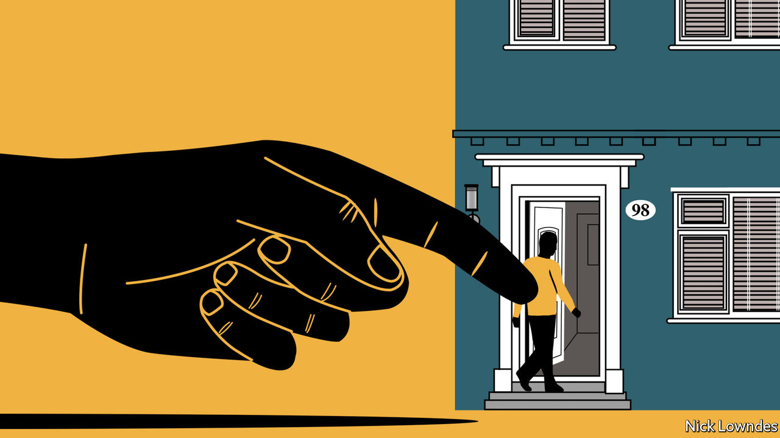

Editor’s note: The Economist is making some of its most important coverage of the covid-19 pandemic freely available to readers of The Economist Today, our daily newsletter. To receive it, register [here](https://www.economist.com/newslettersignup). For more coverage, see our coronavirus [hub](https://www.economist.com/coronavirus)

IMAGINE THAT America is preparing for the outbreak of an unusual Asian disease that is expected to kill 600 people. Two alternative responses are proposed. Assume that the consequences of the programmes are as follows: if option A is adopted, 200 people will be saved. If B is chosen, there is a one-third probability that 600 people will be saved and a two-thirds probability that none will be. Which would you choose?

Now assume a different pair of options. If C is implemented, 400 people will perish; if D is preferred, there is a one-third probability that nobody will die and a two-thirds probability that 600 people will. Which will you choose now?

If you are like most people, you chose A in the first scenario, and D in the second. If you stopped and deliberately did the maths, though, or have read Daniel Kahneman’s “Thinking, Fast and Slow”, you will have noticed that the two scenarios are identical: A and C offer the same outcome, as do B and D. Mr Kahneman won the Nobel prize in economics for his pioneering work (with the late Amos Tversky) in behavioural economics, which focuses on how people’s choices are swayed by a host of factors that should not affect decision-making, but perennially do. The first two paragraphs above are taken from a survey the two researchers conducted in 1981, eerily presaging today’s pandemic.

The glitches in human psychology that the pair identified include “negativity bias”: bad outcomes loom larger in people’s minds than positive ones. That is why A appeals (“200 people will be saved”), whereas the identical but differently framed C (“400 people will die”) does not; focusing on the negative pushes three-quarters of people away from this choice. This effect interacts with another one: willingness to gamble. People will not gamble with a sure thing in hand (200 living people) but they will take a risk to avoid certain losses (400 dead).

How can this inform effective communication over covid-19? It may be tempting for governments to stress the negative: “If you go out you may get sick.” No one wants a bad thing—but neither do they want to be stuck at home with no food, toilet paper or fun. Faced with two bad options—one certain (no fun), the other (becoming ill) worse but only hypothetical—many people will take the risk. They might be pushed in the opposite direction by stressing the good thing they have in hand: “Stay safe” rather than “Stop coronavirus spreading”. Most countries seem to be using both tactics.

Another research finding, tested in the real world, uses social psychology. Britain’s tax office added a single line to reminder notices telling overdue filers that most people pay their taxes on time, and that the recipient was one of the few who had not. That raised prompt filings by five percentage points. This kind of social shame might work for the virus, too.

But good framing is not enough. Leaders must also be clear and firm. Denmark, which has imposed a lockdown, is a fine example. “Cancel Easter lunch,” its government told citizens in no uncertain terms. “Postpone family visits. Don’t go sightseeing around the country.” As the Local, a Swedish news website, noticed, that injunction contrasts starkly with the language in Sweden, which (so far) has taken a much softer approach to containing the disease (see article). Its government said: “Ahead of the breaks and Easter, it is important to consider whether planned travel in Sweden is necessary.”

The Danish instructions seem to be working; police report few violations of the rules. As Orla Vigso, a Danish professor of language in Gothenburg, Sweden, says, the strictures are well-calibrated. Danes consider themselves “the anarchists of the Nordic countries”. To be made to comply they need to be told directly. But there is a wider lesson. Recommendations that sound more advisory than mandatory seem to presume rational adults will do the right thing with accurate information. The central insight of behavioural economics is that they do not, at least not reliably.

Rule number one in crisis communications, says Mr Vigso, is coherence. Mixed messages allow people to follow their biases and believe whatever they want. America is hobbled in two regards here. Its federal structure means a president, 50 governors and countless mayors are saying different things. And it has a president who said he wanted to see “packed” churches at Easter, then decided otherwise. You’re much more likely to tell people what they want to hear if you can’t make up your own mind.

Dig deeper:  
For our latest coverage of the covid-19 pandemic, register for The Economist Today, our daily [newsletter](https://www.economist.com/newslettersignup), or visit our [coronavirus hub](https://www.economist.com/coronavirus)

This article was downloaded by calibre from <https://www.economist.com/books-and-arts/2020/04/03/how-to-frame-public-health-messages-so-people-hear-them>

|  |  |  |  |
| --- | --- | --- | --- |
| Previous | Articles | Sections | Next |

|  |  |  |  |
| --- | --- | --- | --- |
| Previous | Articles | Sections | Next |

#### A family affair

# Why you should be watching “I, Claudius”

Ancient Rome is a memorable setting for a saga of bloodshed and intrigue

Apr 4th 2020 |



A RICH FAMILY takes control of one of the world’s two superpowers and rules for generations with the aid of a compliant Senate. That is not the plot of a 21st-century political satire but of “I, Claudius”, a British television drama of the 1970s about the Roman imperial family, based on novels by Robert Graves.

The series features some terrific actors such as John Hurt (as Caligula), Patrick Stewart (as Sejanus, a scheming consul) and, in the title part, Derek Jacobi as the stuttering, lame emperor. Brian Blessed, normally a very hammy performer, is marvellously effective as Augustus. Siân Phillips plays his tricksy wife, Livia.

Apart from the acting, two things make the show a pleasure to revisit in isolation. The first is that this is just the right kind of history to dramatise: familiar-sounding but only half-remembered. Most people will have heard, if dimly, of Augustus, Tiberius, Caligula and Nero; the Roman Empire is still revered. Second, this is soap opera on a grand scale, featuring murder, madness, incest and betrayal. It is “Game of Thrones” without the dragons and direwolves.

The story is told in flashback by the aged Claudius as he recalls the (literally) poisonous feuds that engulfed his family and resulted in his unlikely ascent to the imperial throne. Indeed, he only becomes emperor because the praetorian guard needed a ruler to justify their existence, after the assassination of Caligula. In a speech to a doubtful Senate, Claudius says: “As for being half-witted: well, what can I say, except that I have survived to middle age with half my wits, while thousands have died with all of theirs intact. Evidently, quality of wits is more important than quantity.”

Many scenes stick in the mind 40 years after they were first broadcast. In one, Livia carefully explains to Augustus how she has poisoned him with fruit from a fig tree, as Mr Blessed stares in mute, unblinking silence for what seems like five minutes. In another, Claudius’s mother, Antonia, imprisons her daughter, Livilla, after the latter killed her own husband. As Livilla screams, Claudius asks, “How can you leave her to die?” “That’s her punishment,” his mother answers. “How can you bear to sit out here and listen to her?” Claudius says. Antonia replies, “And that’s mine.”

Gulp this down now, and you will need to make allowances. The 1970s were an era of limited budgets, so the series was shot in the studio; vast Roman legions are represented by half a dozen soldiers. But the story is so compelling that it overcomes these shortcomings. It is, above all, a meditation on the corrupting influence of absolute power. Place all authority in the hands of one individual, and society is at risk from his follies and petty jealousies. Even the well-meaning Claudius is betrayed by almost everyone he trusts and, in his dying moments, learns that his dreams of a restoration of a republic will be dashed. ■

This article was downloaded by calibre from <https://www.economist.com/books-and-arts/2020/04/04/why-you-should-be-watching-i-claudius>

|  |  |  |  |
| --- | --- | --- | --- |
| Previous | Articles | Sections | Next |

|  |  |  |  |
| --- | --- | --- | --- |
| Previous | Articles | Sections | Next |

#### Gambling with the future

# The joys of teaching poker to your kids

The lessons they glean will last a lifetime—so long as they hurt

Apr 4th 2020 |

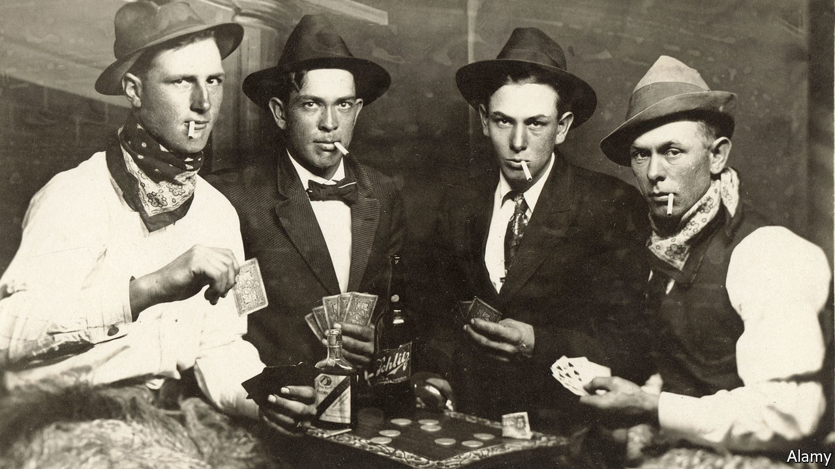

“THE BEAUTY of poker,” writes David Sklansky in the introduction to “The Theory of Poker”, perhaps the best book written about the best card game invented, “is that on the surface it is a game of utter simplicity, yet beneath the surface it is profound, rich and full of subtlety.” Cooped-up children can learn the rules in just a few open hands—that is, rounds played with all cards visible and all moves explained. The lessons they glean will last a lifetime.

To sceptics, poker conjures up images of casinos, late nights and smoky back rooms—all places inappropriate for kids. That outmoded caricature need not trouble people playing in quarantined homes, at reasonable hours and without cigars. And, yes, poker is a form of gambling, but it is primarily a game of skill and nerve.

Luck plays a larger role than in purely skill-driven games such as chess, but that is what makes poker so appealing for put-upon parents: you will be a better player than your children, but they will still win often enough to keep them interested. As Mr Sklansky puts it, “The 500th best player could easily win a [poker] tournament. By contrast, the 500th best golfer is not going to win a golf tournament.”

There are enough variations for children to pick personal favourites; in other words, like literature and music, it offers them a chance for self-expression within a shared passion. Just as a parent thrills to see their offspring reading, even if what the child chooses to read is not what the adult would, a poker-enthusiast parent will happily play Five-card Draw with his child, even if he prefers Texas Hold ‘Em.

The goal is always straightforward: amass a better five-card hand than your opponents. But the paths to success are many and divergent. Sometimes it involves bluffing, a practice that, initially, children embrace with lunatic enthusiasm. A parent may feel guilty about taking all his child’s chips the fourth time the kid goes all-in with nothing higher than a nine. Persist: eventually, they will learn that they cannot always lie their way to victory, and that sometimes the wiser action is to withdraw from the fight. They will also learn the corollary of that lesson: sometimes bluffing works.

Soon they will figure out how to read their opponents—observing that cockiness can be a cover for weakness, and reticence a ploy to tempt others into overconfidence. They will see that a lost hand is not a lost game, and a lost game today does not augur the same tomorrow. In poker, as in life, the race is not always to the swift, and chance and bad beats (losing a winnable hand) happeneth to one and all.

But the only way they will learn any of these lessons is if they hurt. After a few practice rounds with matchsticks or toothpicks, the stakes must be actual money—and adults must keep it when they win. This may be difficult: children come into the world lovable but broke, and no parent wants to further impoverish their own. On the other hand, children are also expensive. Consider any victory a partial repayment for their upbringing. ■

This article was downloaded by calibre from <https://www.economist.com/books-and-arts/2020/04/04/the-joys-of-teaching-poker-to-your-kids>

|  |  |  |  |
| --- | --- | --- | --- |
| Previous | Articles | Sections | Next |

|  |  |  |
| --- | --- | --- |
| Books and arts | Sections | Graphic detail |

Economic and financial indicators

Economic data, commodities and markets

.

|  |  |  |
| --- | --- | --- |
| Books and arts | Sections | Graphic detail |

|  |  |  |  |
| --- | --- | --- | --- |
|  | Articles | Sections | Next |

# Economic data, commodities and markets

Apr 4th 2020 |

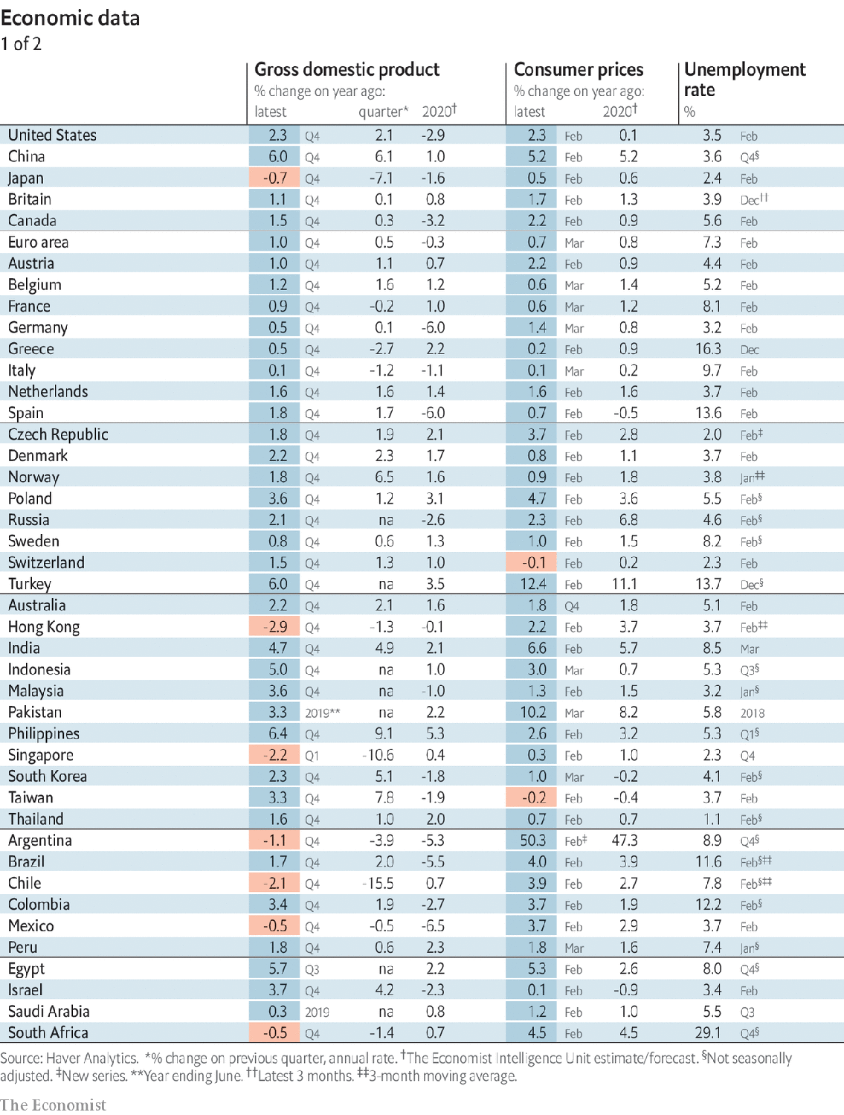

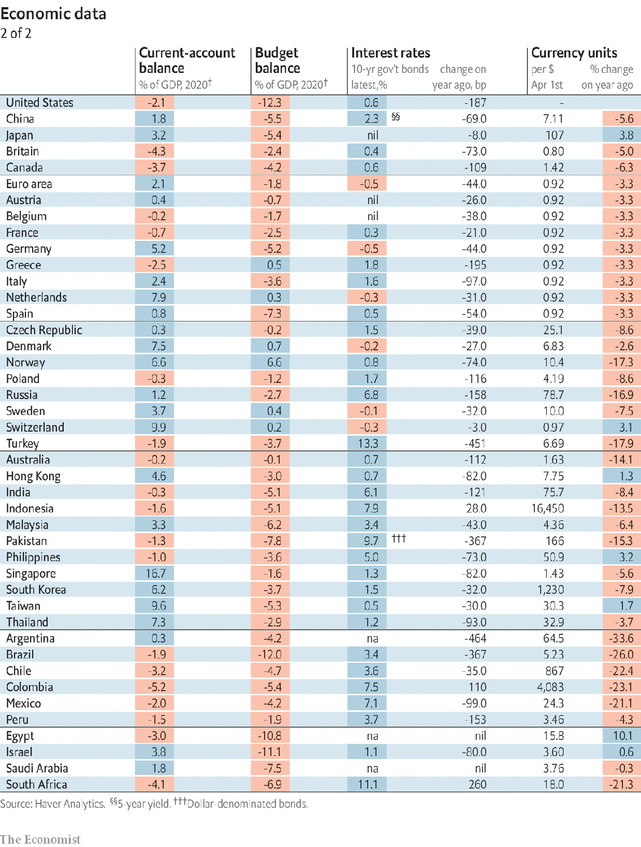

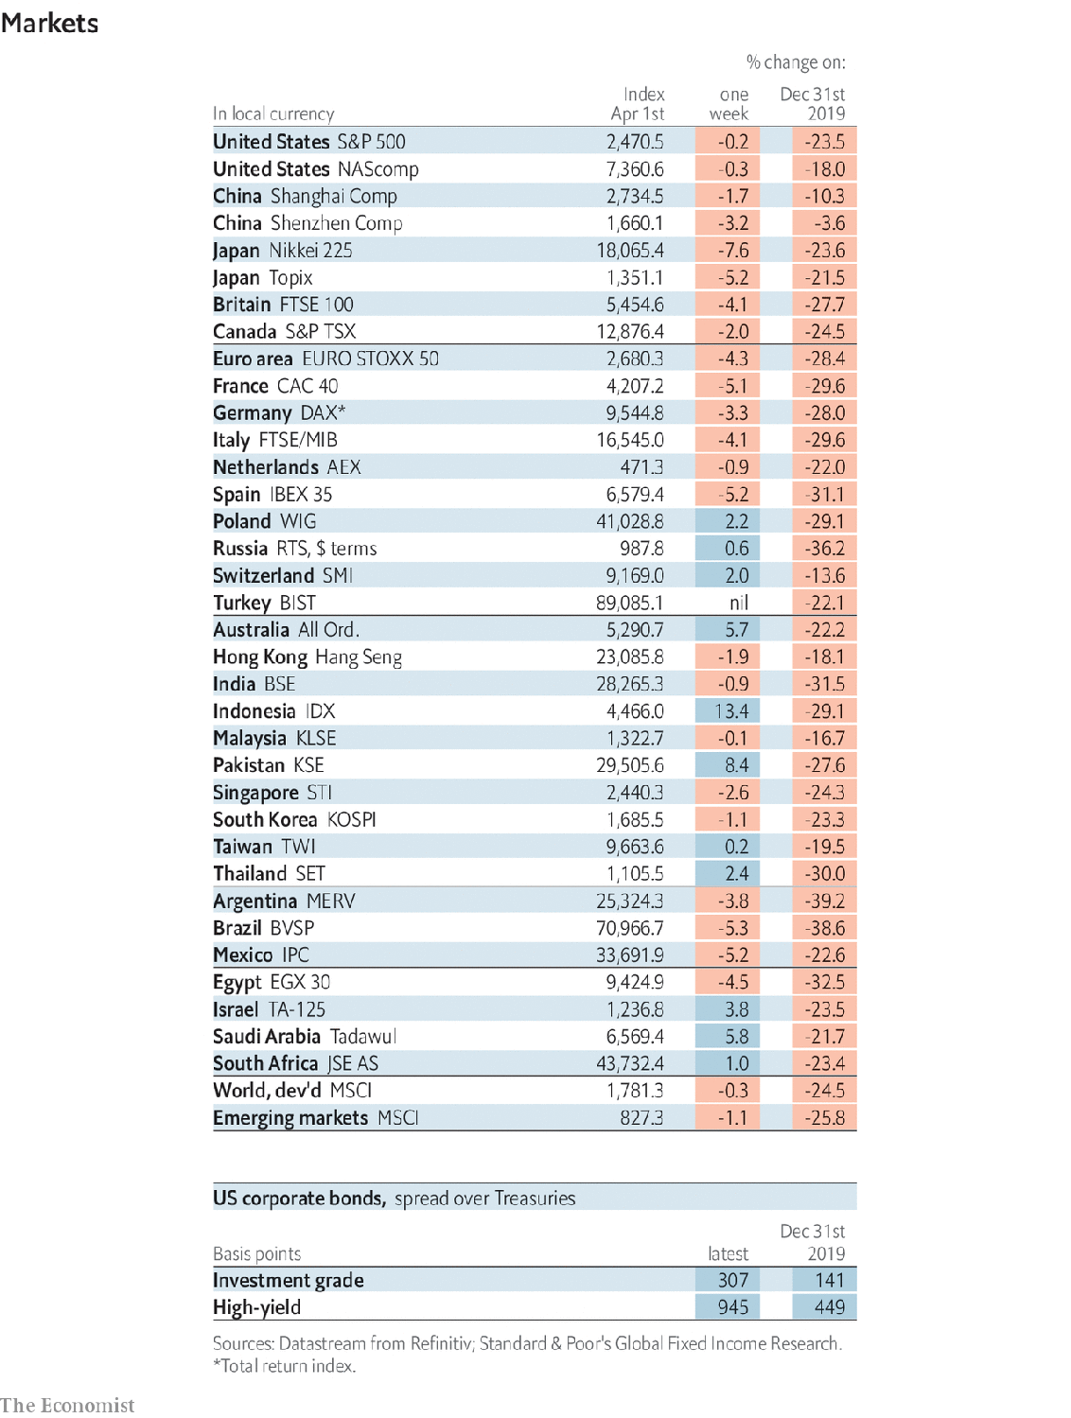

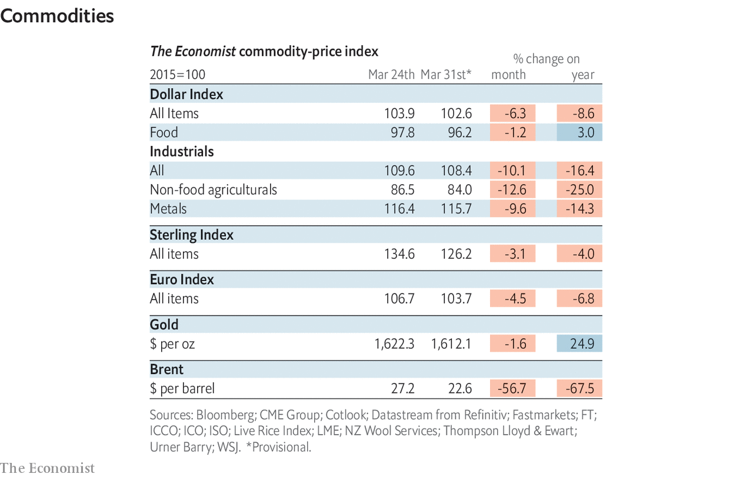

This article was downloaded by calibre from <https://www.economist.com/economic-and-financial-indicators/2020/04/04/economic-data-commodities-and-markets>

|  |  |  |  |
| --- | --- | --- | --- |
|  | Articles | Sections | Next |

|  |  |  |
| --- | --- | --- |
| Economic and ... | Sections | Obituary |

Graphic detail

Coronavirus statistics: Fatal flaws

.

|  |  |  |
| --- | --- | --- |
| Economic and ... | Sections | Obituary |

|  |  |  |  |
| --- | --- | --- | --- |
|  | Articles | Sections | Next |

#### Fatal flaws

# Covid-19’s death toll appears higher than official figures suggest

Measuring the total number of deaths tells a grimmer tale

Apr 4th 2020 |

Editor’s note: The Economist is making some of its most important coverage of the covid-19 pandemic freely available to readers of The Economist Today, our daily newsletter. To receive it, register [here](https://www.economist.com/newslettersignup). For more coverage, see our coronavirus [hub](https://www.economist.com/coronavirus)

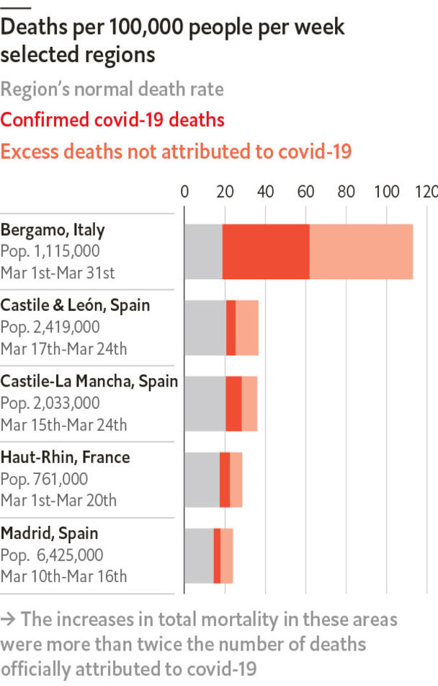

THE SPREAD of covid-19 is most often measured by two numbers: how many people are infected, and how many have died. The first is very uncertain. Some carriers show no symptoms, and most countries do not test people who seem healthy. Because data on infections are unreliable, researchers have focused on deaths. Yet new statistics suggest that current fatality numbers may also understate the damage.

Official death tolls for covid-19 may exclude people who died before they could be tested. They also ignore people who succumbed to other causes, perhaps because hospitals had no room to treat them. The latter group has been large in other disasters. For example, when Hurricane Maria struck Puerto Rico in 2017, America recorded only 64 deaths. A study later found that the surge in total deaths was close to 3,000. Many occurred in hospitals that lost power.

Such analysis is not yet possible for nations battling covid-19. The only European country whose total death rate (as calculated by EuroMOMO, a research group) had spiked by March 20th was Italy. This estimate is based on a group of cities. Unfortunately, Italy does not break down covid-19 deaths by city, precluding a comparison of covid-19 and total deaths in the same area.

However, journalists and scholars have crunched their own numbers. L’Eco di Bergamo, a newspaper, has obtained data from 82 localities in Italy’s Bergamo province. In March these places had 2,420 more deaths than in March 2019. Just 1,140, less than half of the increase, were attributed to covid-19. “The data is the tip of the iceberg,” Giorgio Gori, the mayor of Bergamo’s capital, told L’Eco. “Too many victims are not included in the reports because they die at home.”

Comparable figures can be found across Europe. In Spain El País, a newspaper, has published the results of a study by the government’s health research centre, showing that “excess” deaths in the Castile-La Mancha region were double the number attributed to covid-19. Jean-Marc Manach, a French reporter, has found a similar disparity in the department of Haut-Rhin.

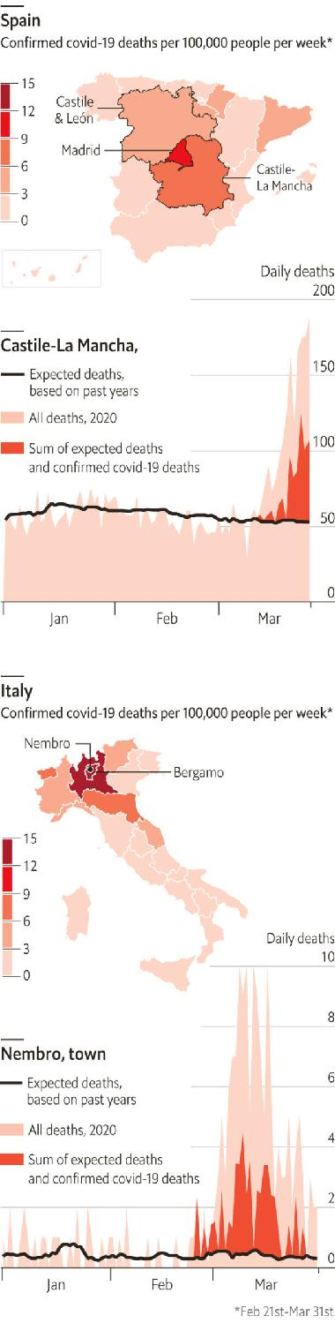

These differences may shrink over time. Official counts of covid-19 fatalities could be updated to include people who have already died, because confirming the cause sometimes takes several days. The toll from other types of death might fall soon: lockdowns could reduce accidents and violence, and many frail covid-19 victims were already likely to die of other causes. And mortality data are noisy in smaller regions—especially hard-hit ones that may not be representative of entire countries.

Still, the official covid-19 count will always seem too low in places like Nembro, a Bergamasque town of 11,000 people. It suffered 152 deaths in March, with only 39 attributed to the virus so far. “Almost all the old people got it,” says Luca Foresti, a researcher. “And therefore they died, a lot.” ■

Sources: Claudio Cancelli; Luca Foresti; L'Eco di Bergamo; El País; INSEE; Santé Publique France; Ministero della Salute; Tuttitalia; Ministerio de Sanidad; Datadista; Instituto de Salud Carlos III; Instituto Nacional de Estadística; InTwig

Dig deeper:  
For our latest coverage of the covid-19 pandemic, register for The Economist Today, our daily [newsletter](https://www.economist.com/newslettersignup), or visit our [coronavirus hub](https://www.economist.com/coronavirus)

This article was downloaded by calibre from <https://www.economist.com/graphic-detail/2020/04/03/covid-19s-death-toll-appears-higher-than-official-figures-suggest>

|  |  |  |  |
| --- | --- | --- | --- |
|  | Articles | Sections | Next |

|  |  |  |
| --- | --- | --- |
| Graphic detail | Sections |  |

Obituary

Joseph Lowery: Justice like waters

.

|  |  |  |
| --- | --- | --- |
| Graphic detail | Sections |  |

|  |  |  |  |
| --- | --- | --- | --- |
|  | Articles | Sections | Next |

#### Justice like waters

# Joseph Lowery died on March 27th

The preacher and fiery civil-rights campaigner was 98

Apr 4th 2020 |

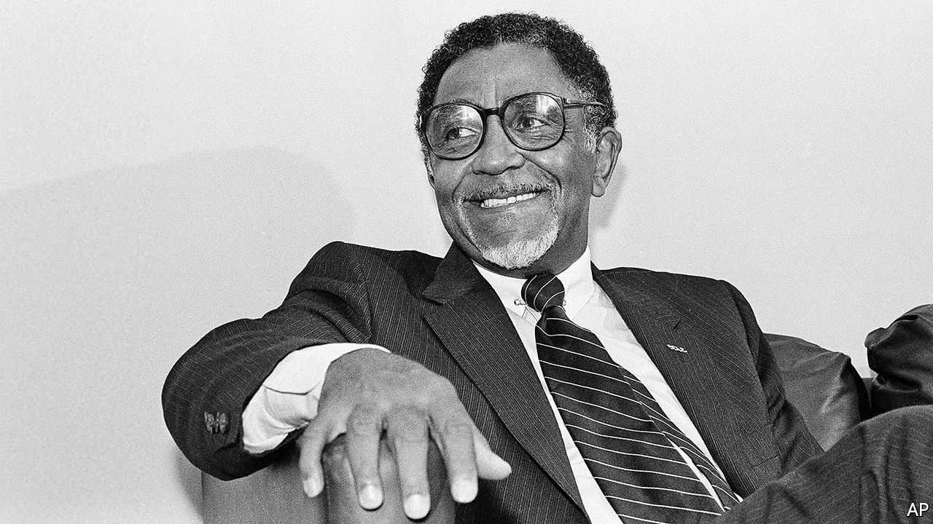

AS HE RAN home crying, the hot tears coursing down his cheeks, he knew exactly what he had to do. He would find his father’s pearl-handled .32. He knew where it was. Then he would run back to the family store while the white police officer was still there, the one who had told him “Get back, nigger! Don’t you see a white man coming in the door?” and had smacked him in the belly with his nightstick—and he would shoot him dead.

Luckily his father stopped him in time, saving his child-self from being lynched by the outraged whites of Huntsville, Alabama. And it seemed to Joseph Lowery that a seed was planted that day, a seed of struggle. It could have made him hate: just one more insult among the many he was used to, being born black. Instead, it grew towards love. He had learned non-violence. Several years later, when he had given up struggling against the Lord’s call to be a Methodist preacher, the New Testament repeated the lesson: do good to them that hate you. Or as he liked to put it later in one of his rhymes, not suppressing a smile, “An eye for an eye and a tooth for a tooth, will leave us all blind and gummin’ our food.”

That conviction grew all the stronger when he met Martin Luther King. (He liked the guy from the start, even though he was Baptist.) Together in 1957 they founded the Southern Christian Leadership Conference that led, with prayers, sit-ins and marches, the civil-rights campaigns of the 1960s: for desegregated lunch counters, for equality in hiring and education, for the vote. When Martin was killed, at 39, in 1968 the SCLC fell on hard times for a decade, but in 1977 he took over as president and broadened what it did. Now it raised its voice against poverty and discrimination in general, against police brutality and the death penalty, as well as for peace in all corners of the world. Justice would roll down like waters, and righteousness like a mighty stream.

He felt no fear in speaking truth to power. Both Jimmy Carter and Bill Clinton felt the hot lash of his tongue for failing to raise up people out of poverty. Both Bushes, senior and junior, were scolded publicly over Iraq: for war, billions more, but no more for the poor. After the march on Selma in 1965 he presented a voting petition to Governor George Wallace—going like Moses through the Red Sea, through a Blue Sea of state troopers—and told him frankly that God would hold him accountable. Though he might seem a mild fellow, with his spectacles and jokes, he had a fire in him that fire-hoses couldn’t wash out. For years he had thought that social justice on Earth had little to do with the kingdom of Heaven. Now he knew that a minister’s job was also to make Earth more heavenly.

Besides, non-violence had wrought a spiritual change in him. He had become a new creature, perplexing to his enemies, as everyone in the movement had. The first proof came early. In Mobile in 1955 he and another minister rode one day in the front of the bus to Prichard, a more racist town. When a white passenger came up to bawl them out he quietly told him to sit down, and the man obeyed. Pretty soon, no black person on Mobile’s buses had to give up his seat to a white. After this success Martin asked him to help with the year-long bus boycott in much bigger Montgomery, which in 1956 led to the desegregation of buses all over America. Patience paid off. Love worked. They were crazy, perhaps; but good crazy.

Time and again as he campaigned the Lord protected him. (Preachers were useful to Him for that streaming down of justice: independent, strong and servants of the people, not servants of chambers of commerce.) The Lord made him decide to take a train back to Nashville on the night his motel room in Birmingham was blown apart. He held him and his wife Evelyn in the palm of His hand when Klansmen’s bullets whooshed over his head, and through their car, in Decatur, where he was supporting a mentally disabled black man accused of raping a white woman. The Lord even organised it that when he and others were judged by an Alabama court to have libelled a state official, the Supreme Court in 1964 overturned the judgment, and his car, which had been seized, was bought back at auction by a member of his flock.

In each of these trials the old anger would flash through him, and with prayer he would hold it back. The hardest point came on that spring day when Martin was shot in Memphis, a rare day when he was not at his side. He curbed his grief by pouring energy into the two big United Methodist churches, Central and Cascade, which he ran in Atlanta for many years, building up membership mightily. But he poured even more into the SCLC, Martin’s organisation as he saw it, by keeping that flame burning and by reminding Americans what sort of man his friend had been. A doer, not a dreamer; a revolutionary who challenged the capitalist system and the powers that be, whose birthday should be marked every year with marches against the injustice and inequality that still stalked the land. The job was far from finished. And they had marched too long, bled too profusely, to give up striving now.

He believed deeply in that struggle. But he also knew that God’s plan was bound to work out. Crooked places would be made straight, the lion would lie down with the lamb and every tear would be dried. Sometimes he could feel God moving in history, nudging it along. It happened when the boss of Morrison’s cafeterias in Montgomery, who refused to desegregate his lunch counters, dropped dead just before the Civil Rights Act; and it happened when a black man in 2008 ran for president of the United States.

At Barack Obama’s inauguration he was asked to give the benediction. He was delighted to; that way, he would get the last word. Time for a rhyme, but a heartfelt one. He prayed for a day when black would not be asked to get back, brown could stick around, yellow would be mellow, and white would embrace what was right. “The Star-Spangled Banner” was the only thing that followed him.

As an anti-war campaigner it was not a piece he liked, with all that “bombs bursting in air” stuff. But it sounded better than ever then. It was not the anthem that had changed; the country had changed. Say amen! And amen! In the fierce cold of that January day, hot tears coursed down his cheeks.■

This article was downloaded by calibre from <https://www.economist.com/obituary/2020/04/04/joseph-lowery-died-on-march-27th>

|  |  |  |  |
| --- | --- | --- | --- |
|  | Articles | Sections | Next |